

**DEPARTMENT OF COMPUTER SCIENCE & ENGINEERING**

A Dissertation Report on

**Smart Parking System**

Submitted by

KOUSHIK A S         1MS15CS058

MAHESH V        1MS15CS062

MOHAN RAJ          1MS15CS071

***Bachelor of Engineering in Computer Science & Engineering***

Under the guidance of

                                                            Dr. Divakar Harekal

(Assistant Professor, Dept. of CSE, RIT)

                                                             (Dept of CSE, RIT)

**M.S.RAMAIAH INSTITUTE OF TECHNOLOGY**

**(Autonomous Institute, Affiliated to VTU)**

**BANGALORE-560054**

2017-2018, [www.msrit.edu](http://www.msrit.edu),



**Ramaiah Institute of Technology**

**(Autonomous Institute, Affiliated to VTU)**

**BANGALORE-560054**

# Department of Computer Science & Engineering

**CERTIFICATE**

This is to certify that the project work titled **Internet of Things(IoT) Smart Parking System,** is a bonafide work carried out by **Koushik A S (1MS15CS058), Mahesh V(1MS15CS062), Mohan Raj (1MS15CS071)** in partial fulfillment for the course of Bachelor of Engineering in Computer Science and Engineering during the year 2018. The Project report has been approved as it satisfies the academic requirements with respect to the project work. To the best of our understanding the work submitted in this report has not been submitted anywhere.

### Signature of the Guide Signature of the HOD

Dr. Divakar Harekal Dr. Anita Kanavalli

**External Examiners**

Name of the Examiners: Signature

1.

2.

**Contents**

1. Abstract
2. Hardware block diagram and different component specification
3. Software block diagram /flowchart of different modules
4. Circuit diagram
5. Implementation
6. Result
7. Code
8. Conclusion

**ABSTRACT:**

In recent times Parking has been huge problem in all metropolitan cites. The limited parking spaces available should be used properly to tackle this problem. However, there is still lack of organization in many parking spaces in malls and other places. This is due to lack of information of how many cars are there in parking lot and what is the normal trend of peak traffic of intake of cars. This can be solved by using Internet of things (IoT) technologies. We in this project propose propose a way to monitor how may cars are there in parking lot and to see daily trends of intake of cars with the help of online application such as Ubidots. PIR sensors is used to detect motion using change in infrared in an environment when a body has entered. Since car engine emit lot of infrared rays when they can activate PIR sensor. We configured two PIR sensors one at entry other at exit to increment and decrement counter (no of cars) respectively when they are activated. This gives us how many cars in parking lot accurately without human effort. We also configured cloud server as a data repository. The no of cars is displayed in remote dashboard. We can also get a daily report of traffic of intake of cars with their time stamp. With this we can monitor traffic inside parking lot and take appropriate steps to manage cars inside parking lot. This project proposes a prototype system design, implementation and description of required tools and technologies to develop Internet of Things (IoT) based Smart parking System.

**Hardware block diagram /different component specs**

Hardware components used for Smart parking is

**Node MCU**

NodeMCU is an open source LUA based firmware developed for ESP8266 wifi chip. Since NodeMCU is open source platform, their hardware design is open for edit/modify/build.

NodeMCU Dev has Arduino like Analog (i.e. A0) and Digital (D0-D8) pins on its board. It supports serial communication protocols such as UART, SPI, I2C etc. Using such serial protocols, we can connect it with serial devices like I2C enabled LCD display, PIRs, MPU-6050 Gyro meter, RTC chips, GPS modules. It has a built in wifi module also by that we can easily connect to that device.

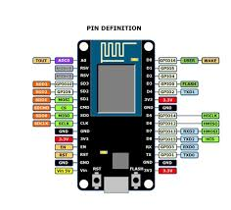

Figure 1 NodeMcu Model

**PIR (Passive Infrared Sensor)**

PIRs (Passive infrared sensor) are basically pyroelectric sensors which can detect levels of infrared radiation as well as motion. The sensor in a motion detector is actually split in two halves.

One half will detect the infrared radiations and other half will detect the motion of the object. The sensor is also having one delay time adjust component and sensitivity adjust component. We can adjust the amount of delay for a particular object to detect by the sensor by delay time adjust component and as well as the sensitivity of the sensor can also be adjusted by the sensitivity component.

It has lenses internally, the plastic window covering may have multiple facets moulded into it, to focus the infrared energy onto the sensor. Each individual facet is a Fresnel lens. The reason why we chose this sensor in this project is to detect the objects. We have used two sensors, one as an entry sensor and other as an exit sensor.

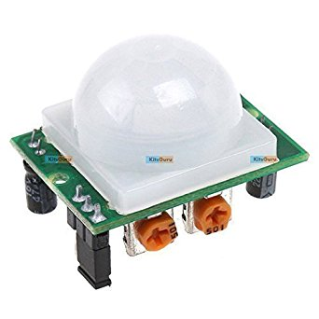

Figure2 PIR Sensor

**Cloud Platform**

We are using cloud for maintaining the count for number of cars so that the organization can easily get the information about the number of space left in the parking lot and also, they will get the idea about arranging the space for remaining vehicles. We can also get the statistics of a vehicle traffic in different times of day. We have used Ubidots a cloud development platform for this. They provides simple mechanism for data collection, analysis and provide powerful visual tools.

**Software block diagram /flowchart of different modules**

**Arduino IDE**:

Arduino is an open-source platform used for building electronics projects. Arduino consists of both a physical programmable circuit board and a piece of software, or IDE (Integrated Development Environment) that runs on your computer, used to write and upload computer code to the physical board. Unlike most previous programmable circuit boards, the Arduino does not need a separate piece of hardware (called a programmer) in order to load new code onto the board we can simply use a USB cable. Additionally, the Arduino IDE uses a simplified version of C++, making it easier to learn to program. Finally, Arduino provides a standard form factor that breaks out the functions of the micro-controller into a more accessible package. The flow chart for the smart parking system

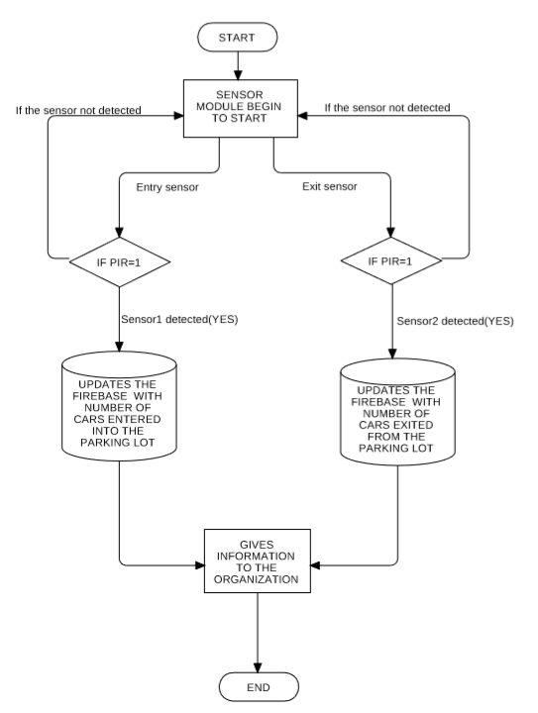

Figure 3: Flowchart of the Module

**CIRCUIT DIAGRAM:**

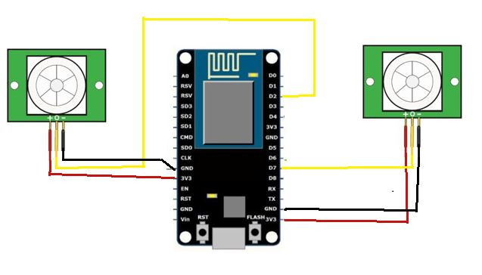

Figure 4: Circuit Diagram

Following figure represents the circuit diagram of Smart Parking System. The two PIR sensors are Data Out Pins are connected to Node MCU Digital I/o pin D7 and D2. The Vcc of both is connected to Vcc 3V3 in noe Mcu and Ground is connected to GND of Node MCU.

Wire up the Hardware as shown in the circuit diagram. The connections are made as follows.:

* The NodeMCU and sensor are connected in a series connection as shown above.
* The VIN PIR sensor is connected to NodeMCU Digital I/o pin D7 and D2.
* The 3.3V(+) of the NodeMCU is connected to positive terminals of the sensors.
* The grounds of the NodeMCU are connected negative terminals of sensors

**IMPLEMENTATION:**

The prototype can be implemented on parking Lots by fitting PIR sensor connected to D12 to entry path and other which is connected to D3 to exit path. After connecting the circuit, we have to configure Node MCU to Cloud server (Ubidot). Ubidots will be assigned a default token. This token is a software key that will allow Our prototype of Smart Parking Lot to communicate with the Ubidots server and log the data for analysis.

To validate the proper working of Node MCU and PIR Sensors we can just test it with a moderate hot body over PIR sensor and see whether counter is incrementing (or decrementing) in the cloud server. We can also plot graph of the continuous data analysed by setting up dashboard in Ubidots.

**RESULT:**

The results can be observed in the below snapshots of the hardware and the software code. As shown in figure 6, the LED glows when the sensor is activated. The figure 5 shows the same when LED is low (i.e sensor is not activated).

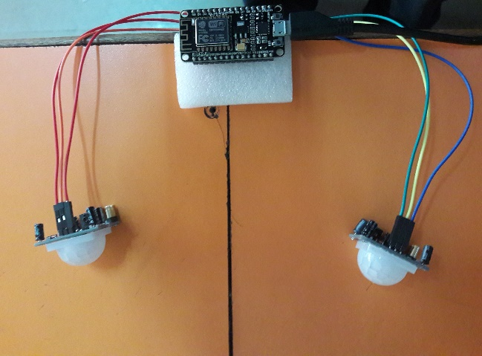 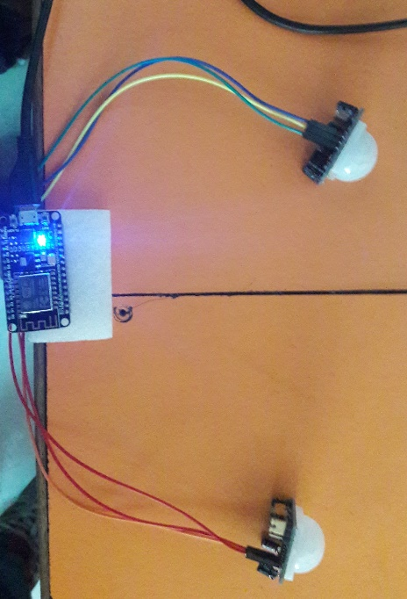

Figure 5: Working of the Module when Figure 6: Working of the Module when the PIR sensor is not activate the PIR sensor is activate

The software readings recorded in the Node MCU , show a value of no of cars which

Is incremented or decremented when PIR sensor is activated respectively.

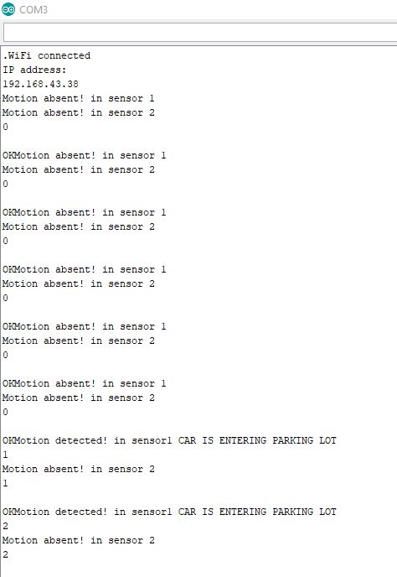  
Figure 7: Results shown in the monitor

Figure in the monitor

The Ubidot software also provides a graph which show the time series analysis of the readings recorded at a particular interval of time. The graph and the readings are shown in figure no 9.

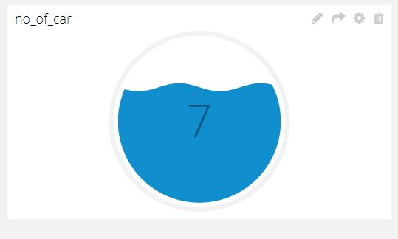

Figure 8: Indicating no of cars in the Parking Lot

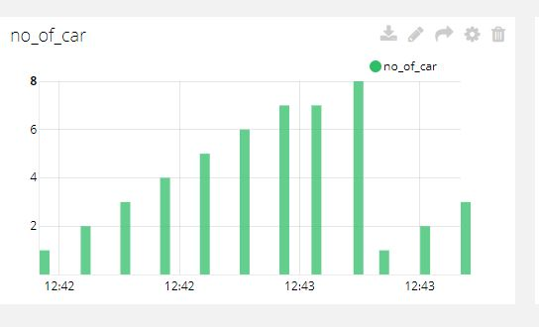

Figure 9: Graph showing the Traffic of cars inside Parking Lot with Time stamps.

**CODE:**

#include "UbidotsMicroESP8266.h"

LiquidCrystal_I2C lcd(0x27, 16, 2);

#define TOKEN "Token_Generated_In_Ubidots"

#define WIFISSID "Name_OF_WIFI"

#define PASSWORD "Password_Of_WIFI"

Ubidots client(TOKEN);

int Status = 12;

int no_of_car=0;

int sensor1 = 13;

int sensor2 = 4;

void setup() {

Serial.begin(115200);

no_of_car=0;

pinMode(LED_BUILTIN, OUTPUT);

pinMode(sensor1, INPUT);

pinMode(sensor2, INPUT);

client.wifiConnection(WIFISSID, PASSWORD);

delay(25);

}

void loop() {

int state1 = digitalRead(sensor1);

if(state1 == 1) {

digitalWrite(LED_BUILTIN, HIGH);

Serial.println("Motion detected! in sensor1 CAR IS ENTERING PARKING LOT ");

no_of_car=no_of_car+1;

Serial.println(no_of_car);

delay(4000);

}

else {

digitalWrite (LED_BUILTIN, LOW);

Serial.println("Motion absent! in sensor 1");

delay(2000);

}

long state2 = digitalRead(sensor2);

if(state2 == HIGH) {

digitalWrite(LED_BUILTIN, HIGH);

Serial.println("Motion detected! in sensor2 CAR IS EXITING OUT OF PARKING LOT");

no_of_car=no_of_car-1;

Serial.println(no_of_car);

delay(4000);

}

else {

digitalWrite (LED_BUILTIN, LOW);

Serial.println("Motion absent! in sensor 2");

delay(2000);

}

client.add("no_of_car", no_of_car);

client.sendAll(true);

delay(5000);

}

**CONCLUSION:**

IoT based proposed system is used to details about no of cars in parking lot in real time from any location, any device connected to Internet. This data can be used for various purposes for better management of parking spaces. Monitoring no of cars from remote location may be very useful when it is not possible to visit location physically every time. The system can be implemented in different parking lot by fixing sensors in suitable places. In future, the proposed system can be used to monitor and analyze the incoming traffic of cars according to the timestamps. Concluding the proposed IoT based Smart Parking Lot monitoring system will be helpful to collect, analyze and predict the no of cars at parking lot and can be used to effectively to better organize cars during peak hours.