**Manish Racha**

**Usability Evaluation**

**Resources:**

Read the content of  [Usability Evaluation Basics | Usability.gov (Links to an external site.)](https://www.usability.gov/what-and-why/usability-evaluation.html)

Read the content of [Usability Evaluation Methods | Usability.gov (Links to an external site.)](https://www.usability.gov/how-to-and-tools/methods/usability-evaluation/index.html)

Note: Examples of evaluation methods (but not limited to): Baseline usability testing on an existing site, focus groups, surveys or interviews to establish user goals, Card Sort testing to assist with IA development, Wireframe testing to evaluate navigation, First click testing to make sure your users go down the right path, Usability testing to gauge the user interaction end-to-end and, and Satisfaction surveys to see how the site fares in the real world.

To perform a usability evaluation, you need to

1) chose a usability evaluation method (from the previous links)

2) come up with 5 additional questions to the list provided next to collect/gather/ask yourself when performing the usability evaluation method.

In addition to the following questions, add 5 more questions not mentioned next.

1. Does the interface have an Intuitive design: a nearly effortless understanding of the architecture and navigation of the site?
2. Is the interface easy to learn: how fast a user who has never seen the user interface before can accomplish basic tasks?
3. What is the interface’s Efficiency of use: How fast an experienced user can accomplish tasks?
4. Explain the interface’s Memorability: after visiting the site, if a user can remember enough to use it effectively in future visits
5. What is the Error frequency and severity: how often do users make errors while using the system, how serious the errors are, and how do users recover from the errors?
6. What is its subjective satisfaction: If the user likes using the system?
7. Provide Screenshots: images of the interface and its uses (at least 5).

In total, you will be collecting/reporting the answer to 12 questions.

**Q1: Perform a usability evaluation of a user interface of your choice of any interactive game.**

Performing Usability Evaluation for a Candy rush saga game



* **10% of grade ~ Include the URL / app name/ link /etc. (give us the ability to access it ourselves)**

<https://www.usability.gov/how-to-and-tools/methods/usability-evaluation/index.html>

https://www.wikihow.com/Play-Candy-Crush-Saga#:~:text=The%20game%20is%20played%20by,a%20series%20of%20different%20goals.&text=Match%20more%20than%203%20candies%20to%20create%20combos

<https://www.king.com/game/candycrush>

* **10% of grade ~ Specify the name of the usability evaluation method you will be used to evaluate the system you choose. Explain it and explain why you chose it?**

To analyze the system Candy Crush Saga, I've chosen Heuristic Evaluation and Expert Review. In a heuristic evaluation, usability experts examine your interface and compare it to basic usability standards. The study generates a list of potential issues. The main benefit of this evaluation for designers is that they receive feedback at an early point in the design process.

* **10% of grade ~Insert an empty form of the evaluation method (e.g. list the questions and any additional instructions you would give to a tester. In this case it is going to be you).**

We may use this template to record usability flaws in any app using Jakob Nielsen's ten general principles for interaction design.

|  |  |  |
| --- | --- | --- |
| S.No | **Principles** | **Feedback** |
| 1 | System status visibility |  |
| 2 | Relationship between the system and the actual world |  |
| 3 | User control and liberty |  |
| 4 | Standards and consistency |  |
| 5 | Error avoidance |  |
| 6 | Rather than recollect, recognize |  |
| 7 | Usefulness and adaptability |  |
| 8 | Aesthetic and simple design |  |
| 9 | Assist users in identifying, diagnosing, and recovering from problems. |  |
| 10 | Assistance and documentation |  |

* **10% of grade ~Perform/carry out the usability testing by answering the questions and reporting additional information such as effort, the time you spent on this activity, etc.**

**Note:**

0 = I disagree that this is a usability issue at all.

1 = Cosmetic issue: does not need to be addressed unless more time is available on the project.

2 = Minor usability issue: addressing this should be a low priority.

3 = Major usability issue: must be addressed as soon as possible.

4 = Usability disaster: must be addressed before the product is published (Nielsen).

It took over more than 2 hours to complete the questions by trying the system.

|  |  |  |  |
| --- | --- | --- | --- |
| **S.No** | **Principles** | **Usability Test Feedback** | **Severity** |
| 1 | System status visibility | The user may check the current state of what is going on. |  |
| 2 | Relationship between the system and the actual world | Conventions are straightforward. |  |
| 3 | User control and liberty | Gave information on emergency exit |  |
| 4 | Standards and consistency | Make the context clear. |  |
| 5 | Error avoidance | If there are any errors, they should be communicated. | 3 |
| 6 | Rather than recollect, recognize | It is simple to go from one dialogue to another; there is no need to remember anything. |  |
| 7 | Usefulness and adaptability | Anyone can easily use this as this is highly adaptable. |  |
| 8 | Aesthetic and simple design | There was no relevant data given. |  |
| 9 | Assist users in identifying, diagnosing, and recovering from problems. | To give error messages if found any | 3 |
| 10 | Assistance and documentation | Help documentation was given |  |

* **50% of grade ~ Insert a completed form of the usability testing. (Complete this in a table. 2 columns and 13 rows. The first row will have "Questions" in the left column and "answer" in the right column. The remaining rows will list the questions in the left column and the answers in the right column).**

|  |  |
| --- | --- |
| **Does the interface have an Intuitive design: a nearly effortless understanding of the architecture and navigation of the site?** | We may complete levels by swapping coloured candy pieces on a game board to create a match of three or more of the same colour, then removing those candies from the board and replacing them with new ones that may make additional matches. Matches of four or more candies generate special sweets that function as power-ups, allowing you to clear the board faster. Various objectives, such as achieving a given score or collecting a specific quantity of a type of candy, must be completed within a certain number of movements or times on the board. It is simple to play and travel around. This game is simple enough for everyone to grasp. |
| **Is the interface easy to learn: how fast a user who has never seen the user interface before can accomplish basic tasks?** | It is simple to get started right away because it begins with a lesson. It will show you how to match candies and will give you directions on what to do and how many moves you have. |
| **What is the interface’s Efficiency of use: How fast an experienced user can accomplish tasks?** | They have an excellent user interface. Giving information and colours of candies to match, as well as tips supplied to match candies, make it more efficient, and anybody with no expertise may play it easily. |
| **Explain the interface’s Memorability: after visiting the site, if a user can remember enough to use it effectively in future visits** | There are a few crucial elements to which you should pay attention:  1) The number at the top of the screen indicates how many movements are left.  2) Your current score is displayed in the progress bar in the upper-left area of the screen.  3) Your current level's objective is determined by the "Target" number in the upper-right corner of the screen.  This is obvious and accessible from the main page, and memorability plays a role.  The Candy Crush interface is also more accessible because it is less than 5 screens long and has little text. |
| **What is the Error frequency and severity: how often do users make errors while using the system, how serious the errors are, and how do users recover from the errors?** | Swiping and matching sweets you didn't plan to match is the most typical human mistake. However, because this is a game, most players will be unconcerned. The terrible game has crashed error is one of the troubles you may experience when playing this game on your Android device. This frequently happens when you try to start the game for the first time. This can be fixed by rebooting the phone and emptying the cache. |
| **What is its subjective satisfaction: If the user likes using the system?** | Candy Crush Saga is one of the most addictive games ever released on the App Store, which is both a good and terrible thing. It's fascinating and interesting, and it adds enough variety to the match-three genre to make it stand out. |
| **Age of user?** | 30 |
| **How often do you play this game?** | Regularly |
| **What features make you decide to play this game?** | Special features in some candies |
| **What is the best thing that you like the most in this game?** | Different stages have different stages |
| **overall experience of the game?** | It is fun to play |

**Provide Screenshots: images of the interface and its uses (at least 5).**

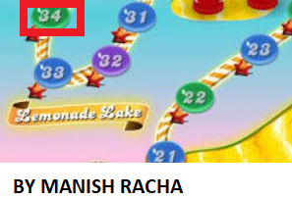

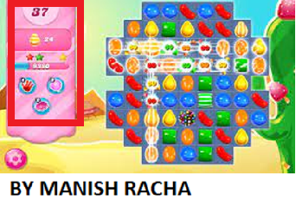

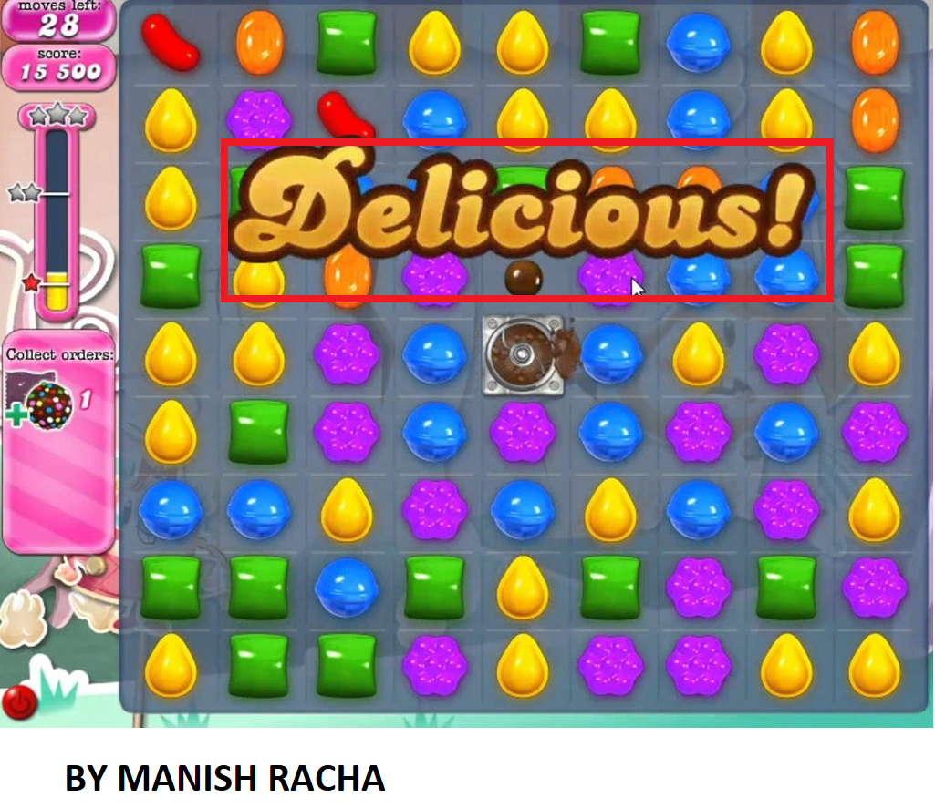

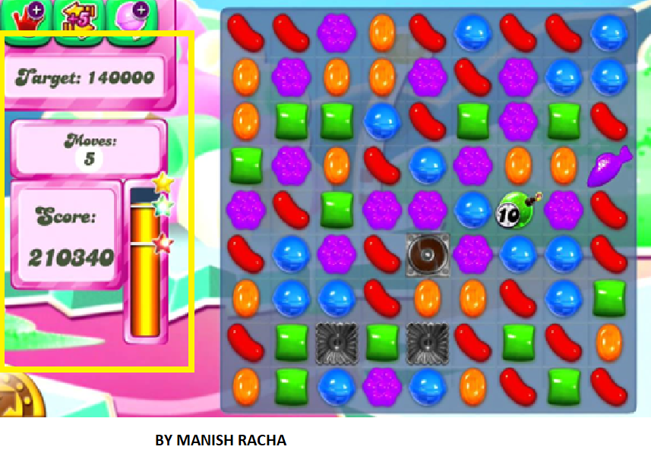

* **10% of grade ~Write a short conclusion about your experience, 1) what you liked and 2) did not like about the system you are testing, 3) was the usability evaluation useful? 4) will you change the usability evaluation method you used?**

While I believe the application to be user-friendly, anyone who wants extra assistance may select the settings icon, which gives step-by-step instructions with illustrations. It may be used by gamers as a "How To" guide. This is clear and accessible from the home page, and memorability helps. Because it is fewer than 5 screens long and features little text, the Candy Crush interface is more user-friendly. Furthermore, by sticking to its core principles, the game has remained stable over time. The essential purpose of puzzle-solving has never changed. Finding new ways to make it difficult has been the way it has progressed through time.

This involves the inclusion of new "anti-boosters" that would gradually blend into the game seamlessly. As you continue through the levels, you can anticipate them to get more challenging, making Candy Crush more efficient as a whole.

What I appreciate best about this game is how simple it is to pick up, learn, and play. This game is very simple to play for those with no prior knowledge. In the UI, the colours used for candies are more appealing. Another advantage is that you don't need WIFI to play this game.

What I don't like about the game is how addicting it is and how quickly it passes the time. We have no way of knowing how many mistakes will occur.

Usability testing is beneficial since it allows us to forecast about 75% of problems and saves a significant amount of money.

Heuristic evolution is my preferred method since it offers several benefits and saves money.

This assessment technique can be changed if desired.

* **Upload document**