**Rancher Installation Steps**

Create an Ubuntu VM with at least 4 cores and 16GB RAM.



Run these commands:

1. **sudo apt update**



1. **sudo apt upgrade -y**



Remove any kind of Taints if present.

You can refer this official documentation

<https://ranchermanager.docs.rancher.com/getting-started/installation-and-upgrade/install-upgrade-on-a-kubernetes-cluster>



or just follow the steps I mention below.

Prerequisites



1. Kubectl



1. Helm



Install helm using this command

1. **sudo snap install helm --classic**



Now, run this command to install rancher-stable helm repository from internet.

1. **helm repo add rancher-stable** [**https://releases.rancher.com/server-charts/stable**](https://releases.rancher.com/server-charts/stable)



Now, pull this repository and make it as a folder so that you can customize it.

1. **helm pull rancher-stable/rancher --untar**



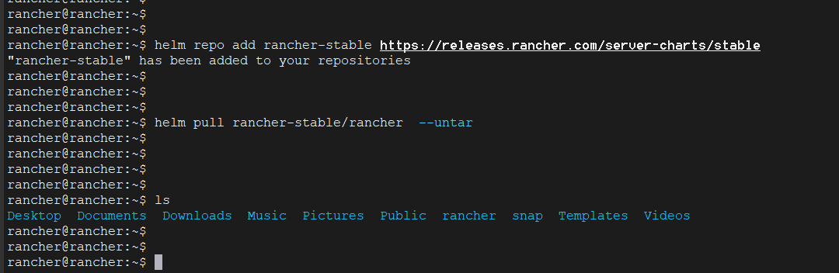

Go to **/home/rancher-demo/rancher/templates/** location by executing this command



**cd /home/rancher-demo/rancher/templates/**



Now, edit the deployment.yaml file and add this part in it.

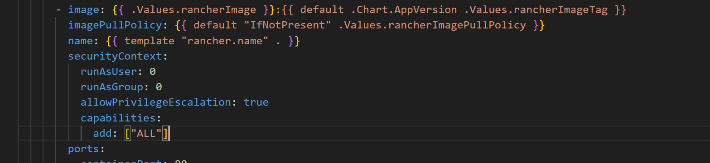



Now, move back to this location

1. **cd /home/rancher-demo/rancher/**



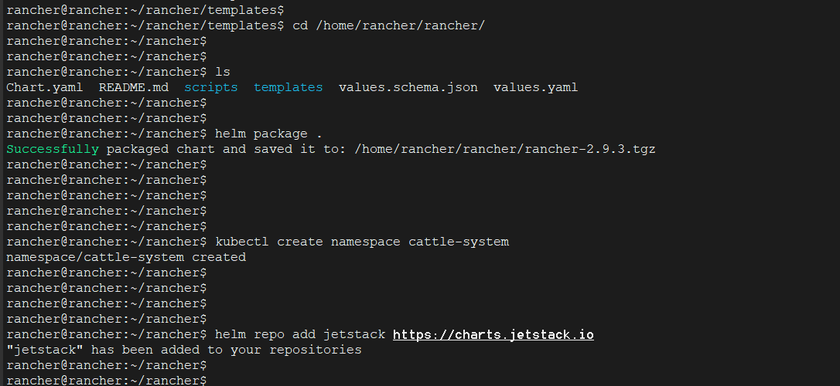

These repos should be there when you execute this command

You should get this output when you execute this command

To be on safe side, just pull this docker image using this docker command

1. **docker pull rancher/rancher:v2.9.2**



After which execute this command  
**helm install rancher /home/rancher/rancher/rancher-2.9.2.tgz --namespace cattle-system --set hostname=rancher.my.org --set bootstrapPassword=admin**  
Make sure the location “**rancher /home/rancher/rancher/rancher-2.9.2.tgz”**  and the docker image in the below command.



Later, execute this command to see this status

1. **kubectl -n cattle-system get deploy rancher**



Execute this command to view the services

1. **kubectl get svc -n cattle-system**



Now, execute this command and check the port of the newly created service



Access the rancher UI from using the VM ip and the Nodeport that you can get from the above command output.

<https://10.205.211.136:31658>



You will be prompted for bootstrap password which you should enter as **“admin”**



And enter your password so that from now on you can login to rancher UI using that password and username is **“admin”**



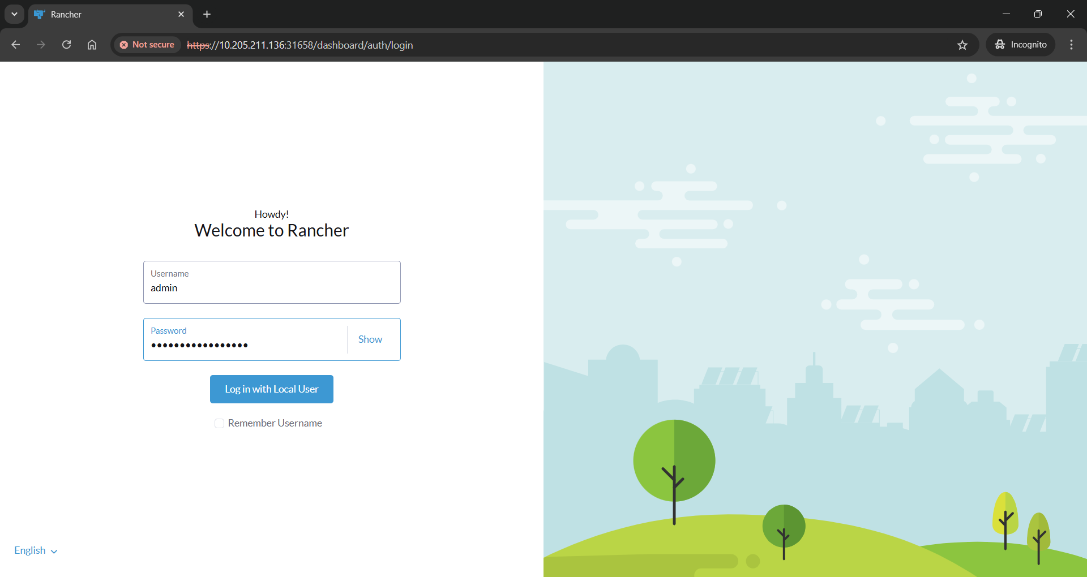

Create a new cluster using button available

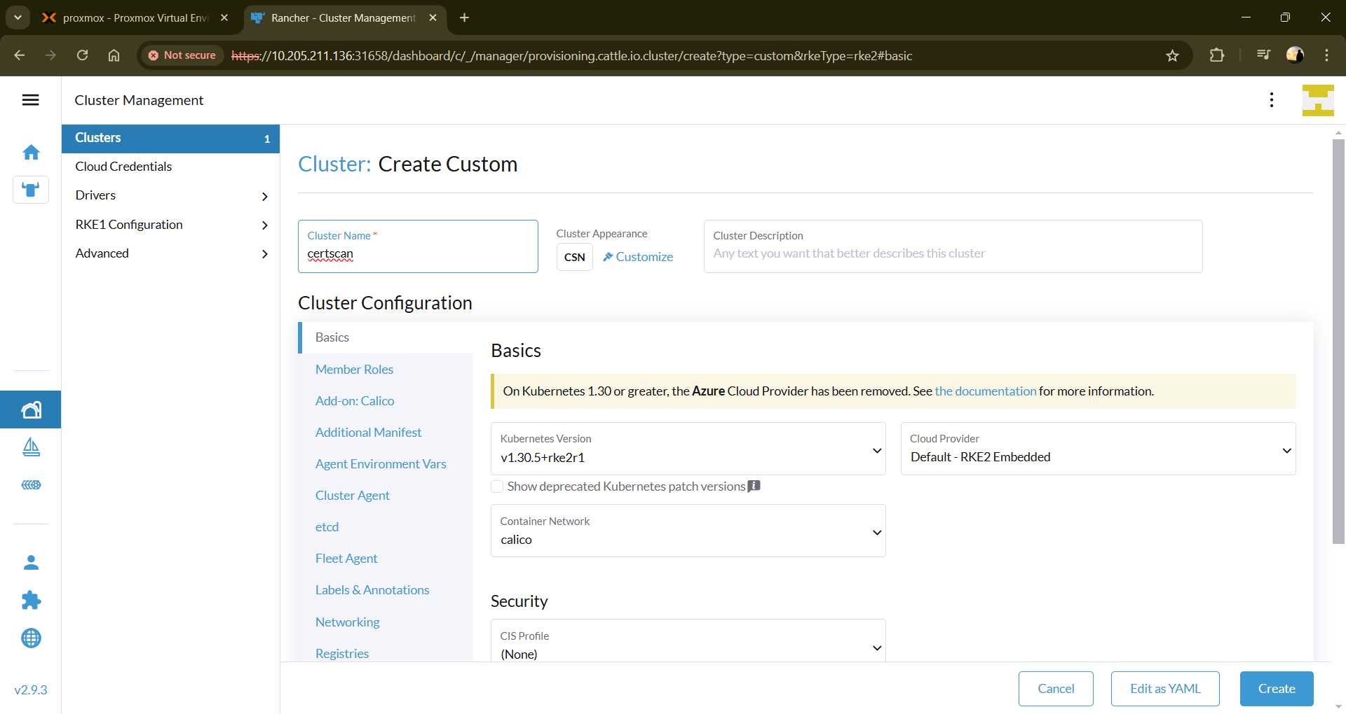  
  
choose RKE2 from the options available and give a name.

Now, Choose if you want to configure a node as a Master or Worker

And choose similarly for Worker as well.

If you ever get this error

The add **-k** argumentjust after **curl** keyword like this.



The nodes get configured and gets connected to the Rancher Cluster.

Now, you can access this cluster from CLI by downloading the kubeconfig file.

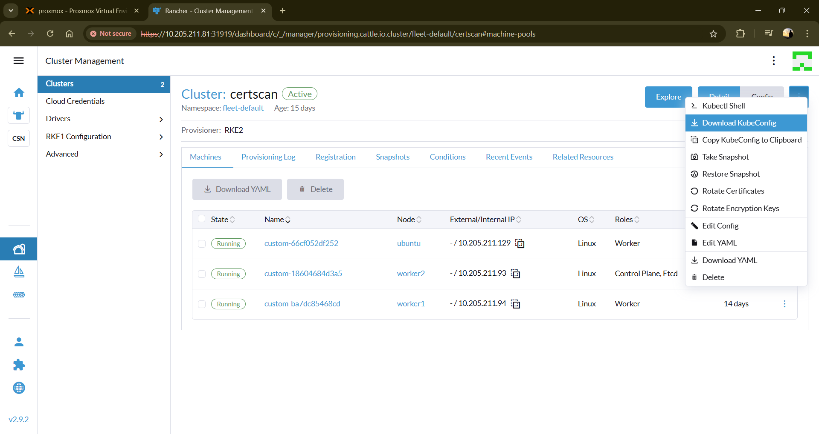

Just configure the kubeconfig file in your system.

If it’s WINDOWS:



If it’s LINUX:

This is how informative Rancher Cluster is:

