Date: 5th October, 2020
Name: Koushik Sahu
Roll no: 118CS0597

1.

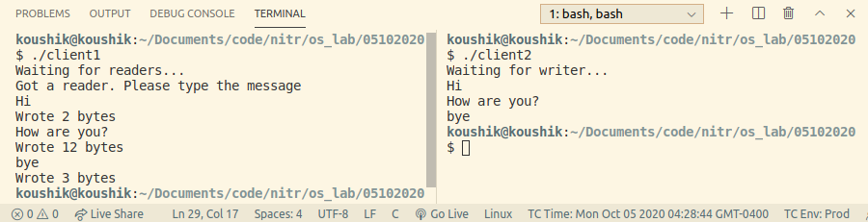
2.

