Koushik Sahu

118CS0597

Machine Learning Lab – 11

Output File

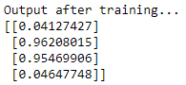

0.28