**INFORMATION CENTER MANAGEMENT SYSTEM**

**INTRODUCTION**

Information Center Management System is software that is designed to manage all the functions of a library. It helps librarian to maintain the database of new books and the books that are borrowed by members along with their due dates. It allows both the admin and the student to search for the desired book. This system completely automates all our library’s activities. The best way to maintain, organize and handle countless books systematically is to implement a information center management system software.

**OBJECTIVES**

* To manage all the details about members, books, issues and students
* To track all the details about books, students and issues
* To build a monitoring system that is able to monitor and manage all library operations efficiently
* Give an opportunity to librarians to reduce mistakes that always happen during manual method

**RESEARCH**

**State Of Research**

As the library and information services community seeks to cope with new patterns of information provision, new technology and changing financial circumstances, it is critical to gain new thinking across the profession. The Latest research, innovative theory and best organizational practice are all presented in Library Management System. Library Management System website which is used to supply the books to the user. This is done through JAVA technologies. This has various technical areas. It includes WINDOWS XP as the operating System, Oracle as Database. The front end deals with GUI and source code deals with Oracle.

**Cost**

* **High Cost** - The implementation of this project requires high cost.

**Features**

* Online access
* Barcode Scanning
* Self management

**ADVANTAGES**

* Secure and Reliable
* Simple and Easy to Use
* Increases Efficiency
* Record Maintenance
* Saves Time and Cost

**DISADVANTAGES**

* High cost
* Risk of computer cost

**APPLICATIONS**

* Schools
* College

**DEFINING SYSTEM**

[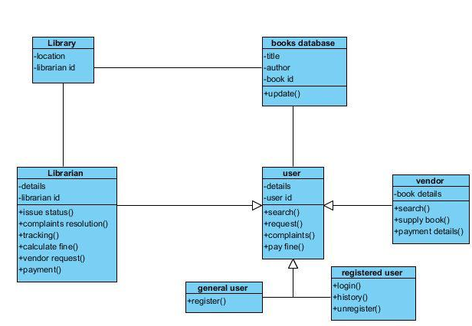](https://user-images.githubusercontent.com/98836479/153248742-ee472496-2474-4faf-84b1-e01de99e051a.PNG)

* User shall be able to add books in the library
* User shall be able to delete books from the library
* User shall be able to view the selected books from the library
* User shall be able to complaint or raise an issue about the books in the library

**5W'S and 1H**

**What**

Information Center Management Systems is software that helps to maintain a database that is useful to enter new books & record books borrowed by the members with the respective submission dates.

**Who**

Information Center Management System is an application used by all the students and staff who are having id's.

**When**

During the need of the book readers such as students, teachers, public people etc.,

**Where**

Information Center Management System is nowadays essential for schools, colleges, private libraries, and other organizations. They can use this software as the purpose of books issuing and returning for renewal.

**Why**

Information Center Management System is very useful when there are large no of readers visit library to return, renewal, or take books. It is very tedious to enter the records manually so here this project comes into handy.

**How**

Information Center Management System is implemented to do the book issue, return and renewal purpose by entering the student or faculty id as input.

**SWOT ANALYSIS**

**Strengths**

* Simple and easy to use
* Increased library engagement
* Efficient cloud data management
* Highly secure, scalable & reliable
* Mobile access

**Weakness**

* The data stored is prone to cyber hacks
* Costly and expensive
* Complicated to operate
* Online systems require high-speed internet connectivity
* Risk of computer virus

**Opportunities**

The future of library systems will consist of a mixture of open and closed systems as well as local and shared (or hosted) services. With an increasing move towards closed platforms (like Facebook, for example) and proprietary ecosystems (like Apple), libraries will be required to navigate these different spaces and ecosystems.

**Threats**

Libraries now send and retrieve data from databases to help better manage inventory and the like, but some libraries don’t have the right data encryption practices in place. This can often lead to lost data and sometimes, the data easily obtainable by criminals.

**DETAIL REQUIREMENTS**

**High Level Requirements**

[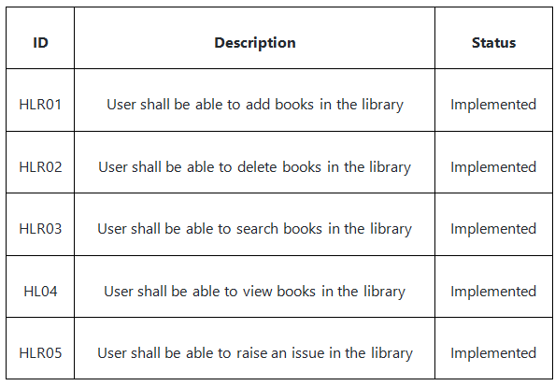](https://user-images.githubusercontent.com/98836479/153268400-f4c31cc9-ed76-4a78-bce9-059049e4522f.PNG)

**Low Level Requirements**

[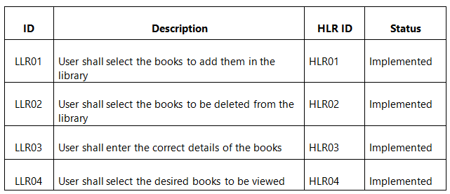](https://user-images.githubusercontent.com/98836479/156114778-7b691690-86bf-443a-9599-57103c1f138d.PNG)

**ARCHITECTURE**

**DESIGN**

**STRUCTURE DIAGRAMS**

**1) High Level Design**

* Class Diagram

[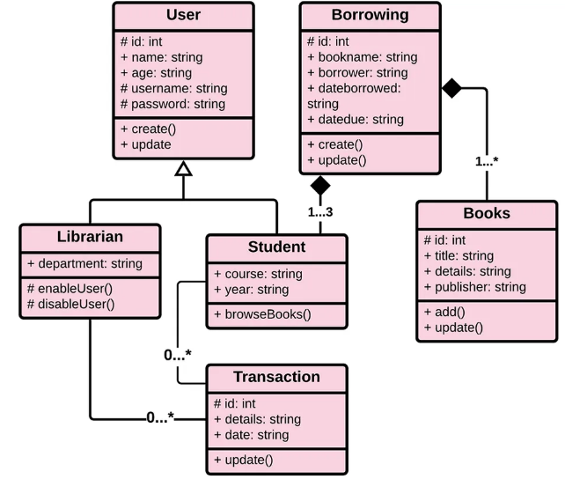](https://user-images.githubusercontent.com/98836479/153355332-8d187171-d48e-49e5-a4b6-e286624b8136.PNG)

**2) Low Level Design**

* Component Diagram

[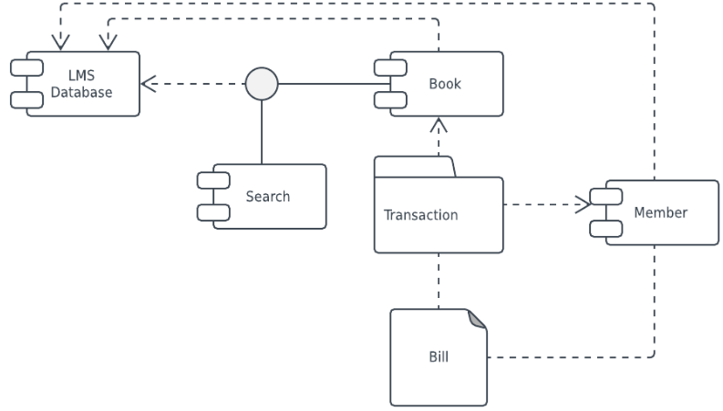](https://user-images.githubusercontent.com/98836479/153358275-e0321768-7744-4f48-bdc1-71f44e9cd463.PNG)

**BEHAVIOR DIAGRAM**

**1) High Level Design**

* Activity Diagram

[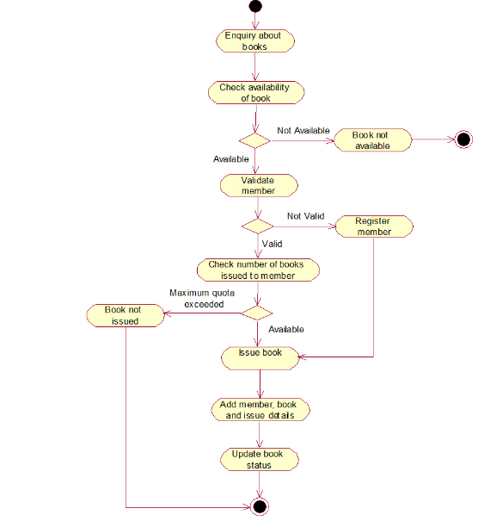](https://user-images.githubusercontent.com/98836479/156132087-0a9410ee-9a70-4e9e-85d1-8e07a3af9490.PNG)

**2) Low Level Design**

* Usecase Diagram

[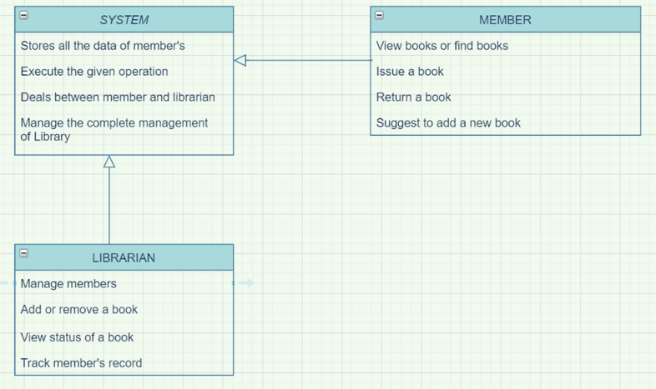](https://user-images.githubusercontent.com/98836479/153364927-34217e43-73ec-4179-af4c-a6b4a48fd874.PNG)

# TEST PLAN

## HIGH LEVEL TEST PLAN

[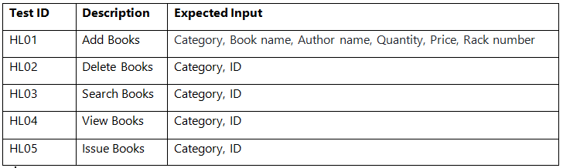](https://user-images.githubusercontent.com/98836479/153413374-614bf39c-bda1-4194-aeb7-5b6e216bd2fc.PNG)

## LOW LEVEL TEST PLAN

[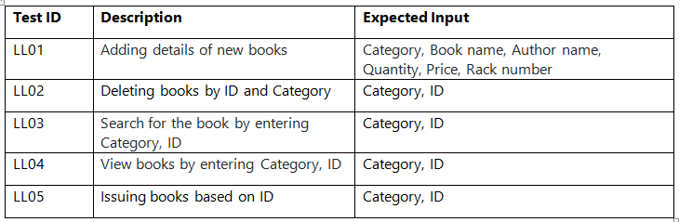](https://user-images.githubusercontent.com/98836479/153413475-615ec9a2-cbdc-4e76-ad72-b1b981f9d26c.PNG)

**CONCLUSION**

The “INFORMATION CENTER MANAGEMENT SYSTEM” project reduces human errors and also increase the efficiency. The main focus of this project is to lessen human efforts. The maintenance of the records is made efficient, as all the records are stored in the access database through which data can be retrieved easily.

**LEARNING RESOURCES**

* Tutorials point
* Geeks for geeks
* Future skills