**SAFETY AUTOMATION USING FIRE AND GAS DETECTION SYSTEM**

**1.1 INTRODUCTION**

Safety automation using fire and gas detection system is a project used to detect the liquid petroleum gas (LPG) leakage to avoid the fire accidents in home and in the industry and increase the safety feature with more accuracy and with more efficiency as we know that security is an important issue. This system detects the leakage of an LPG using gas sensor and also detects the flames or fire using fire sensor. The gas sensor and fire sensor simultaneously collect data from the environment and then transfer it to the Arduino UNO board in the form of analog and digital inputs. The Arduino board then check the inputs and act according to it.

**1.2 RESEARCH**

**1.2.1 State of art**

The main aim of this project is to ensure safety condition for that a system has been developed which is reliable in detecting fire and gas leakage and can even detect the specific room or floor in which the fault is present. Moreover, the system can also show an alert message regarding the information of fire detection or gas leakage to the screen. The gas sensor and fire sensor are connected with a microcontroller that will control the total system. In this sense, this device will be helpful for the mankind. It will make personnel’s life secured and will reduce the loss of assets.

**1.2.2 Identifying Features**

* Intimation of fire using buzzer
* Clearance of gas leakage using exhaust fan
* Gas sensor is used to detect the leakage of gas
* Detection of fire using fire sensor

**1.2.3 COST**

* Medium Cost - The implementation of this project requires medium cost.

**1.3 SWORT ANALYSIS**

[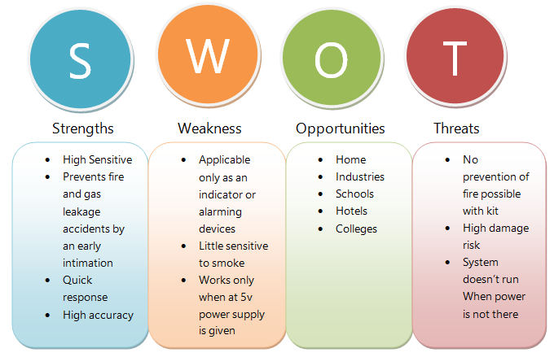](https://user-images.githubusercontent.com/98836479/157179249-2f584993-f2b6-44e2-8d15-4258735f87e1.PNG)

**1.4 5W's and 1H**

[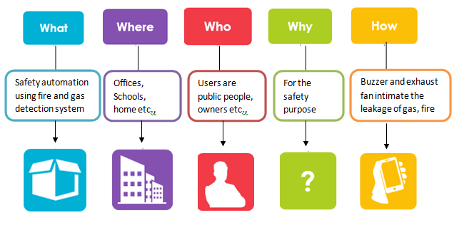](https://user-images.githubusercontent.com/98836479/157187234-d9c7156e-2c0e-4cd8-8e73-3da7ca945285.PNG)

**1.5 REQUIREMENTS**

**1.5.1 High Level Requirements**

[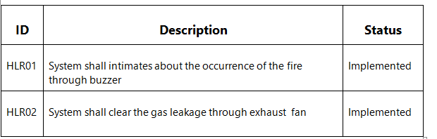](https://user-images.githubusercontent.com/98836479/157198543-d032f881-6c51-4305-b3b8-9913f08c9910.PNG)

### 2.2 Low Level Requirements

[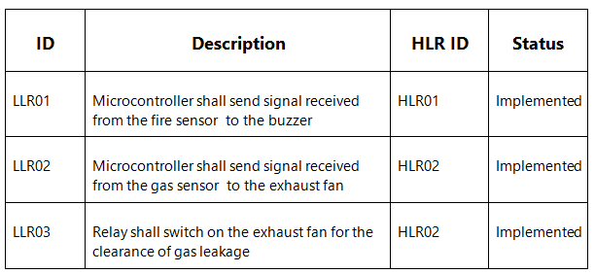](https://user-images.githubusercontent.com/98836479/157198574-7f8ee5f3-c80f-42df-a950-ac564e4b242a.PNG)

**2 ARCHITECTURE**

## 2.1 BLOCK DIAGRAM

[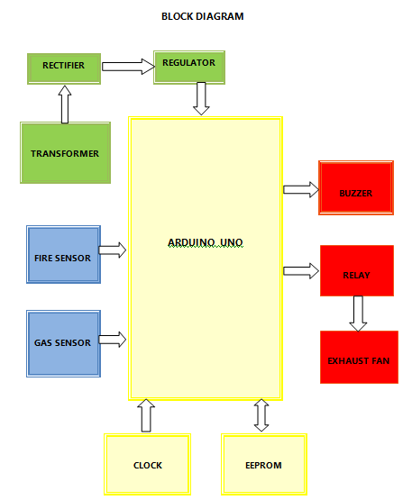](https://user-images.githubusercontent.com/98836479/157279152-27998c8e-860f-4933-81d9-27128a35c5ae.PNG)

[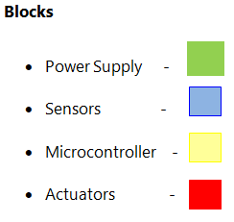](https://user-images.githubusercontent.com/98836479/157230589-5d0c8360-388d-4fc4-bb3b-727644410edc.PNG)

## 2.2 COMPONENTS DESCRIPTION

### 2.2.1 SENSORS

**2.2.1.1 ANALOG SENSOR**

**Gas Sensor**

Gas Sensor is an analog sensor used to sense the gas leakage. It sends signal to the exhaust fan through Arduino UNO.

**2.2.1.2 DIGITAL SENSOR**

**Fire Sensor**

Fire Sensor is a digital sensor used to sense the occurence of the fire and it also sends signal to the buzzer through Arduino UNO.

### 2.2.2 MICROCONTROLLER

**2.2.2.1 Arduino UNO**

Arduino UNO is used to control the entire process. It sends signals received from gas and fire sensors to the exhaust fan and buzzer respectively.

**2.2.2.2 Clock**

Clock is an internal component of Arduino UNO. It measures the time.

**2.2.2.3 EEPROM**

EEPROM is user modifiable read-only memory(ROM) that allows all users to erase and reprogram stored data repeatedly in an application.

### 2.2.3 ACTUATORS

**2.2.3.1 Buzzer**

Buzzer is connected with Aruino UNO. It is used to intimate the occurence of the fire.

**2.2.3.2 Relay**

Relay is used to switch on and off the exhaust fan according to the command received from Arduino UNO.

**2.2.3.3 Exhaust Fan**

Exhaust fan is connected with the relay. It is used to send out the gas leakage by means of blowing.

### 2.2.4 POWER SUPPLY

**2.2.4.1 Transformer**

Transformer is used in this project is a step down transformer. It is used to step down 230 AC Voltage into 5 AC voltage.

**2.2.4.2 Rectifier**

Rectifier is used to convert 5 volt AC power supply into 5 volt DC power supply.

**2.2.4.3 Regulator**

Regulator is used to send a constant voltage to the system.

## 2.3 BEHAVIORAL DIAGRAMS

### 2.3.1 High Level Flow Chart Behavioral Diagram

[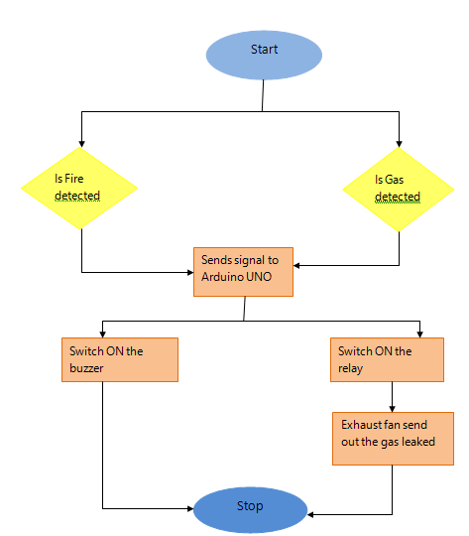](https://user-images.githubusercontent.com/98836479/157252515-d3626ee5-f08c-4be2-b313-b2670feba3eb.PNG)

### 2.3.1 Low Level Flow Chart Behavioral Diagram

[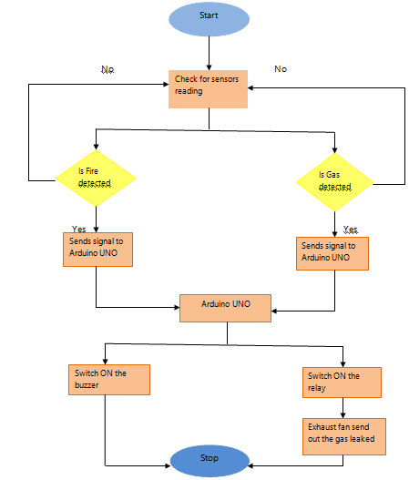](https://user-images.githubusercontent.com/98836479/157252880-09d9304f-47a2-4bec-a94c-90c71b1768fb.PNG)

## 2.4 STRUCTURAL DIAGRAMS

### 2.4.1 High Level Use case Structural Diagram

[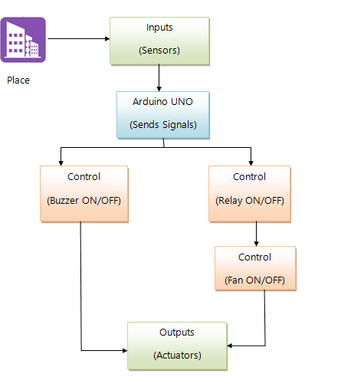](https://user-images.githubusercontent.com/98836479/157248846-cb003b68-210e-4e14-9b4f-688c2432fa76.PNG)

## 2.4.2 Low Level Use case Structural Diagram

[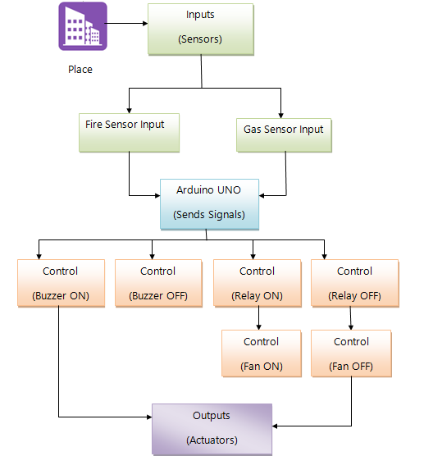](https://user-images.githubusercontent.com/98836479/157248962-a4e711c2-532f-461b-b4f3-d60cb30447fd.PNG)

## 2.5 BEST METHODS FOLLOWED

## Exact mapping of code to avoid confusions

## Mentioning of both high level and low level behavioral and structural diagrams for better understanding

## Followed the exact symbols to make the understanding easier

* Detailed explanation in behavioral and structural diagrams

# 3 ADVANTAGES AND DISADVANTAGES

## 3.1 Advantages

* Easy to detect
* Ensuring safety factors
* Inform emergency situations
* Reliable stability

## 3.2 Disadvantages

* Applicable only as an indicator or an alarming device
* The system doesn't work when there is no power supply

# 4 APPLICATIONS

* This system can be used in different industries and mills to prevent fire and take precautions
* It can be a life saver of hundreds of innocent lives
* Properties worth of billion bucks can be saved using this simple device

### 5 Conclusion And Future Scope

### 5. 1 Conclusion

Fire and gas detections are vital issues for all spheres of lives where precautions are very important. The system is very useful and simple. By ensuring fire and gas security in different industries this system can help reducing losses of lives, livelihoods and properties.

## 5.2 Future Scope

In future, some of the modifications can make this system more useful, reliable and give it more applications for real life situations.

* The system can be connected by fire department to solve the problems
* Ability to connect multiple sensors wirelessly
* Having a separate back-up power system

## 5.3 Challenges faced and how was it overcome

* I have faced issues in file handling. So, I used strings
* Updating and deleting a file was overcame by using a temporary file to store data for some time

## 5.4 Learning Resources

* Tutorials point
* You tube
* Geeks for geeks