**02_Hello World RESTful Web Service**

**Navigation for file creation**

* **Folder:**  
  src/main/java/com/cognizant/springlearn/controller/
* **File to create:**  
  HelloController.java

**HelloController.java**

package com.cognizant.springlearn.controller;

import org.slf4j.Logger;

import org.slf4j.LoggerFactory;

import org.springframework.web.bind.annotation.GetMapping;

import org.springframework.web.bind.annotation.RestController;

@RestController

public class HelloController {

private static final Logger LOGGER = LoggerFactory.getLogger(HelloController.class);

@GetMapping("/hello")

public String sayHello() {

LOGGER.info("START: sayHello()");

String message = "Hello World!!";

LOGGER.info("END: sayHello()");

return message;

}

}

**Configuration notes**

1. Ensure your **SpringLearnApplication.java** is in:

swift

CopyEdit

src/main/java/com/cognizant/springlearn/SpringLearnApplication.java

with:

java

CopyEdit

@SpringBootApplication

public class SpringLearnApplication { ... }

1. Spring Boot will **automatically detect** your controller via @RestController and @ComponentScan.
2. Ensure your pom.xml has:

xml

CopyEdit

<dependency>

<groupId>org.springframework.boot</groupId>

<artifactId>spring-boot-starter-web</artifactId>

</dependency>

for the web layer to run.

**OUTPUT:**

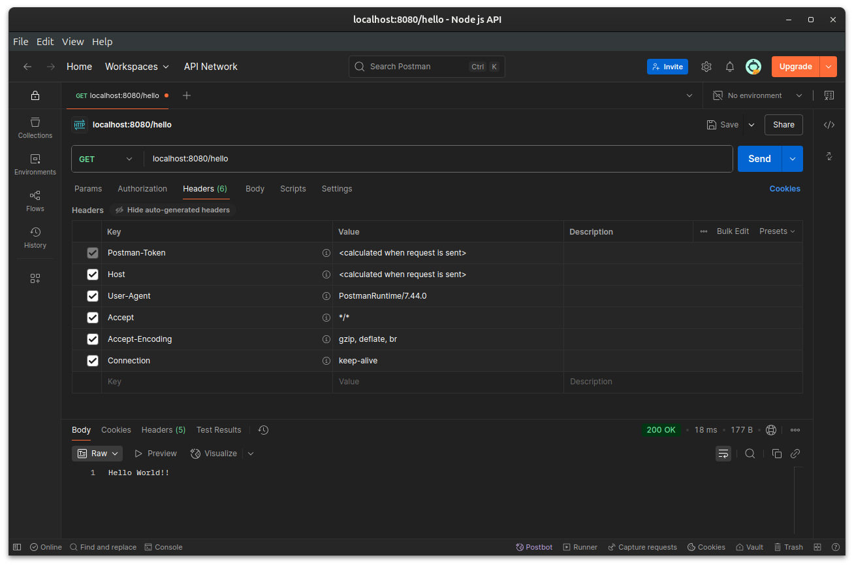

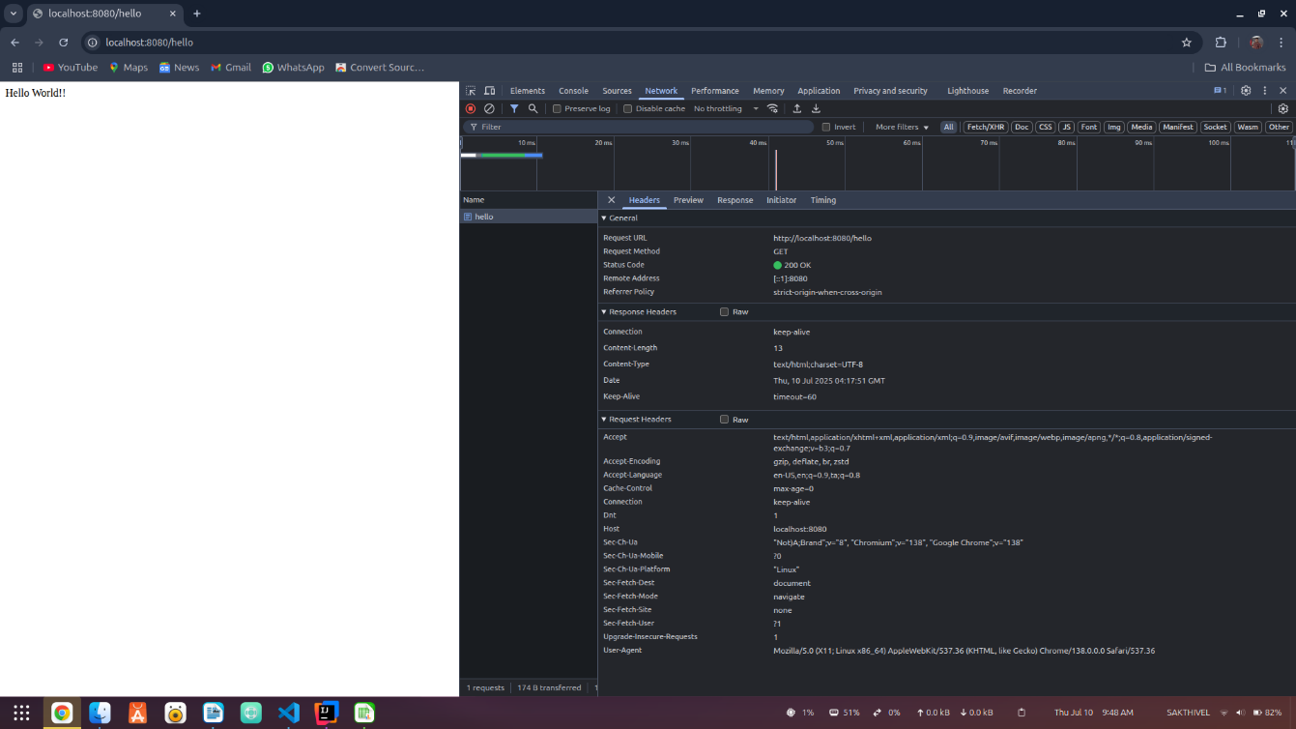

**03_REST - Country Web Service**

**CountryController.java**

package com.cognizant.springlearn.controller;

import com.cognizant.springlearn.Country;

import org.slf4j.Logger;

import org.slf4j.LoggerFactory;

import org.springframework.context.ApplicationContext;

import org.springframework.context.support.ClassPathXmlApplicationContext;

import org.springframework.web.bind.annotation.RequestMapping;

import org.springframework.web.bind.annotation.RestController;

@RestController

public class CountryController {

private static final Logger LOGGER = LoggerFactory.getLogger(CountryController.class);

@RequestMapping("/country")

public Country getCountryIndia() {

LOGGER.info("START: getCountryIndia()");

ApplicationContext context = new ClassPathXmlApplicationContext("country.xml");

Country country = context.getBean("country", Country.class);

LOGGER.info("END: getCountryIndia()");

return country;

}

}

**Configuration notes**

1. Ensure **country.xml** is already present in:

css

CopyEdit

src/main/resources/country.xml

with:

xml

CopyEdit

<bean id="country" class="com.cognizant.springlearn.Country">

<property name="code" value="IN" />

<property name="name" value="India" />

</bean>

1. Ensure your Country class has proper **getters, setters, and toString()**.
2. Ensure **SpringLearnApplication.java** is present and correct.
3. Ensure **spring-boot-starter-web** is included in pom.xml for REST capabilities.

**OUTPUT:**

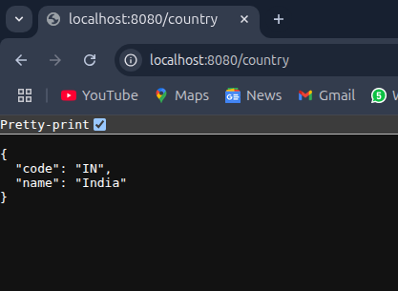

## 05_REST - Get country based on country code

## Folder and File Structure

css

CopyEdit

spring-learn/

│

├── src/

│ ├── main/

│ │ ├── java/

│ │ │ └── com/

│ │ │ └── cognizant/

│ │ │ └── springlearn/

│ │ │ ├── controller/

│ │ │ │ └── CountryController.java

│ │ │ ├── service/

│ │ │ │ └── CountryService.java

│ │ │ ├── Country.java

│ │ │ └── SpringLearnApplication.java

│ │ └── resources/

│ │ └── country.xml

│

├── pom.xml

## Update country.xml to include multiple countries

**Path:** src/main/resources/country.xml

<?xml version="1.0" encoding="UTF-8"?>

<beans xmlns="http://www.springframework.org/schema/beans"

xmlns:xsi="http://www.w3.org/2001/XMLSchema-instance"

xsi:schemaLocation="http://www.springframework.org/schema/beans

http://www.springframework.org/schema/beans/spring-beans.xsd">

<bean id="countryList" class="java.util.ArrayList">

<constructor-arg>

<list>

<bean class="com.cognizant.springlearn.Country">

<property name="code" value="US" />

<property name="name" value="United States" />

</bean>

<bean class="com.cognizant.springlearn.Country">

<property name="code" value="DE" />

<property name="name" value="Germany" />

</bean>

<bean class="com.cognizant.springlearn.Country">

<property name="code" value="IN" />

<property name="name" value="India" />

</bean>

<bean class="com.cognizant.springlearn.Country">

<property name="code" value="JP" />

<property name="name" value="Japan" />

</bean>

</list>

</constructor-arg>

</bean>

</beans>

## Create CountryService.java

**Path:** src/main/java/com/cognizant/springlearn/service/CountryService.java

package com.cognizant.springlearn.service;

import com.cognizant.springlearn.Country;

import org.slf4j.Logger;

import org.slf4j.LoggerFactory;

import org.springframework.context.ApplicationContext;

import org.springframework.context.support.ClassPathXmlApplicationContext;

import org.springframework.stereotype.Service;

import java.util.List;

@Service

public class CountryService {

private static final Logger LOGGER = LoggerFactory.getLogger(CountryService.class);

public Country getCountry(String code) {

LOGGER.info("START: getCountry() with code {}", code);

ApplicationContext context = new ClassPathXmlApplicationContext("country.xml");

List<Country> countryList = (List<Country>) context.getBean("countryList");

Country country = countryList.stream()

.filter(c -> c.getCode().equalsIgnoreCase(code))

.findAny()

.orElse(null);

LOGGER.info("END: getCountry()");

return country;

}

}

## Create or Update CountryController.java

**Path:** src/main/java/com/cognizant/springlearn/controller/CountryController.java

package com.cognizant.springlearn.controller;

import com.cognizant.springlearn.Country;

import com.cognizant.springlearn.service.CountryService;

import org.slf4j.Logger;

import org.slf4j.LoggerFactory;

import org.springframework.beans.factory.annotation.Autowired;

import org.springframework.web.bind.annotation.GetMapping;

import org.springframework.web.bind.annotation.PathVariable;

import org.springframework.web.bind.annotation.RestController;

@RestController

public class CountryController {

private static final Logger LOGGER = LoggerFactory.getLogger(CountryController.class);

@Autowired

private CountryService countryService;

@GetMapping("/countries/{code}")

public Country getCountry(@PathVariable String code) {

LOGGER.info("START: getCountry() in controller with code {}", code);

Country country = countryService.getCountry(code);

LOGGER.info("END: getCountry() in controller");

return country;

}

}

**OUTPUT:**

