CSA0998-PROGRAMMING IN JAVA

DAY-3

ASSIGNMENT

Name: K.Koushiknath Reddy

Reg.no:192110156

Dept:CSE

1.**Program:**

import java.util.Scanner;

class Student {

int marksPython, marksC, marksMath, marksPhysics;

void inputMarks() {

Scanner scanner = new Scanner(System.in);

System.out.print("Enter the marks in Python: ");

marksPython = scanner.nextInt();

System.out.print("Enter the marks in C Programming: ");

marksC = scanner.nextInt();

System.out.print("Enter the marks in Mathematics: ");

marksMath = scanner.nextInt();

System.out.print("Enter the marks in Physics: ");

marksPhysics = scanner.nextInt();

}

int calculateTotal() {

return marksPython + marksC + marksMath + marksPhysics;

}

double calculateAggregate() {

return calculateTotal() / 4.0;

}

}

class Result extends Student {

void displayGrade() {

double aggregate = calculateAggregate();

System.out.println("Total = " + calculateTotal());

System.out.println("Aggregate = " + aggregate);

if (aggregate > 75) {

System.out.println("DISTINCTION");

} else if (aggregate >= 60 && aggregate < 75) {

System.out.println("FIRST DIVISION");

} else if (aggregate >= 50 && aggregate < 60) {

System.out.println("SECOND DIVISION");

} else if (aggregate >= 40 && aggregate < 50) {

System.out.println("THIRD DIVISION");

} else {

System.out.println("FAIL");

}

}

}

public class Main {

public static void main(String[] args) {

Result student1 = new Result();

student1.inputMarks();

student1.displayGrade();

Result student2 = new Result();

student2.marksPython = 73;

student2.marksC = 78;

student2.marksMath = 79;

student2.marksPhysics = 75;

student2.displayGrade();

displayGrade() method.

}

}

Output:

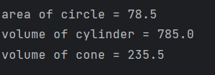

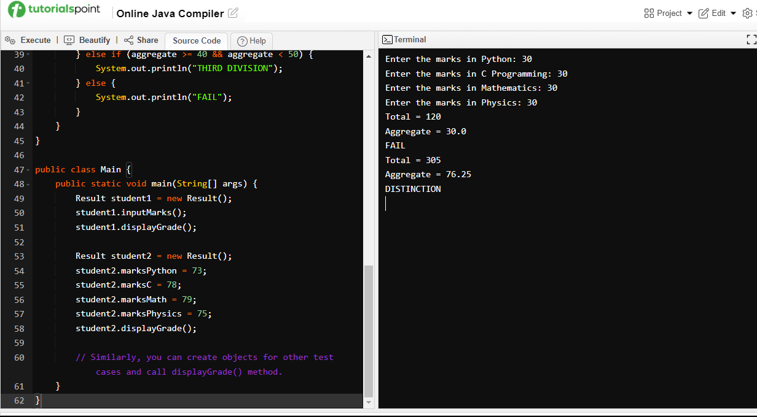

2.**Program:**

class circle

{

protected double area;

private int r;

void get()

{

r=5;

}

void cal()

{

area=3.14*r*r;

}

}

class cylinder extends circle

{

private double volume;

private int h;

void get1()

{

h=5;

}

void cal1()

{

volume=area*h;

}

void display()

{

System.out.println("area of circle"+area);

System.out.println("volume of cylinder"+volume);

}

class inher

{

public static void main(String args[])

{

cylinder cy=new cylinder();

cy.get();

cy.cal();

cy.get1();

cy.cal1();

cy.display();

}

}

}

Output: