Name: Koushik Gaddam
Email – koushikgaddam04@gmail.com
Date: 29-12-2025 à Day 2 – Querying & Modifying Data
Create Sample Insurance database named InsuranceDB with tables, constraints, and initial sample data. Based on following er diagram and descriptions.
Entities we’ll model:
- Customers – people who buy insurance
- Policies – insurance products (Health, Motor, Life)
- Agents – insurance agents
- PolicyAssignments – which customer bought which policy
- Claims – claims raised against policies
Relationship Explanation
- One Customer → Many PolicyAssignments
- One Policy → Many PolicyAssignments
- One Agent → Many PolicyAssignments
- One PolicyAssignment → Many Claims

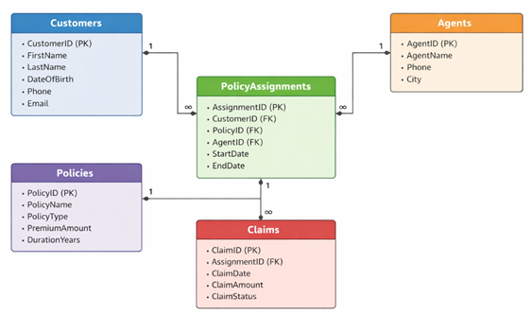
Submit following:
- Create Database command.
Query:
Create database InsuranceDB
Output:
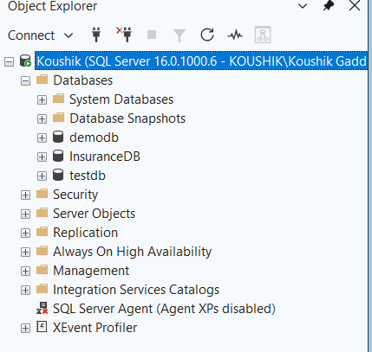
- Create table commands for all the tables with constraints, relationships etc.
Query:
create table customers(
CustomerID int identity primary key,
FirstName varchar(25),
LastName varchar(25),
DateOfBirth date,
Phone varchar(15),
email varchar(50));
create table Policies(
PolicyID int identity primary key,
PolicyName varchar(50),
PolicyType varchar(50),
PremiumAmount int,
DurationYears int
);
create table Agents(
AgentID int identity primary key,
AgentName varchar(50),
Phone float(10),
City varchar(30)
)
create table PolicyAssignments(
AssignmentID int identity primary key,
CustomerID int,
AgentID int,
StartDate date,
EndDate date
constraint for_key_CustID Foreign Key (CustomerID) references Customers(CustomerID),
constraint for_key_AgentID Foreign Key (AgentID) references Agents(AgentID)
constraint for_key_PolicyID Foreign Key(PolicyID) references Policies(PolicyID)
)
CREATE TABLE Claims (
ClientID int IDENTITY PRIMARY KEY,
AssignmentID int,
claimDate date,
claimAmount int,
claimStatus int,
CONSTRAINT for_key_assignID FOREIGN KEY (AssignmentID) REFERENCES PolicyAssignments(AssignmentID)
);
Output:
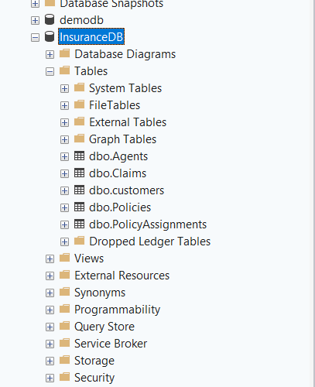
- Insert commands for all tables.
Query:

insert into Customers (FirstName, LastName, DateOfBirth, Phone, Email) values
('Koushik', 'Reddy', '1995-05-15', '9876543210', 'koushikreddy@gmail.com'),
('Rishik', 'Sharma', '2005-03-22', '8765432109', 'rishiksharma@gmail.com'),
('Madhumitha', 'Patel', '2010-07-08', '7654321098', 'madhumithapatel@gmail.com'),
('Tejaswini', 'Kumar', '1985-11-30', '6543210987', 'tejaswinikumar@gmail.com'),
('Krishna', 'Singh', '2008-09-12', '5432109876', 'krishnasingh@gmail.com'),
('Anirudh', 'Nair', '2015-01-25', '4321098765', 'anirudhnair@gmail.com'),
('Navaneeth', 'Joshi', '1990-06-18', '3210987654', 'navaneethjoshi@gmail.com'),
('Sujith', 'Menon', '2002-12-05', '2109876543', 'sujithmenon@gmail.com'),
('Rikhil', 'Iyer', '2018-08-14', '1098765432', 'rikhilier@gmail.com'),
('Pabitha', 'Bhat', '2003-02-28', '9988776655', 'pabithabhat@gmail.com'),
('Abhijeet', 'Verma', '1998-04-10', '9876543211', 'abhijeetverma@gmail.com'),
('Kishore', 'Pillai', '2007-08-03', '8765432110', 'kishorepillai@gmail.com'),
('Ganesh', 'Chopra', '2012-12-17', '7654321109', 'ganeshchopra@gmail.com'),
('Manikumar', 'Das', '2004-03-29', '6543211098', 'manikumardas@gmail.com'),
('Srinayani', 'Bansal', '2016-07-14', '5432109877', 'srinayanibansal@gmail.com'),
('Spoorthy', 'Gupta', '2009-06-20', '9876543222', 'spoorthygupta@gmail.com');

Insert into Agents (AgentName, Phone, City) values
('Ruthvik Gupta', '9123456789', 'Jaipur'),
('Koushik Desai', '9234567890', 'Mumbai'),
('Rishik Kapoor', '9345678901', 'Bengaluru'),
('Madhumitha Rao', '9456789012', 'Chennai'),
('Tejaswini Mehta', '9567890123', 'Nagpur'),
('Krishna Thakur', '9678901234', 'Pune'),
('Anirudh Malhotra', '9789012345', 'Jaipur'),
('Navaneeth Pillai', '9890123456', 'Bengaluru'),
('Sujith Verma', '9901234567', 'Delhi'),
('Rikhil Das', '9912345678', 'Kanpur');

Insert into PolicyAssignments(CustomerID, AgentID, PolicyID, StartDate, EndDate) values (1,1,1,'2024-01-15','2026-01-15'),
(2,2,2,'2024-02-20','2034-02-20'),
(3,3,3,'2024-03-10','2025-03-10'),
(4,4,4,'2024-04-05','2027-04-05'),
(5,5,1,'2024-05-12','2026-05-12'),
(5,6,7,'2024-06-18','2026-06-18'),
(5,7,9,'2024-07-22','2026-07-22'),
(6,8,2,'2024-08-30','2026-08-30'),
(7,9,5,'2024-09-14','2025-09-14'),
(8,10,8,'2024-10-25','2026-10-25'),
(9,1,10,'2024-11-03','2025-11-03'),
(10,2,11,'2024-12-08','2025-12-08'),
(11,3,6,'2025-01-14','2027-01-14'),
(12,4,12,'2025-02-19','2026-02-19'),
(13,5,3,'2025-03-25','2026-03-25'),
(16,6,4,'2025-04-01','2027-04-01');

Insert into Policies (PolicyName, PolicyType, PremiumAmount, DurationYears) values
('HealthGuard Pro', 'Health', 25000, 2),
('LifeSecure Plus', 'Life', 45000, 10),
('AutoShield Elite', 'Motor', 18000, 1),
('HomeProtect Max', 'Home', 12000, 3),
('TravelSafe Premium', 'Travel', 8000, 1),
('EduFuture Plan', 'Education', 30000, 5),
('CancerCare Shield', 'Health', 22000, 1),
('TermLife Basic', 'Life', 32000, 20),
('HeartCare Plan', 'Health', 28000, 3),
('CarComprehensive', 'Motor', 25000, 1),
('FamilyHealth Basic', 'Health', 15000, 1),
('BikeShield Pro', 'Motor', 7500, 1);

Insert into Claims (AssignmentID, ClaimDate, ClaimAmount, ClaimStatus) values
(1,'2024-11-10',50000,’Rejected’),
(2,'2024-12-05',250000, ‘Accepted’),
(3,'2025-01-18',35000, ‘Accepted’),
(4,'2025-02-22',80000, Rejected’),
(5,'2025-03-15',12000, ‘Accepted’),
(6,'2025-04-08',75000, ‘Accepted’),
(7,'2025-05-20',45000, Rejected’),
(8,'2025-06-12',28000, ‘Accepted’),
(9,'2025-07-25',95000, ‘Accepted’),
(10,'2025-08-30',15000, Rejected’),
(11,'2025-09-15',32000, ‘Accepted’),
(12,'2025-10-20',180000, Rejected’),
(13,'2025-11-25',45000, ‘Accepted’),
(1,'2025-12-01',65000, Rejected’),
(2,'2025-12-15',22000, ‘Accepted’);

4. Select commands
- View all records Customers table.
Query:
Select * from Customers;
Output:
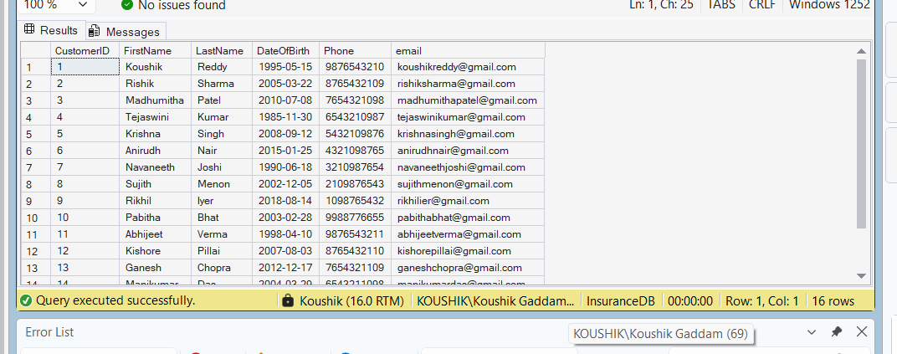

- View all records of PolicyAssignment table with CustomerId, PolicyId, StartDate and EndDate columns only.
Query:
Select CustomerID, PolicyID, StartDate, EndDate from PolicyAssignments;
Output:
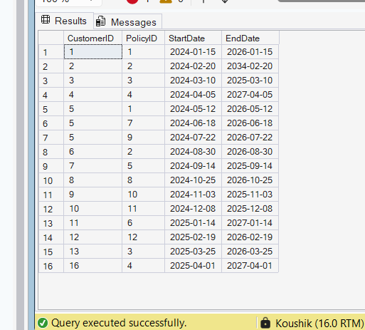

- Display all policies of Health type.
Query:
Select * from Policies where PolicyType = 'Health';
Output:
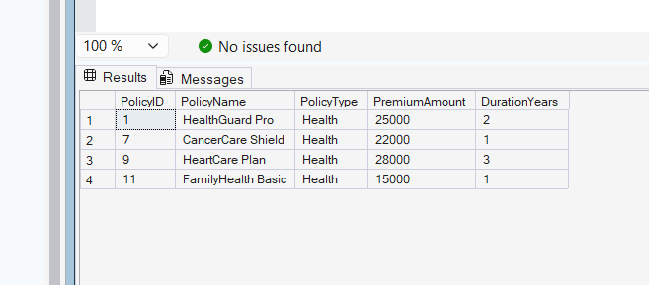

- Display policies having premium amount more than 10000 and DurationYears is 1.
Query:
Select * from Policies where PremiumAmount > 10000 and DurationYears=1;
Output:
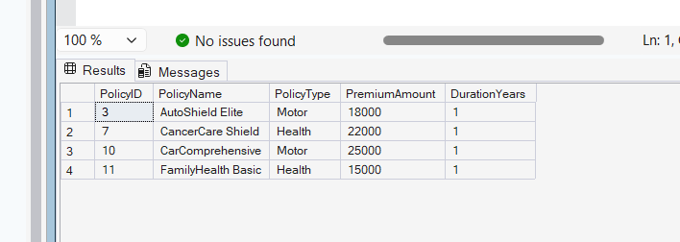

- Display unique city names from where agents belong to.
Query:
Select distinct(City) from Agents;
Output:
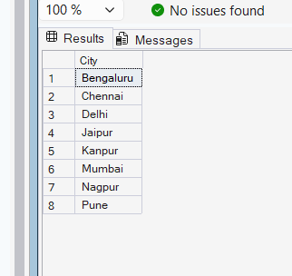

- List policies of type Life, Health, Motor use OR clause.
Query:
Select * from Policies where PolicyType = 'Health' or PolicyType='Motor' or PolicyType='Life';
Output:
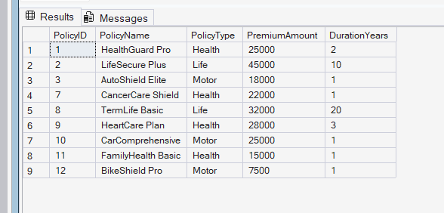

- List policies of type Life, Health, Motor use IN operator.
Query:
Select * from Policies where PolicyType in ('Health', 'Motor', 'Life');
Output:
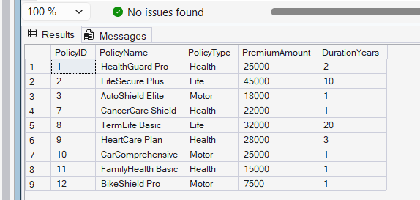

- Display list of customers born after January 1st, 2001 and before December 31st, 2020 using >= and <= operators.

Query:

Select * from Customers where DateOfBirth >= '2001-01-01' and DateOfBirth <= '2020-12-31';

Output:
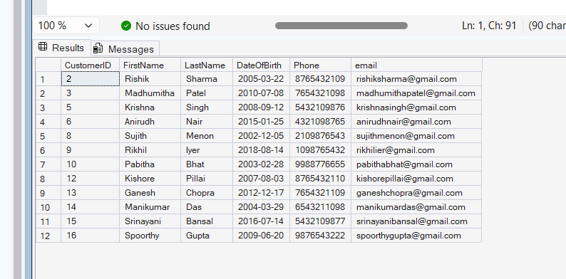
- Display list of customers born after January 1st, 2001 and before December 31st, 2020 using between operator.
Query:
Select * from Customers where DateOfBirth between '2001-01-01' and '2020-12-31';
Output:
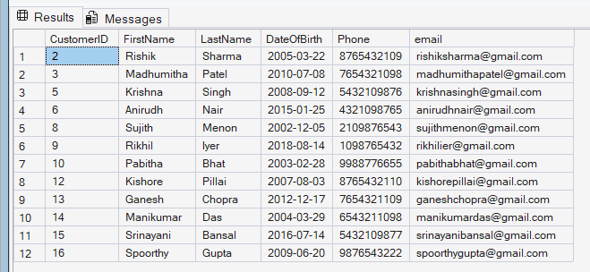

- Display claims data where claim status is Rejected.
Query:
Select * from Claims where claimStatus='Rejected';
Output:
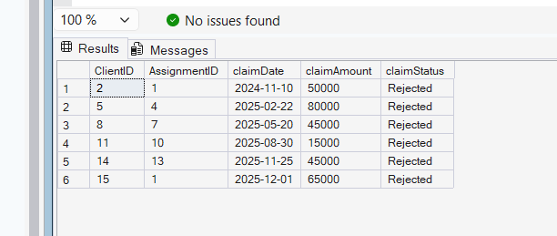

- Display records of Agents who stay in a city whose second letter is 'a'.
Query:
Select * from Agents where City like '_a%';
Output:
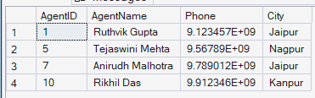

- Display highest and lowest claimAmount from Claims table.
Query:
Select max(claimAmount) as HighestClaimAmount, min(claimAmount) as LeastClaimAmount from Claims;
Output:
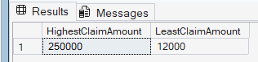

- Display latest claim record.
Query:
Select max(claimDate) as latestClaim from Claims;
Output:
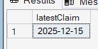

- Increase premium amount to 10% for all health insurance policies.
Query:
update Policies set PremiumAmount = PremiumAmount*1.1 where PolicyType='Health';

Output:
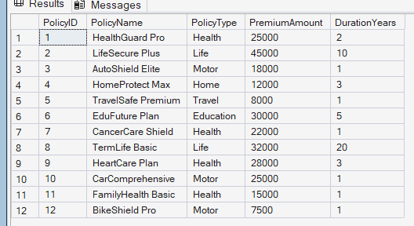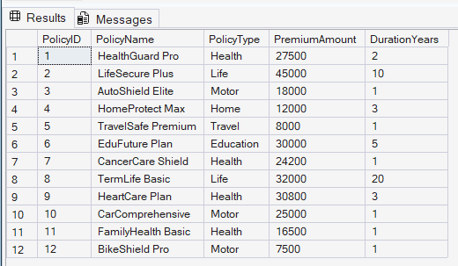

- Delete the record of PolicyAssignments whose EndDate is before today's date.
Query:
Delete from PolicyAssignments where EndDate<GETDATE();

We can not delete the records directly. Because the data in the Claims table is referenced to the current table data which will be deleted. So we first have to delete the records in Claims table where the EndDate < Today’s Date. Correct order of Querries:

- Delete from Claims where AssignmentID in (
Select AssignmentID from PolicyAssignments where EndDate < GETDATE()
);
2) Delete from PolicyAssignments where EndDate<GETDATE();

Output:
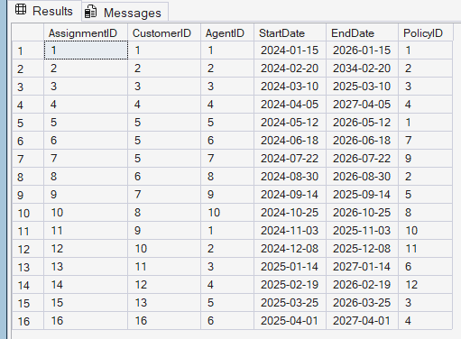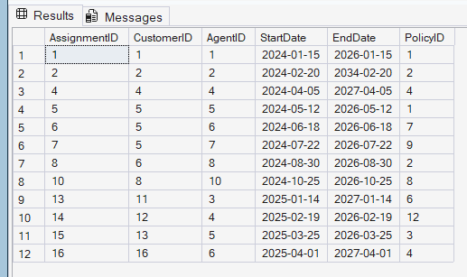

- Display no of claims rejected.
Query:
Select count(*) as Count from Claims where claimStatus='Rejected';
Output:
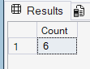

- Display PolicyId, PolicyName, PremiumAmount along with computed fields not in table à 6% LocalTaxes, PremiumAmountWithTax and MonthlyPremiumAmount considering PremiumAmount is Annual.

Query:
Select PolicyID,PolicyName,PremiumAmount,PremiumAmount * 0.06 as LocalTaxes,PremiumAmount * 1.06 as PremiumAmountWithTax,PremiumAmount / 12.0 as MonthlyPremiumAmount from Policies;
Output:
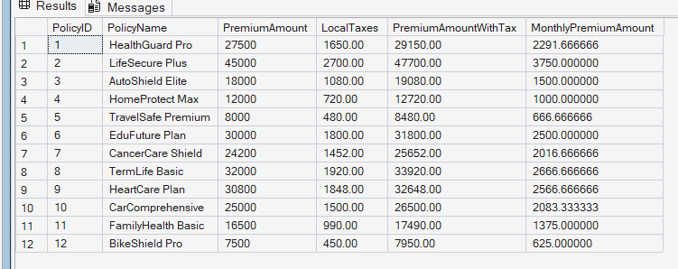

- Write a command to add Address and City Columns in the Customers table.
Query:
alter table Customers add Address varchar(100);
alter table Customers add City varchar(50);
Output:
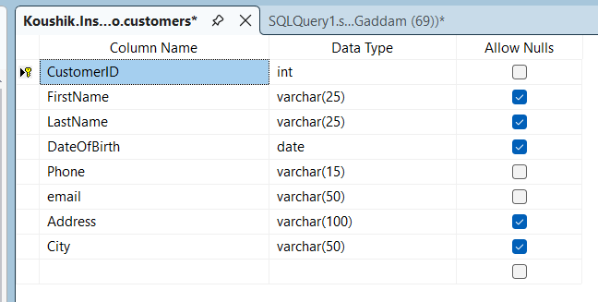

- Write a command to add a new column named DevOfId (DevelopmentOfficerId) in an existing Agents table.
Query:
alter table agents add DevOfID int;
Output:
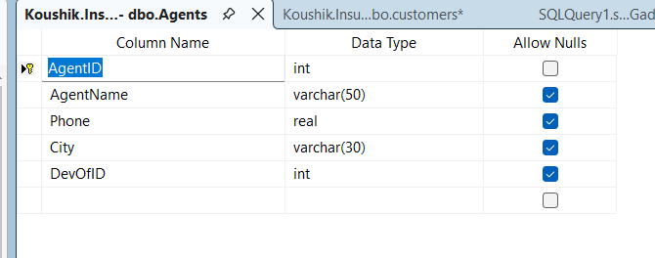
- Write command to make the above DevOfId as a recursive foreign key to AgentId as Parent.
Query:
alter table Agents add constraint for_key_DevOfID foreign key(DevOfID) references Agents(AgentID);
Output:
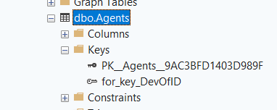

5. Queries using Joins, Group By, Having etc.

- List all Policies for a CustomerId 5.
Query:
select P2.PolicyName from PolicyAssignments P1 join Policies P2 on P2.PolicyID = P1.PolicyID where CustomerID=5;
Output:
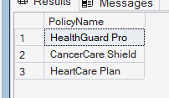

- View all customers with their policies.
Query:
select c.FirstName, c.LastName, p.PolicyName, p.PolicyType from Customers c left join PolicyAssignments pa on c.CustomerID = pa.CustomerID
left join Policies p on pa.PolicyID = p.PolicyID;
Output:
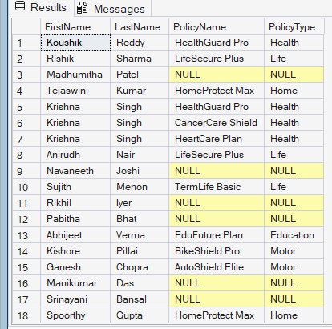

- View claims with customer name.
Query:
select c.FirstName, cl.ClientID, cl.ClaimAmount, cl.ClaimDate, cl.ClaimStatus from Claims cl join PolicyAssignments pa on cl.AssignmentID = pa.AssignmentID join Customers c on pa.CustomerID = c.CustomerID order by cl.ClaimDate desc;

Output:
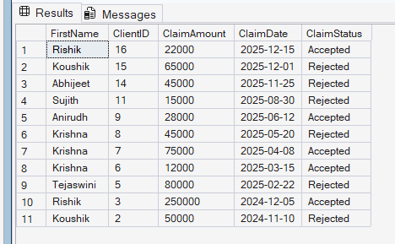

- Display FirstName, PolicyName, AgentName, StartDate and EndDate from their respective tables.
Query:
select c.FirstName, p.PolicyName, a.AgentName, pa.StartDate, pa.EndDate from Customers c join PolicyAssignments pa on c.CustomerID = pa.CustomerID join Agents a on pa.AgentID = a.AgentID join Policies p on pa.PolicyID = p.PolicyID order by c.FirstName;

Output:
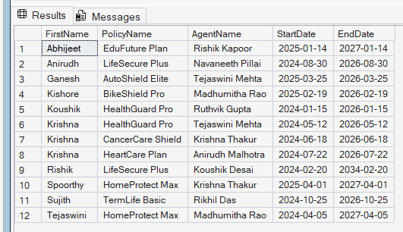

- Display claims report with FirstName, PolicyName, ClaimAmount, ClaimStatus, and ClaimDate from their respective tables.
Query:
select c.FirstName, p.PolicyName, cl.ClaimAmount, cl.ClaimStatus, cl.ClaimDate from Claims cl join PolicyAssignments pa on cl.AssignmentID = pa.AssignmentID join Customers c on pa.CustomerID = c.CustomerID join Policies p on pa.PolicyID = p.PolicyID order by cl.ClaimDate desc;

Output:
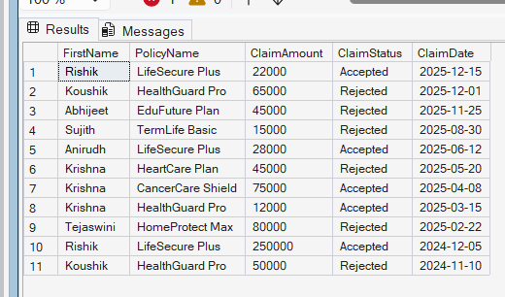

- Display records of Customers with or without Policies.
Query:
select c.FirstName, c.LastName, p.PolicyName from Customers c left join PolicyAssignments pa on c.CustomerID = pa.CustomerID left join Policies p on pa.PolicyID = p.PolicyID order by c.CustomerID;

Output:
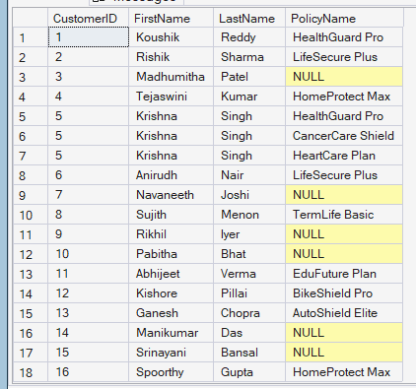

- Display all Customers with NO Claims.
Query:
select c.FirstName, c.LastName from Customers c left join PolicyAssignments pa on c.CustomerID = pa.CustomerID left join Claims cl on pa.AssignmentID = cl.AssignmentID group by c.CustomerID, c.FirstName, c.LastName having count(cl.ClientID) = 0;

Output:

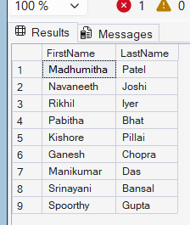

- Show CustomerName with Total Claim Amount per Customer.
Query:
select c.FirstName, sum(cl.ClaimAmount) as TotalClaimAmount from Customers c left join PolicyAssignments pa on c.CustomerID = pa.CustomerID left join Claims cl on pa.AssignmentID = cl.AssignmentID group by c.CustomerID, c.FirstName, c.LastName;

Output:

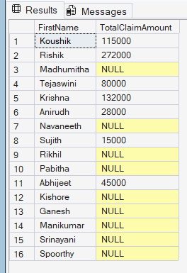

- Show names and total claim amount of Customers With Claim Amount > 50000 (Use HAVING Clause).
Query:
select c.FirstName + ' ' + c.LastName as CustomerName, sum(cl.ClaimAmount) as TotalClaimAmount from Customers c left join PolicyAssignments pa on c.CustomerID = pa.CustomerID left join Claims cl on pa.AssignmentID = cl.AssignmentID group by c.CustomerID, c.FirstName, c.LastName having sum(cl.ClaimAmount) > 50000;
Output:
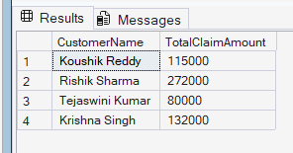

- Display list with Agent Wise Policy Count.

Query:
select a.AgentName, count(pa.AssignmentID) as PolicyCount from Agents a left join PolicyAssignments pa on a.AgentID = pa.AgentID group by a.AgentID, a.AgentName order by PolicyCount desc;

Output:
