Name: Koushik Gaddam
Email: koushikgaddam04@gmail.com

Day 3 - Daily Exercises – SQL Server
Date: 30-12-2025 → Day 3 – Subqueries, Set Operators & CTEs
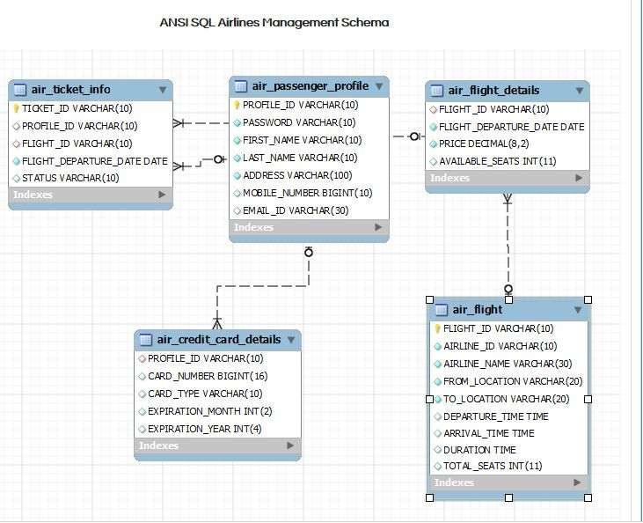
- Write a query to display the average monthly ticket cost for each flight in ABC Airlines. The query should display the Flight_Id, From_location, To_Location, Month Name as “Month_Name” and average price as “Average_Price”. Display the records sorted in ascending order based on flight id and then by Month Name.
Query:
select f.flight_id, f.from_location, f.to_location, datename(month, fd.flight_departure_date) as Month_Name, avg(fd.price) as Average_Price
from air_flight f join air_flight_details fd on f.flight_id = fd.flight_id
where f.airline_id like 'ABC%'
group by f.flight_id, f.from_location, f.to_location, datename(month, fd.flight_departure_date)
order by f.flight_id, Month_Name;

Output:
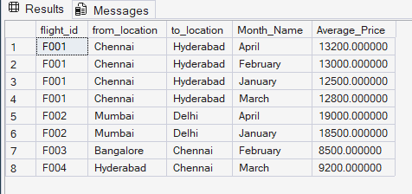

- Write a query to display the customer(s) who has/have booked least number of tickets in ABC
Airlines. The Query should display profile_id, customer’s first_name, Address and Number of tickets booked as “No_of_Tickets”. Display the records sorted in ascending order based on
customer's first name.
Query:
select p.profile_id, p.first_name, p.address, count(t.ticket_id) as No_of_Tickets
from air_passenger_profile p left join air_ticket_info t on p.profile_id = t.profile_id
group by p.profile_id, p.first_name, p.address
having count(t.ticket_id) = (select min(cnt) from (select count(ticket_id) cnt from air_ticket_info group by profile_id) min_tix)
order by p.first_name;

Output:
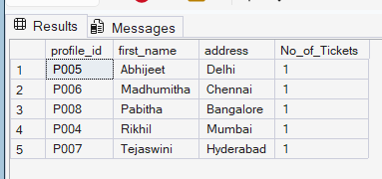

- Write a query to display the number of flight services between locations in a month. The Query should display From_Location, To_Location, Month as “Month_Name” and number of flight services as “No_of_Services”. Hint: The Number of Services can be calculated from the number of scheduled departure dates of a flight. The records should be displayed in ascending order based on From_Location and then by To_Location and then by month name.

Query:
select f.from_location, f.to_location, datename(month, fd.flight_departure_date) as Month_Name, count(fd.flight_departure_date) as No_of_Services
from air_flight f join air_flight_details fd on f.flight_id = fd.flight_id
group by f.from_location, f.to_location, datename(month, fd.flight_departure_date)
order by f.from_location, f.to_location, Month_Name;

Output:
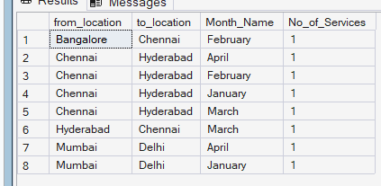

- Write a query to display the customer(s) who has/have booked maximum number of tickets in ABC Airlines. The Query should display profile_id, customer’s first_name, Address and Number of tickets booked as “No_of_Tickets”. Display the records in ascending order based on customer's first name.

Query:
select p.profile_id, p.first_name, p.address, count(t.ticket_id) as No_of_Tickets
from air_passenger_profile p left join air_ticket_info t on p.profile_id = t.profile_id
group by p.profile_id, p.first_name, p.address
having count(t.ticket_id) = (select max(cnt) from (select count(ticket_id) cnt from air_ticket_info group by profile_id) max_tix)
order by p.first_name;

Output:
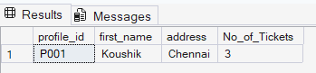

- Write a query to display the number of tickets booked from Chennai to Hyderabad. The Query should display passenger profile_id,first_name,last_name, Flight_Id , Departure_Date and number of tickets booked as “No_of_Tickets”. Display the records sorted in ascending order based on profile id and then by flight id and then by departure date.

Query:
select p.profile_id, p.first_name, p.last_name, t.flight_id, t.flight_departure_date, count(t.ticket_id) as No_of_Tickets
from air_passenger_profile p join air_ticket_info t on p.profile_id = t.profile_id
join air_flight f on t.flight_id = f.flight_id
where f.from_location = 'Chennai' and f.to_location = 'Hyderabad'
group by p.profile_id, p.first_name, p.last_name, t.flight_id, t.flight_departure_date
order by p.profile_id, t.flight_id, t.flight_departure_date;

Output:
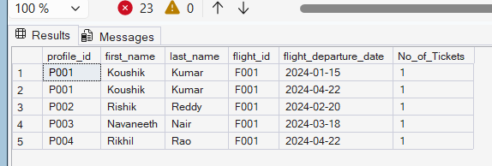

- Write a query to display flight id,from location, to location and ticket price of flights whose departure is in the month of april.

Query:
select f.flight_id, f.from_location, f.to_location, fd.price as ticket_price
from air_flight f join air_flight_details fd on f.flight_id = fd.flight_id
where month(fd.flight_departure_date) = 4;

Output:
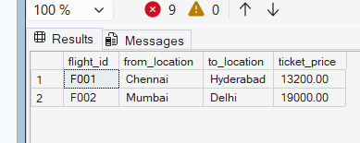

- Write a query to display the average cost of the tickets in each flight on all scheduled dates. The query should display flight_id, from_location, to_location and Average price as “Price”. Display the records sorted in ascending order based on flight id and then by from_location and then by to_location.

Query:
select f.flight_id, f.from_location, f.to_location, avg(fd.price) as Price
from air_flight f join air_flight_details fd on f.flight_id = fd.flight_id
group by f.flight_id, f.from_location, f.to_location
order by f.flight_id, f.from_location, f.to_location;

Output:
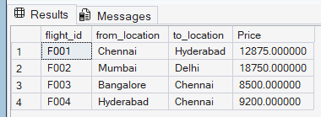

- Write a query to display the customers who have booked tickets from Chennai to Hyderabad. The query should display profile_id, customer_name (combine first_name & last_name with comma in b/w), address of the customer. Give an alias to the name as customer_name. Hint: Query should fetch unique customers irrespective of multiple tickets booked. Display the records sorted in ascending order based on profile id.

Query:
select distinct p.profile_id, p.first_name + ', ' + p.last_name as customer_name, p.address
from air_passenger_profile p join air_ticket_info t on p.profile_id = t.profile_id
join air_flight f on t.flight_id = f.flight_id
where f.from_location = 'Chennai' and f.to_location = 'Hyderabad'
order by p.profile_id;

Output:
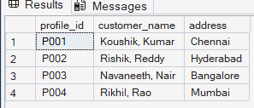

- Write a query to display profile id of the passenger(s) who has/have booked maximum number of tickets. In case of multiple records, display the records sorted in ascending order based on profile id.

Query:
select profile_id from air_ticket_info
group by profile_id
having count(ticket_id) = (select max(cnt) from (select count(ticket_id) cnt from air_ticket_info group by profile_id) x)
order by profile_id;

Output:
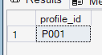

- Write a query to display the total number of tickets as “No_of_Tickets” booked in each flight in ABC Airlines. The Query should display the flight_id, from_location, to_location and the number of tickets. Display only the flights in which atleast 1 ticket is booked. Display the records sorted in ascending order based on flight id.

Query:
select t.flight_id, f.from_location, f.to_location, count(t.ticket_id) as No_of_Tickets
from air_ticket_info t join air_flight f on t.flight_id = f.flight_id
where f.airline_name like 'ABC%'
group by t.flight_id, f.from_location, f.to_location
having count(t.ticket_id) >= 1
order by t.flight_id;

Output:
