|  |  |
| --- | --- |
| Activity | Data Type |
| Number of beatings from Wife | Integer |
| Results of rolling a dice | Integer |
| Weight of a person | Float |
| Weight of Gold | Float |
| Distance between two places | Float |
| Length of a leaf | Float |
| Dog's weight | Float |
| Blue Color | String |
| Number of kids | Integer |
| Number of tickets in Indian railways | Integer |
| Number of times married | Integer |
| Gender (Male or Female) | String |

Q1) Identify the Data type for the Following:

Q2) Identify the Data types, which were among the following

Nominal, Ordinal, Interval, Ratio.

|  |  |
| --- | --- |
| Data | Data Type |
| Gender | Nominal |
| High School Class Ranking | Ordinal |
| Celsius Temperature | Interval |
| Weight | Ratio |
| Hair Color | Nominal |
| Socioeconomic Status | Ordinal |
| Fahrenheit Temperature | Interval |
| Height | Ratio |
| Type of living accommodation | Nominal |
| Level of Agreement | Interval |
| IQ(Intelligence Scale) | Interval |
| Sales Figures | Ratio |
| Blood Group | Nominal |
| Time Of Day | Interval |
| Time on a Clock with Hands | Interval |
| Number of Children | Ratio |
| Religious Preference | Nominal |
| Barometer Pressure | Ratio |
| SAT Scores | Interval |
| Years of Education | Ratio |

Q3) Three Coins are tossed, find the probability that two heads and one tail are obtained?

P=HHH, TTT, HHT, HTH, THH,TTH,THT,HTT = 8

P(n)=3/8

Q4) Two Dice are rolled, find the probability that sum is

1. Equal to 1
2. Less than or equal to 4
3. Sum is divisible by 2 and 3

ANS:

P = {(1,1),(1,2),(1,3),(1,4),(1,5),(1,6)

(2,1),(2,2),(2,3),(2,4),(2,5),(2,6)

(3,1),(3,2),(3,3),(3,4),(3,5),(3,6)

(4,1),(4,2),(4,3),(4,4),(4,5),(4,6)

(5,1),(5,2),(5,3),(5,4),(5,5),(5,6)

(6,1),(6,2),(6,3),(6,4),(6,5),(6,6)}

P(a) = 0

P(b) = {(1,1),(1,2),(1,3),(2,1),(2,2),(3,1)} = 6/36

P(c) = {(1,1),(1,2),(1,5),(2,4),(3,3),(4,2),(5,1),(6,6)}=8/36

Q5) A bag contains 2 red, 3 green and 2 blue balls. Two balls are drawn at random. What is the probability that none of the balls drawn is blue?

Ans: 10/21

Q6) Calculate the Expected number of candies for a randomly selected child

Below are the probabilities of count of candies for children (ignoring the nature of the child-Generalized view)

|  |  |  |
| --- | --- | --- |
| CHILD | Candies count | Probability |
| A | 1 | 0.015 |
| B | 4 | 0.20 |
| C | 3 | 0.65 |
| D | 5 | 0.005 |
| E | 6 | 0.01 |
| F | 2 | 0.120 |

Child A – probability of having 1 candy = 0.015.

Child B – probability of having 4 candies = 0.20

ANS:

Expected Number of candies=

(1*0.015)+(4*0.2)+(3*0.65)+(5*0.005)+(6*0.01)+(2*0.12)

* 0.015+0.8+1.95+0.025+0.06+0.24
* 3.125

So, the expected number of candies for a randomly selected child is 3.125

Q7) Calculate Mean, Median, Mode, Variance, Standard Deviation, Range & comment about the values / draw inferences, for the given dataset

* For Points,Score,Weigh>

Find Mean, Median, Mode, Variance, Standard Deviation, and Range and also Comment about the values/ Draw some inferences.

**Use Q7.csv file**

**ANS:**

|  |  |  |  |
| --- | --- | --- | --- |
|  | **Points** | **Score** | **Weigh** |
| **Mean** | **3.596563** | **3.21725** | **17.84875** |
| **Median** | **3.695** | **3.325** | **17.1** |
| **Mode** | **3.92** | **3.44** | **17.02** |
| **Variance** | **0.2858814** | **0.957379** | **3.193166** |
| **Standard Deviation** | **0.5346787** | **0.9784574** | **1.786943** |
| **Range** | **2.76-4.93** | **1.512-5.424** | **14.5-22.9** |
|  |  |  |  |

Q8) Calculate Expected Value for the problem below

1. The weights (X) of patients at a clinic (in pounds), are

108, 110, 123, 134, 135, 145, 167, 187, 199

Assume one of the patients is chosen at random. What is the Expected Value of the Weight of that patient?

Ans:

Expected value of mean=(Sum of all weights)/(Total number of patients)

Total number of patients = 9

Sum of all weights= 108+110+123+134+135+145+167+187+199

= 1308

Expected value of mean= 1308/9

= 145.33

Code:

X=(108,110,123,134,135,145,167,187,199)

expected_value=statistics.mean(X)

print("Expected value of weight:", expected_value)

**Q9) Calculate Skewness, Kurtosis & draw inferences on the following data**

**Cars speed and ditance**

**Use Q9_a.csv**

**Ans:**

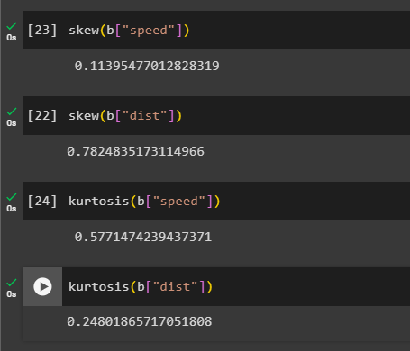

**SP and Weight(WT)**

**Use Q9_b.csv**

**ANS:**

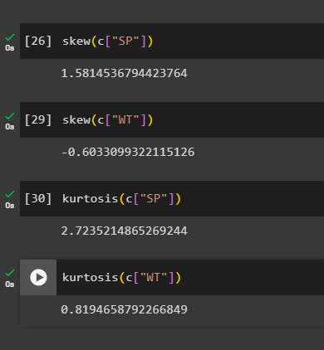

**Q10) Draw inferences about the following boxplot & histogram**



ANS:

Histogram:

In the above-mentioned Histogram, the data points are plotted with a difference of 50 units each with a minimum and maximum range of 0-400 units on Chick Weight $weight (X-axis), and the Frequency(Y-axis) contains the data points with a difference of the 50 units each with a minimum and maximum range of 0- 200 units. So, the minimum range of frequency of 0-100 occurred in the range of 350-400, hence we observed that it is a right skewed.

Boxplot:

By looking at the boxplot, we can see that there are some outliers present, we also observe that the median is less than mean as there are less data points between Q1 and below points range, hence we can consider it as the right skewed

**Q11) Suppose** we want to estimate the average weight of an adult male in Mexico. We draw a random sample of 2,000 men from a population of 3,000,000 men and weigh them. We find that the average person in our sample weighs 200 pounds, and the standard deviation of the sample is 30 pounds. Calculate 94%,98%,96% confidence interval?

**Q12)** Below are the scores obtained by a student in tests

**34,36,36,38,38,39,39,40,40,41,41,41,41,42,42,45,49,56**

1. Find mean, median, variance, standard deviation.
2. What can we say about the student marks?

Q13) What is the nature of skewness when mean, median of data are equal?

Ans: if mean and median is same for a data set then the symmetric of graph is equally distributed. This is also called as Symmetrical Skewness. Therefore the Skewness of data is close to zero.

Q14) What is the nature of skewness when mean > median ?

Ans:

When the mean is greater than the median (or) median is lesser than the mean, then it is going to be right skewness.

Q15) What is the nature of skewness when median > mean?

Ans:

When the median is greater than the mean (or) mean is lesser than the median, then it is going to be considered as left skewness.

Q16) What does positive kurtosis value indicates for a data ?

Ans: A positive kurtosis value indicates that a dataset has heavy tails with more peaks.

Q17) What does negative kurtosis value indicates for a data?

Ans: A negative kurtosis Value indicates that a dataset has tinner tails.

Q18) Answer the below questions using the below boxplot visualization.



What can we say about the distribution of the data?

Ans: the data is actually distributed to the right-side which it contains most of the data values was in between the 10 – 18, hence the plotting was also be form in that range only, where median lies around at the 15.3.

What is nature of skewness of the data?

ANS:

In the box plot, most of the data was lying in the range of 10-18, hence it will be considered as the left skewed, as the data values in upper quadrant contains more than the low quadrant.

What will be the IQR of the data (approximately)?

ANS:

Q1=10.2

Q2=15.3

Q3=18.2

IQR= Q3-Q1

=18.2-10.2  
=8

Q19) Comment on the below Boxplot visualizations?



Draw an Inference from the distribution of data for Boxplot 1 with respect Boxplot 2.

Ans:

In the above 2 boxplots, we can observe that mean and medium are equal, even though the whisker level is high in boxplot 2, hence we can consider the distribution is symmetrical.

Q 20) Calculate probability from the given dataset for the below cases

Data _set: Cars.csv

Calculate the probability of MPG of Cars for the below cases.

MPG <- Cars$MPG

* 1. P(MPG>38)
  2. P(MPG<40)

c. P (20<MPG<50)

Q 21) Check whether the data follows normal distribution

1. Check whether the MPG of Cars follows Normal Distribution

Dataset: Cars.csv

1. Check Whether the Adipose Tissue (AT) and Waist Circumference(Waist) from wc-at data set follows Normal Distribution

Dataset: wc-at.csv

Q 22) Calculate the Z scores of 90% confidence interval,94% confidence interval, 60% confidence interval

Q 23) Calculate the t scores of 95% confidence interval, 96% confidence interval, 99% confidence interval for sample size of 25

Q 24**)** A Government company claims that an average light bulb lasts 270 days. A researcher randomly selects 18 bulbs for testing. The sampled bulbs last an average of 260 days, with a standard deviation of 90 days. If the CEO's claim were true, what is the probability that 18 randomly selected bulbs would have an average life of no more than 260 days

Hint:

rcode 🡪 pt(tscore,df)

df 🡪 degrees of freedom