CarbonShift
A Carbon-Aware Compute Scheduler for Real-Time Grid-Responsive Energy Efficiency

Newness / Uniqueness
Most energy-efficiency tools optimize how much power is used. CarbonShift instead optimizes when and where compute jobs run, based on real-time carbon intensity of the electricity grid. Unlike static off-peak scheduling (which only considers price), it uses live grid-carbon-intensity data (renewable vs. fossil mix) to delay or relocate non-urgent, interruptible workloads to the cleanest available time window or region — with no hardware changes.

Concept & Objective
A lightweight scheduler/middleware layer plugs into existing job queues (cron, Kubernetes CronJobs, CI/CD pipelines). It queries public grid-carbon APIs, forecasts the next low-carbon window within a user-defined deadline, and automatically reschedules jobs accordingly. Objective: reduce the carbon footprint of computing without added hardware cost or performance compromise for time-flexible tasks.

Application Areas
- Cloud / data-center batch processing and ML training
- Enterprise IT — backups, report generation, CI/CD builds
- Smart offices and campuses with flexible compute needs
- EV charging and appliance scheduling (future scope)

Market Potential
Data centers consume roughly 2% of global electricity, and this is rising fast with AI workloads. Enterprises face growing ESG and carbon-reporting mandates. A zero-hardware, plug-in software solution offering measurable carbon-reduction metrics is attractive to cloud providers, sustainability-focused SaaS platforms, and enterprises seeking low-cost compliance wins — a large and rapidly growing addressable market.

System Block Diagram
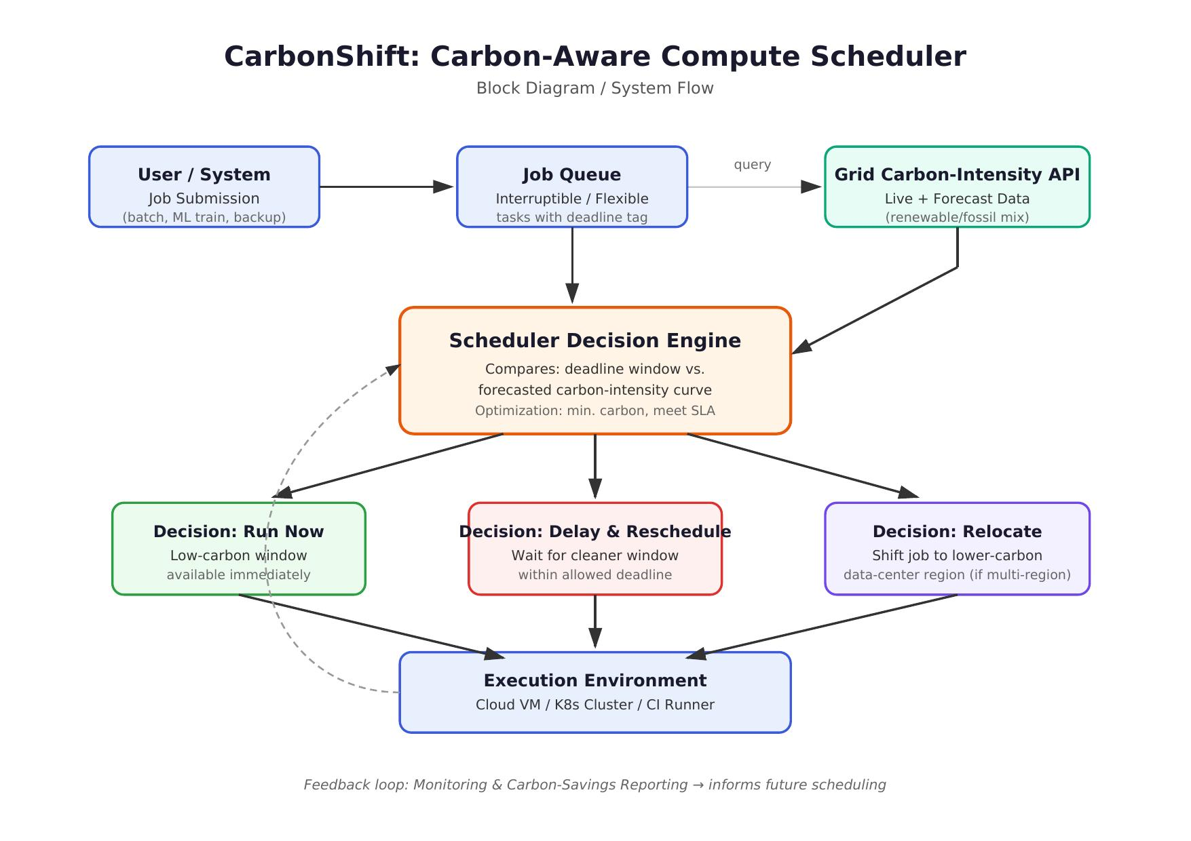

Concept Overview
