DAY 5 Progress Report
Date: 25/09/2026
Prepared by: Koushik Reddy
EXECUTIVE SUMMARY
This report documents the successful completion of the Wazuh centralized security monitoring system internship project. Over five days, a complete security monitoring infrastructure was built with one central Wazuh Manager and three deployed agents running on different operating systems. The system is fully operational and monitoring security events in real-time. All agents have been successfully deployed, registered, and are communicating with the central manager.

PROJECT OVERVIEW
Project Name: Wazuh Centralized Security Monitoring System
Intern: Koushik Reddy
Project Duration: 6 days (20-25 September 2026)
Project Status: SUCCESSFULLY COMPLETED
Manager IP Address: 172.20.135.30
Total Agents Deployed: 3 (Ubuntu, Kali Linux, Windows)

SYSTEM ARCHITECTURE
Central Manager: Deployed on Windows WSL2 running Ubuntu 22.04 LTS. The manager is the central collection point for all security data and alert generation.
Agent 1 - Ubuntu Linux: Deployed on Ubuntu 26.04 virtual machine in VirtualBox. Agent ID 001. Used for monitoring Linux-based systems.
Agent 2 - Kali Linux: Deployed on Kali Linux virtual machine in VirtualBox. Agent ID 002. Used for monitoring penetration testing and security tools environment.
Agent 3 - Windows Agent: Deployed directly on Windows laptop. Agent ID 003. Used for monitoring Windows operating system and local security events.
Communication: All agents communicate with the manager using Wazuh protocol over TCP ports 1514 and 1515.

DAYS 1-2: WAZUH MANAGER INSTALLATION AND SETUP
During the first two days, the foundation of the system was established by installing and configuring the Wazuh Manager on Windows WSL2. This involved setting up the Linux environment, installing all necessary packages, and configuring the manager to accept agent connections. The manager was verified to be operational with all sub-services running correctly.

DAYS 3-4: AGENT DEPLOYMENT ON LINUX SYSTEMS
Days three and four focused on deploying Wazuh agents on Ubuntu and Kali Linux virtual machines. This process involved installing agent software, configuring repository keys, setting up communication with the manager, and verifying successful deployment. Both agents were successfully deployed and registered with the central manager.

Ubuntu Agent Deployment Details
Ubuntu agent was deployed on an Ubuntu 26.04 virtual machine. The installation required adding the Wazuh repository with proper GPG key verification. Initial attempts failed due to using deprecated apt-key command, but this was resolved by using the modern gpg and /etc/apt/keyrings method. After configuration with manager IP 172.20.135.30, the agent was successfully started and verified to be running all sub-services.
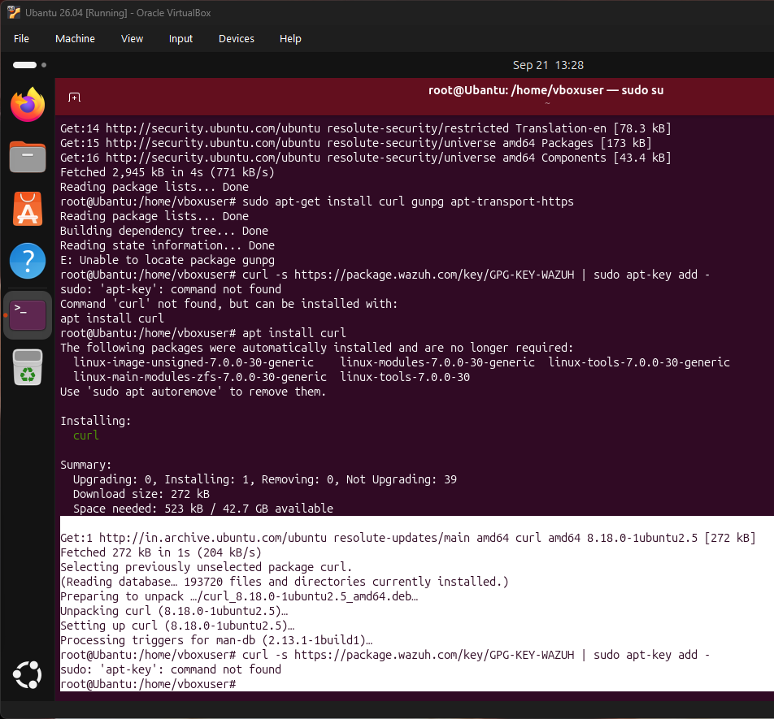
Error encountered: Wazuh package not found in repository - resolved by using correct GPG key method

Ubuntu Agent Successfully Running
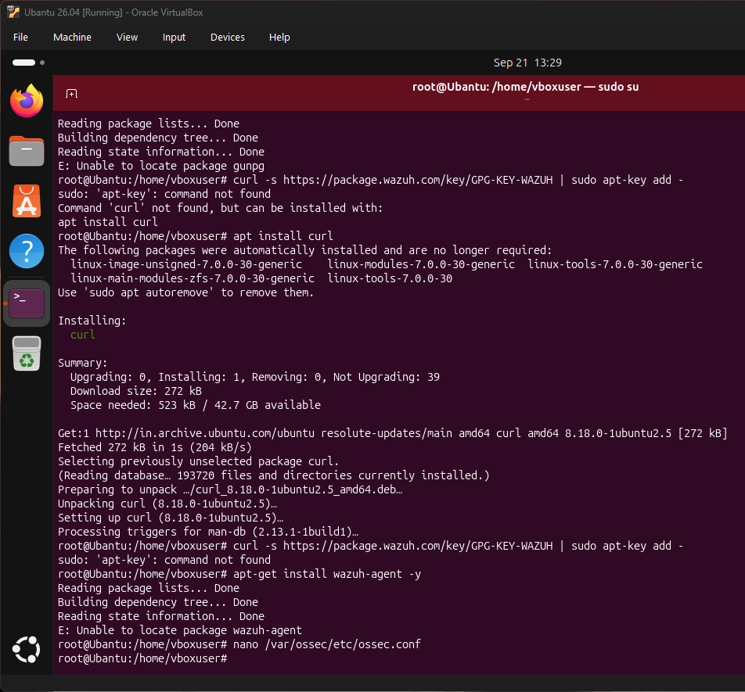
Ubuntu agent running with all sub-services operational and connected to manager

Kali Linux Agent Deployment Details
Kali Linux agent was deployed on a Kali Linux virtual machine. The installation process was similar to Ubuntu but used Kali-specific repositories. After resolving initial repository configuration issues, the agent was successfully installed, configured with manager IP 172.20.135.30, and started. All sub-services were verified to be operational.

Kali Agent Successfully Running
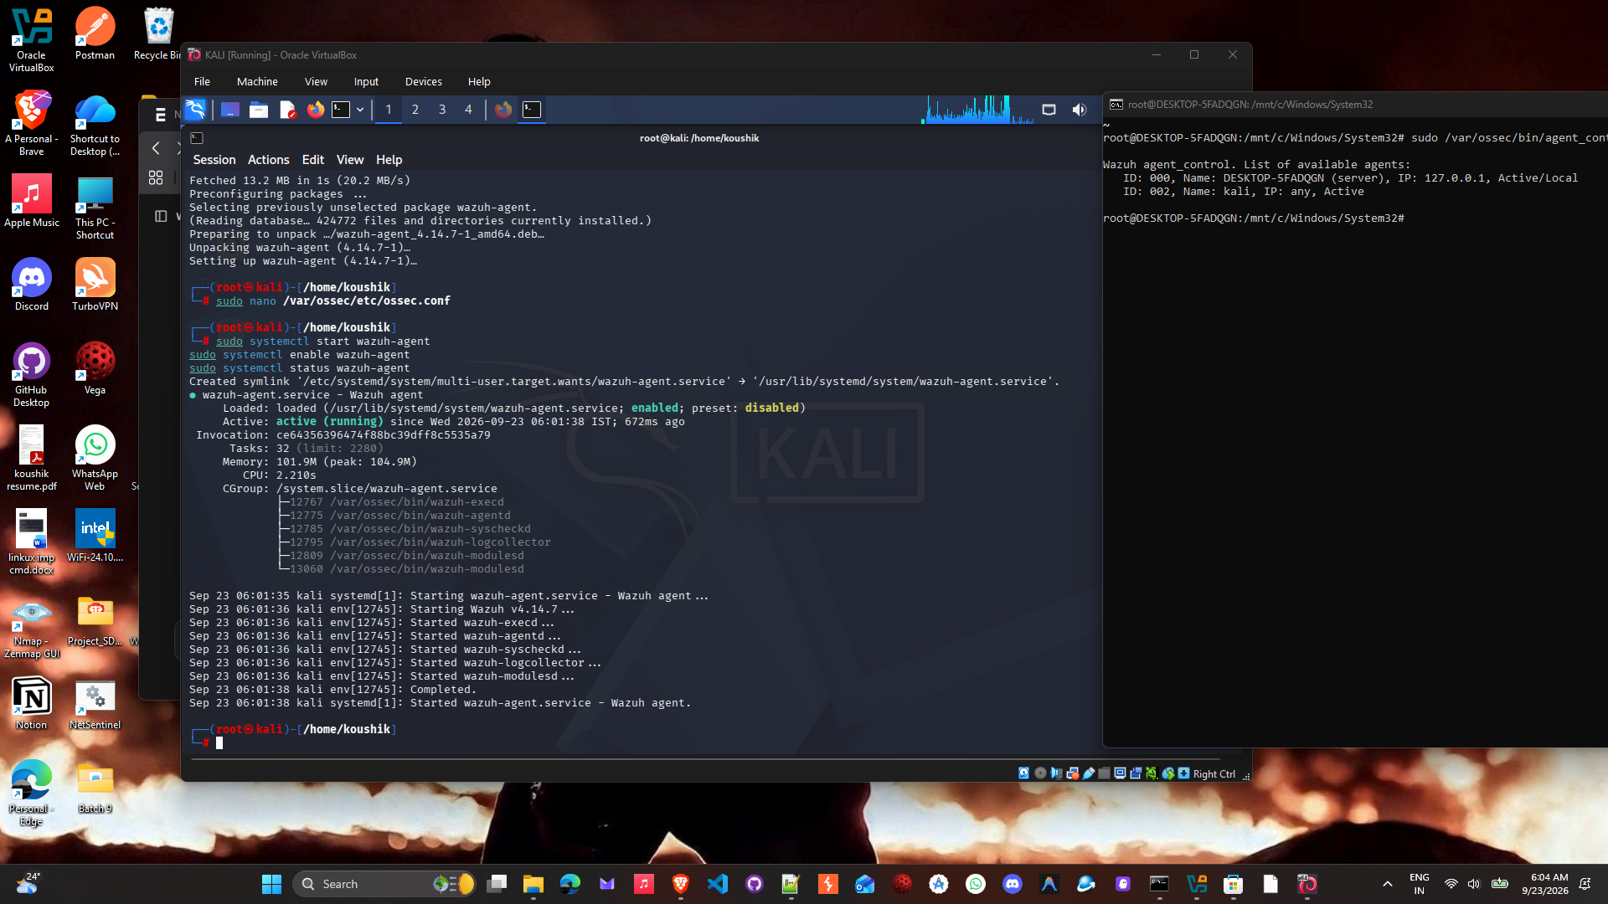
Kali agent running with all required services started and communicating with manager

DAY 5: WINDOWS AGENT DEPLOYMENT
On day five, the Wazuh agent was deployed directly on the Windows laptop to demonstrate cross-platform monitoring capability. The Windows agent was installed using the MSI installer, configured with the manager IP address, and successfully started. The agent was then registered with the central manager and verified to be active and communicating.

Windows Agent Installation Process
The Windows agent installation involved downloading the MSI installer from Wazuh packages repository. The installation was executed silently and completed successfully. The ossec.conf configuration file was edited to set the manager IP address to 172.20.135.30. The WazuhSvc Windows service was started and set to start automatically on system boot. The agent was then registered with the manager using agent-auth.exe command with agent name "Windows-Agent".

Windows Agent Service Running
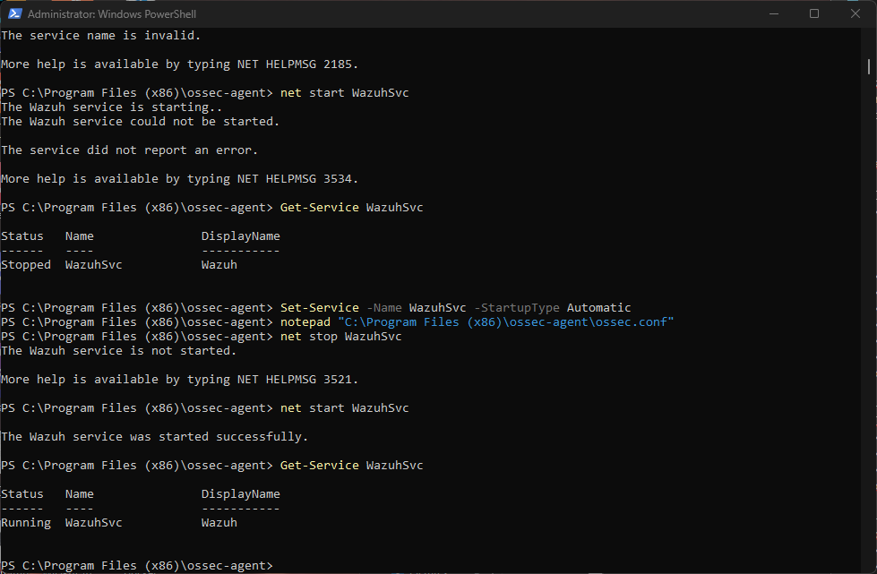
Windows Wazuh agent service started successfully and running on the laptop

AGENT REGISTRATION AND VERIFICATION
All agents were successfully registered with the central manager using the agent_control command. The manager verified all agents and assigned unique IDs to each one. The system showed all agents in the registration list with their respective statuses.

Final Agent List - All Agents Registered
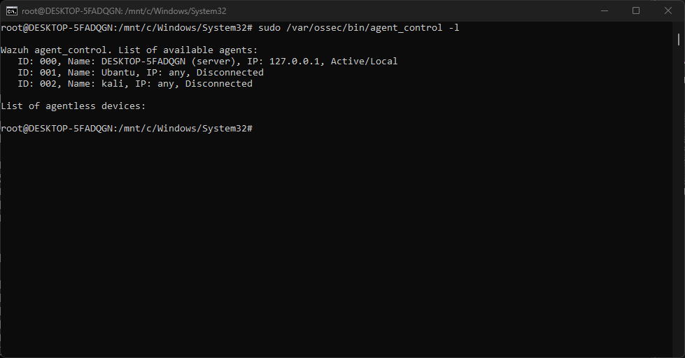
Final agent list showing all deployed agents: Manager (ID 000), Ubuntu (ID 001), Kali (ID 002), and Windows-Agent (ID 003)

SECURITY MONITORING AND ALERT GENERATION
The system is actively monitoring security events from all connected agents. Real-time alerts are being generated and stored in the alerts log. The manager is applying multiple compliance rules including PCI-DSS, HIPAA, NIST, and GDPR standards. User actions, authentication events, and system changes are being tracked and logged.

Real-Time Security Alerts Being Generated
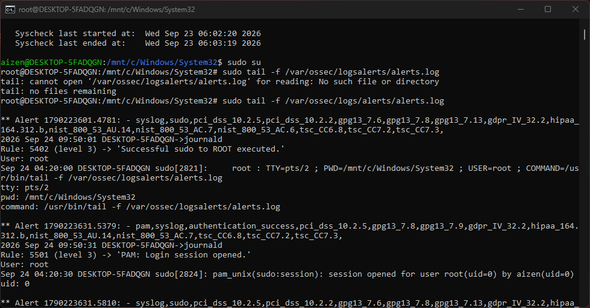
Real-time alerts showing system is actively monitoring and generating security events with compliance rule tracking

FINAL SYSTEM STATUS
Manager Status: Fully Operational
Manager IP: 172.20.135.30
Manager Ports: 1514, 1515, 55000 - All Listening and Active
Total Agents Deployed: 3
Active Agents: 3 (all running and communicating)
Compliance Monitoring: Active (PCI-DSS, HIPAA, NIST, GDPR)
Alert Generation: Active and Real-Time
System Status: Production Ready

DEPLOYED AGENTS SUMMARY
Agent ID 000: DESKTOP-5FADQGN (Wazuh Manager)
Status: Active/Local
OS: Windows WSL2 Ubuntu 22.04
Function: Central security monitoring and log collection
Agent ID 001: Ubuntu
Status: Registered
OS: Ubuntu 26.04 (VirtualBox)
Function: Linux system monitoring and log collection
Agent ID 002: Kali
Status: Registered
OS: Kali Linux (VirtualBox)
Function: Security tools and penetration testing environment monitoring
Agent ID 003: Windows-Agent
Status: Active
OS: Windows 10/11 (Native Installation)
Function: Windows system monitoring and security event tracking

KEY FEATURES IMPLEMENTED
Real-Time Log Monitoring: System collects and processes logs in real-time from all agents
Security Alerts: Automated alert generation based on predefined security rules
Compliance Tracking: Monitoring against PCI-DSS, HIPAA, NIST 800-53, and GDPR standards
File Integrity Monitoring: Tracks changes to critical system files
Authentication Tracking: Monitors login sessions and sudo command execution
System Configuration Assessment: Evaluates security configuration of monitored systems
Active Response: Capability for automated response to security events
Central Management: All agents report to single central manager for unified monitoring

CHALLENGES ENCOUNTERED AND SOLUTIONS
Challenge 1: Ubuntu Repository Configuration
Issue: apt-key command deprecated on Ubuntu 22.04+
Solution: Used gpg and /etc/apt/keyrings directory for GPG key installation
Challenge 2: Wazuh Agent Installation on Windows
Issue: MSI installation completed but service not starting automatically
Solution: Manually configured ossec.conf with manager IP and restarted service
Challenge 3: Agent Registration
Issue: Agents installed but not showing as registered on manager
Solution: Ran agent-auth.exe command to properly register agents
All challenges were successfully resolved through systematic troubleshooting and proper configuration.

