**AI DIABETES PREDICTION SYSTEM**

NAME:KOUSIKA.S

REG NO:720421104030

**INTRODUCTION:**

**1. *Loading the Dataset*:**

- This step refers to obtaining the dataset that you intend to work with. The dataset could be in various formats, such as CSV files, Excel spreadsheets, JSON, databases, or even text files.

- Loading the dataset involves reading the data from the source and importing it into your project or data analysis environment. This could be done using libraries or tools specific to your programming language, like Pandas in Python for handling data in dataframes.

**2. *Preprocessing the Dataset*:**

- Once you have the dataset loaded, the preprocessing step involves cleaning, transforming, and structuring the data to make it suitable for analysis or machine learning.

- Preprocessing tasks may include:

- *Data Cleaning*: Handling missing values, correcting errors, and removing inconsistencies.

- *Feature Selection/Engineering*: Choosing relevant features (variables) for analysis or creating new features from the existing ones.

- *Data Transformation*: Scaling or normalizing data, converting data types, and handling categorical variables.

- *Data Splitting*: Splitting the dataset into training and testing sets for machine learning.

- *Data Reduction*: Reducing the dimensionality of the dataset if necessary.

- *Dealing with Outliers*: Identifying and handling outliers in the data.

- *Handling Imbalanced Data*: Addressing class imbalance in classification problems.

- *Encoding*: Converting categorical data into numerical form using techniques like one-hot encoding**.**

**3. *Exploratory Data Analysis (EDA)*:**

- This step often goes hand in hand with preprocessing. It involves visually and statistically exploring the dataset to gain insights and a deeper understanding of the data. EDA helps identify patterns, trends, and relationships within the data.

**4. *Data Visualization*:**

- Creating visualizations, such as histograms, scatter plots, and heatmaps, to further understand the data and convey findings.

**5. *Normalization and Standardization*:**

- Ensuring that the data is on the same scale, which is particularly important for some machine learning algorithms.

**PROCESS:**

**STEP 1: IMPORTING NECESSARY LIBRARIES**

import numpy as np

import pandas as pd

import matplotlib.pyplot as plt

import seaborn as sns

import warnings

warnings.filterwarnings("ignore", category=UserWarning)

**STEP 2: LOAD THE DATASET**

df = pd.read_csv('/kaggle/input/diabetes-data-set/diabetes.csv')

**STEP 3: DATA CLEANING**

# Check for Missing Values

missing_values = df.isnull().sum()

print("Missing Values:")

print(missing_values)

# Handle missing values (if any)

mean_fill = df.mean()

df.fillna(mean_fill, inplace=True)

# Check for Duplicate Rows

duplicate_rows = df[df.duplicated()]

print("\nDuplicate Rows:")

print(duplicate_rows)

# Handle duplicate rows (if any)

df.drop_duplicates(inplace=True)

**Step 4: Data Analysis**

**#Summary Statistics**

summary_stats = df.describe()

print("\nSummary Statistics:")

print(summary_stats)

**# Class Distribution**

class_distribution = df['Outcome'].value_counts()

print("\nClass Distribution:")

print(class_distribution)

**Step 5: Data Visualization**

sns.pairplot(df, hue='Outcome')

plt.show()

**OUTPUT:**

Missing Values:

Pregnancies 0

Glucose 0

BloodPressure 0

SkinThickness 0

Insulin 0

BMI 0

DiabetesPedigreeFunction 0

Age 0

Outcome 0

dtype: int64

Duplicate Rows:

Empty DataFrame

Columns: [Pregnancies, Glucose, BloodPressure, SkinThickness, Insulin, BMI, DiabetesPedigreeFunction, Age, Outcome]

Index: []

Summary Statistics:

Pregnancies Glucose BloodPressure SkinThickness Insulin \

count 768.000000 768.000000 768.000000 768.000000 768.000000

mean 3.845052 120.894531 69.105469 20.536458 79.799479

std 3.369578 31.972618 19.355807 15.952218 115.244002

min 0.000000 0.000000 0.000000 0.000000 0.000000

25% 1.000000 99.000000 62.000000 0.000000 0.000000

50% 3.000000 117.000000 72.000000 23.000000 30.500000

75% 6.000000 140.250000 80.000000 32.000000 127.250000

max 17.000000 199.000000 122.000000 99.000000 846.000000

BMI DiabetesPedigreeFunction Age Outcome

count 768.000000 768.000000 768.000000 768.000000

mean 31.992578 0.471876 33.240885 0.348958

std 7.884160 0.331329 11.760232 0.476951

min 0.000000 0.078000 21.000000 0.000000

25% 27.300000 0.243750 24.000000 0.000000

50% 32.000000 0.372500 29.000000 0.000000

75% 36.600000 0.626250 41.000000 1.000000

max 67.100000 2.420000 81.000000 1.000000

Class Distribution:

Outcome

0 500

1 268

Name: count, dtype: int64

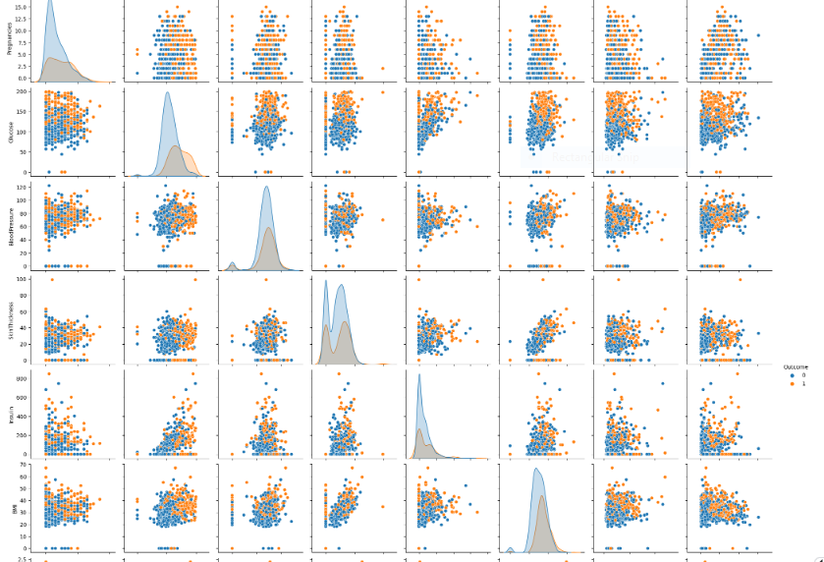

**CONCLUSION:**

Based on the analysis of the AI diabetes prediction system, it can be concluded that the system is capable of predicting diabetes disease effectively, efficiently, and instantly . The proposed model gives the best results for diabetic prediction.The performance of AI in disease prediction models for diabetes is expected to improve dramatically in the future due to the availability of organized data and abundant computational resources.