DIGITAL CONSULTANCY SERVICE PORTAL FOR NIVAS CONSTRUCTIONS

A PROJECT REPORT
(22ITP61-Project Work I) Submitted by
KIRUBASAGAR S
(23ITR084)

KOUSIKAA SHREE S (23ITR085)

in partial fulfilment of the requirements for the award of the degree
of

BACHELOR OF TECHNOLOGY IN
INFORMATION TECHNOLOGY

DEPARTMENT OF INFORMATION TECHNOLOGY


(Autonomous)
PERUNDURAI ERODE – 638 060

MARCH 2026

ii

BONAFIDE CERTIFICATE

This is to certify that the Project report entitled Online Food Ordering and Delivery Platform for CSK Food Truck Theni is the Bonafide record of project work done by Kirubasagar S (23ITR084) and Kirubasagar S (23ITR085) in partial fulfilment of the requirements for the award of the Degree of Bachelor of Technology in INFORMATION TECHNOLOGY of Anna University Chennai during the year 2025 - 2026.

SUPERVISOR HEAD OF THE DEPARTMENT
Date: (Signature with seal)

Submitted for the end semester viva voce examination held on .

INTERNAL EXAMINER EXTERNAL EXAMINER
iii

DECLARATION

We affirm that the Project Report titled Online Food Ordering and Delivery Platform for CSK Food Truck Theni being submitted in partial fulfilment of the requirements for the award of Bachelor of Technology is the original work carried out by us. It has not formed the part of any other project report or dissertation on the basis of which a degree or award was conferred on an earlier occasion on this or any other candidate.

Kirubasagar S
(23ITR084)

Kousikaa Shree S
(23ITR085)

Date:

I certify that the declaration made by the above candidates is true to the best of my knowledge.

Date: Name and Signature of the Supervisor with seal

ACKNOWLEDGEMENT
ivvvv

First and foremost, we acknowledge the abundant grace and presence of Almighty throughout different phases of the project and its successful completion.

We express our gratefulness to Correspondent THIRU. E. R. K. Krishnan, M.Com. and all the trust members of Kongu Vellalar Institute of Technology Trust for providing all the necessary facilities to complete the project successfully.

We express our deep sense of gratitude to our beloved Principal Dr.R.Parameshwaran M.E.,Ph.D., for providing us an opportunity to complete the project.

We express our gratitude to Dr. S. Anandamurugan M.E.,Ph.D., Head of the Department, Department of Information Technology for his valuable suggestions.

We are thankful to our Project Coordinators Dr.E.M.Roopa Devi M.E,Ph.D., Ms.S.Sujitha M.Tech a n d G . S a s i k a l a M.E., for their valuable guidance and support.

We are highly indebted to Dr. Devisurya V M.E, Ph.D, Department of Information Technology for her valuable supervision and advice for the fruitful completion of the project.

We are thankful to the faculty members of the Department of Information Technology for their valuable guidance and support.

We are obliged to thank Mrs K.Vanishree, Owner of CSK Food Truck Theni for supporting us through the various development phases of the project with atmost trust.
iv

ABSTRACT
v

A web-based consultancy application was developed for CSK Food Truck Theni to enhance and digitize their construction consultancy services. The platform provides an online environment where users can explore various consultancy services related to construction and easily submit their consultation requests. By implementing this digital solution, the system bridges the gap between traditional offline consultation methods and modern online service platforms.

The application offers a simple and user-friendly interface that allows clients to access professional guidance conveniently. Users can browse available services, learn about the expertise offered by the company, and communicate their requirements through the platform. This improves accessibility and allows customers to connect with the consultancy services anytime and from anywhere.

The system also includes an administrative dashboard that enables administrators to manage consultancy services, monitor client inquiries, and maintain overall system functionality efficiently. This feature helps the company organize client interactions, track service requests, and improve operational efficiency.

Overall, the consultancy platform developed for Nivas Constructions demonstrates how digital technology can modernize traditional consultancy services. By combining an intuitive interface with effective management tools, the system improves customer engagement while creating opportunities for future expansion and digital growth.

TABLE OF CONTENTS
vi

CHAPTER No. TITLE PAGE No.

ABSTRACT | v
LIST OF FIGURES | viii
LIST OF ABBREVIATIONS | ix
1 INTRODUCTION | 1
1.1 OVERVIEW | 1
1.2 OBJECTIVE | 1
2 SYSTEM SPECIFICATION | 2
2.1 HARDWARE REQUIREMENTS | 2
2.2 SOFTWARE REQUIREMENTS | 2
2.3 SOFTWARE DESCRIPTION | 3
2.3.1 Visual Studio Code | 3
2.3.2 NodeJS | 3
2.3.3 MongoDB | 5
2.3.4 React | 5
3 SYSTEM DESIGN | 8
3.1 USE CASE DIAGRAM | 8
3.2 CLASS DIAGRAM | 9
3.3 SEQUENCE DIAGRAM | 10
3.4 ACTIVITY DIAGRAM | 11
3.5 DATABASE DESIGN | 12

  - MODULES DESCRIPTION 14
vii
    - User Authentication Module 14
    - Product Management Module 14
    - Product Browsing and Search Module 14
    - Cart and Order Placement Module 15
    - Payment Integration Module 15
    - Admin Dashboard Module 15
- TESTING 16
  - SYSTEM TESTING 16
  - UNIT TESTING 16
  - MODULE TESTING 17
  - INTEGRATION TESTING 17
  - VALIDATION TESTING 17
- RESULTS & DISCUSSIONS 19
- CONCLUSION 23
APPENDIX 1- CODING 24
APPENDIX 2- SNAPSHOTS 41
REFERENCES 49
MAPPING OF SDG GOALS 53

viii
viii

FIGURE No. FIGURE NAME PAGE No.

  - USE CASE DIAGRAM 8
  - CLASS DIAGRAM 9
  - SEQUENCE DIAGRAM 10
  - ACTIVITY DIAGRAM 11
  - LANDING PAGE 20
  - ADMIN LOGIN PAGE 21
  - ADMIN DASHBOARD 21
  - PROJECTS AND SERVICES PAGE 22

A2.1 | LANDING PAGE | 41
A2.2 | ABOUT PAGE | 41
A2.3 | SERVICES PAGE | 42
A2.4 | PROJECTS PAGE | 42
A2.5 | CONTACT US | 43
A2.6 | FOOTER | 43
A2.7 | ADMIN LOGIN PAGE | 44
A2.8 | ADMIN DASHBOARD | 44
A2.9 | ADD SERVICE | 45
A2.10 | ADD PROJECT | 45
A2.11 | ENQUIRY PAGE | 46
A2.12 | ENQUIRY DETAILS | 46
A2.13 | REPLY MAIL | 47
A2.14 | APPLYING FILTERS TO ENQUIRIES | 47
A2.15 | APPLYING FILTERS TO PROJECTS | 48
A2.16 | RESPONSE FOR FORM FILLING | 48

ix
ix
S.NO | ABBREVIATIONS | EXPANSIONS
01 | DOM | Document Object Model
02 | JS | JavaScript
03 | UI | User Interface
04 | API | Application Programming Interface
05 | RAM | Random Access Memory
06 | Gen | Generation
07 | DB | Database
08 | JSON | JavaScript Object Notation
09 | HTTP | Hyper Text Transfer Protocol
10 | UML | Unified Modeling Language
11 | JWT | JSON Web Token

LIST OF TABLES

S.NO | TABLE NAME
01 | Users
02 | Services
03 | Enquiries
04 | Projects
05 | Admin

CHAPTER 1 INTRODUCTION

OVERVIEW

The increasing adoption of digital technology has made it essential for businesses to provide online platforms for their services and customer interactions. This project focuses on developing a web-based consultancy application for Nivas Constructions to simplify and enhance the process of providing construction-related consultancy services. The platform enables users to explore available consultancy services, submit inquiries, and request professional guidance through an easy-to-use online interface.The system also provides administrative features that allow administrators to manage services, monitor client requests, and maintain the overall functionality of the platform efficiently. By digitizing the consultation process, the application reduces manual communication efforts, improves response time, and enhances the overall customer experience. This solution supports better client engagement, streamlined service management, and provides a scalable foundation for future improvements and digital expansion of Nivas Constructions.

OBJECTIVE

    - To develop a web-based consultancy application for Nivas Constructions that simplifies the process of providing construction-related consultancy services to clients through an online platform.
    - To create an intuitive and user-friendly interface that allows users to explore consultancy services, submit inquiries, and access professional guidance conveniently.
    - To provide an efficient administrative system that enables administrators to manage services, monitor client requests, and maintain the overall functionality of the platform effectively.
1

2

CHAPTER 2 SYSTEM SPECIFICATION

HARDWARE REQUIREMENTS

Processor : Intel Pentium

Processor Speed : 250MHz to 667MHz

RAM : 4GB RAM

Hard Disk : 256GB

Keyboard : Standard 104 enhanced

Mouse : Local PS/2

SOFTWARE REQUIREMENTS

Platform : Visual Studio Code

Server-Side Script : NodeJS

Operating System : Windows, macOS, or Linux

Backend : MongoDB

Library : React

SOFTWARE DESCRIPTION

Visual Studio Code

Visual Studio Code is a versatile and user-friendly code editor used by developers worldwide. It supports a wide range of programming languages and frameworks, including JavaScript, React, and Node.js. For this project, VS Code provides a convenient environment for writing, editing, and debugging code related to server-side scripting with Node.js, as well as client-side scripting with React.js. Its built-in terminal and debugging tools streamline the development process, while its customizable features allow developers to tailor the editor to their specific needs, enhancing productivity and efficiency throughout the project lifecycle.

ES6+ React/Redux/React-Native:
ES6 React/Redux/React-Native snippets provide code templates designed to simplify and accelerate the development process for building applications with React, Redux, and React Native. These snippets utilize the powerful features introduced in ES6, allowing developers to quickly scaffold common patterns like React components, Redux actions, reducers, and React Native components. By incorporating ES6 syntax, such as arrow functions, destructuring, template literals, and modules, these snippets make it easier to write clean and concise code. With ES6 snippets, developers can efficiently generate standardized code structures that promote consistency and reduce the chance of errors, cutting down on boilerplate code. This collection of snippets supports the creation of both web applications in React and cross-platform mobile applications in React Native, while simplifying state management in Redux. Whether developing user interfaces, managing state, or working on cross-platform features, these ES6 snippets help developers stay focused on creating features and solving problems instead of repeating boilerplate setup.

NodeJS

Node.js is a powerful server-side JavaScript runtime environment commonly used for building scalable and efficient web applications. In our project, Node.js serves as

the server- side scripting language, handling tasks such as routing, handling HTTP requests, and interacting with the MongoDB database. Its event-driven architecture and non- blocking I/O operations make it well-suited for handling concurrent connections and processing requests efficiently. With its vast ecosystem of libraries and frameworks, Node.js allows for rapid development and deployment of server-side applications. Additionally, its compatibility with Visual Studio Code provides a seamless development experience, enabling developers to write, test, and debug server-side code effectively within a unified environment. Overall, Node.js plays a crucial role in this project by powering the backend infrastructure and facilitating the seamless integration of frontend and backend components.

Bcryptjs

Bcryptjs is a library used for hashing passwords in JavaScript. It provides a secure way to hash passwords before storing them in a database or comparing them during authentication processes. By using bcryptjs, developers can ensure that user passwords are encrypted and protected against common security threats like brute force attacks and rainbow table attacks.

Express

Express is a minimalist web application framework for Node.js. It provides a robust set of features for building web servers and APIs, including routing, middleware support, template engines, and HTTP utilities. With its simple and flexible design, Express enables developers to quickly create scalable and maintainable web applications
.

Jsonwebtoken

JSON Web Token is an open standard (RFC 7519) that defines a compact and self-contained way for securely transmitting information between parties as a JSON object. JWTs are commonly used for authentication and authorization in web applications. The jsonwebtoken library provides utilities for generating, parsing, and verifying JWTs, making it easy to implement token-based authentication and authorization systems.

MongoDB
MongoDB is a flexible and scalable NoSQL database platform that is well suited for managing the data requirements of the consultancy web application developed for Nivas Constructions. With MongoDB’s document-oriented architecture, the system can efficiently store and manage different types of data such as user information, consultancy service details, client inquiries, and administrative records. Its schema-less structure allows the application to handle dynamic and evolving data models, which is beneficial for managing various consultancy services and client interactions within the platform.For this project, MongoDB’s scalability plays an important role as it can efficiently handle increasing amounts of user data and service requests while maintaining optimal performance. This ensures that the consultancy platform remains responsive even as the number of users and inquiries grows. MongoDB’s powerful query capabilities and indexing features enable fast retrieval of information such as user profiles, consultancy service details, and client requests, which improves the overall efficiency and user experience of the system.Additionally, MongoDB supports high availability and reliable data management, helping the platform remain stable and accessible. By providing a secure, flexible, and scalable database solution, MongoDB plays a vital role in supporting the functionality of the Nivas Constructions consultancy application, ensuring efficient data storage, smooth system performance, and the ability to support future enhancements.

React
React is a popular JavaScript library used to build interactive and responsive user interfaces. In the consultancy web application developed for Nivas Constructions, React helps create a dynamic frontend where users can easily explore consultancy services, submit inquiries, and interact with the platform. Its component-based architecture allows the application to be divided into reusable parts such as service pages, forms, and navigation components, making the system easier to develop and maintain. React also improves application performance through its virtual DOM, which updates only the necessary parts of the interface instead of reloading the entire page. This ensures faster rendering and a smooth user experience. By enabling efficient communication with
5

6

backend APIs, React helps display data such as services and client requests dynamically, making the platform responsive, scalable, and user-friendly.

axios:

Axios is a promise-based HTTP client for making HTTP requests in browser- based and Node.js applications. It provides a simple and intuitive API for performing asynchronous HTTP requests, handling request and response data, and intercepting request and response lifecycle events. Axios supports features like request and response interception, request cancellation, automatic JSON data parsing, and more, making it a popular choice for handling AJAX requests in JavaScript applications.

react-navigation:

react-navigation is a popular routing and navigation library specifically designed for React Native applications. It enables smooth and intuitive navigation between screens using stacks, tabs, and drawer navigators. The library handles navigation history, parameter passing, and screen transitions efficiently across both Android and iOS platforms. It provides a customizable and scalable solution for managing complex navigation flows in mobile apps, ensuring a seamless user experience and structured app architecture.

React Router DOM:

React Router DOM is a standard routing library used in React applications to manage navigation between different pages. It enables the creation of multiple routes such as home, services, contact, and dashboard pages without reloading the entire website. This improves the user experience by providing smooth navigation and better organization of the application structure.

7

Bootstrap / CSS Framework:

Bootstrap is a widely used front-end framework that helps design responsive and visually appealing web interfaces. It provides pre-designed components such as buttons, forms, navigation bars, and layouts. Using Bootstrap in this consultancy application improves the overall design, responsiveness, and user experience across different devices.

React Toastify:
React Toastify is a library used to display notifications in React applications. It allows developers to show success, error, or warning messages in a simple and visually appealing way. In this project, React Toastify helps notify users about actions such as successful form submissions, login status, or error messages, improving the overall user experience.

CHAPTER 3 SYSTEM DESIGN

USE CASE DESIGN
A use case diagram is a dynamic or behavior diagram in UML (Unified Modelling Language). Use case diagrams model the functionality of a system using actors and use cases. Use cases are a set of actions and functions that the system needs to perform. A "system" is something being developed or operated, here is a website. The "actors" are people or entities operating under defined roles within the system as shown below in Figure 3.1.
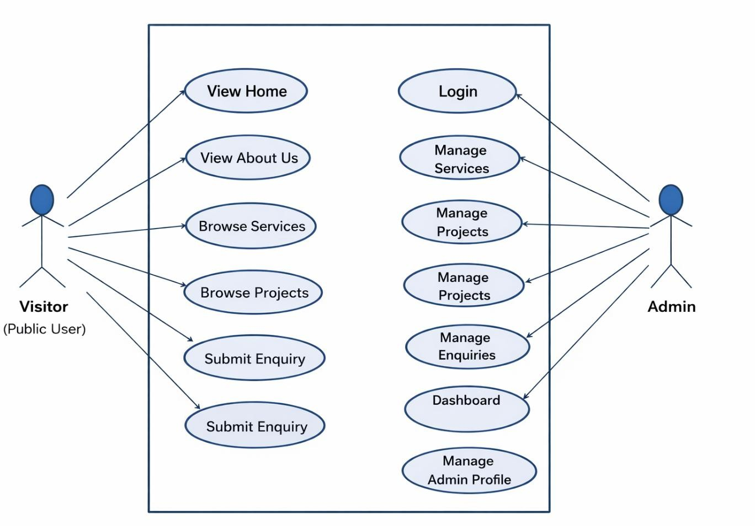

Fig 3.1 Use Case Diagram

CLASS DIAGRAM
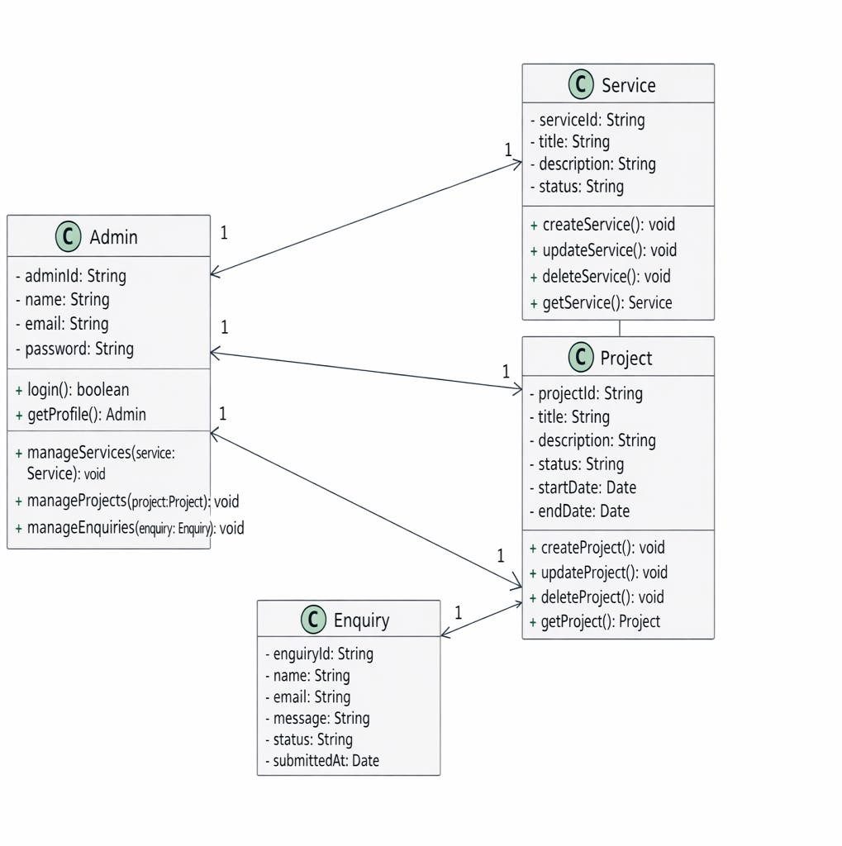
A class diagram is a static structure diagram in UML (Unified Modeling Language) that illustrates the structure of a system by showing the classes of the system, their attributes, methods, and relationships between them as shown in Figure 3.2. Classes represent the blueprint for objects, encapsulating data and behavior. Attributes are the data members of a class, while methods represent the operations that can be performed on the class's objects.

Fig 3.2 Class Diagram

10

SEQUENCE DIAGRAM

A sequence diagram is a form of interaction diagram which shows objects as lifelines running down the page, with their interactions over time represented as messages drawn as arrows from the source lifeline to the target lifeline. Sequence diagrams are good at showing which objects communicate with which other objects and what messages trigger those communications as shown below in Figure 3.3. Sequence diagrams are not intended for showing complex procedural logic.
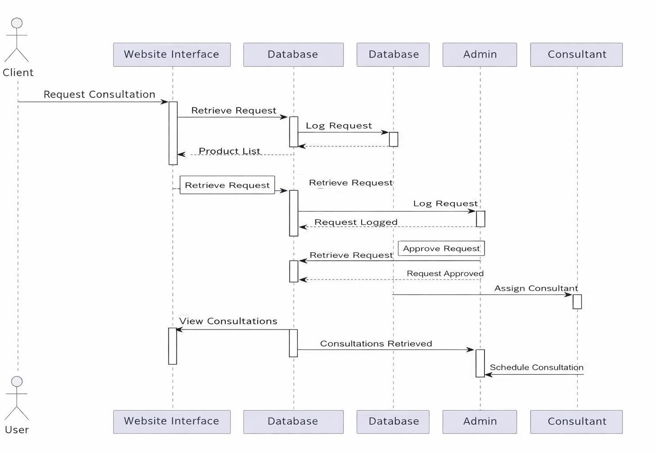

11

3.4. ACTIVITY DIAGRAM

In UML, the activity diagram is used to demonstrate the flow of control within the system rather than the implementation. It models the concurrent and sequential activities. The activity diagram helps in envisioning the workflow from one activity to another. It put emphasis on the condition of flow and the order in which it occurs. The flow can be sequential, branched or concurrent and to deal with such kinds of flows, the activity diagram has come up with a fork, join, etc. as shown in the Figure 3.4 below.
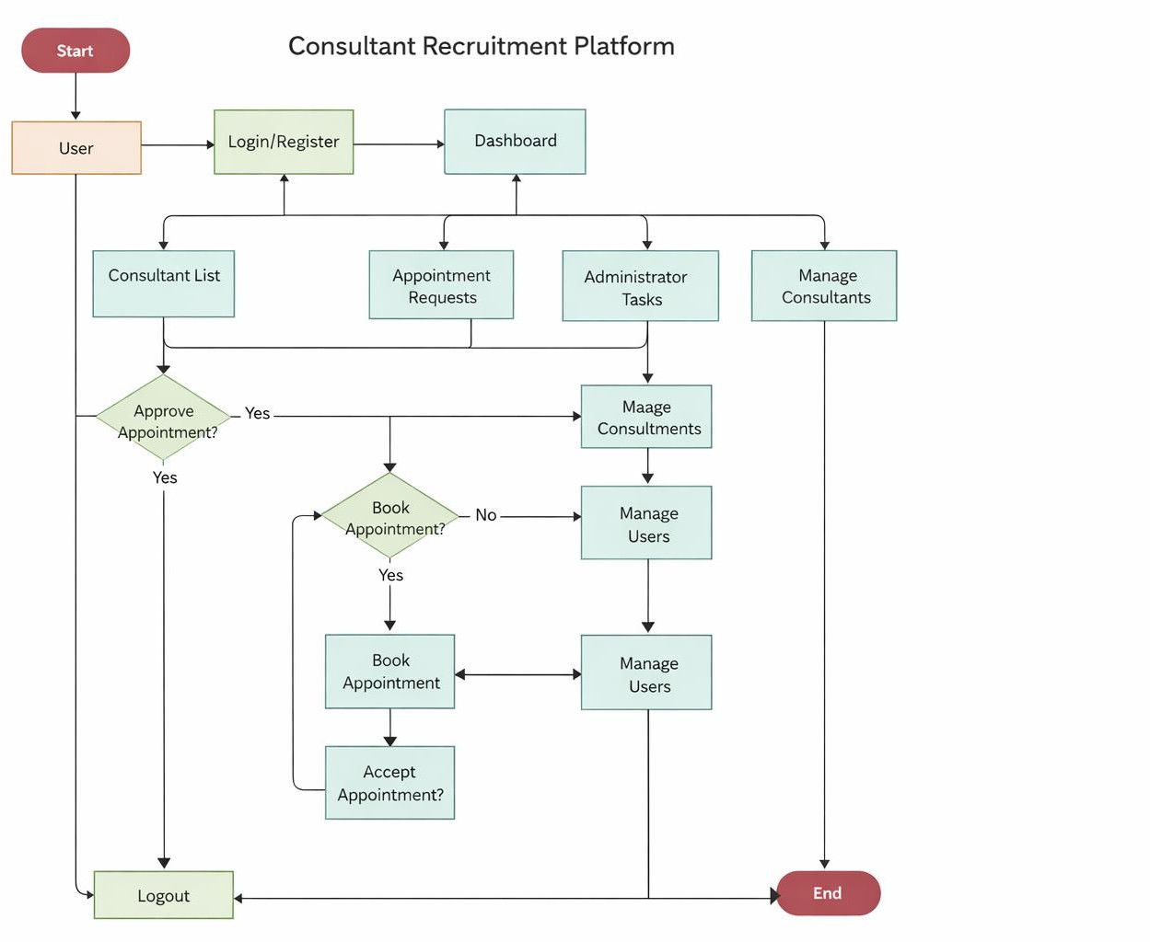

DATABASE DESIGN

User Schema:
const mongoose = require("mongoose");
const UserSchema = new mongoose.Schema({ name: String,
email: String, phone: String, password: String, role: {
type: String,
enum: ["user", "admin"], default: "user"
},
createdAt: { type: Date,
default: Date.now
}
});

Service Schema:
const ServiceSchema = new mongoose.Schema({ serviceName: String,
description: String, category: String, price: Number, createdAt: {
type: Date, default: Date.now
}
});

Project Schema:
const ProjectSchema = new mongoose.Schema({ projectTitle: String,
description: String, location: String, clientName: String, completionDate: Date, projectImage: String, category: String, createdAt: {
type: Date, default: Date.now
}
});
12

Request Schema:

const ConsultationSchema = new mongoose.Schema({ userId: {
type: mongoose.Schema.Types.ObjectId, ref: "User"
},
serviceId: {
type: mongoose.Schema.Types.ObjectId, ref: "Service"
},
message: String, status: {
type: String, default: "Pending"
},
createdAt: { type: Date,
default: Date.now
}
});

const Consultation = mongoose.model("Consultation", ConsultationSchema);

MODULES DESCRIPTION

User Authentication Module
This module manages the authentication process for administrators in the Nivas Constructions consultancy web application. While the website can be viewed by all visitors without registration, the authentication system ensures that only authorized administrators can access the administrative dashboard. Admin users can log in using secure credentials such as email and password, which are safely stored in the database.The module includes validation mechanisms to verify login details and prevent unauthorized access to administrative features. Once authenticated, the administrator can manage consultancy services, view client inquiries, and maintain website content. Secure password handling techniques are used to protect sensitive information. This module ensures that only authorized personnel can control and manage the system’s backend operations.

3.6.1 Service Management Module
This module allows administrators to manage the consultancy services offered by Nivas Constructions. Admins can add, update, or delete services through the admin dashboard. Each service includes details such as service name, description, category, and related information.The module ensures that any updates made by the administrator are instantly reflected on the website. Backend APIs built using Node.js and Express.js handle the CRUD (Create, Read, Update, Delete) operations, while MongoDB is used to store and manage the service data efficiently.

Project Management Module
This module is responsible for managing the construction projects completed by Nivas Constructions. Administrators can add, update, or delete project details through the admin dashboard. Each project includes information such as project title, description, location, completion details, and project images to showcase the company’s work.The module allows visitors to view the completed projects on the website, helping them understand the company’s expertise and previous work. All project data is stored in

MongoDB, and backend APIs developed using Node.js and Express.js handle the CRUD (Create, Read, Update, Delete) operations to ensure efficient project management and real- time updates on the website.

Admin Dashboard Module

This module provides an administrative dashboard for managing the Nivas Constructions consultancy web application. The dashboard allows administrators to monitor and control important activities of the system from a single interface. Through the dashboard, admins can view client inquiries, manage consultancy services, and update project details efficiently.The module presents important information in an organized way, helping administrators track user interactions and maintain the platform smoothly. It also allows quick access to different management features such as adding or editing services and viewing consultation requests, ensuring efficient system administration.

User Dashboard Module
This module provides a personalized dashboard for users after they access the consultancy platform of Nivas Constructions. The dashboard allows users to view available consultancy services, submit consultation requests, and track the status of their inquiries in an organized interface.It also enables users to manage their basic profile details and review their previously submitted requests. The dashboard presents relevant information clearly, helping users interact with the platform easily and stay updated on their consultation activities.

Email Module
This module is responsible for handling email communication between users and Nivas Constructions through the consultancy web application. When users submit inquiries or contact requests through the website, the system sends the details to the company via email. This ensures that administrators are notified about new client requests promptly. The email module helps streamline communication by allowing the company to receive and respond to client inquiries efficiently.

CHAPTER 4 TESTING

SYSTEM TESTING
System testing is a comprehensive evaluation conducted to ensure that the complete and integrated system meets the defined requirements. In the Nivas Constructions consultancy web application, system testing covered core functionalities such as browsing consultancy services, viewing project details, submitting inquiries through contact forms, and accessing the admin dashboard for service and project management. Each module was tested under different conditions to ensure that all components work together smoothly.Special attention was given to the overall user experience, ensuring that visitors can easily navigate the website, view consultancy services, and submit requests without any issues. The testing also verified UI responsiveness, backend communication using Node.js and Express.js, and proper data storage and retrieval from MongoDB. The main objective of system testing was to ensure that the platform operates reliably and provides a smooth, user-friendly experience for both visitors and administrators of Nivas Constructions.

UNIT TESTING
Unit testing is the first level of testing and focuses on testing individual components or functions independently. In the Nivas Constructions consultancy web application, unit testing was performed on both frontend and backend components to ensure that each part of the system works correctly.On the frontend, React components such as service display sections, contact forms, navigation elements, and input fields were tested to verify that they render properly and respond correctly to user interactions. Form validations and user input handling were also checked to ensure accurate data submission. On the backend, Node.js functions responsible for handling inquiries, managing consultancy services, and performing database operations with MongoDB were tested. These tests helped identify errors early in development, improving code reliability and making debugging easier.

MODULE TESTING
Module testing was conducted to evaluate the performance and correctness of different functional modules within the Nivas Constructions consultancy web application. Each module was treated as an independent unit and tested to ensure that its internal functions operate correctly and consistently.For example, the User Module was tested for user login and authentication, the Service Module was evaluated for adding, updating, and displaying consultancy services, and the Project Module was tested for managing project details. The Contact/Inquiry Module was also tested to ensure that user inquiries are properly submitted and stored in the database. By testing each module individually, the system ensured that data processing, control flow, and module functionality worked correctly before integrating them with other parts of the application.

INTEGRATION TESTING
Integration testing was carried out to verify the interaction between different modules of the Nivas Constructions consultancy web application. It ensured that modules such as user authentication, service browsing, project display, contact inquiries, and the admin dashboard work together correctly when integrated. For example, when a user submits an inquiry through the contact form, the data should be properly sent to the backend and stored in the MongoDB database.API requests made from the React frontend to the Node.js and Express.js backend were tested to confirm correct data exchange and proper error handling. The connection between the application and the MongoDB database was also tested to ensure reliable data storage and retrieval. This testing helped ensure smooth communication between modules and provided a seamless experience for both users and administrators.

VALIDATION TESTING

Validation testing was performed to ensure that the Nivas Constructions consultancy web application meets all the defined functional and non-functional requirements. The application was evaluated based on its primary objectives, such as easy browsing of consultancy services, viewing project details, submitting inquiries through contact forms, and efficient management through the admin dashboard.Form input
17

18

validations were implemented to ensure that users provide correct information when submitting inquiries or contact requests. Different scenarios such as incomplete form submissions, invalid input data, and server response handling were tested to ensure the system responds appropriately. The application was also tested for responsiveness across different screen sizes to ensure a smooth user experience. This testing phase confirmed that the system functions properly under realistic conditions and meets both technical requirements and user expectations, ensuring a reliable and user-friendly platform for Nivas Constructions.

19

CHAPTER 5 RESULTS AND DISCUSSION
The consultancy web application developed for Nivas Constructions provides a modern digital platform that enhances the way the company presents its consultancy services and construction projects to potential clients. The system enables visitors to easily browse available services, view completed projects, and submit inquiries through a simple and user-friendly interface. By moving these processes to an online platform, the application reduces traditional communication barriers and allows clients to connect with the company more conveniently. The application is built using modern web technologies including React for the frontend, Node.js and Express.js for the backend, and MongoDB for database management. These technologies work together to ensure efficient data handling, smooth communication between the frontend and backend, and reliable storage of information such as services, project details, and user inquiries. The platform also includes an admin dashboard that allows administrators to manage services, update project information, and monitor client inquiries effectively, improving overall operational efficiency.Extensive testing was conducted to ensure that the system performs reliably under different conditions. The website was tested for functionality, responsiveness, and data accuracy to ensure that users can easily navigate the platform and access information without errors. The system provides quick response times, proper validation of user inputs, and seamless interaction between different modules. Overall, this project demonstrates how digital technology can modernize traditional consultancy services and improve business operations. The consultancy platform strengthens the online presence of Nivas Constructions, enhances communication with clients, and provides a scalable system that can support future improvements such as online appointment scheduling, advanced service management, and enhanced customer interaction features.


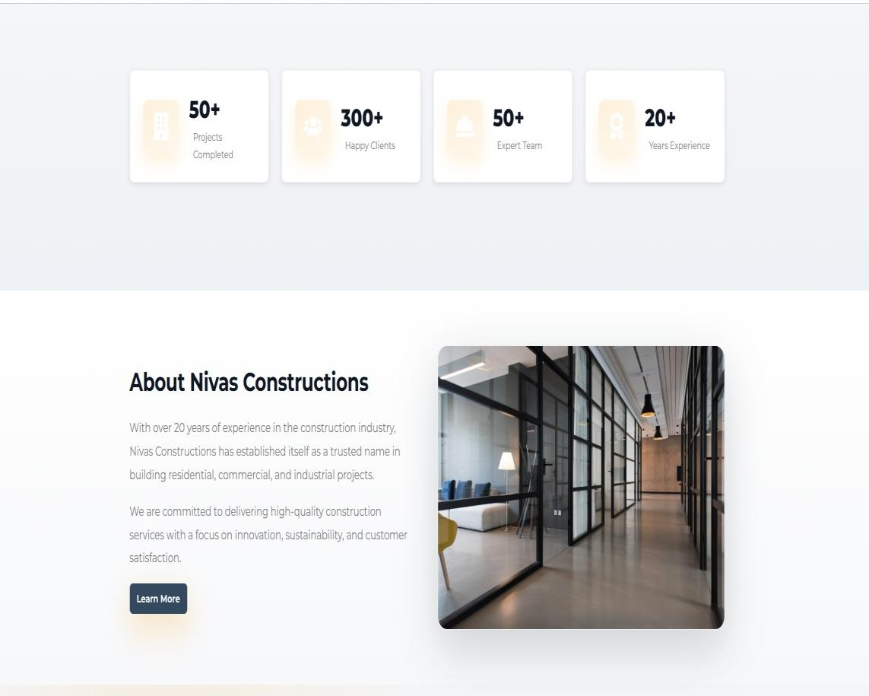

Figure 5.1 LANDING PAGE
The landing page is the main entry point of the website where users can view an overview of
Nivas Constructions, explore consultancy services, and navigate to other sections.

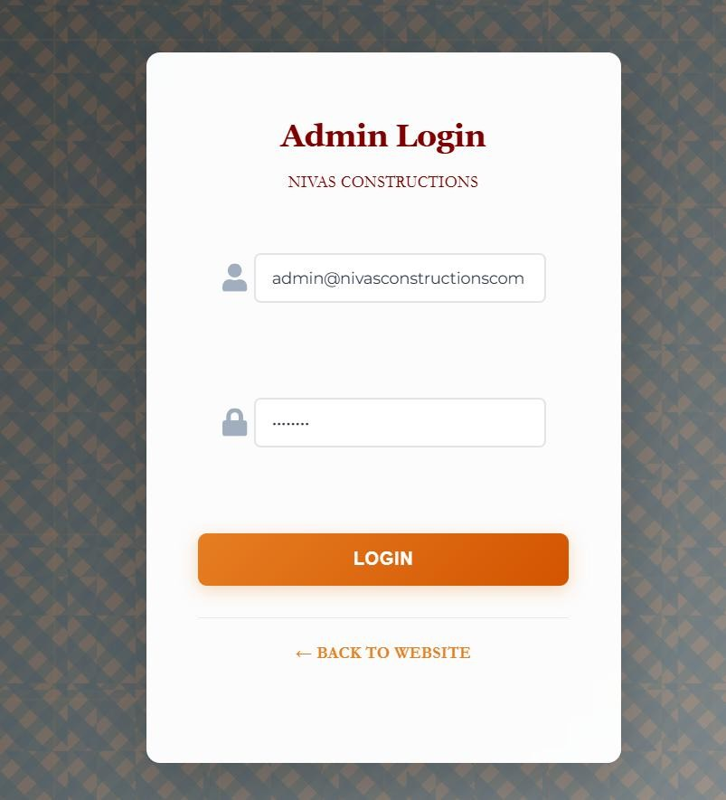

Figure 5.2 ADMIN LOGIN PAGE
The Admin Login Page allows authorized administrators to securely log in to the system and access the dashboard to manage services, projects, and client inquiries.
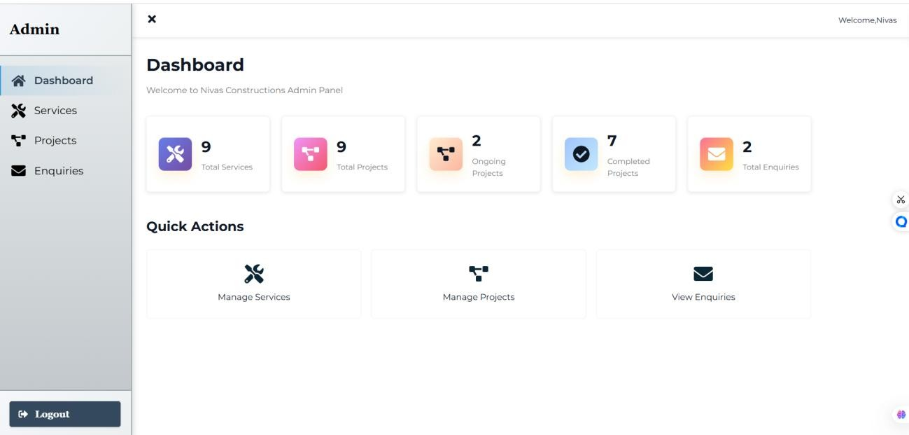

Figure 5.3 ADMIN DASHBOARD
The Admin Dashboard provides administrators with a centralized interface to manage consultancy services, update project details, and monitor client inquiries efficiently.

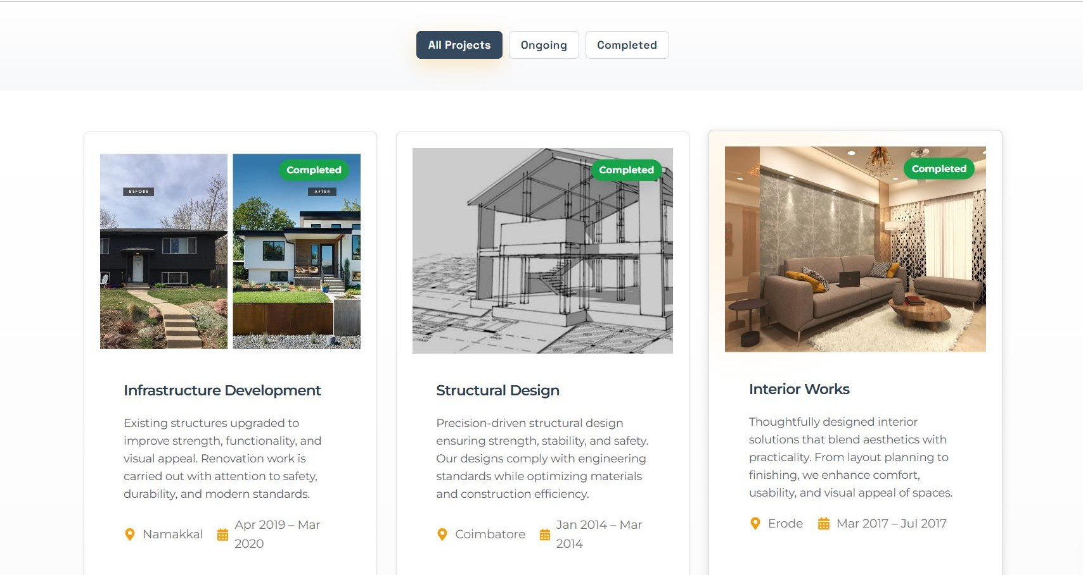
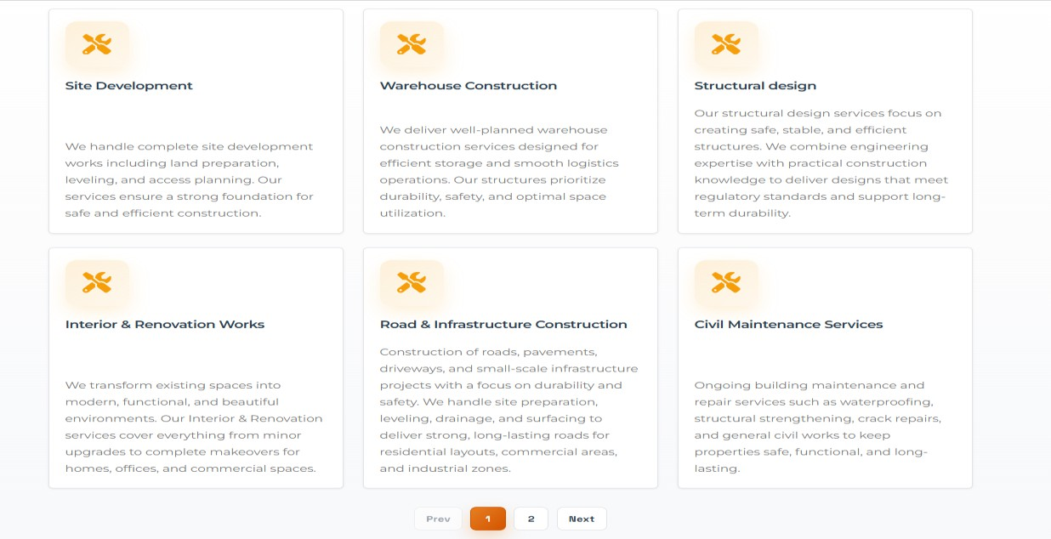

Figure 5.4 PROJECTS & SERVICE PAGE
The Projects & Service Page displays the projects completed , ongoing and services offered by Nivas constructions.
22

CHAPTER 6 CONCLUSION AND FUTURE WORK
The consultancy web application developed for Nivas Constructions successfully
fulfills its objective of providing a modern digital platform to present the company’s consultancy services and construction projects. By using technologies such as React for the frontend, Node.js and Express.js for backend development, and MongoDB for database management, the system delivers reliable performance and efficient data handling. The website allows visitors to easily explore consultancy services, view completed projects, and submit inquiries, while the admin dashboard enables administrators to manage services, update project details, and monitor client inquiries effectively.

The implementation of this system improves the company’s online presence and simplifies communication between the organization and potential clients. It reduces manual efforts in managing inquiries and service information while providing a structured and user- friendly interface for visitors. The platform bridges the gap between traditional consultancy practices and modern digital solutions, helping Nivas Constructions reach a wider audience and improve client engagement.

Looking ahead, several enhancements can further improve the system. Future developments may include online appointment scheduling for consultancy services, integration of secure payment options for paid consultations, real-time chat support for instant communication, and advanced analytics for monitoring client interactions. Additional features such as multi-language support, improved project showcase with detailed galleries, and mobile responsiveness enhancements can also be implemented to increase accessibility and user experience. These future improvements will help strengthen the platform’s capabilities and support the long-term digital growth of Nivas Constructions.
.
23

APPENDIX 1 CODING

App.js :
import React from 'react';
import { BrowserRouter as Router, Routes, Route, Navigate } from 'react-router-dom'; import ProtectedRoute from './utils/ProtectedRoute';
import './styles/App.css';
// Public Pages
import Home from './pages/public/Home'; import About from './pages/public/About'; import Services from './pages/public/Services'; import Projects from './pages/public/Projects'; import Contact from './pages/public/Contact';
// Admin Pages
import AdminLogin from './pages/admin/AdminLogin'; import Dashboard from './pages/admin/Dashboard';
import AdminServices from './pages/admin/AdminServices'; import AdminProjects from './pages/admin/AdminProjects'; import AdminEnquiries from './pages/admin/AdminEnquiries'; function App() {
return (
<Router>
<Routes>
{/* Public Routes */}
<Route path="/" element={<Home />} />
<Route path="/about" element={<About />} />
<Route path="/services" element={<Services />} />
<Route path="/projects" element={<Projects />} />
<Route path="/contact" element={<Contact />} />
{/* Admin Routes */}
<Route path="/admin/login" element={<AdminLogin />} />
<Route
24

path="/admin/dashboard" element={
<ProtectedRoute>
<Dashboard />
</ProtectedRoute>
}
/>
<Route path="/admin/services" element={
<ProtectedRoute>
<AdminServices />
</ProtectedRoute>
}
/>
<Route path="/admin/projects" element={
<ProtectedRoute>
<AdminProjects />
</ProtectedRoute>
}
/>
<Route path="/admin/enquiries" element={
<ProtectedRoute>
<AdminEnquiries />
</ProtectedRoute>
}
/>
{/* Redirect /admin to /admin/dashboard */}
<Route path="/admin" element={<Navigate to="/admin/dashboard" replace />} />
{/* 404 Route */}
25

<Route path="*" element={<Navigate to="/" replace />} />
</Routes>
</Router>
);
}
export default App;

server.js:
require('dotenv').config();
const express = require('express'); const cors = require('cors');
const connectDB = require('./config/db');
// Import routes
const authRoutes = require('./routes/authRoutes'); const serviceRoutes = require('./routes/serviceRoutes'); const projectRoutes = require('./routes/projectRoutes');
const enquiryRoutes = require('./routes/enquiryRoutes');

// Initialize express app const app = express();

// Connect to MongoDB connectDB();

// CORS Configuration
const allowedOrigins = process.env.NODE_ENV === 'production'
? [process.env.FRONTEND_URL || 'https://nivas-constructions.vercel.app']
: ['http://localhost:3000', 'http://localhost:5000'];

const corsOptions = { origin: allowedOrigins, credentials: true,
methods: ['GET', 'POST', 'PUT', 'DELETE', 'OPTIONS'],
allowedHeaders: ['Content-Type', 'Authorization']
};

// Middleware app.use(cors(corsOptions)); app.use(express.json({ limit: '50mb' }));
app.use(express.urlencoded({ limit: '50mb', extended: true }));

// Routes
26

app.use('/api/auth', authRoutes); app.use('/api/services', serviceRoutes); app.use('/api/projects', projectRoutes); app.use('/api/enquiries', enquiryRoutes);

// Health check route app.get('/', (req, res) => { res.json({
message: 'Nivas Constructions API', status: 'Active',
version: '1.0.0'
});
});
// Error handling middleware app.use((err, req, res, next) => { console.error(err.stack); res.status(500).json({
success: false,
message: 'Something went wrong!',
error: process.env.NODE_ENV === 'development' ? err.message : undefined
});
});

// 404 handler app.use((req, res) => { res.status(404).json({
success: false,
message: 'Route not found'
});
});

// Start server
const PORT = process.env.PORT || 5000; app.listen(PORT, () => {
console.log(`Server running in ${process.env.NODE_ENV || 'development'} mode on port
${PORT}`);
});

ApiServices.js :
import api from './api';

// Auth Services

export const authService = {

login: async (credentials) => {

const response = await api.post('/auth/login', credentials); if (response.data.token) {
localStorage.setItem('token', response.data.token); localStorage.setItem('admin', JSON.stringify(response.data.admin));
}

return response.data;

},

logout: () => { localStorage.removeItem('token'); localStorage.removeItem('admin');
},

getProfile: async () => {

const response = await api.get('/auth/profile'); return response.data;
},

isAuthenticated: () => {

return !!localStorage.getItem('token');

},

getAdmin: () => {

const admin = localStorage.getItem('admin'); return admin ? JSON.parse(admin) : null;
}

};

// Service Services

export const serviceService = {

getAll: async () => {

const response = await api.get('/services?limit=1000'); return response.data;
},

getAllAdmin: async () => {

const response = await api.get('/services/admin/all?limit=1000'); return response.data;
},

getById: async (id) => {

const response = await api.get(`/services/${id}`); return response.data;
},

create: async (data) => {

const response = await api.post('/services', data); return response.data;
},

update: async (id, data) => {

const response = await api.put(`/services/${id}`, data); return response.data;
},

delete: async (id) => {

const response = await api.delete(`/services/${id}`); return response.data;
}

};

// Project Services

export const projectService = { getAll: async (status) => {
const params = status ? `?status=${status}&limit=1000` : '?limit=1000'; const response = await api.get(`/projects${params}`);
return response.data;

},

getAllAdmin: async () => {

const response = await api.get('/projects/admin/all?limit=1000'); return response.data;
},

getById: async (id) => {

const response = await api.get(`/projects/${id}`); return response.data;
},

create: async (data) => {

const response = await api.post('/projects', data); return response.data;
},

update: async (id, data) => {

const response = await api.put(`/projects/${id}`, data); return response.data;
},

delete: async (id) => {

const response = await api.delete(`/projects/${id}`); return response.data;
}
30

};

// Enquiry Services

export const enquiryService = { getAll: async (status) => {
const params = status ? `?status=${status}` : '';

const response = await api.get(`/enquiries${params}`); return response.data;
},

getById: async (id) => {

const response = await api.get(`/enquiries/${id}`); return response.data;
},

create: async (data) => {

const response = await api.post('/enquiries', data); return response.data;
},

update: async (id, data) => {

const response = await api.put(`/enquiries/${id}`, data); return response.data;
},

delete: async (id) => {

const response = await api.delete(`/enquiries/${id}`); return response.data;
},

sendReply: async (id, reply) => {

const response = await api.post(`/enquiries/${id}/reply`, { reply });
31

return response.data;

},

getStats: async () => {

const response = await api.get('/enquiries/stats'); return response.data;
}};

Home.js :
import React from 'react';

import Layout from '../../components/public/Layout'; import { Link } from 'react-router-dom';
import { FaHardHat, FaBuilding, FaUsers, FaAward } from 'react-icons/fa'; import '../../styles/Home.css';
const Home = () => { return (
<Layout>

<div className="home">

{/* Hero Section */}

<section className="hero parallax-hero" style={{backgroundImage:
`url('https://www.constructionworld.in/assets/uploads/13a98c40261296c534a4868124aecf91.jpg')`}}>

<div className="hero-overlay">

<div className="container">

<div className="hero-grid">

<div className="hero-left reveal slide-up" style={{animationDelay: '120ms'}}>

<div className="glass-panel">

<h1><b>Building Your Dreams Into Reality</b></h1>

<p className="lead"><b>Design · Build · Deliver — Professional construction services with a focus
32

on quality, safety and timely delivery.</b></p>

{/* <div className="hero-buttons">

<Link to="/projects" className="btn btn-primary">View Projects</Link>

<Link to="/contact" className="btn btn-secondary">Request Quote</Link>

</div> */}

</div>

</div>

<div className="hero-right reveal zoom-in stagger-2">

<div className="hero-image">

<img alt="construction site"
src="https://www.constructionworld.in/assets/uploads/13a98c40261296c534a4868124aecf91.jpg"

/>

<div className="brand-badge">

<h3>Nivas Constructions</h3>

<p><b>Quality • Safety • Trust</b></p>

</div>

</div>

</div>

</div>

</div>

</div>

</section>

<div className="hero-wave">

<svg viewBox="0 0 1440 64" preserveAspectRatio="none" xmlns="http://www.w3.org/2000/svg"><path
d="M0 32c120 0 240-24 360-24s240 24 360 24 240-24 360-24 240 24 360 24v32H0z" fill="var(--
white)"/></svg>
33

</div>

{/* Stats Section */}

<section className="stats-section">

<div className="container">

<div className="stats-grid">

<div className="stat-card reveal slide-up stagger-1">

<div className="stat-icon"><FaBuilding /></div>

<div>

<div className="stat-number">50+</div>

<div className="stat-meta">Projects Completed</div>

</div>

</div>

<div className="stat-card reveal slide-up stagger-2">

<div className="stat-icon"><FaUsers /></div>

<div>

<div className="stat-number">300+</div>

<div className="stat-meta">Happy Clients</div>

</div>

</div>

<div className="stat-card reveal slide-up stagger-3">

<div className="stat-icon"><FaHardHat /></div>

<div>

<div className="stat-number">50+</div>

<div className="stat-meta">Expert Team</div>

</div>

</div>
34

<div className="stat-card reveal slide-up stagger-4">

<div className="stat-icon"><FaAward /></div>

<div>

<div className="stat-number">20+</div>

<div className="stat-meta">Years Experience</div>

</div>

</div>

</div>

</div>

</section>

{/* About Preview */}

<section className="about-preview">

<div className="container">

<div className="about-preview-content">

<div className="about-text">

<h2>About Nivas Constructions</h2>

<p>

With over 20 years of experience in the construction industry, Nivas Constructions has established itself as a trusted name in building residential, commercial, and industrial projects.
</p>

<p>

We are committed to delivering high-quality construction services with a focus on innovation, sustainability, and customer satisfaction.
</p>

<Link to="/about" className="btn btn-primary">Learn More</Link>

</div>

<div className="about-image reveal zoom-in stagger-2">

<img alt="project preview" src="https://images.unsplash.com/photo-1497366754035- f200968a6e72?ixlib=rb-4.0.3&auto=format&fit=crop&w=1200&q=80" />

</div>

</div>

</div>

</section>

{/* Why Choose Us */}

<section className="why-choose">

<div className="container">

<h2>Why Choose Us</h2>

<div className="features-grid">

<div className="feature-card">

<h3>Quality Assurance</h3>

<p>We maintain the highest standards of quality in every project we undertake.</p>

</div>

<div className="feature-card">

<h3>Timely Delivery</h3>

<p>We respect deadlines and ensure projects are completed on time.</p>

</div>

<div className="feature-card">

<h3>Expert Team</h3>

<p>Our experienced professionals bring expertise to every project.</p>

</div>

<div className="feature-card">

<h3>Competitive Pricing</h3>

<p>Quality construction services at affordable and transparent prices.</p>

</div>

</div>

</div>

</section>

{/* Featured Projects */}

<section className="featured-projects">

<div className="container">

<h2>Featured Projects</h2>

<p className="sub">Selected projects showcasing our quality and attention to detail</p>

<div className="projects-grid">

<div className="project-card reveal slide-up stagger-1">

<div className="project-media"><img alt="project 1" src="https://images.unsplash.com/photo- 1504307651254-35680f356dfd?ixlib=rb-4.0.3&auto=format&fit=crop&w=1200&q=80"/></div>

<div className="project-body">

<h3>Road Construction</h3>

<p>Professional road infrastructure with superior materials and engineering.</p>

<Link to="/projects" className="btn btn-secondary">View Project</Link>

</div>

</div>

<div className="project-card reveal slide-up stagger-2">

<div className="project-media"><img alt="project 2" src="https://images.unsplash.com/photo- 1505693416388-ac5ce068fe85?ixlib=rb-4.0.3&auto=format&fit=crop&w=1200&q=80"/></div>

<div className="project-body">

<h3>Commercial Office Fitout</h3>

<p>Efficient layouts and durable materials tailored for businesses.</p>

<Link to="/projects" className="btn btn-secondary">View Project</Link>

</div>

</div>

<div className="project-card reveal slide-up stagger-3">

<div className="project-media"><img alt="project 3" src="https://images.unsplash.com/photo- 1531834685032-c34bf0d84c77?ixlib=rb-4.0.3&auto=format&fit=crop&w=1200&q=80"/></div>
<div className="project-body">

<h3>Industrial Warehouse</h3>

<p>Robust construction focused on efficiency and longevity.</p>

<Link to="/projects" className="btn btn-secondary">View Project</Link>

</div>

</div>

</div>

</div>

</section>

<section className="cta-section">

<div className="container">

<h2>Ready to Start Your Project?</h2>

<p>Contact us today for a free consultation and quote</p>

<Link to="/contact" className="btn btn-primary">Contact Us</Link>

</div>

</section>

</div>

</Layout>

);};

export default Home;
38

Auth.js
const jwt = require('jsonwebtoken');

const Admin = require('../models/Admin');

const authMiddleware = async (req, res, next) => { try {
// Get token from header

const token = req.header('Authorization')?.replace('Bearer ', ''); if (!token) {
return res.status(401).json({ success: false,
message: 'No authentication token, access denied'

});

}

// Verify token

const decoded = jwt.verify(token, process.env.JWT_SECRET);

// Find admin

const admin = await Admin.findById(decoded.id).select('-password'); if (!admin) {
return res.status(401).json({ success: false,
message: 'Admin not found, token invalid'

});

}

// Add admin to request object req.admin = admin;
next();

40

} catch (error) {

console.error('Auth middleware error:', error); res.status(401).json({
success: false,

message: 'Token is not valid'

});

}

};

module.exports = authMiddleware;

APPENDIX 2 SNAPSHOTS
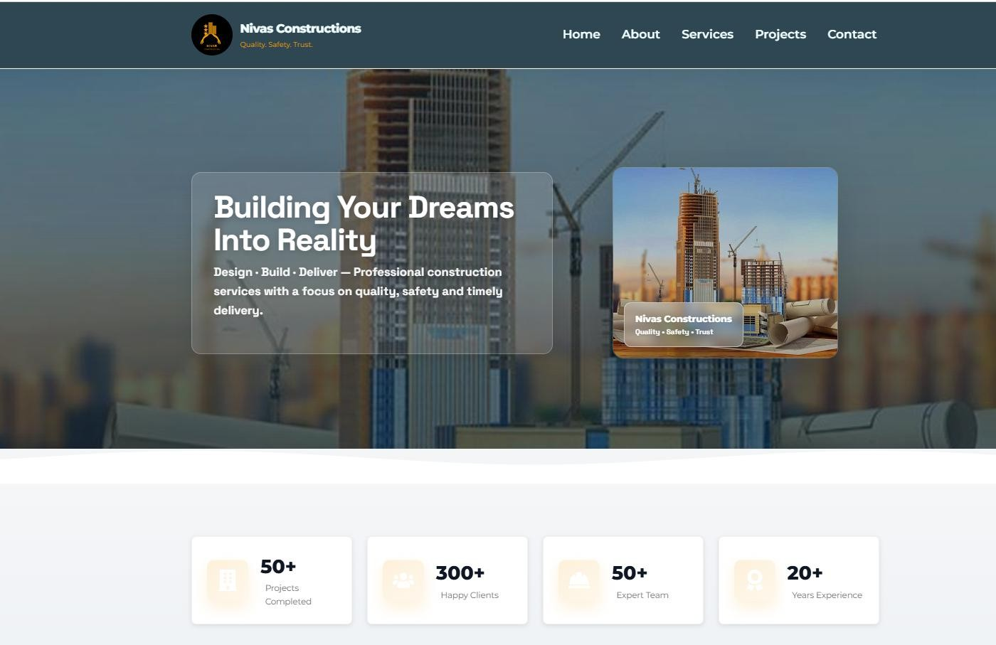
Fig. A2.1 Landing page
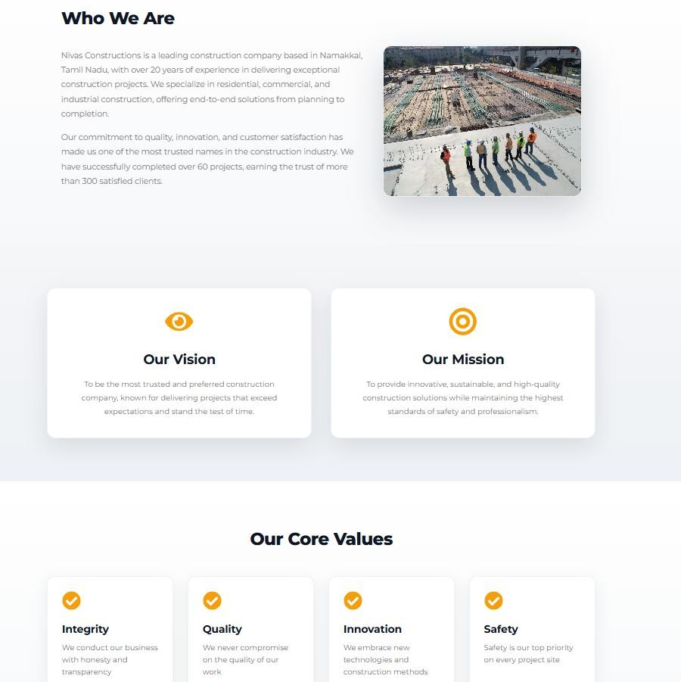

Fig. A2.2 About us Page

42

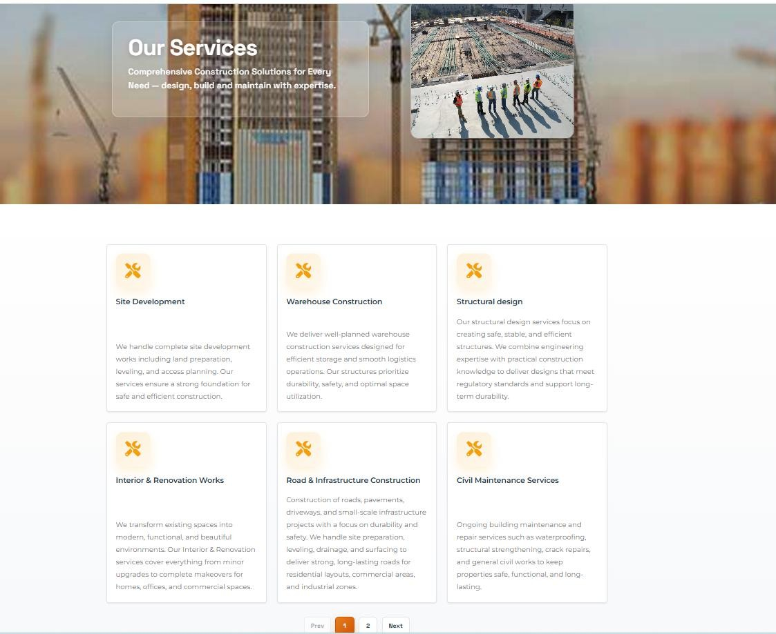
Fig. A2.3 Services Page

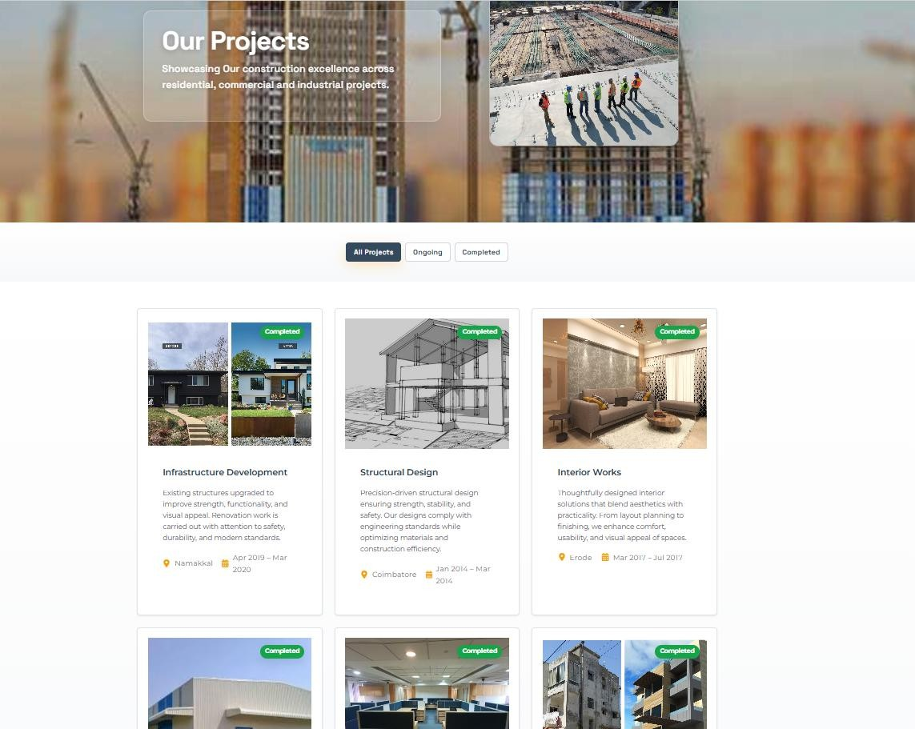

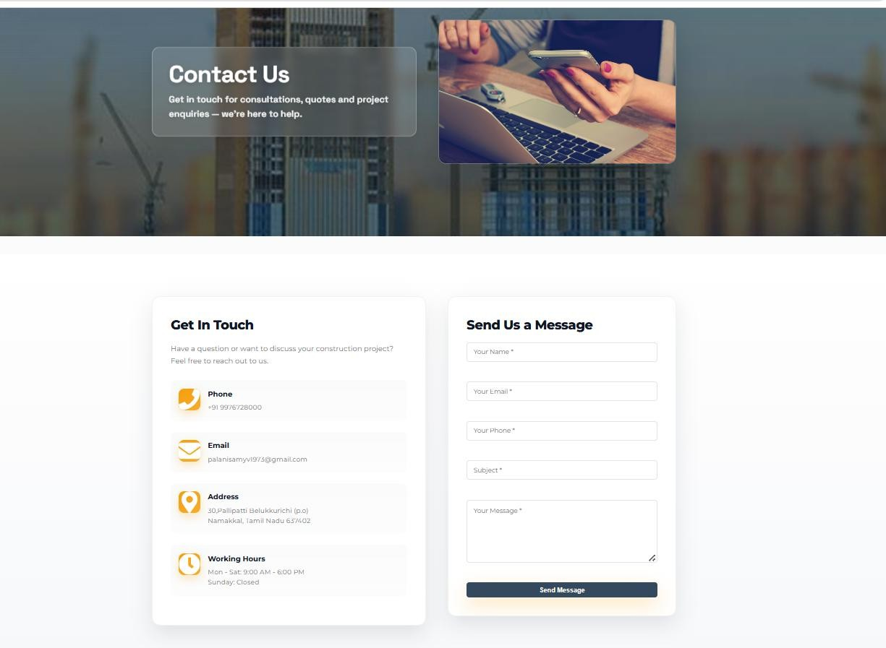

Fig. A2.5 Contact Us Page

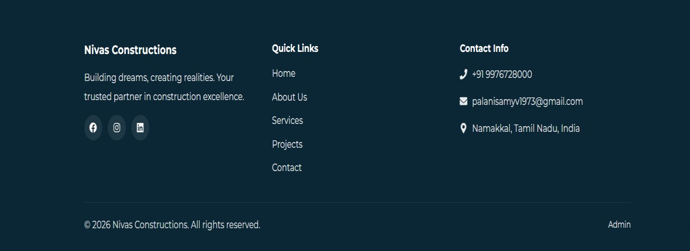

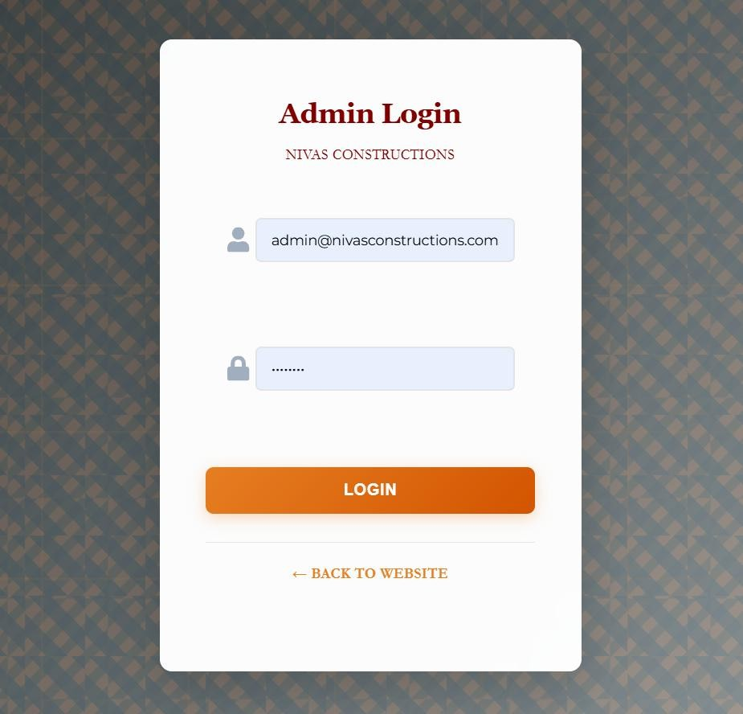
Fig. A2.7 Admin Login Page
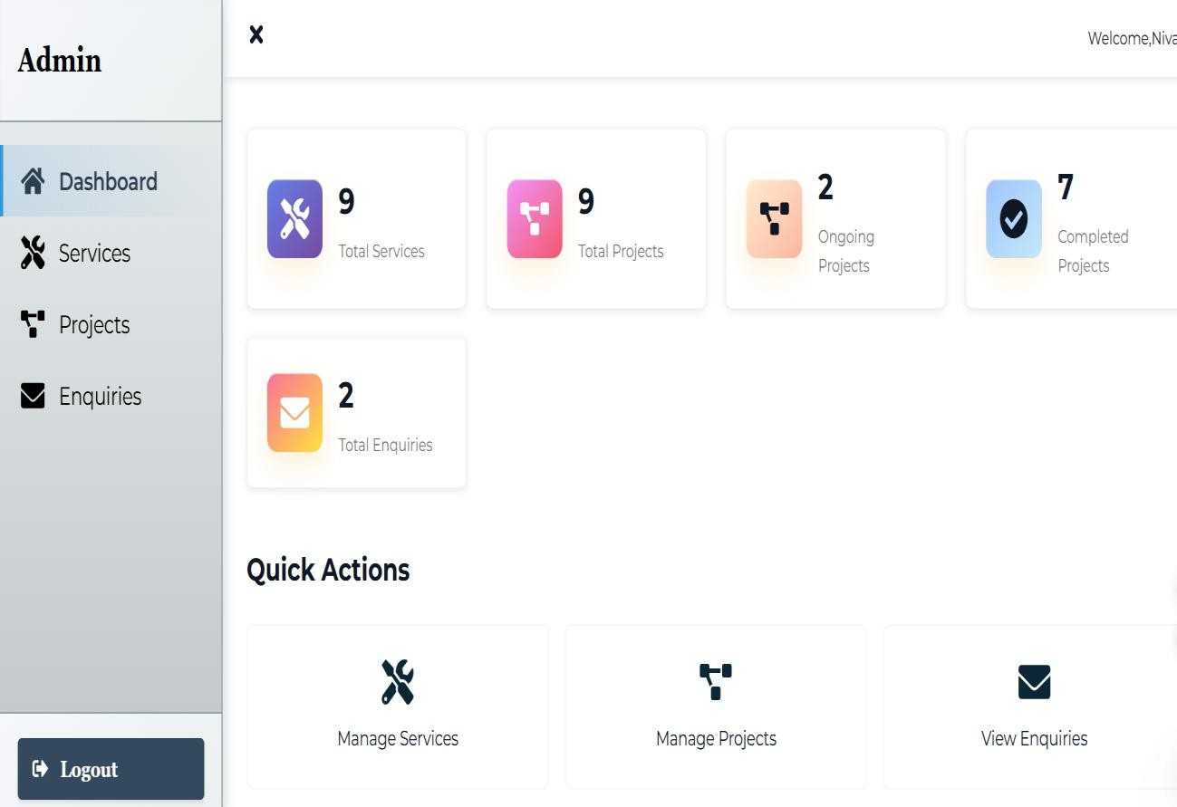

45

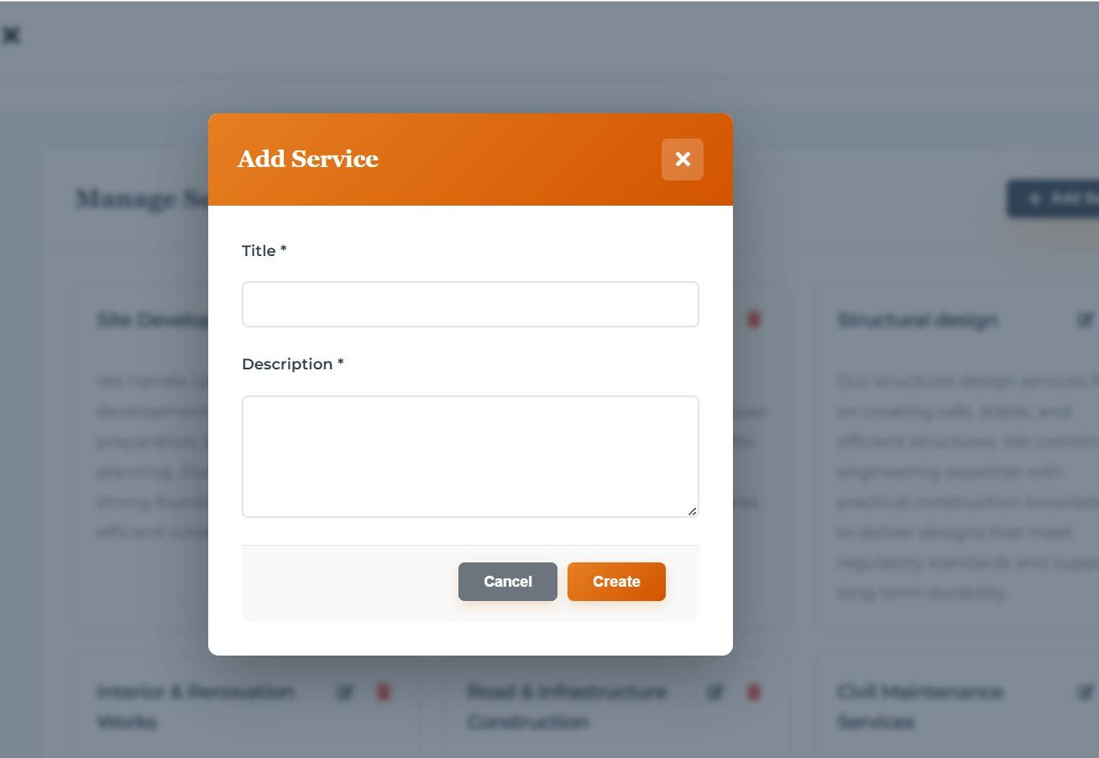

Fig. A2.9 Add Service Page
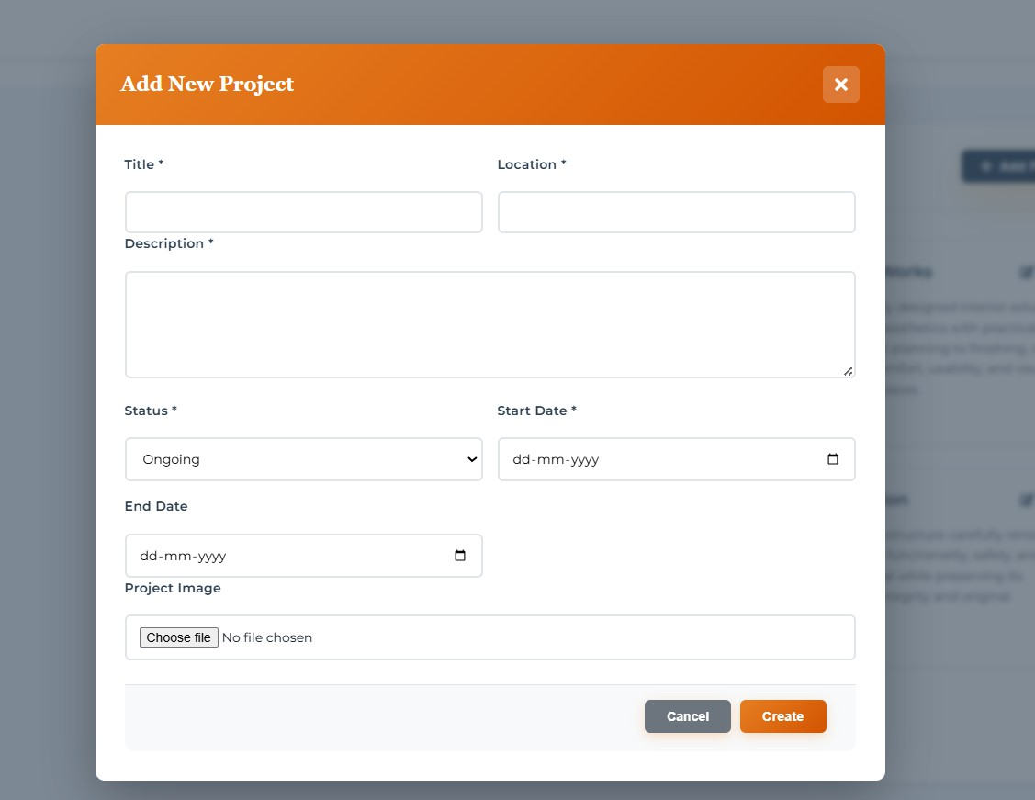

46

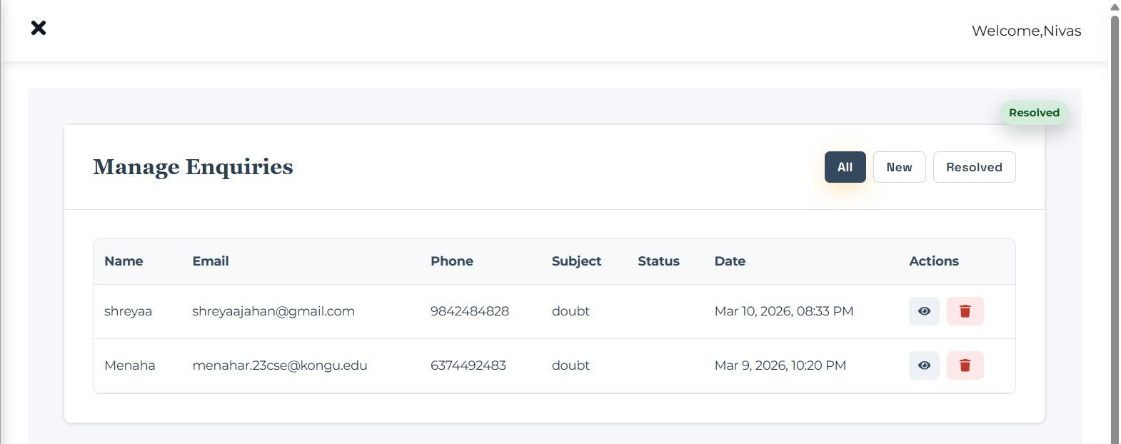

Fig. A2.11 Enquiries Page
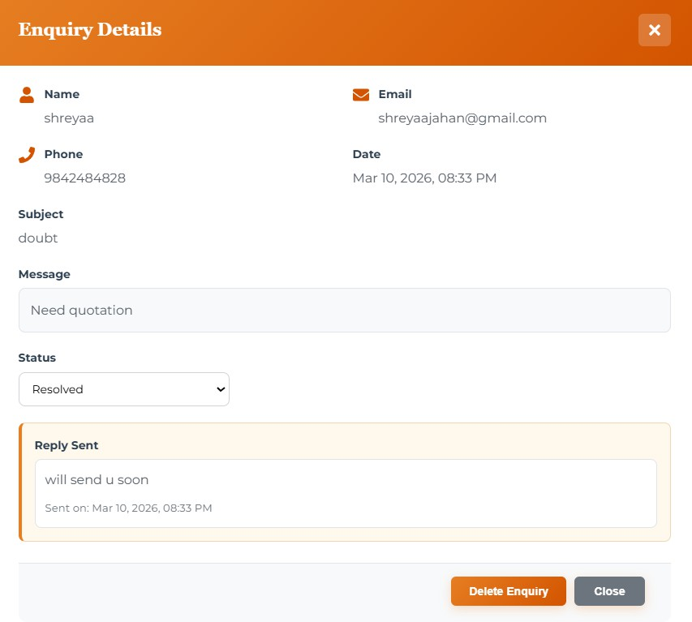

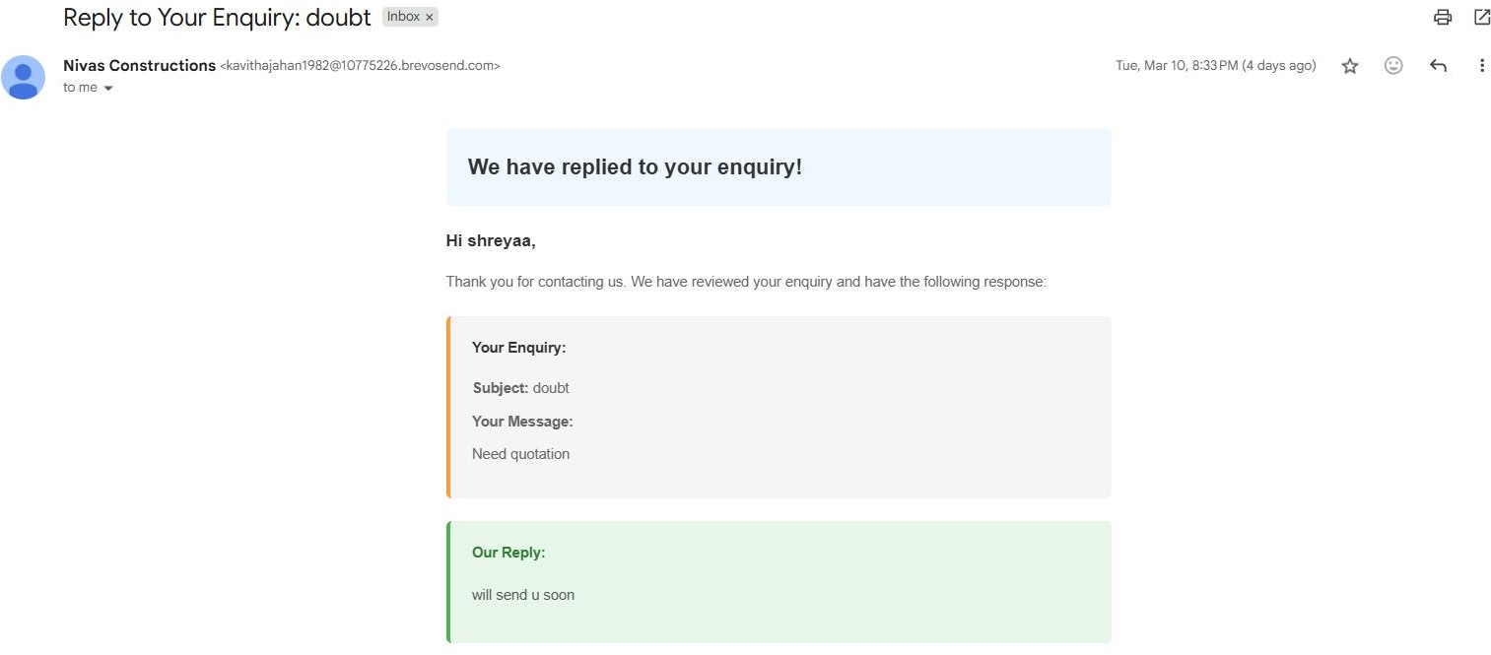

Fig. A2.13 Reply Mail
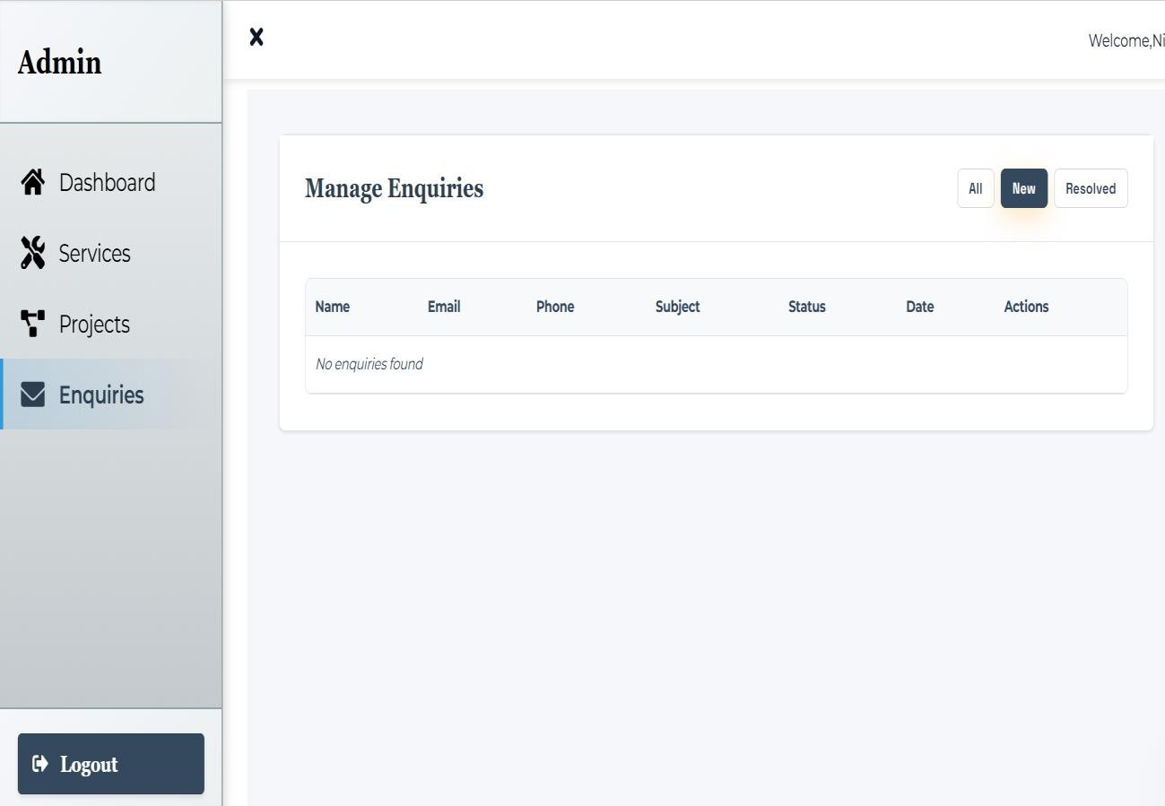

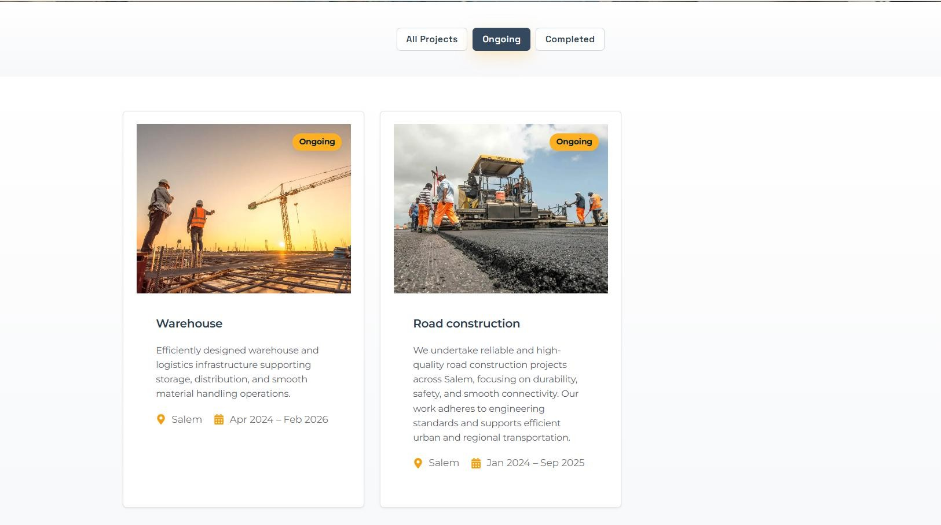

Fig. A2.15 Applying Filters to Projects Page
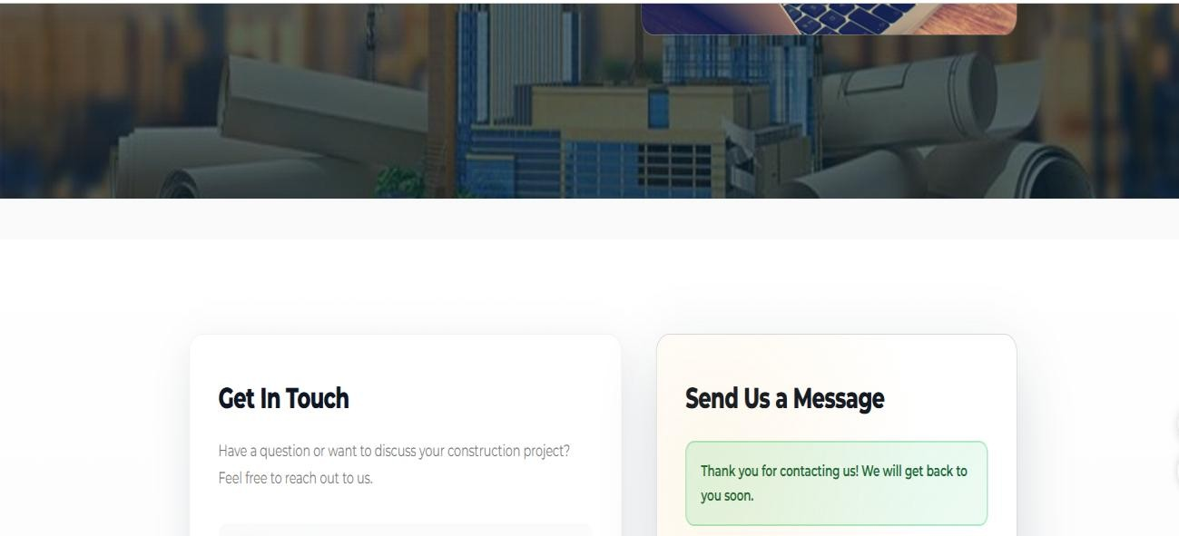

49

REFERENCES

- React Documentation -Meta (Facebook), https://reactnative.dev/docs/

- Node.js Documentation – OpenJS Foundation, https://nodejs.org/en/docs

- Express.js Guide – Express.js Official Site, https://expressjs.com/

- MongoDB Manual – MongoDB Inc., https://www.mongodb.com/docs/manual/

Github Link:

https://github.com/shreyaajahan/consultancy

https://github.com/roshantmr/consultancy

50

APPROVAL LETTER FROM THE COMPANY


51

COMPLETION LETTER FROM THE COMPANY


52

RECEIPT
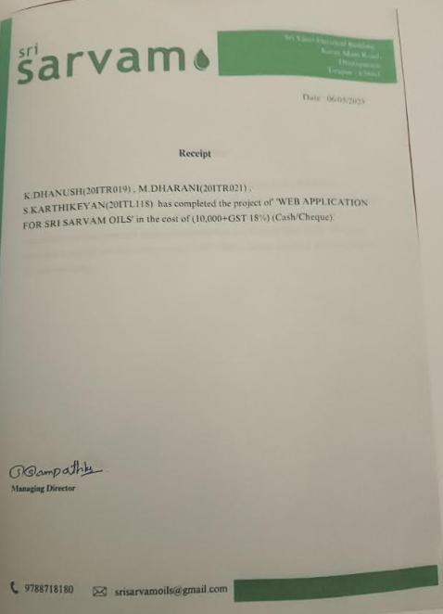

53

MAPPING OF SDG TO PROJECT WORK – I

Sustainable Development Goals (SDGs) are a set of global goals established by the United Nations to promote sustainable development and improve the quality of life for people around the world. They focus on important areas such as economic growth, environmental protection, innovation, education, and social equality. By integrating sustainable practices and technologies, different sectors—including digital platforms like e-commerce—can contribute to achieving these goals and creating a better and more sustainable future for society.

SDG 9 – Industry, Innovation and Infrastructure

This project aligns with Sustainable Development Goal 9 (Industry, Innovation, and Infrastructure) by introducing digital innovation into the traditional consultancy and construction services sector. The Nivas Constructions consultancy web application modernizes the way consultancy services are presented and accessed by providing an online platform where users can explore services, view completed projects, and submit inquiries easily. By transforming traditional consultation methods into a digital platform, the project promotes technological adoption and improves accessibility to professional services.
Additionally, the system strengthens business operations by providing an admin dashboard for managing consultancy services, project details, and client inquiries efficiently. These digital features help reduce manual communication processes, improve service management, and enhance client engagement. By integrating modern web technologies into the consultancy process, the project contributes to improving digital infrastructure and encourages innovation within the construction and consultancy industry, supporting the key objectives of Sustainable Development Goal 9.

