COMPILER DESIGN

COMPILER – ASSIGNMENT

# Team Members:

Anuj Arora – 2021HS70037

Abhishek Mondal – 2021HS70019

Koustabh Ghosh – 2021HS70001

Sheetal Raj – 2021HS70018

UML Diagram:

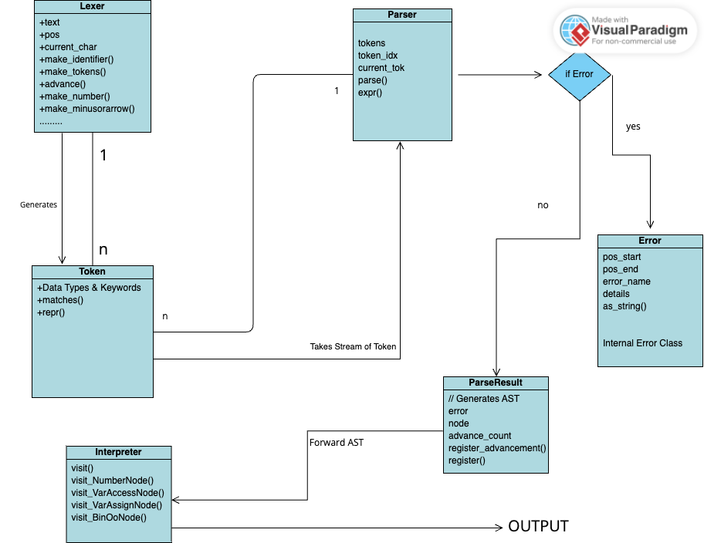

GRAMMAR:

Expr : KEYWORD:VAR IDENTIFIER EQ expr

: comp-expr ((KEYWORD:AND|KEYWORD:OR) comp-expr)*

comp-expr : NOT comp-expr

: arith-expr ((EE|LT|GT|LTE|GTE) arith-expr)*

arith-expr : term ((PLUS|MINUS) term)*

term : factor ((MUL|DIV) factor)*

factor : (PLUS|MINUS) factor

: power

power : call (POW factor)*

call : atom (LPAREN (expr (COMMA expr)*)? RPAREN)?

atom : INT|FLOAT|IDENTIFIER

: LPAREN expr RPAREN

: if-expr

: for-expr

: while-expr

: func-def

if-expr : KEYWORD:IF expr KEYWORD:THEN expr

(KEYWORD:ELIF expr KEYWORD:THEN expr)*

(KEYWORD:ELSE expr)?

for-expr : KEYWORD:FOR IDENTIFIER EQ expr KEYWORD:TO expr

(KEYWORD:STEP expr)? KEYWORD:THEN expr

while-expr : KEYWORD:WHILE expr KEYWORD:THEN expr

func-def : KEYWORD:FUN IDENTIFIER?

LPAREN (IDENTIFIER (COMMA IDENTIFIER)*)? RPAREN

ARROW expr