Created By:

Koustav Das (2015CSB1017)

Sachin Bijalwan (2015CSB1027)

Report

**Part 1**

We have used the inbuilt matlab Kmeans clustering algorithm. It is used as follows

idx=kmeans(X,c)

where X is the dataset and c is the number of clusters.

We have clustered the 5000 image dataset on the different cluster and these are the results generated

**For 10 Cluster**

Accuracy : 57.77%

The confusion matrix

Predicted

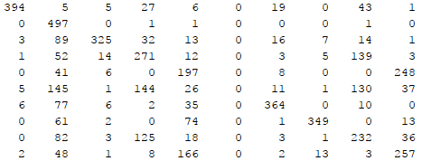

Actual

Class labels that were assigned to each cluster :  


Note: We have used 1 indexing. Hence the highest label that gets assigned to a cluster is 10. Actually this corresponds to 9.

Values that are merging

1. 4 is merging with 9
2. 5 is merging with 1 and 3

For 15 cluster

Accuray: 68.62%

The confusion matrix

Predicted

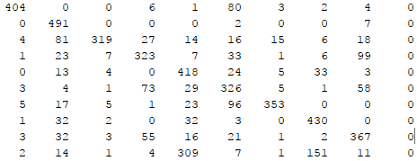

Actual

Class labels that were assigned to each cluster :  


Values that are merging

1. 9 is merging with 4. They also look the same.

For 5 cluster:

Accuray: 43.36%

The confusion matrix

Predicted

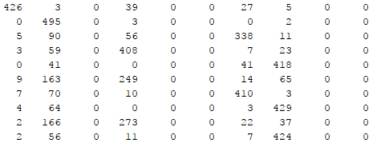

Actual

Class labels that were assigned to each cluster :  


Values that are merging

1. 9 is merging up with 7
2. 2 is merging up with 6
3. 4 is merging up with 7
4. 8 is merging up with 1 and 3
5. 5 is merging up with 1 and 3

Part 2

What is principal component analysis?

This is a dimensionality reduction technique. Here we project the data onto lower dimension such that these dimension correspond to the maximum variation in the values.

How it is implemented in this assignment?

We found the covariance matrix. Then using this matrix we generate all the 400 dimension of the transformed space(all the principal components). We then reconstruct the image by taking only a few principal components. This creates some reconstruction error.

For reaching the reconstruction error of 0.1 we need **191** principal components.

This is the error plot that has been generated

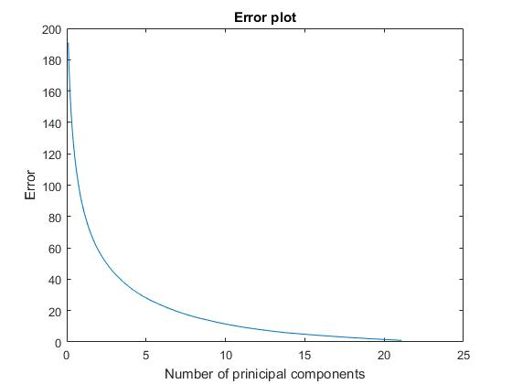

Observations

1. We find that on increasing the number of principal components the reconstruction error decreases exponentially.
2. Hence the reconstructed image is getting clearer.

Reconstruction of the image

For 0

The first reconstructed image is for principal component 2

The first reconstructed image is for principal component 3

The first reconstructed image is for principal component 100

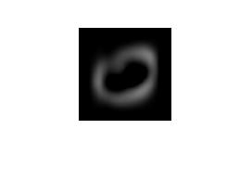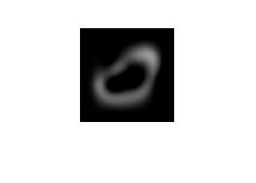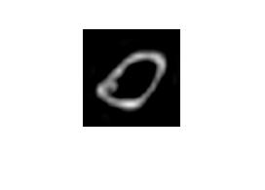

For 7

The first reconstructed image is for principal component 2

The first reconstructed image is for principal component 3

The first reconstructed image is for principal component 100

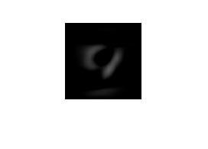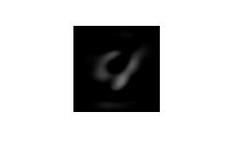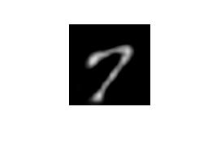

Observations

1. The image is getting clearer as the number of principal components is increased since the amount of reconstruction error is getting decreased.

Part 3

For 5 Clusters

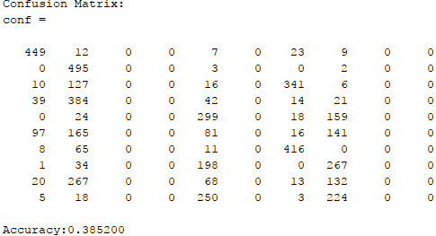

For 10 Clusters

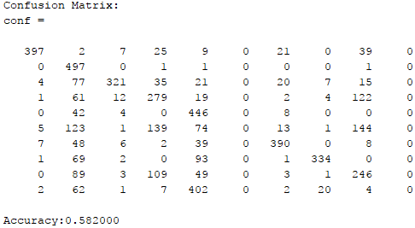

For 15 Clusters

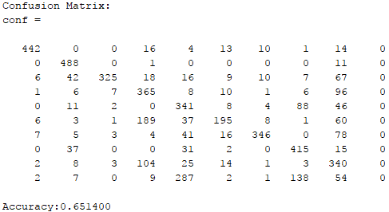

Observation

1. It can be seen that in some cases the accuracy of Kmeans clustering is actually increasing. This can happen due to the fact that unwanted noise is getting removed because of the reconstruction and only the important information is left on which the clustering algorithm is performing better.