**Git - Assignment**

1.

2.

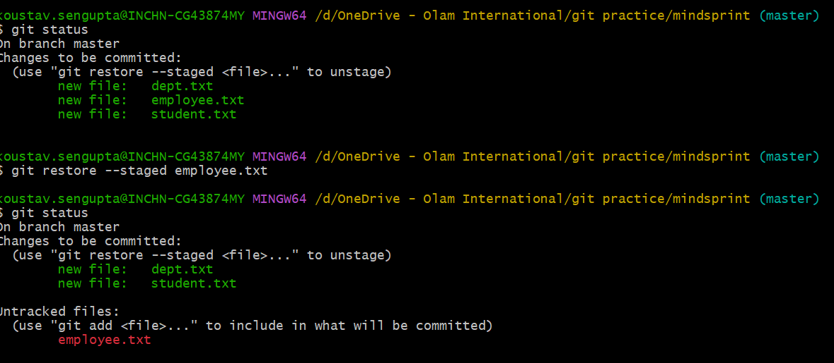

3.

4.



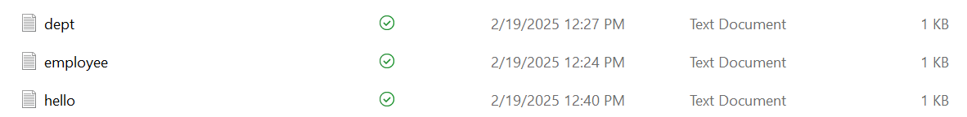

5.

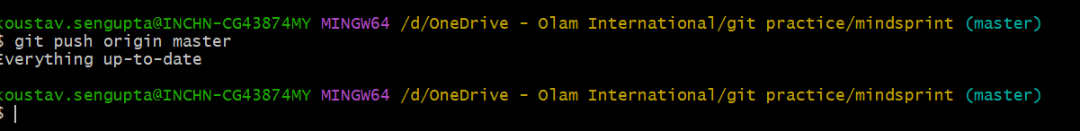

6.

