1.

2.

3.





4.

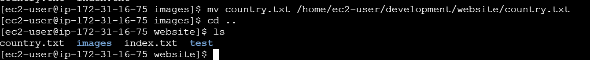

5.

6.

7.

8.

9.

