## <https://github.com/KovacsAndrea/FLCD/tree/main/Assignment4>

## Lab 4 DOCUMENTATION

**Write a program that:**

**1. Reads the elements of a FA (from file).**

**2. Displays its elements, using a menu: the set of states, the alphabet, all the transitions, the initial state and the set of final states.**

**3. For a DFA, verifies if a sequence is accepted by the FA.**

# **EDNF Definitions**

* ***lowerCaseLetter*** *= “a” | “b” | … | “z”*
* ***upperCaseLetter*** *= “A” | “B” | … | “Z”*
* ***letter*** *= lowerCaseLetter | upperCaseLetter*
* ***specialCharacter*** *= “!” | “%” | “*” | “(” | “)” | “[” | “]” | “{” | “}” | “’” | “”” | “:” | “:” | “|” | “\” | “/” | “.” | “,” | “_” | “+” | “-”*
* ***digit*** *= “0” | “1” | “2” | … | “9”*
* ***nonZeroDgit*** *= “1” | “2” | … | “9”*
* ***letterSequence*** *= letter {letter}*
* ***digitSequence*** *= {digit}*
* ***nonZeroDigitSequence*** *= {nonZeroDigit}*
* ***sign*** *= “+” | “-“*
* ***state* = letter**
* ***stateSequence* = sequence {sequence}**
* ***initialState* = state**
* ***finalStates* = sequence {sequence}**
* ***alphabetCharacter* = letter | digit | specialCharacter**
* ***alphabet* = alphabetCharacter { alphabetCharacter }**
* ***transition* = state alphabetCharacter alphabet**
* ***transitionSequence* = {transition}**
* ***FA.in* = stateSequence “\n” alphabet “\n” initialState “\n” finalStates “\n” transitionSequence**

# **Settings & Runner Packages & Main Class**

Implemented Settings Class that stores enums.

* ACTIONS.TEST_FA if this option is selected, tests for the Finite Automata will be run. All requirements for the Lab will be executed, (1, 2 and 3)
* ADTIONS.RUN_PROGRAMS
  + If this option is selected, the program will scan the problems from the selected files, will generate their symbol table and the pif files
  + RUNNER.STANDARD if this option is selected, the program will use the configurations from the previous lab (elements will be determined using a regex)
  + RUNNERS.FINITE_AUTOMATA if this option is selected, the program will use the new configurations (elements will be determined using the Finite Automata)
  + Users can choose which problem to run with the PROBLEMS enum

***Main Class***

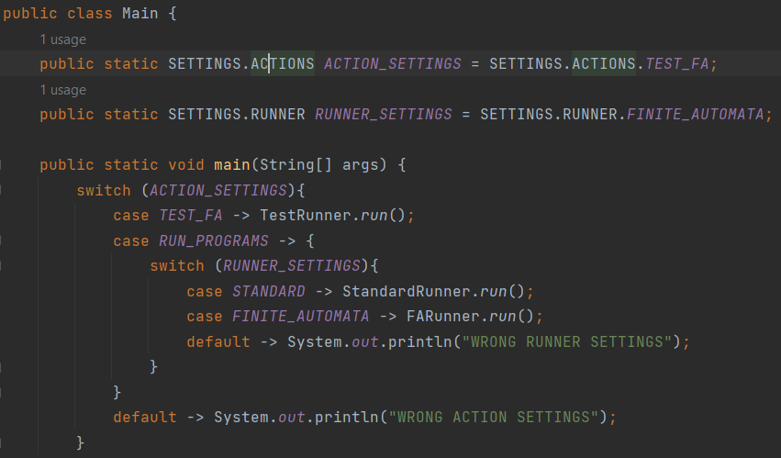

* An instance of SETTINGS.ACTIONS and SETTRINGS.RUNNER is created
* If ACTION_SETTINGS is set to TEST_FA, the run() function of TestRunner class is called
* IF ACTION_SETTINGS is set to RUN_PROGRAMS, we check for the value of RUNNER_SETTINGS
  + RUNNER_SETTINGS is set to STANDARD, the run() function of StandardRunner class is called
  + RUNNER_SETTINGS is set to STANDARD, the run() function of StandardRunner class is called

***Test Runner***

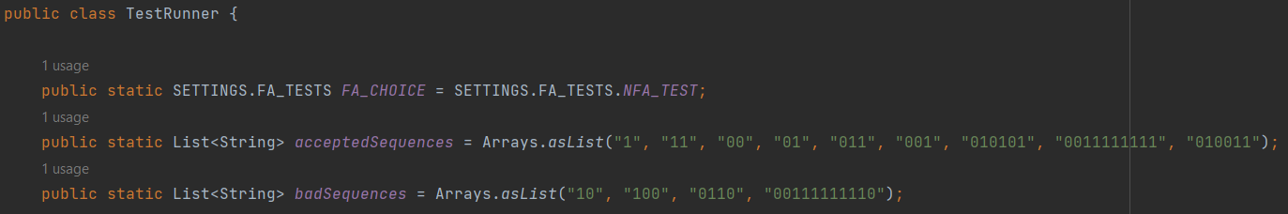

* An instance of SETTINGS.FA_TESTS is created
  + FA_TEST.DFA_TEST this option holds the path to the DFA.in file. If this option is selected, the test will be run for DFA.in, which stores the data for a deterministic finite automaton
  + FA_TEST.NFA_TEST this option holds the path to the NFA.in file. If this option is selected, the test will be run for DFA.in, which stores the data for a non - deterministic finite automaton
* The acceptedSequences holds the sequences that are accepted by the DFA and badSequences has sequences that are not accepted by the DFA. In the run() function, both will be tested.

# **DFA.in**

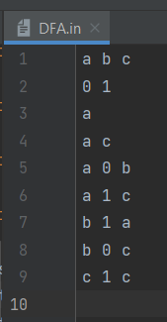

***Graphical Representation:***

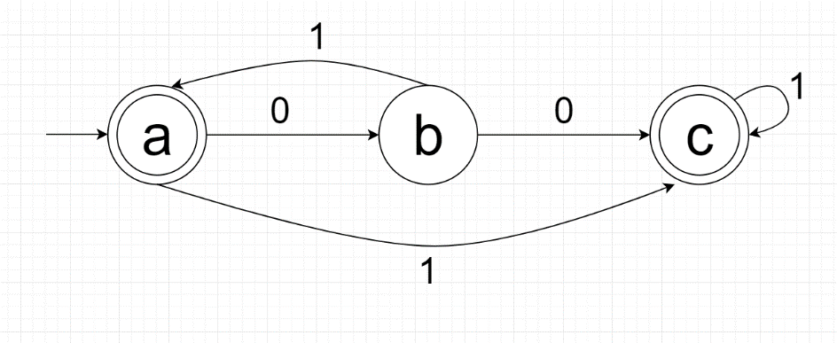

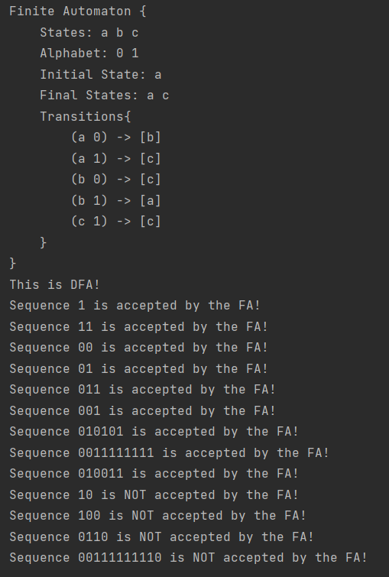

# **NFA.in**

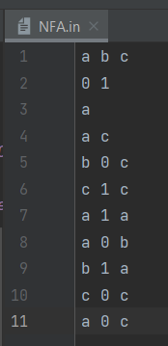

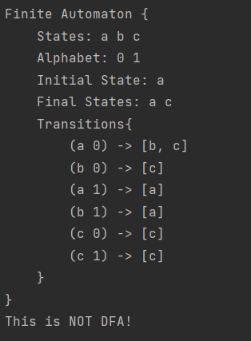

# **Exceptions Package**

LiteralException Class

* Extends Exception class
* Input: line number, position, file and message
  + message: can be one of the following “ ” expected”, “ ‘ expected”, “Illegal literal”
  + file: the path of the program file being scanned
  + line number: the number of the line where the Lexical Error is found
  + position: the position in the line where the error is encountered
* getMessage function will return a String regarding the details of the Lexical Error encountered

# **Files Package**

* has all .in or .text files used in the project
* .in files for Finite Automata
* .text files for the program file, symbol table files and program internal form files

# **Finite Automata Package**

# **My Components Package**

Component Class

* Parametrized class
* Attributes
  + protected Set<K> _components: will hold a set of elements
* Methods
  + boolean contains(K k): returns true if _components contains element k and false otherwise
  + String toString(): returns a string consisting of all elements saved in _components separated by a space

Alphabet Class

* Extends Component Class

State Class

* Extends Component Class

FinalState Class

* Extends State Class

Transition Class

* Transitions are kept in a map, where the key is a pair of two Strings(Source State and Alphabet Value) and the Value is Set of Strings with Resulting States

***FA Class***

Attributes

* public State _states;
* public Alphabet _alphabet;
* public String _initialState;
* public FinalState _finalStates;
* public Transition _transitions;

Methods

* void initFA(String filename): The Fa will be read from a file, given as parameter to the constructor. First line will represent states, second line will represent the alphabet, third row will represent the initial state, fourth row will represent the final states, and all following rows will represent transitions. Duplicate or invalid transitions will be ignored
* public boolean isDFA():

For a non-deterministic finite automaton (NFA), for a particular input symbol, the machine can move to any combination of the states in the machine. In other words, the exact state to which the machine moves cannot be determined. For a deterministic finite automaton (DFA), a pair of transition and symbol can compute to only one state.

Below is the representation for a DFA:

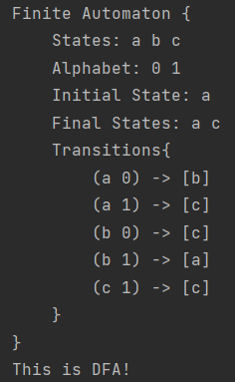

Each pair of State and Symbols computes to only one state, so we know exactly to what state the machine will move.

A NFA will look like this:

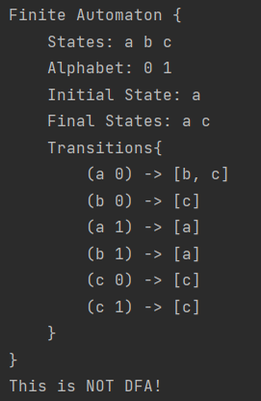

Therefore, the isDFA() function will return true if all sets have length 1 and false otherwise

* boolean accepts(String sequence): On the first run, the current state will be the initial state. We parse each character of the given sequence, and we check that the pair formed by the current state and the character itself is found in the key set of _transitions. If it is, the state that the pair computes to, will become the current state and we move on to the next character. If the pair is not found in the transitions key set, we return false. If we reach the end of the sequence and the execution was not interrupted, we return true if the current state is the final state and false otherwise.

***DFA Class***

* creates four instances of FA
  + public final FA _identifier: the FA for identifiers. The data for this FA is stored in DFAIdentifier.in
  + public final FA _string: the FA for string constants. The data for this FA is stored in DFAString.in
  + public final FA _char: the FA for char constants. The data for this FA is stored in DFAChar.in
  + public final FA _integer: the FA for integer constants. The data for this FA is stored in DFAInteger.in

# **Specification Package**

Constants

* static Class
* has three static attributes: a regex for numeric patterns (signed and unsigned), a regex for char patterns, and a regex for string patterns
* has three static methods that are getters for the three regexes

Identifiers

* has the regex for identifiers and a getter

Operators

* stores all operators
* getAll() getter for the stored operators
* isOperator function returns true if a string is an operator and false otherwise
* isPartOfOperator is used for operators that contain more than one character, such as ==, !=, <=, =>, ++, --, returns true if the given string is =, !, <, + or – and false otherwise

ReservedWords

* Stores all reserved words
* getAll(): getter for reserved words
* isReservedWord function returns true if a string is a reserved word and false otherwise;

Separators

* Stores all separators
* getAll(): getter for separators
* isSeparator function returns true if a string is a separator and false otherwise;

***Specifications***

* Attributes
  + final static HashMap<String, Integer> codification – will hold sets of Strings and Integers, where the Strings are Reserved Words, Operators, Separators, indicator for Constants and Identifiers. Will hold 0 for identifiers and 1 for constants;
* Methods
  + isConstant(String s) returns true if s is a Constant and false otherwise
  + isIdentifier(String s) returns true is f is an Identifier and false otherwise
  + isSymbol(String s) returns true if s is an Operator, Reserved Word, or Separator and false otherwise
  + createCodifications() places tuples 0 “identifiers” and 1 “constants” in the codification HashMap; for all other symbols, increments the code and places the tuple in the HashMap
  + getCode(String token) returns the code of a token

# **Core Package**

Pair

* parametrized record class
* getKey() returns the key of the element
* getValue() returns the value of the element
* equals() override for the equals function, returns true if the keys and the values are equal

HashTable

* class has 2 attributes
* _variablesAndConstants is an array of arrays (hash table)
* _size is an integer, initialized in the constructor
* getSize(): returns the value stored in _size
* hash(): computes the hash value of a token(string); hash value will be computed by sum%_size where sum is the sum of the ascii values of all characters in the string, and the _size is the size given initially to the hash table
* add(): will add a token in the table, if the key already exists, the token will not be added again; if two elements hash to the same position, the new element will be added on the next position in the array
* contains(): returns true if the hash table contains the string and false otherwise
* getPosition(): returns Pair<Integer, Integer>, where the key is the position of the secondary array in the main array, and the value is the position of the element in the secondary array
* remove(): removes an element from the hash table

PIF

* Attributes
  + final List<Pair<Integer, Pair<Integer, Integer>>> pif – a list of pairs where the first value is an Integer and the second value is a pair of integer and integer
* Methods
  + void add(Integer code, Pair<Integer, Integer> value)
  + receives a code and a Pair of integer and integer and adds is to the pif attribute

MyScanner

* Attributes
  + private final HashTable _symbolTable – will hold a reference to an instance of HashTable class
  + private final PIF _pif - will hold a reference to an instance of PIF class
  + private final String _programFile – will hold a reference to the program file
  + private final String _PIFFile – will hold a reference to the file where the resulting symbol table will be written
  + private final String _STFile – will hold a reference to the file where the resulting program internal form will be written
  + private int lineNr – will hold the number of the current line that is being scanned; initialized with 1
  + private boolean _lexicalCorrect – will be true if the program is lexically correct and false otherwise; initialized with true
* Methods
  + void scan() – lineNr is initialized with 1, program file is opened. For each line calls the runTokens() function and receives an Array of strings representing the tokens found on that specific line. Adds the tokens in a List of pairs, where the first value is a token and the second value is the line number. After iterating the file, if _lexicalCorrect is true, it prints a message stating as such. Calls buildPIF() and writeResults() functions.
  + List<String> runTokens(String line) - a wrapper for tokenize() function. It runs the tokenize() function and if it encounters any exceptions, it prints its message and sets _lexicalCorrect to false
  + List<String> tokenize() receives a line and checks for constants, identifiers, operators, separators and reserved words, and adds them in the _hashTable
  + String getStringConstant(String line, int position) checks for the next position of the character “. If it is not fount, it throws a new LiteralException with the message “” expected”. If it is found, it generates a substring from the first “ and checks if it matches the string pattern
  + String getCharConstant(String line, int position) checks for the next position of the character ‘. If it is not fount, it throws a new LiteralException with the message “’ expected”. If it is found, it generates a substring from the first ‘ and checks if it matches the string pattern
  + String getIdentifier(String line, int position) checks for the position of the next separator, operator or white space. If it is not found, a substring from the given position and to the end of the line is generator. If it is found, a substring from the given position and the new found position is generated. Returns the substring if it matches the identifier pattern, throws a LiteralException otherwise. Function will also return reserved words. In the tokenize function e will check if the string is a reserved word. If it is, we will not add it to the hash table
  + String getInteger(String line, int position): If integer is signed, checks if there is a space between + or - and the integer. If what follows after the sign is an identifier, it returns null. Otherwise it checks for the position of the next white space, arithmetic operator or relational operator. If it is found, generates a string from the given position to the found symbol, otherwise, to the end of the line. If the string does not match the numeric pattern, it throws a Literal Exception, or returns it otherwise.
  + void buildPIF(List<Pair<String, Integer>> tokens) – receives a list of Pairs of String and Integer.
    - If it is a symbol, _pif will add the code saved in Specifications Class, and the Pair will fold values -1 and -1
    - If it is an identifier _pif will add code 0 and the position of the identifier saved in the symbol table
    - If it is a constant _pif will add code 1 and the position of the constant saved in the symbol table
  + void writeResults() will open the _PIFFile and will write the data in _pif. Will open _STFile and will write the data in _symbolTable.

MyFAScanner

* works exactly like MyScanner Class but uses the Finite Automata class (FA) instead of regexes to determine the correctness of constants, identifiers and symbols.