# Chapter 1. Dive in A Quick Dip: Breaking the Surface

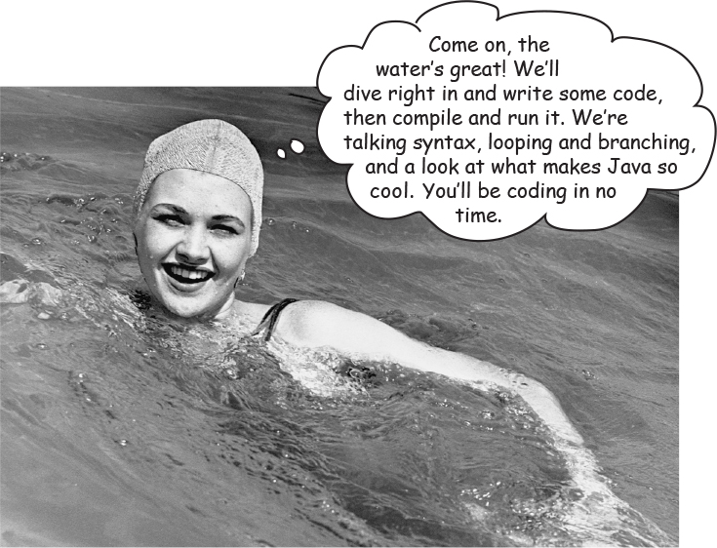

**Java takes you to new places.** From its humble скромный release to the public as the (wimpy слабак) version 1.02, Java seduced Совращение programmers with its friendly syntax, object-oriented features, memory management, and best of all —the promise of portability. The lure of **write-once/run-anywhere** is just too strong. A devoted following exploded, as programmers fought against bugs, limitations, and, oh yeah, the fact that it was dog slow. But that was ages ago. If you’re just starting in Java, **you’re lucky**. Some of us had to walk five miles in the snow, uphill both ways (barefoot), to get even the most trivial application to work. But *you*, why, *you* get to ride the **sleeker Гладкой, faster, easier-to-read-and-write** Java of today.

**The Way Java Works**

***The goal is to write one application (in this example, an interactive party invitation) and have it work on whatever device your friends have.***

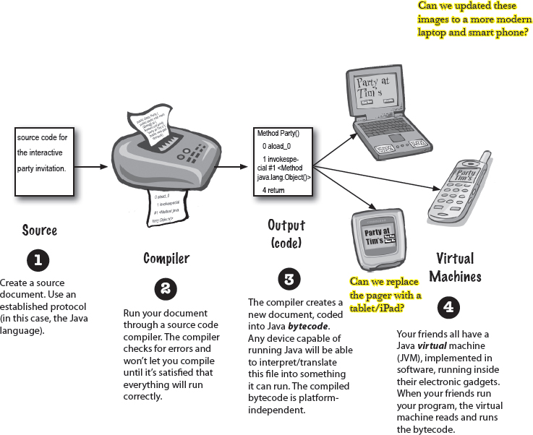

**What you’ll do in Java**

***You’ll type a source code file, compile it using the javac compiler, then run the compiled bytecode on a Java virtual machine.***

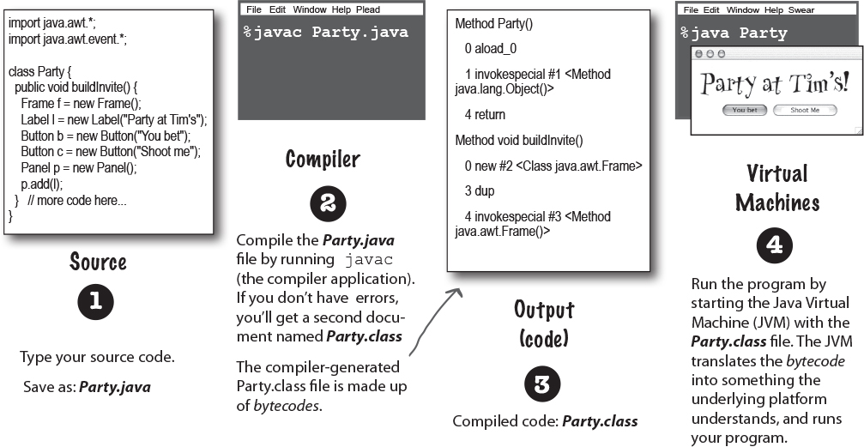

**Note**

(Note: this is **NOT** meant to be a tutorial... you’ll be writing real code in a moment, but for now, we just want you to get a feel for how it all fits together.

In other words, the code on this page isn’t quite real, don’t try to compile it..)

**A Very Brief History of Java**

Java was initially released (some would say “escaped”), on January 23, 1996. It’s over 25 years old! In the first 25 years, Java as a language evolved, and the Java API grew enormously. The best estimate we have is that over 17 gazillion lines of Java code have been written in the last 25 years. As you spend time programming in Java, you will most certainly come across Java code that’s quite old, and some that’s much newer. Java is famous for its backwards compatibility, so old code can run quite happily on new JVMs.

In this book we’ll generally start off by using older coding styles (remember, you’re likely to encounter встреча such code in the “real world”), and then we’ll introduce newer style code.

In a similar fashion, we will sometimes show you older classes in the Java API, and then show you newer alternatives.

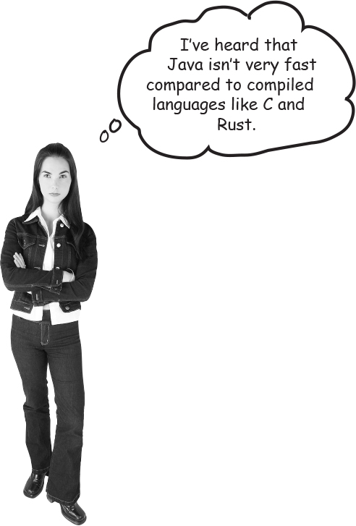

**Speed and Memory Usage**

When Java was first released, it was slow. But soon after, the HotSpot VM was created, as were other performance enhancers Усилители. While it’s true that Java isn’t the fastest language out there, it’s considered to be a very fast language - almost as fast as languages like C and Rust, and ***much*** faster than most other languages out there.

Java has a magic super-power - the JVM. The Java Virtual Machine can optimize your code *while it’s running*, so it’s possible to create very fast applications without having to write specialised high-performance code.

But - full disclosure - compared to C and Rust, Java uses a lot of memory.

**Sharpen your pencil**

image

**Look how easy it is to write Java.**

Try to guess what each line of code is doing... (answers are on the next page).

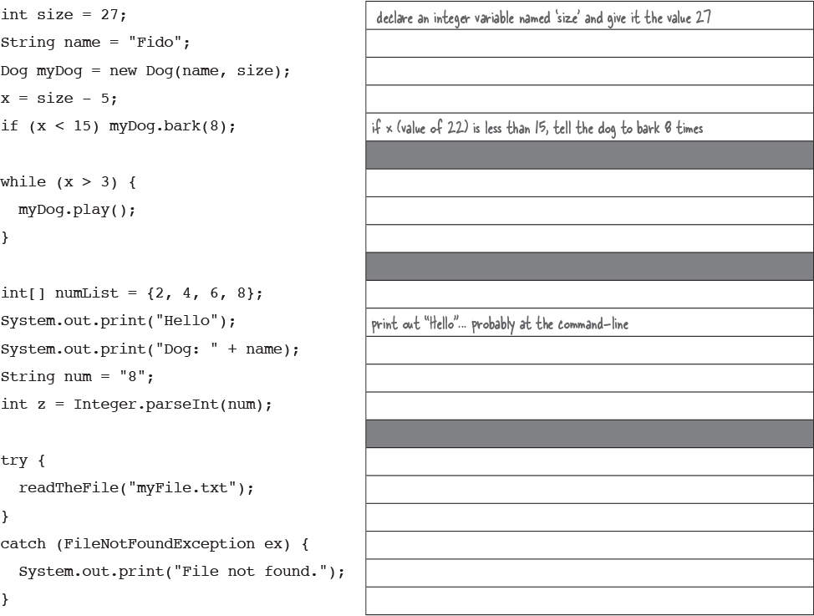

**Q: The naming conventions for Java’s versions are confusing. There was JDK 1.0, and 1.2, 1.3, 1.4 then a jump to J2SE 5.0, then it changed to Java 6, Java 7, and last time I checked, Java was up to Java 18. What’s going on?**

**A:** The version numbers have varied a lot over the last 25+ years! We can ignore the letters (J2SE/SE) since these are not really used now. The numbers are a little more involved.

Technically Java SE 5.0 was actually Java **1.**5. Same for 6 (1.6), 7 (1.7) and 8 (1.8). In theory, Java is still on version 1.x because new versions are backwards compatible, all the way back to 1.0.

However, it was a bit confusing having a version number that was different to the name everyone used, so the official version number from Java 9 onwards продвигающийся is just the number, without the “1” prefix - i.e. Java 9 really is version 9, not version 1.9.

In this book we’ll use the common convention of 1.0 - 1.4, then from 5 onwards we’ll drop the “1” prefix.

Also, since Java 9 was released in September 2017, there’s been a release of Java every six months, each with a new “major” version number, so we moved very quickly from 9 to 18!

**Sharpen your pencil answers**

image

***Don’t worry about whether you understand any of this yet!*** Everything here is explained in great detail in the book (most within the first 40 pages). If Java resembles Напоминает a language you’ve used in the past, some of this will be simple. If not, don’t worry about it. *We’ll get there...*

**Look how easy it is to write Java.**

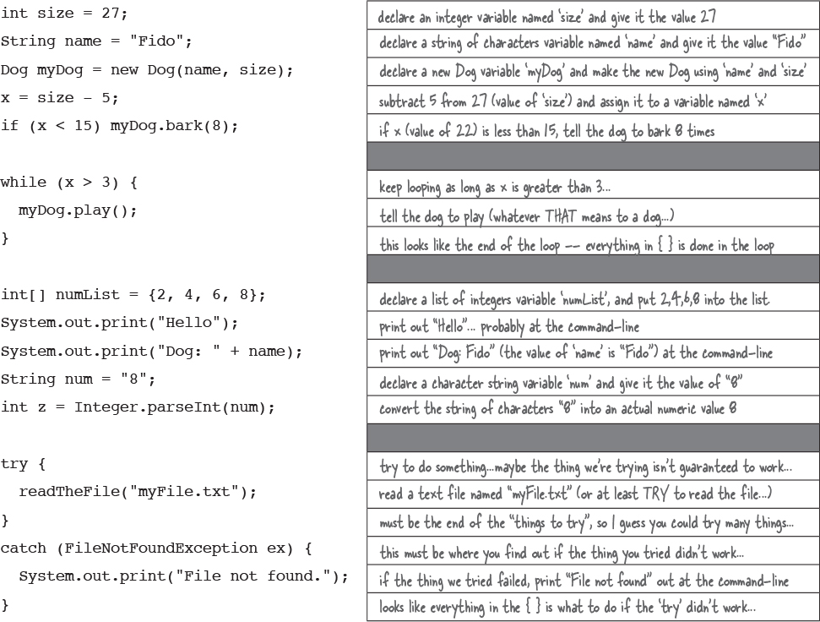

**Code structure in Java**

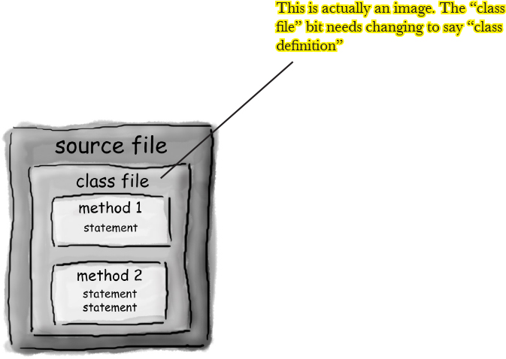

**In a source file, put a** **class.**

**In a class, put** **methods.**

**In a method, put** **statements.**

**What goes in a source file?**

A source code file (with the *.java* extension) holds one ***class*** definition. The class represents a *piece* of your program, although a very tiny application might need just a single class. The class must go within a pair of curly braces.

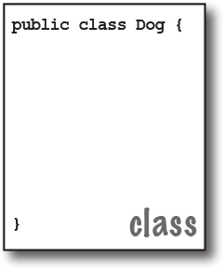

**What goes in a class?**

A class has one or more ***methods***. In the Dog class, the ***bark*** method will hold instructions for how the Dog should bark. Your methods must be declared *inside* a class (in other words, within the curly braces of the class).

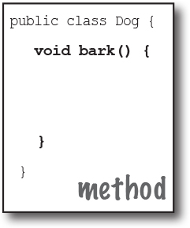

**What goes in a method?**

Within the curly braces of a method, write your instructions for how that method should be performed. Method *code* is basically a set of statements, and for now you can think of a method kind of like a function or procedure.

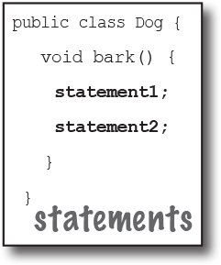

**Anatomy of a class**

When the JVM starts running, it looks for the class you give it at the command line. Then it starts looking for a specially-written method that looks exactly like:

public static void main (String[] args) {

// your code goes here

}

Next, the JVM runs everything between the curly braces { } of your main method. Every Java application has to have at least one **class**, and at least one **main** method (not one main per *class*; just one main per *application*).

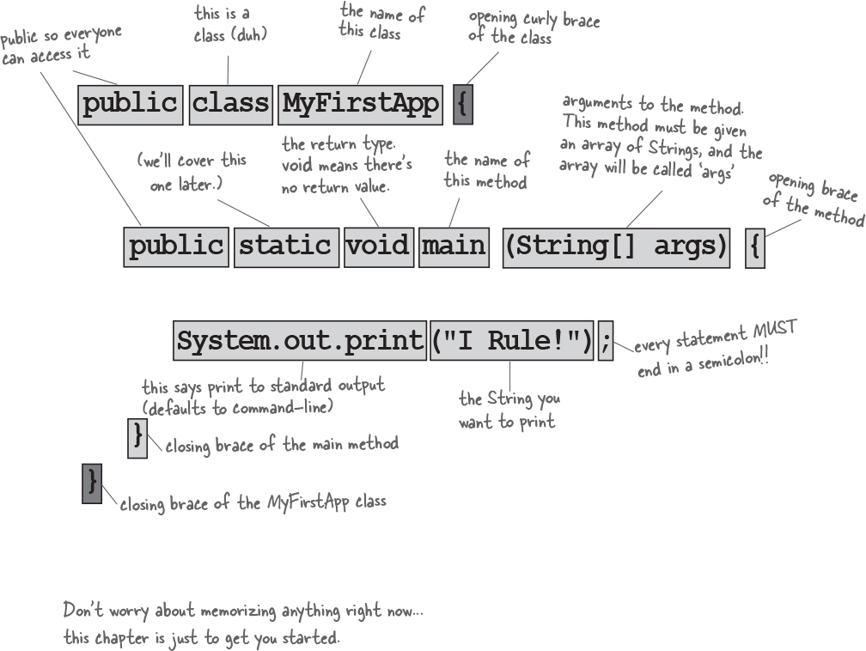

**Writing a class with a main()**

In Java, everything goes in a **class**. You’ll type your source code file (with a .java extension), then compile it into a new class file (with a .class extension). When you run your program, you’re really running a class.

Running a program means telling the Java Virtual Machine (JVM) to “Load the **MyFirstApp** class, then start executing its **main()** method. Keep running ‘til all the code in main is finished.”

In Chapter 2, we go deeper into the whole *class* thing, but for now, the only question you need to ask is, ***how do I write Java code so that it will run?*** And it all begins with **main()**.

The **main()** method is where your program starts running.

No matter how big your program is (in other words, no matter how many *classes* your program uses), there’s got to be a **main()** method to get the ball rolling.

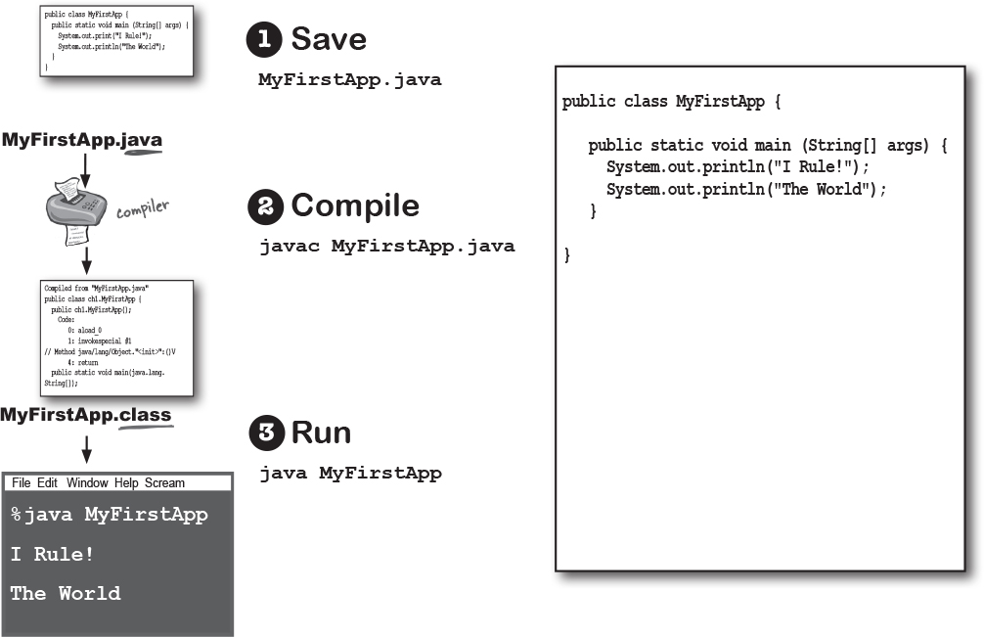

**Fireside Chats**



Tonight’s Talk: **The compiler and the JVM battle over the question, “Who’s more important?”**

|  |  |
| --- | --- |
| **The Java Virtual Machine** What, are you kidding? ***HELLO***. I am Java. I’m the one who actually makes a program run. The compiler just gives you a file. That’s it. Just a file. You can print it out and use it for wall paper, kindling, lining the bird cage whatever, but the file doesn’t do anything unless I’m there to run it. | **The Compiler** I don’t appreciate that tone. |
| And that’s another thing, the compiler has no sense of humor. Then again, if you had to spend all day checking nit-picky little syntax violations... |  |
|  | Excuse me, but without *me,* what exactly would you run? There’s a *reason* Java was designed to use a bytecode compiler, for your information. If Java were a purely interpreted language, where—at runtime—the virtual machine had to translate straight-from-a-text-editor source code, a Java program would run at a ludicrously смехотворно glacial ледниковый pace. |
| I’m not saying you’re, like, *completely* useless. But really, what is it that you do? Seriously. I have no idea. A programmer could just write bytecode by hand, and I’d take it. You might be out of a job soon, buddy. |  |
|  | Excuse me, but that’s quite an ignorant невежественный (not to mention *arrogant* высокомерный) perspective. While it *is* true that —*theoretically—*you can run any properly formatted bytecode even if it didn’t come out of a Java compiler, in practice that’s absurd. A programmer writing bytecode by hand is like painting pictures of your vacation instead of taking photos - sure, it’s an art, but most people prefer to use their time differently. And I would appreciate it if you would *not* refer to me as “buddy.” |
| (I rest my case on the humor thing.) But you still didn’t answer my question, what *do* you actually do? |  |
|  | Remember that Java is a strongly-typed language, and that means I can’t allow variables to hold data of the wrong type. This is a crucial safety feature, and I’m able to stop the vast majority of violations before they ever get to you. And I also— |
| But some still get through! I can throw ClassCast-Exceptions and sometimes I get people trying to put the wrong type of thing in an array that was declared to hold something else, and— |  |
|  | Excuse me, but I wasn’t done. And yes, there *are* some datatype exceptions that can emerge at runtime, but some of those have to be allowed to support one of Java’s other important features— dynamic binding динамическая привязка. At runtime, a Java program can include new objects that weren’t even *known* to the original programmer, so I have to allow a certain amount of flexibility. But my job is to stop anything that would never—*could* never—succeed at runtime. Usually I can tell when something won’t work, for example, if a programmer accidentally tried to use a Button object as a Socket connection, I would detect that and thus protect them from causing harm at runtime. |
| OK. Sure. But what about *security*? Look at all the security stuff I do, and you’re like, what, checking for *semicolons*? Oooohhh big security risk! Thank goodness for you! |  |
|  | Excuse me, but I am the first line of defense, as they say. The datatype violations I previously described could wreak havoc опустошение in a program if they were allowed to manifest. I am also the one who prevents access violations, such as code trying to invoke a private method, or change a method that – for security reasons – must never be changed. I stop people from touching code they’re not meant to see, including code trying to access another class’ critical data. It would take hours, perhaps days even, to describe the significance of my work. |
| Whatever. I have to do that same stuff *too*, though, just to make sure nobody snuck Пробрался in after you and changed the bytecode before running it. |  |
|  | Of course, but as I indicated previously, if I didn’t prevent what amounts to perhaps 99% of the potential problems, you would grind молоть to a halt. And it looks like we’re out of time, so we’ll have to revisit this in a later chat. |
| Oh, you can count on it. *Buddy*. |  |

**What can you say in the main method?**

Once you’re inside main (or *any* method), the fun begins. You can say all the normal things that you say in most programming languages to ***make the computer do something.***

Your code can tell the JVM to:

Images**do something**

**Statements**: declarations, assignments, method calls, etc.

int x = 3;

String name = "Dirk";

x = x * 17;

System.out.print("x is " + x);

double d = Math.random();

// this is a comment

Images**do something again and again**

**Loops**: *for* and *while*

while (x > 12) {

x = x - 1;

}

for (int i = 0; i < 10; i = i + 1) {

System.out.print("i is now " + i);

}

Images**do something under this condition**

**Branching**: *if/else* tests

if (x == 10) {

System.out.print("x must be 10");

} else {

System.out.print("x isn't 10");

}

if ((x < 3) && (name.equals("Dirk"))) {

System.out.println("Gently");

}

System.out.print("this line runs no matter what");

**Syntax Fun**



ImagesEach statement must end in a semicolon.

x = x + 1**;**

Imagessingle-line comment begins with two forward slashes.

x = 22;

**// this line disturbs me**

ImagesMost white space doesn’t matter.

x = 3 ;

ImagesVariables are declared with a **name** and a **type** (you’ll learn about all the Java *types* in Chapter 3).

int weight;

//*type:* int, *name:* weight

ImagesClasses and methods must be defined within a pair of curly braces.

public void go() **{**

// amazing code here

**}**

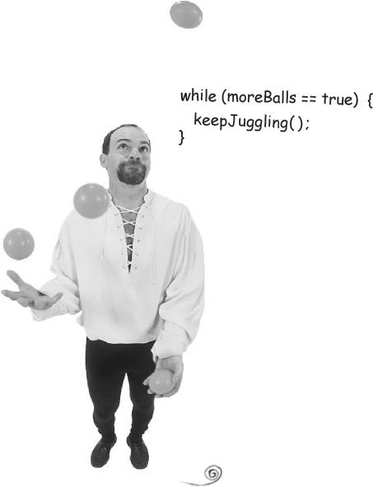

**Looping and looping and...**

Java has a lot of looping constructs: while, do-while, and *for*, being the oldest. You’ll get the full loop scoop later in the book, but not right now. Let’s start with “while”.

The syntax (not to mention logic) is so simple you’re probably asleep already. As long as some condition is true, you do everything inside the loop *block*. The loop block is bounded by a pair of curly braces, so whatever you want to repeat needs to be inside that block.

The key to a loop is the *conditional test*. In Java, a conditional test is an expression that results in a *boolean* value —in other words, something that is either ***true*** or ***false***.

If you say something like, “While *iceCreamInTheTub is true*, keep scooping”, you have a clear boolean test. There either *is* ice cream in the tub or there *isn’t*. But if you were to say, “While *Bob* keep scooping”, you don’t have a real test. To make that work, you’d have to change it to something like, “While Bob is snoring...” or “While Bob is *not* wearing plaid плед...”

**Simple boolean tests**

You can do a simple boolean test by checking the value of a variable, using a comparison operator like:

**<** (less than)

**>** (greater than)

**==** (equality) (yes, that’s *two* equals signs)

Notice the difference between the *assignment* operator (a *single* equals sign) and the *equals* operator (*two* equals signs). Lots of programmers accidentally type ***=*** when they *want* ***==***. (But not you.)

int x = 4; // assign 4 to x

while (x > 3) {

// loop code will run because

// x is greater than 3

x = x - 1; // or we’d loop forever

}

int z = 27; //

while (z == 17) {

// loop code will not run because

// z is not equal to 17

}

**there are no Dumb Questions**

**Q: Why does everything have to be in a class?**

**A:** Java is an object-oriented (OO) language. It’s not like the old days when you had steam-driven compilers and wrote one monolithic source file with a pile of procedures. In Chapter 2 you’ll learn that a class is a blueprint for an object, and that nearly everything in Java is an object.

**Q: Do I have to put a main in every class I write?**

**A:** Nope. A Java program might use dozens of classes (even hundreds), but you might only have *one* with a main method — the one that starts the program running.

**Q: In my other language I can do a boolean test on an integer. In Java, can I say something like:**

**int x = 1;**

**while (x){ }**

**A:** No. A *boolean* and an *integer* are not compatible types in Java. Since the result of a conditional test *must* be a boolean, the only variable you can directly test (without using a comparison operator) is a ***boolean.*** For example, you can say:

**boolean isHot = true;**

**while(isHot) { }**

**Example of a while loop**

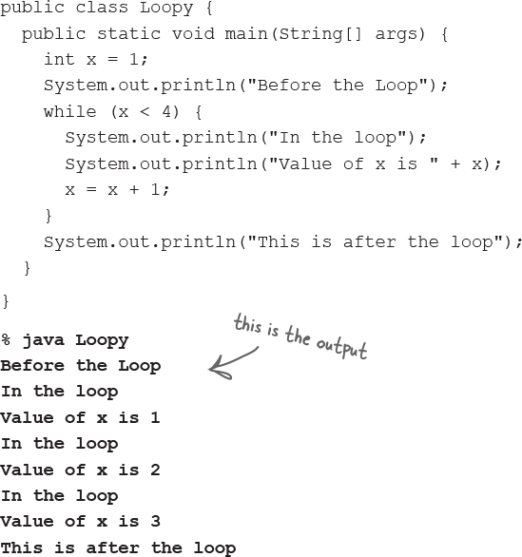

**Bullet Points**

Statements end in a semicolon **;**

Code blocks are defined by a pair of curly braces **{ }**

Declare an *int* variable with a name and a type: **int x;**

The **assignment** operator is *one* equals sign **=**

The **equals** operator uses *two* equals signs **==**

A *while* loop runs everything within its block (defined by curly braces) as long as the *conditional test* is ***true***.

If the conditional test is ***false***, the *while* loop code block won’t run, and execution will move down to the code immediately *after* the loop block.

Put a boolean test inside parentheses:

while **(x == 4)** { }

**Conditional branching**

In Java, an *if* test is basically the same as the boolean test in a *while* loop – except instead of saying, “***while*** there’s still chocolate...”, you’ll say, “***if*** there’s still chocolate...”

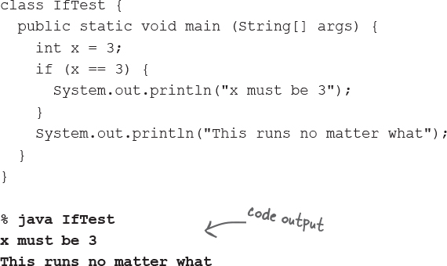

The code above executes the line that prints “x must be 3” only if the condition (*x* is equal to 3) is true. Regardless of whether it’s true, though, the line that prints, “This runs no matter what” will run. So depending on the value of *x*, either one statement or two will print out.

But we can add an *else* to the condition, so that we can say something like, “*If* there’s still chocolate, keep coding, *else* (otherwise) get more chocolate, and then continue on...”

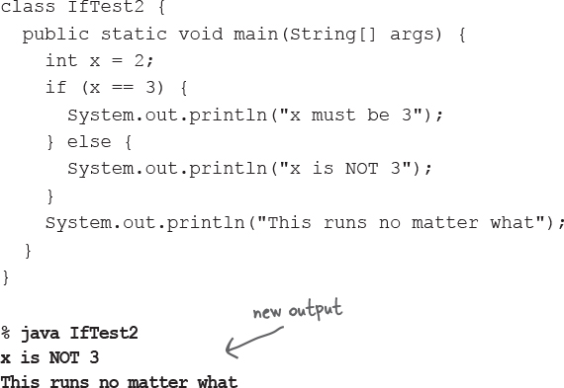

**System.out.print vs. System.out.println**

If you’ve been paying attention (of course you have) then you’ve noticed us switching between **print** and **println.**

**Did you spot the difference?**

System.out.***println*** inserts a newline (think of print***ln*** as **print*new*line** while System.out.***print*** keeps printing to the *same* line. If you want each thing you print out to be on its own line, use print**ln**. If you want everything to stick together on one line, use print.

**Sharpen your pencil**

image

***Given the output:***

**% java DooBee**

**DooBeeDooBeeDo**

***Fill in the missing code:***

public class DooBee {

public static void main(String[] args) {

int x = 1;

while (x < 3 ) {

System.out.print("Doo");

System.out. print ("Bee");

x = x + 1;

}

if (x == 3 ) {

System.out.print("Do");

}

}

}

**Coding a Serious Business Application**



Let’s put all your new Java skills to good use with something practical. We need a class with a *main()*, an *int* and a *String* variable, a *while* loop, and an *if* test. A little more polish, and you’ll be building that business back-end in no time. But *before* you look at the code on this page, think for a moment about how *you* would code that classic children’s favorite, “10 green bottles”

**public class BottleSong {**

**public static void main(String[] args) {**

**int bottlesNum = 10;**

**String word = "bottles";**

**while (bottlesNum > 0) {**

**if (bottlesNum == 1) {**

**word = "bottle"; // singular, as in ONE bottle.**

**}**

**System.out.println(bottlesNum + " green " + word + ", hanging on the wall");**

**System.out.println(bottlesNum + " green " + word + ", hanging on the wall");**

**System.out.println("And if one green bottle should accidentally fall,");**

**bottlesNum = bottlesNum - 1;**

**if (bottlesNum > 0) {**

**System.out.println("There'll be " + bottlesNum +**

**" green " + word + ", hanging on the wall");**

**} else {**

**System.out.println("There'll be no green bottles, hanging on the wall");**

**}** // end else

**}** // end while loop

**}** // end main method

**}** // end class

**Note**

There’s still one little flaw изъян in our code. It compiles and runs, but the output isn’t 100% perfect. See if you can spot the flaw , and fix it.

**Monday Morning at Bob’s Java-Enabled House**



Bob’s alarm clock rings at 8:30 Monday morning, just like every other weekday. But Bob had a wild weekend, and reaches for the SNOOZE ВЗДРЕМНУТЬ button. And that’s when the action starts, and the Java-enabled appliances come to life...



First, the alarm clock sends a message to the coffee maker “Hey, the geek’s sleeping in again, delay the coffee 12 minutes.”

The coffee maker sends a message to the Motorola™ toaster, “Hold the toast, Bob’s snoozing.”

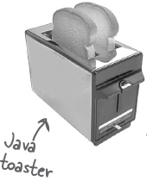

The alarm clock then sends a message to Bob’s Android, “Call Bob’s 9 o’clock and tell him we’re running a little late.”

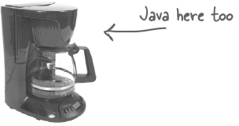

Finally, the alarm clock sends a message to Sam’s (Sam is the dog) wireless collar, with the too-familiar signal that means, “Get the paper, but don’t expect a walk.”

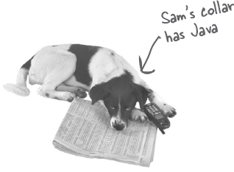

A few minutes later, the alarm goes off again. And *again* Bob hits SNOOZE and the appliances start chattering. Finally, the alarm rings a third time. But just as Bob reaches for the snooze button, the clock sends the “jump and bark” signal to Sam’s collar. Shocked to full consciousness, Bob rises, grateful that his Java skills, and spontaneous internet shopping purchases, have enhanced улучшенный the daily routines of his life.



***His toast is toasted.***

***His coffee steams.***

***His paper awaits.***

Just another wonderful morning in ***The Java-Enabled House***.

Could this story be true? Mostly, yes! There *are* versions of Java running in devices including cell phones (*especially* cell phones), ATMs, credit cards, home security systems, parking meters, game consoles and more –but you might not find a Java dog collar... yet.

Java has multiple ways to use just a tiny part of the Java platform to run on smaller devices (depending upon the version of Java you’re using). It’s very popular for IoT (Internet of Things) development. And, of course, lots of Android development is done with Java and JVM languages.



OK, so the bottle song wasn’t *really* a serious business application. Still need something practical to show the boss? Check out the Phrase-O-Matic code.

public class PhraseOMatic {

public static void main (String[] args) {

Images**// make three sets of words to choose from. Add your own!**

String[] wordListOne = {"agnostic", "opinionated",

"voice activated", "haptically driven", "extensible",

"reactive", "agent based", "functional", "AI enabled",

"strongly typed"};

String[] wordListTwo = {"loosely coupled", "six sigma",

"asynchronous", "event driven", "pub-sub", "IoT", "cloud

native", "service oriented", "containerized", "serverless",

"microservices", "distributed ledger"};

String[] wordListThree = {"framework", "library",

"DSL", "REST API", "repository", "pipeline", "service

mesh", "architecture", "perspective", "design",

"orientation"};

Images**// find out how many words are in each list**

int oneLength = wordListOne.length;

int twoLength = wordListTwo.length;

int threeLength = wordListThree.length;

Images**// generate three random numbers**

java.util.Random randomGenerator = new java.util.Random();

int rand1 = randomGenerator.nextInt(oneLength);

int rand2 = randomGenerator.nextInt(twoLength);

int rand3 = randomGenerator.nextInt(threeLength);

Images**// now build a phrase**

String phrase = wordListOne[rand1] + " " +

wordListTwo[rand2] + " " + wordListThree[rand3];

Images**// print out the phrase**

System.out.println("What we need is a " + phrase);

}

}

**Note**

note: when you type this into an editor, let the code do its own word/line-wrapping! Never hit the return key when you’re typing a String (a thing between “quotes”) or it won’t compile. So the hyphens you see on this page are real, and you can type them, but don’t hit the return key until AFTER you’ve closed a String.

**Phrase-O-Matic**

**How it works.**

In a nutshell, the program makes three lists of words, then randomly picks one word from each of the three lists, and prints out the result. Don’t worry if you don’t understand *exactly* what’s happening in each line. For goodness sake, you’ve got the whole book ahead of you, so relax. This is just a quick look from a 30,000 foot outside-the-box targeted leveraged paradigm парадигма целевого использования.

The first step is to create three String arrays – the containers that will hold all the words. Declaring and creating an array is easy; here’s a small one:

**String[] pets = {"Fido", "Zeus", "Bin"};**

Each word is in quotes (as all good Strings must be) and separated by commas.

For each of the three lists (arrays), the goal is to pick a random word, so we have to know how many words are in each list. If there are 14 words in a list, then we need a random number between 0 and 13 (Java arrays are zero-based, so the first word is at position 0, the second word position 1, and the last word is position 13 in a 14-element array). Quite handily удобно, a Java array is more than happy to tell you its length. You just have to ask. In the pets array, we’d say:

**int x = pets.length;**

and **x** would now hold the value 3.

We need three random numbers. Java ships out-of-the-box with several ways to generate random numbers, including java.util.Random [java.util.concurrent.ThreadLocalRandom is better (int rnd = ThreadLocalRandom.current().nextInt(oneLength);)] (we will see later why this class name is prefixed with java.util). The **nextInt()** method returns a random number between 0 and some-number-we-give-it, *not including* the number that we give it. So we’ll give it the number of elements (the array length) in the list we’re using. Then we assign each result to a new variable. We could just as easily have asked for a random number between 0 and 5, not-including-5:

**int x = randomGenerator.nextInt(5);**

Now we get to build the phrase, by picking a word from each of the three lists, and smooshing them together (also inserting spaces between words). We use the “**+**” operator, which *concatenates* Сцепляет (we prefer the more technical ‘*smooshes*’) the String objects together. To get an element from an array, you give the array the index number (position) of the thing you want by using:

**String s = pets[0]; // s is now the String "Fido"**

**s = s + " " + "is a dog"; // s is now "Fido is a dog"**

Finally, we print the phrase to the command-line and... voila! *We’re in marketing*.

**Note**

**what we need here is a...**

**extensible растяжимый microser-vices pipeline**

**opinionated loosely свободно coupled связанный REST API**

**agent based microservices library**

**AI enabled service oriented orientation**

**agnostic pub-sub DSL**

**functional IoT perspective you are here**

**Exercise**



**Code Magnets**



A working Java program is all scrambled зашифрованный up on the fridge. Can you rearrange переставлять the code snippets Фрагменты to make a working Java program that produces the output listed below? Some of the curly braces fell on the floor and they were too small to pick up, so feel free to add as many of those as you need!

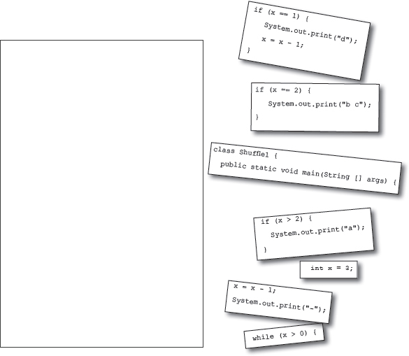

**Output:**

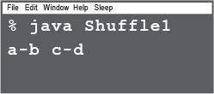

**BE the compiler**



**Each of the Java files on this page represents a complete source file. Your job is to play compiler and determine whether each of these files will compile. If they won’t compile, how would you fix them?**

**A**

**class Exercise1a {**

**public static void main(String[] args) {**

**int x = 1;**

**while (x < 10) {**

**if (x > 3) {**

**System.out.println("big x");**

**}**

**}**

**}**

**}**

**B**

**public static void main(String [] args) {**

**int x = 5;**

**while ( x > 1 ) {**

**x = x - 1;**

**if ( x < 3) {**

**System.out.println("small x");**

**}**

**}**

**}**

**C**

**class Exercise1c {**

**int x = 5;**

**while (x > 1) {**

**x = x - 1;**

**if (x < 3) {**

**System.out.println("small x");**

**}**

**}**

**}**

**JavaCross**



Let’s give your right brain something to do.

It’s your standard crossword, but almost all of the solution words are from Chapter 1. Just to keep you awake, we also threw in a few (non-Java) words from the high-tech world.

**Across**

4. Command-line invoker Вызов командной строки

6. Back again?

8. Can’t go both ways

9. Acronym for your laptop’s power

12. Number variable type

13. Acronym for a chip

14. Say something

18. Quite a crew of characters

19. Announce a new class or method

21. What’s a prompt good for?

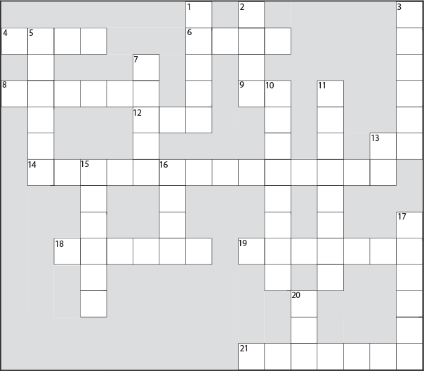

**Down**

1. Not an integer (or _____ your boat)

2. Come back empty-handed

3. Open house

5. ‘Things’ holders

7. Until attitudes improve

10. Source code consumer

11. Can’t pin it down

13. Department for programmers and operations

15. Shocking modifier

16. Just gotta have one

17. How to get things done

20. Bytecode consumer

**Mixed Messages**



A short Java program is listed below. One block of the program is missing. Your challenge is to **match the candidate block of code** (on the left), **with the output** that you’d see if the block were inserted. Not all the lines of output will be used, and some of the lines of output might be used more than once. Draw lines connecting the candidate blocks of code with their matching command-line output. (The answers are at the end of the chapter).

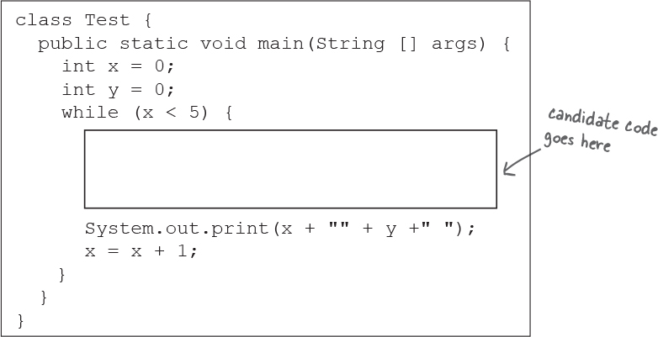

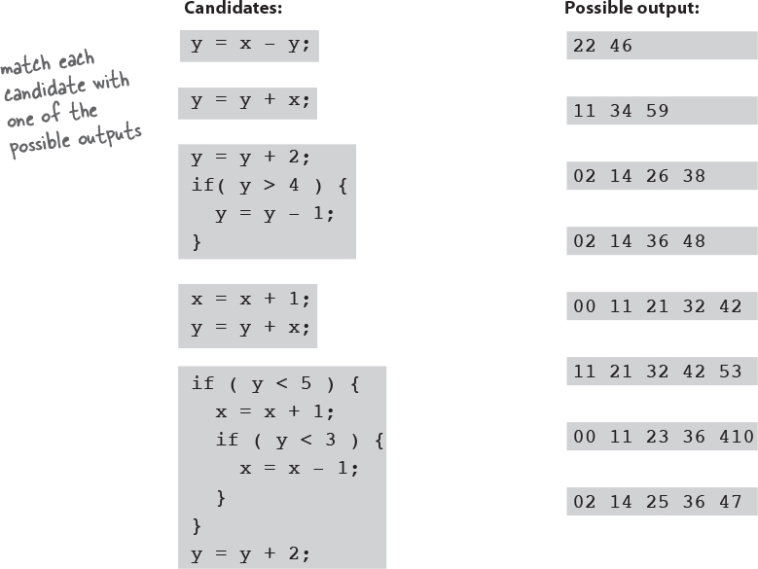

**Pool Puzzle**





Your ***job*** is to take code snippets Фрагменты from the pool and place them into the blank lines in the code. You may **not** use the same snippet more than once, and you won’t need to use all the snippets. Your ***goal*** is to make a class that will compile and run and produce the output listed. Don’t be fooled—this one’s harder than it looks.

**Output**

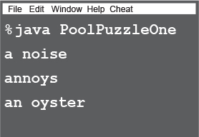

**Note**

**Note: Each snippet обрезок from the pool can be used only once!**

class PoolPuzzleOne {

public static void main(String [] args) {

int x = 0;

while ( __________ ) {

_____________________________

if ( x < 1 ) {

___________________________

}

_____________________________

if ( __________ ) {

____________________________

___________

}

if ( x == 1 ) {

____________________________

}

if ( ___________ ) {

____________________________

}

System.out.println();

____________

}

}

}

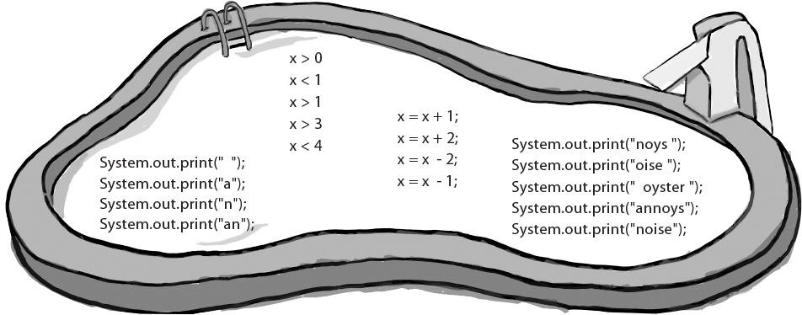

### Exercise Solutions



**Sharpen your pencil:**

**public class DooBee {**

**public static void main(String[] args) {**

**int x = 1;**

**while (x < 3) {**

**System.out.print("Doo");**

**System.out.print("Bee");**

**x = x + 1;**

**}**

**if (x == 3) {**

**System.out.print("Do");**

**}**

**}**

**}**

**Code Magnets:**

class Shuffle1 {

public static void main(String[] args) {

int x = 3;

while (x > 0) {

if (x > 2) {

System.out.print("a");

}

x = x - 1;

System.out.print("-");

if (x == 2) {

System.out.print("b c");

}

if (x == 1) {

System.out.print("d");

x = x - 1;

}

}

}

}

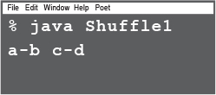

**A**

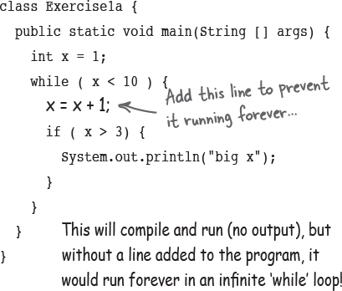

**B**

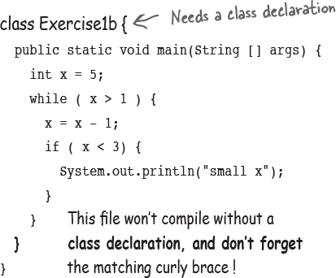

**C**

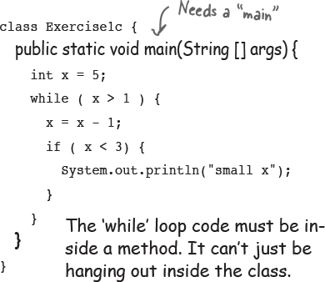

class PoolPuzzleOne {

public static void main(String [] args) {

int x = 0;

while ( **x < 4** ) {

**System.out.print("a");**

if ( x < 1 ) {

**System.out.print(" ");**

}

**System.out.print("n");**

if ( **x > 1** ) {

**System.out.print(" oyster");**

**x = x + 2;**

}

if ( x == 1 ) {

**System.out.print("noys");**

}

if ( **x < 1** ) {

**System.out.print("oise");**

}

System.out.println();

**x = x + 1;**

}

}

}

