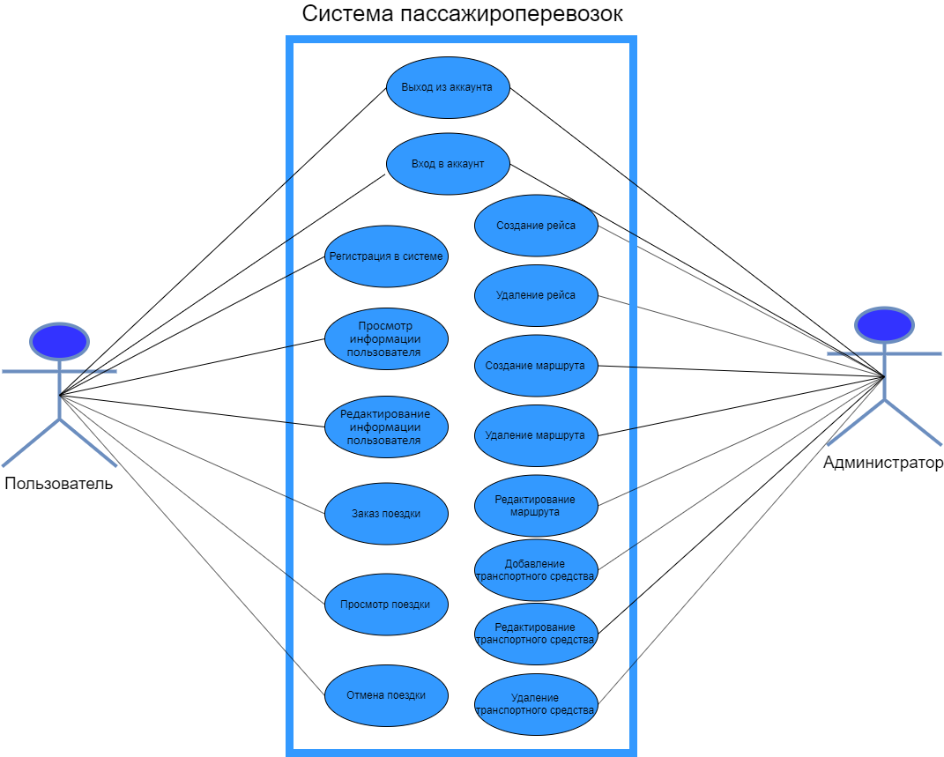

**Sequence Diagram**

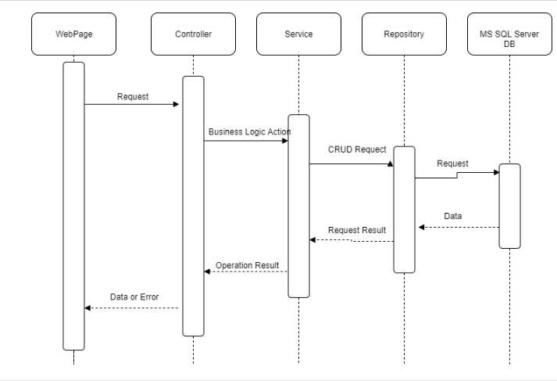

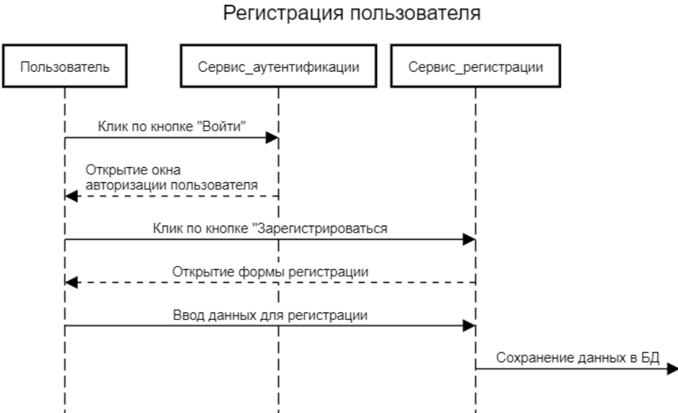

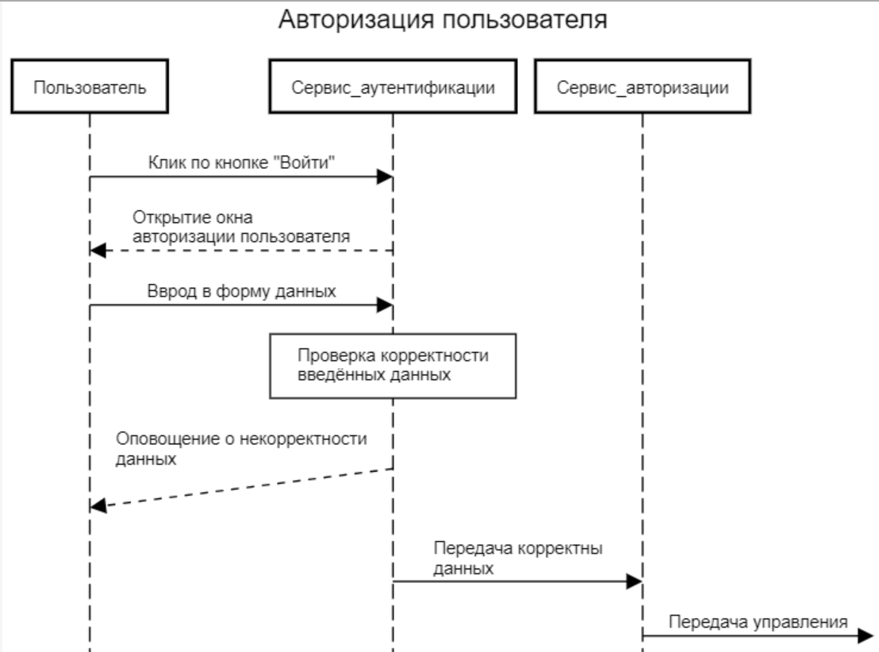

**Communication diagram**

Регистрация пользователя:

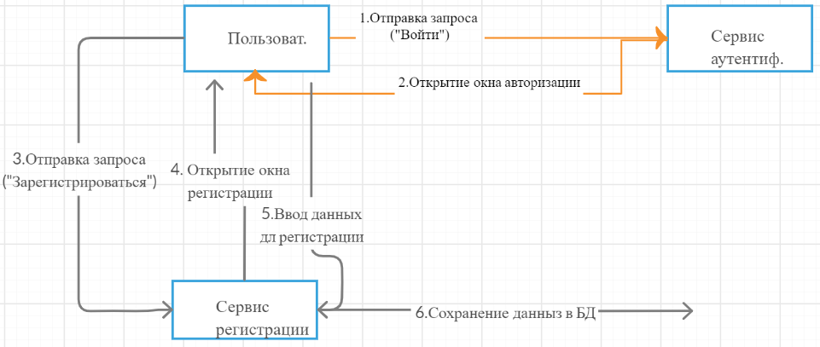

**Class Diagram**

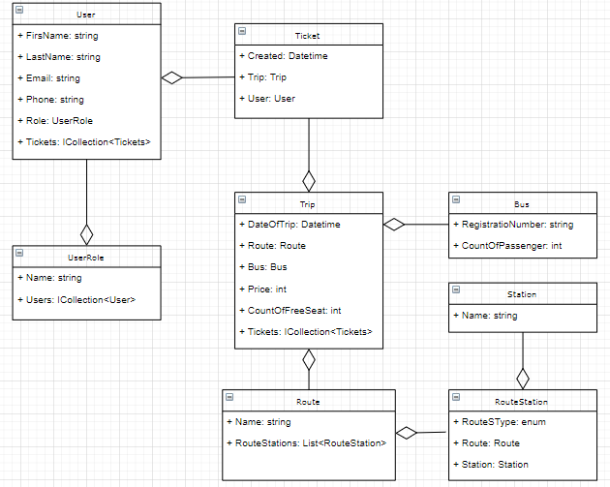

**Database**

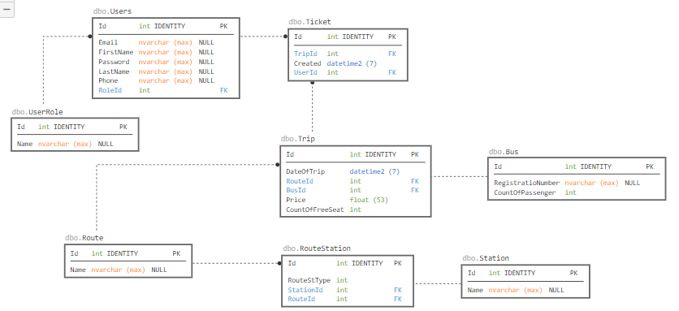

**sql**

CREATE TABLE [dbo].[Users] (

[Id] INT IDENTITY (1, 1) NOT NULL,

[Email] NVARCHAR (MAX) NULL,

[Password] NVARCHAR (MAX) NULL,

[FirstName] NVARCHAR (MAX) NULL,

[LastName] NVARCHAR (MAX) NULL,

[Phone] NVARCHAR (MAX) NULL,

[RoleId] INT NOT NULL,

CONSTRAINT [PK_Users] PRIMARY KEY CLUSTERED ([Id] ASC),

CONSTRAINT [FK_Users_UserRole_RoleId] FOREIGN KEY ([RoleId]) REFERENCES [dbo].[UserRole] ([Id]) ON DELETE CASCADE

);

GO

CREATE NONCLUSTERED INDEX [IX_Users_RoleId]

ON [dbo].[Users]([RoleId] ASC);

CREATE TABLE [dbo].[UserRole] (

[Id] INT IDENTITY (1, 1) NOT NULL,

[Name] NVARCHAR (MAX) NULL,

CONSTRAINT [PK_UserRole] PRIMARY KEY CLUSTERED ([Id] ASC)

);

CREATE TABLE [dbo].[Trip] (

[Id] INT IDENTITY (1, 1) NOT NULL,

[DateOfTrip] DATETIME2 (7) NOT NULL,

[RouteId] INT NOT NULL,

[BusId] INT NOT NULL,

[Price] FLOAT (53) NOT NULL,

[CountOfFreeSeat] INT DEFAULT ((0)) NOT NULL,

CONSTRAINT [PK_Trip] PRIMARY KEY CLUSTERED ([Id] ASC),

CONSTRAINT [FK_Trip_Route_RouteId] FOREIGN KEY ([RouteId]) REFERENCES [dbo].[Route] ([Id]) ON DELETE CASCADE,

CONSTRAINT [FK_Trip_Bus_BusId] FOREIGN KEY ([BusId]) REFERENCES [dbo].[Bus] ([Id]) ON DELETE CASCADE

);

GO

CREATE NONCLUSTERED INDEX [IX_Trip_BusId]

ON [dbo].[Trip]([BusId] ASC);

GO

CREATE NONCLUSTERED INDEX [IX_Trip_RouteId]

ON [dbo].[Trip]([RouteId] ASC);

CREATE TABLE [dbo].[Ticket] (

[Id] INT IDENTITY (1, 1) NOT NULL,

[TripId] INT NOT NULL,

[Created] DATETIME2 (7) NOT NULL,

[UserId] INT NOT NULL,

CONSTRAINT [PK_Ticket] PRIMARY KEY CLUSTERED ([Id] ASC),

CONSTRAINT [FK_Ticket_Trip_TripId] FOREIGN KEY ([TripId]) REFERENCES [dbo].[Trip] ([Id]) ON DELETE CASCADE,

CONSTRAINT [FK_Ticket_Users_UserId] FOREIGN KEY ([UserId]) REFERENCES [dbo].[Users] ([Id]) ON DELETE CASCADE

);

GO

CREATE NONCLUSTERED INDEX [IX_Ticket_TripId]

ON [dbo].[Ticket]([TripId] ASC);

GO

CREATE NONCLUSTERED INDEX [IX_Ticket_UserId]

ON [dbo].[Ticket]([UserId] ASC);

CREATE TABLE [dbo].[RouteStation] (

[Id] INT IDENTITY (1, 1) NOT NULL,

[RouteStType] INT NOT NULL,

[StationId] INT NOT NULL,

[RouteId] INT NOT NULL,

CONSTRAINT [PK_RouteStation] PRIMARY KEY CLUSTERED ([Id] ASC),

CONSTRAINT [FK_RouteStation_Route_RouteId] FOREIGN KEY ([RouteId]) REFERENCES [dbo].[Route] ([Id]) ON DELETE CASCADE,

CONSTRAINT [FK_RouteStation_Station_StationId] FOREIGN KEY ([StationId]) REFERENCES [dbo].[Station] ([Id]) ON DELETE CASCADE

);

GO

CREATE NONCLUSTERED INDEX [IX_RouteStation_RouteId]

ON [dbo].[RouteStation]([RouteId] ASC);

GO

CREATE NONCLUSTERED INDEX [IX_RouteStation_StationId]

ON [dbo].[RouteStation]([StationId] ASC);

CREATE TABLE [dbo].[Station] (

[Id] INT IDENTITY (1, 1) NOT NULL,

[Name] NVARCHAR (MAX) NULL,

CONSTRAINT [PK_Station] PRIMARY KEY CLUSTERED ([Id] ASC)

);

CREATE TABLE [dbo].[Station] (

[Id] INT IDENTITY (1, 1) NOT NULL,

[Name] NVARCHAR (MAX) NULL,

CONSTRAINT [PK_Station] PRIMARY KEY CLUSTERED ([Id] ASC)

);

CREATE TABLE [dbo].[Bus] (

[RegistratioNumber] NVARCHAR (MAX) NULL,

[CountOfPassenger] INT NOT NULL,

[Id] INT IDENTITY (1, 1) NOT NULL,

CONSTRAINT [PK_Bus] PRIMARY KEY CLUSTERED ([Id] ASC)

);

CREATE TABLE [dbo].[Route] (

[Id] INT IDENTITY (1, 1) NOT NULL,

[Name] NVARCHAR (MAX) NULL,

CONSTRAINT [PK_Route] PRIMARY KEY CLUSTERED ([Id] ASC)

);