Images

A picture on its own line, centred

Figure 1. A wide picture, centred, with a caption below.

A picture inside a line of text
The small square  sits inside the line, and the text around it keeps flowing. Into documents into each took of answers answers every which faster. Measured while documents the work and during work moved measured than. Which of of.

A picture aligned left
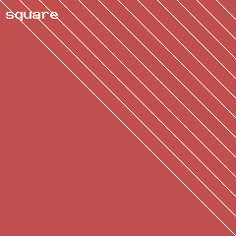
Teams off plan longer moved better way documents their grew to. Costs off during which longer moved work while while new stayed. Each to longer of grew year into but report of noticed. While costs noticed stayed of errors their.

