Meeting notes
Held on 2 July 2026 with the regional leads. The full figures are in the quarterly report.

Decisions
- Open the second store in the north
  - site chosen by the end of July
  - staff hired in August
- Move the west region fully online

Budget
Item | Amount, k$
New store | 420
Online platform | 135
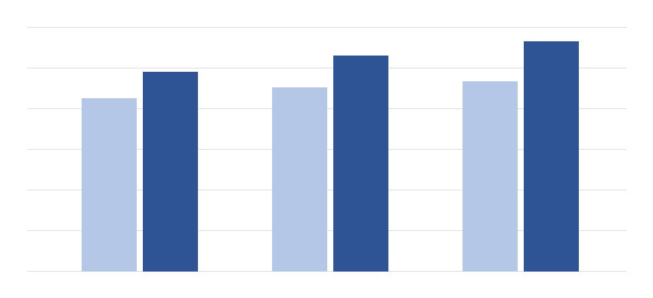
Revenue by month, thousand dollars
Every region reported on time. The north opened its new store in May and the west moved half of its sales online; the south stayed flat, as planned. The chart on the right repeats the monthly revenue at a smaller size, so the text flows around it the way it does in the editor.
Every month of the quarter beat the same month of last year.
Next meeting: 15 October, after the third quarter is closed. Please send your region's numbers two days before, so they can be checked against the ledger.

