Quarterly report
Harbor & Pine Co. · Second quarter 2026

Summary
Revenue reached 3.4 million dollars, 15% more than in the first quarter and ahead of plan. Growth came from the north, where a new store opened, and from online orders in the west. Costs stayed within budget for the third quarter in a row.
- Revenue: 3.4 M$, +15%
- Operating margin: 18%, +2 points
- Online share of sales: 21%
  - twice the share a year ago

Sales by region
Table 1. Revenue by region, thousand dollars
Region | Revenue, k$ |  | Comment
Region | Q1 | Q2 | Comment
North | 1 240 | 1 510 | New store opened in May.
South | 980 | 1 020 | Flat, as planned.
West | 760 | 905 | Online orders doubled.
West | Two stores merged into one
Total | 2 980 | 3 435 | +15.3%

Growth
Quarterly growth is measured as the change of revenue against the previous quarter, where R₁ and R₂ are the revenues of the two quarters:
$g=\frac{R_{2}-R_{1}}{R_{1}}×100\%$
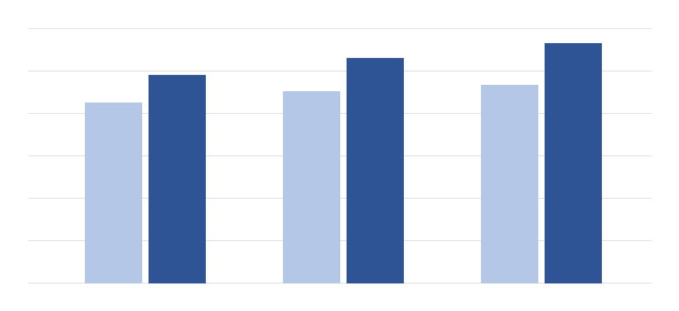
Figure 1. Revenue in April, May and June, thousand dollars: last year (light) and this year (dark)
Every month of the quarter beat the same month of last year. June was the strongest month on record; the summer sale moved part of the July demand into it, so July will look weaker in comparison.

Next steps
- Open the second store in the north
  - Choose the site by the end of July
  - Hire and train the staff in August
- Move the west region fully online
- Report the third quarter by 15 October

Online orders are counted in the region of the warehouse that shipped them.
Since the company started monthly reporting in 2019.

