History file for the deployment and service creation file
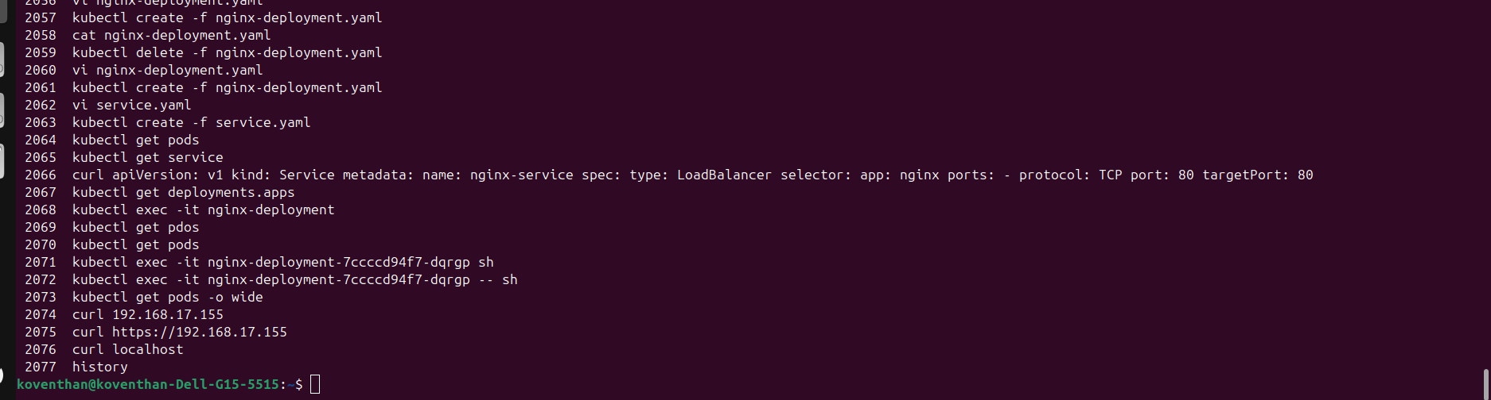
Below details shows the output for EKS gets with eksctl command output

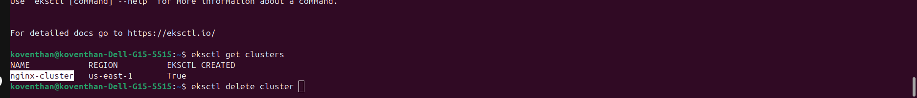

Load balancer Details from the kubernetes service output
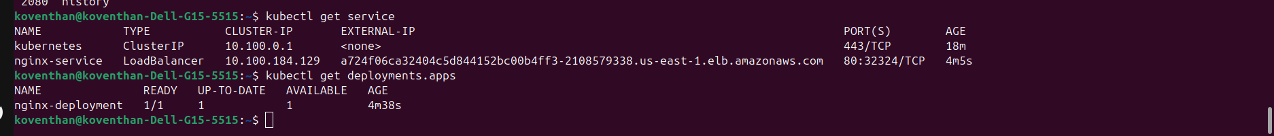

Eksctl command for creating the cluster:
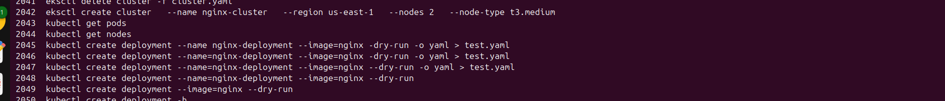

Deployment and service configuration file creation
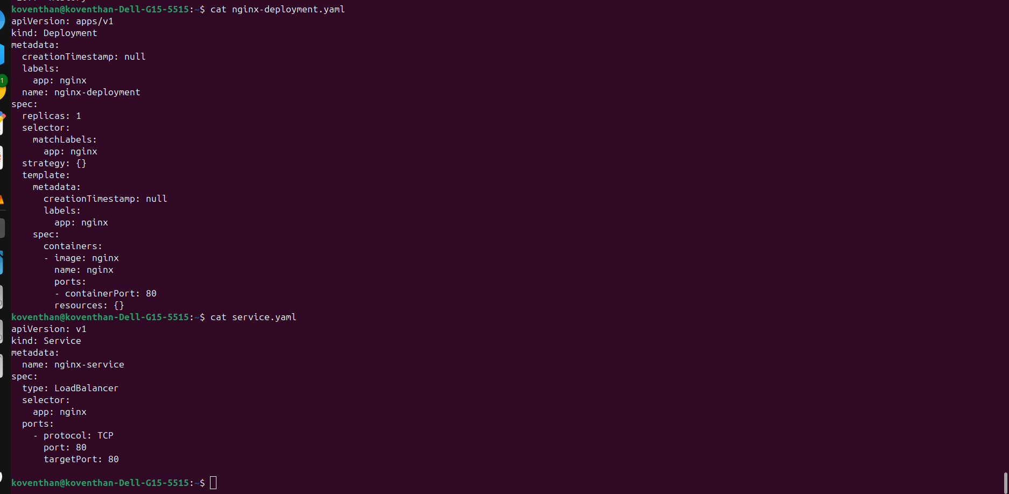

Nginx Output for the site.

