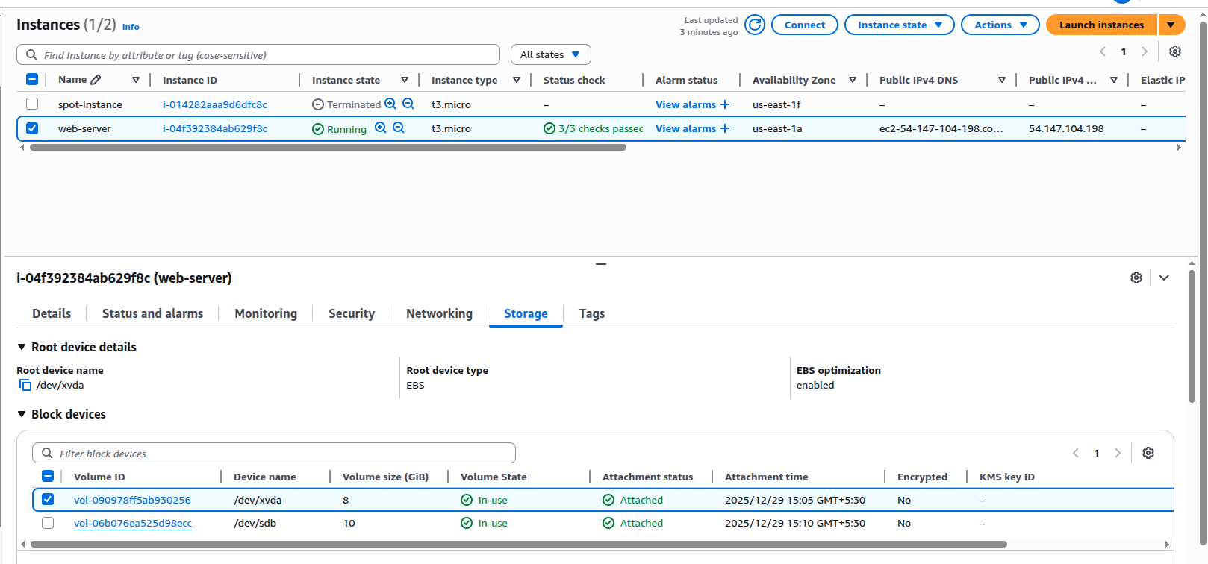
Linux Server with two disks

Snapshots for the webserver with disks

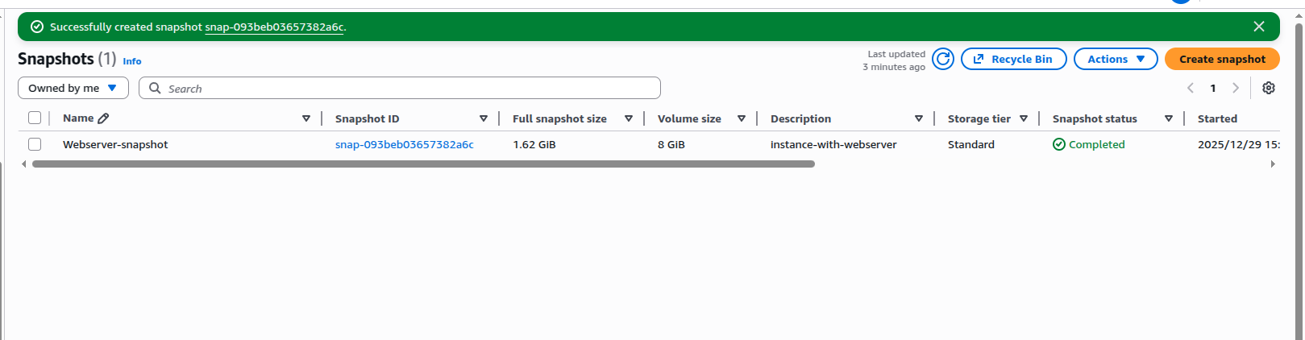

Disk attached to the server from the snapshot taken
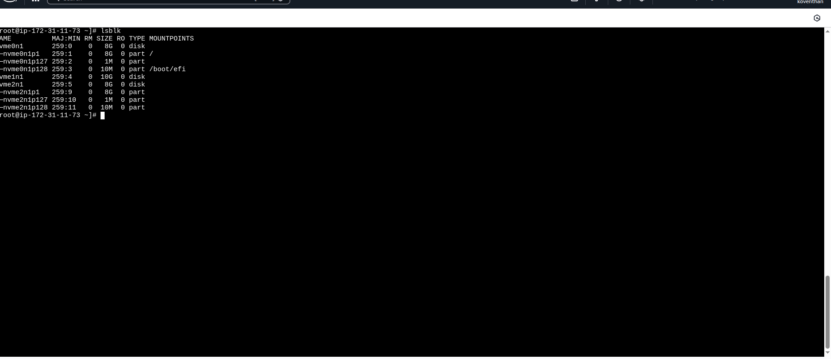

Disks added on the servers
