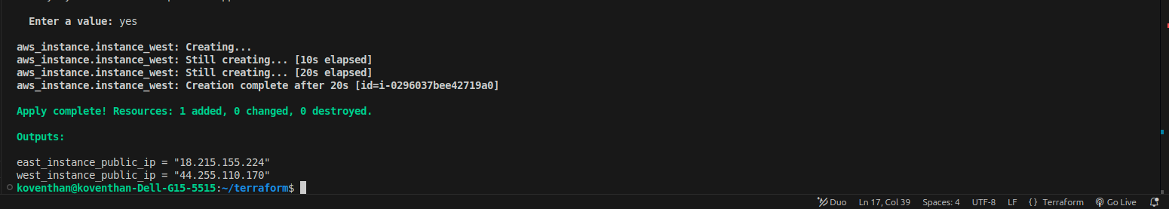
Instance and there ip address

Us-west-2 Location instance and its details
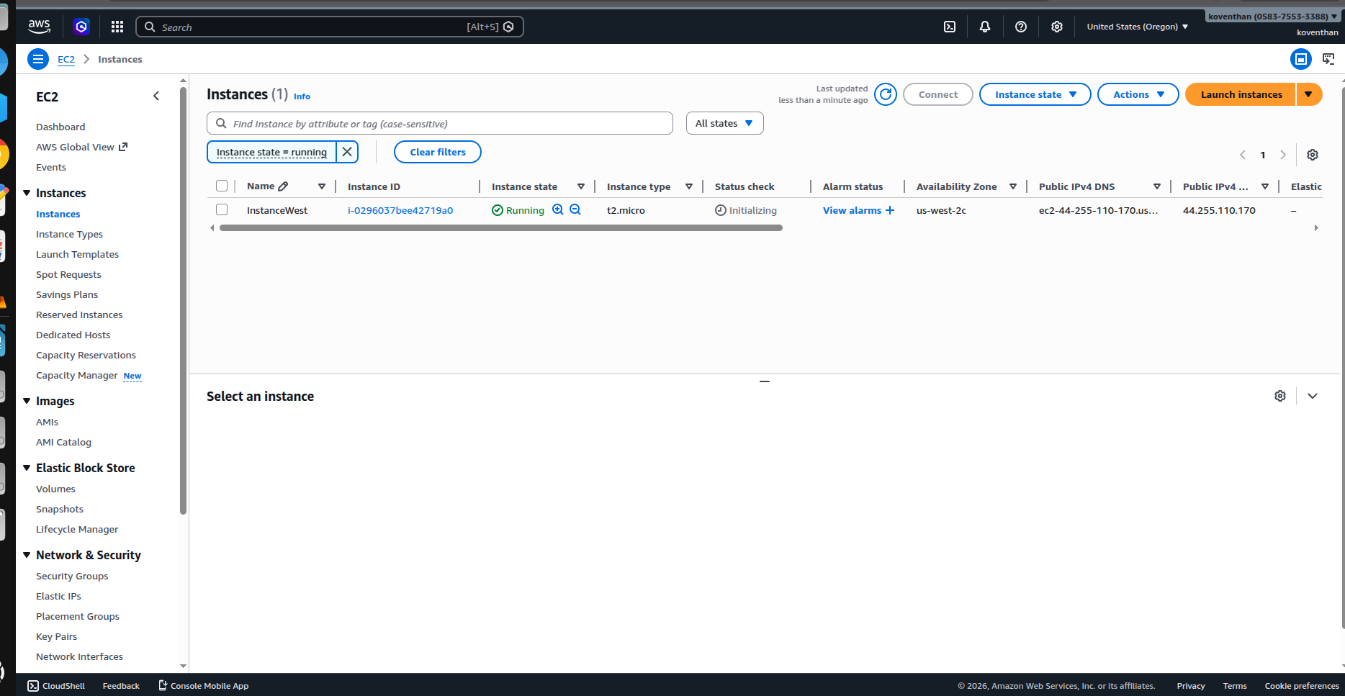
Us-east-1 Location instance and its details

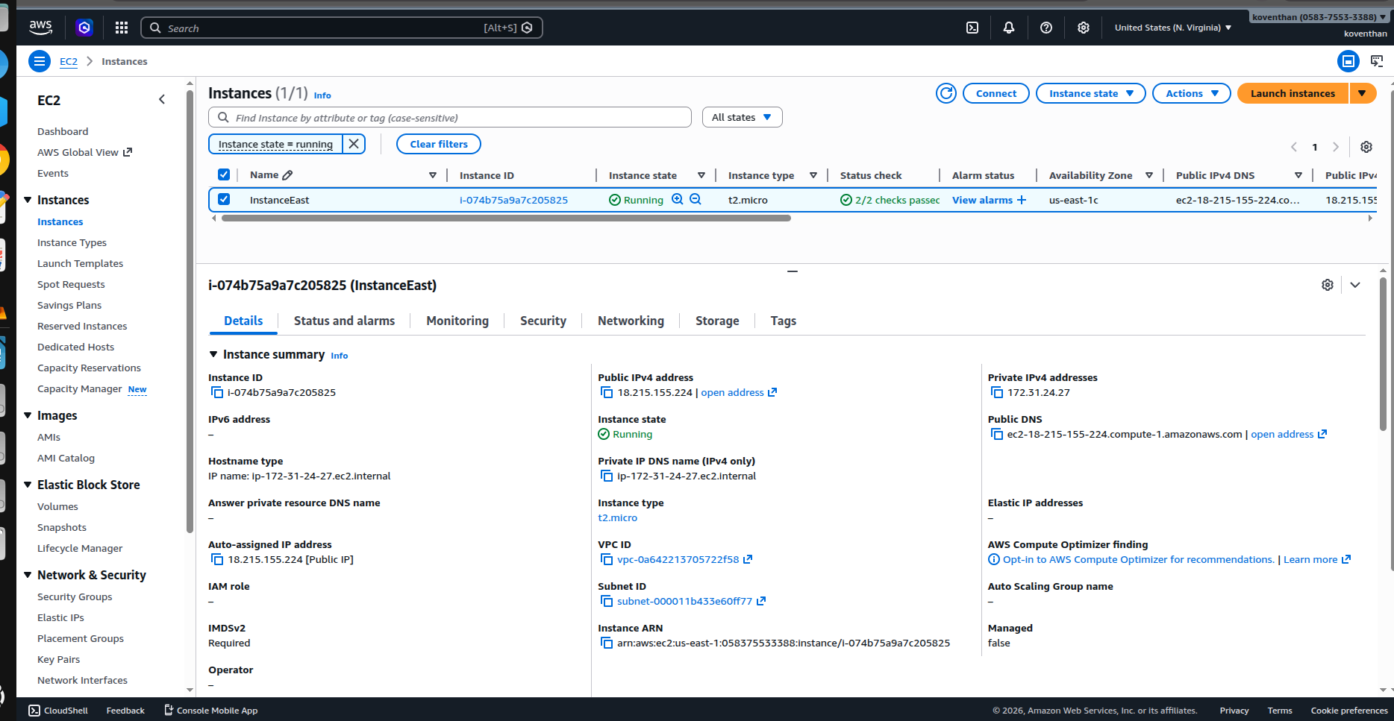

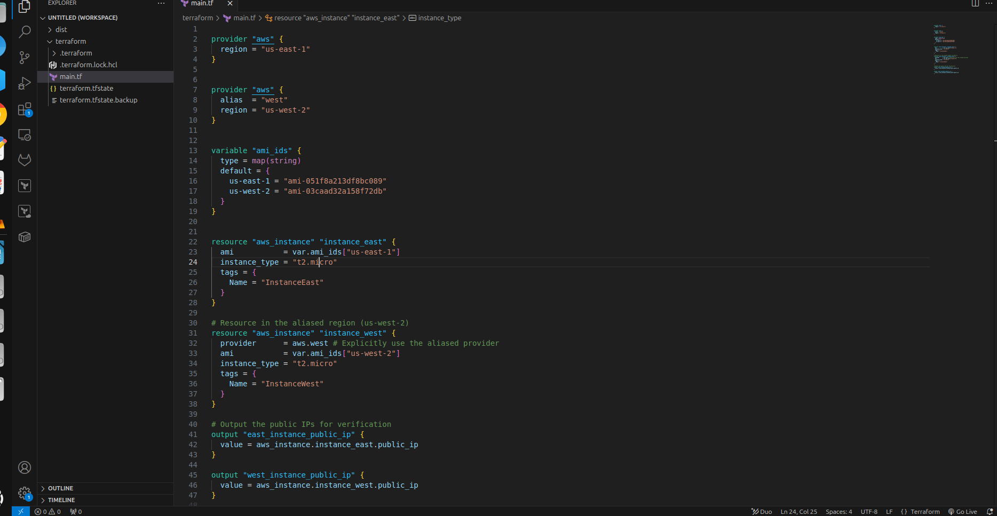
Deploying two instance codes

