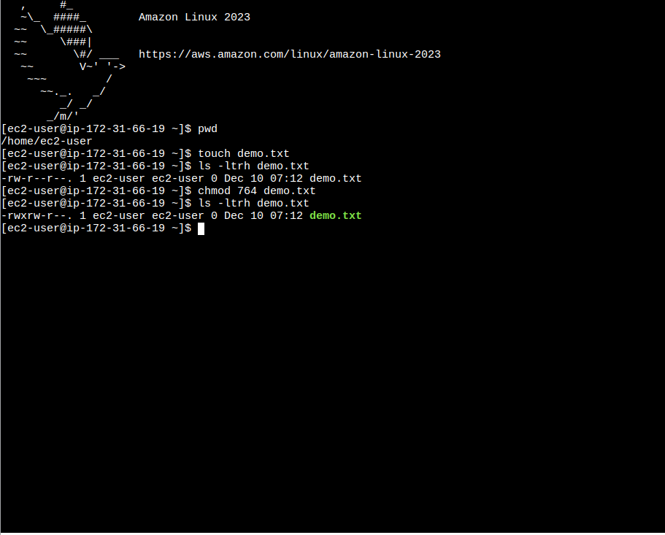
File permission has been set for the particular file as per the user.

