User creation details on Jenkins
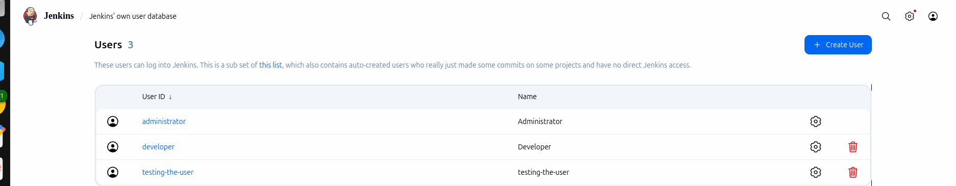

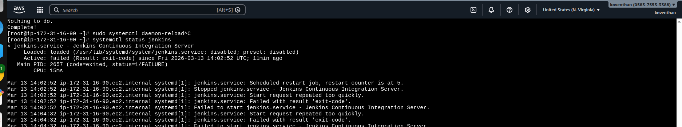
Jenkins Service running on the server

Ec2 creation details
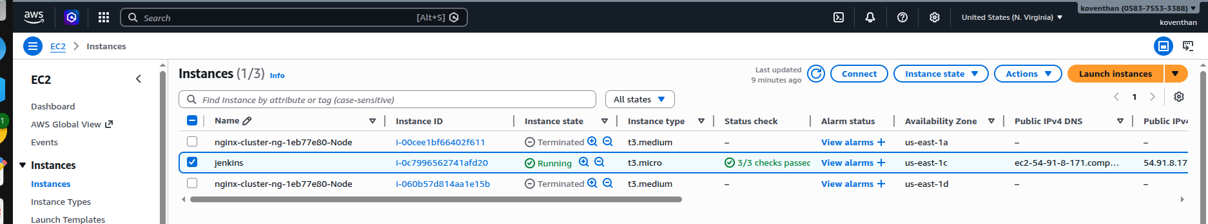

User created on the Jenkins servers
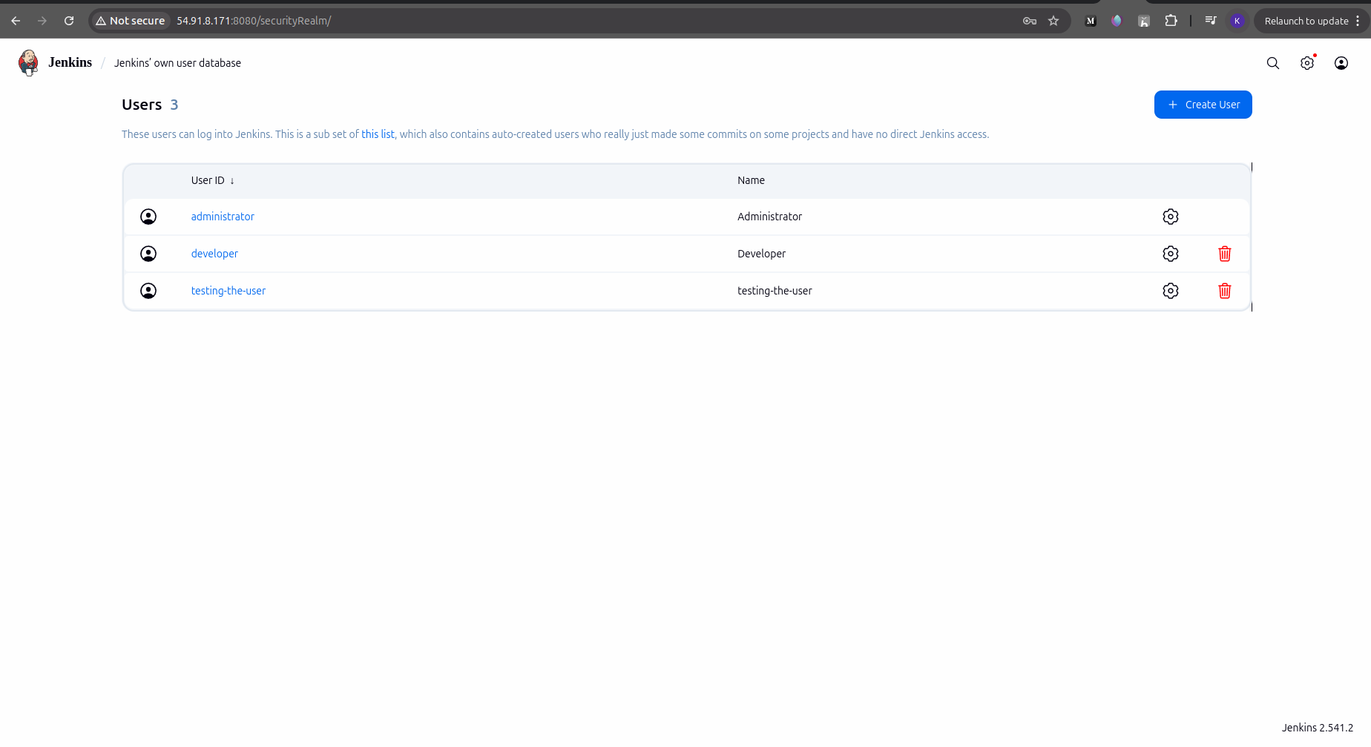

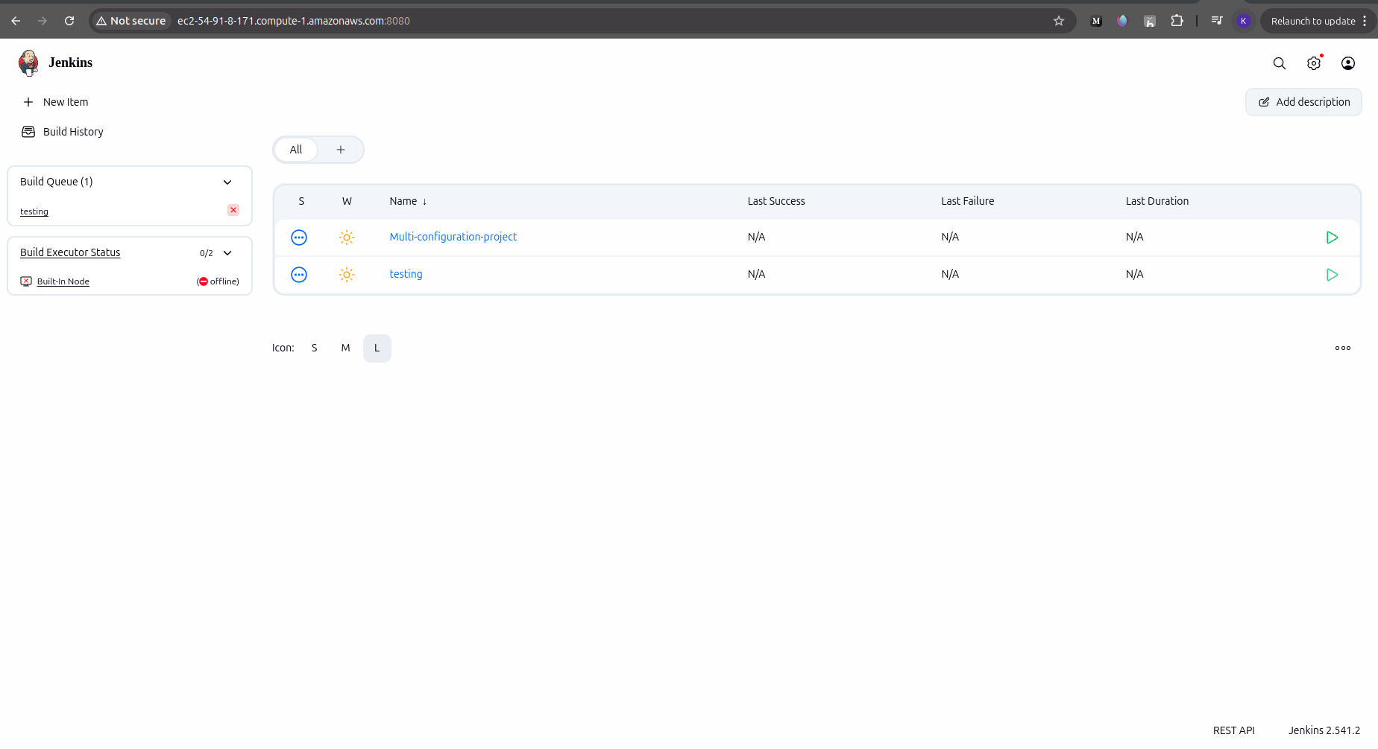
Jenkins Repository details

