Used Nginx for displaying the Instance id and its location US EAST 1
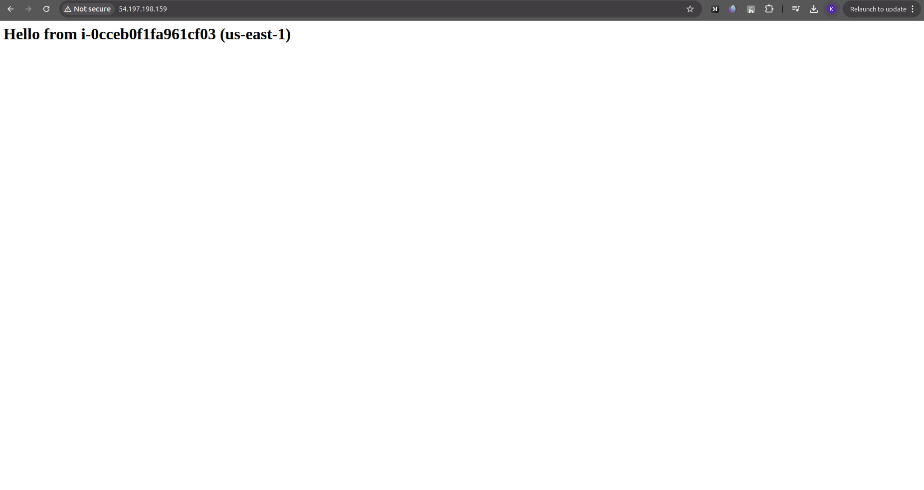

Used Nginx for displaying the Instance id and its location US WEST 2
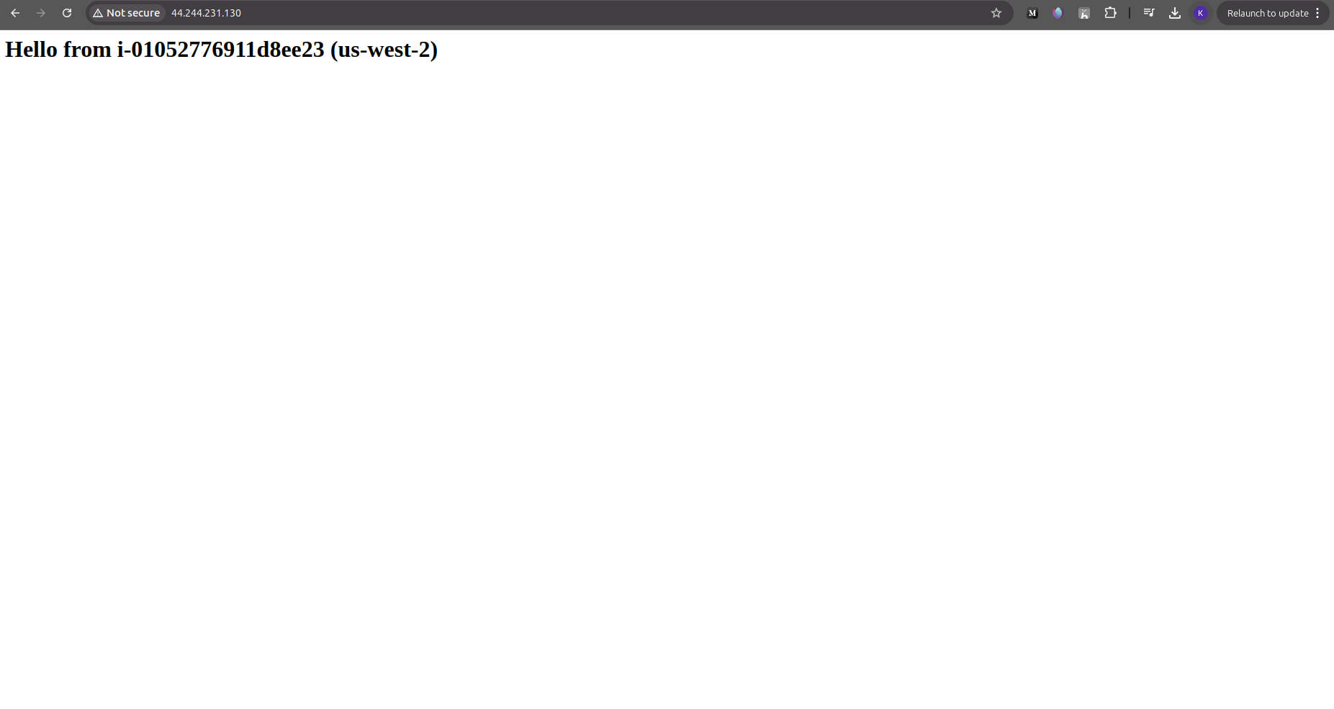

Pasting the entire Code

############################
# Provider Detials
############################
provider "aws" {
region = "us-east-1"
alias = "east"
}

provider "aws" {
region = "us-west-2"
alias = "west"
}

############################
# VPC + Networking (us-east-1)
############################
resource "aws_vpc" "vpc_use1" {
provider = aws.east
cidr_block = "10.0.0.0/16"
enable_dns_support = true
enable_dns_hostnames = true
}

resource "aws_internet_gateway" "igw_use1" {
provider = aws.east
vpc_id = aws_vpc.vpc_use1.id
}

resource "aws_subnet" "subnet_use1" {
provider = aws.east
vpc_id = aws_vpc.vpc_use1.id
cidr_block = "10.0.1.0/24"
map_public_ip_on_launch = true
}

resource "aws_route_table" "rt_use1" {
provider = aws.east
vpc_id = aws_vpc.vpc_use1.id

route {
cidr_block = "0.0.0.0/0"
gateway_id = aws_internet_gateway.igw_use1.id
}
}

resource "aws_route_table_association" "rta_use1" {
provider = aws.east
subnet_id = aws_subnet.subnet_use1.id
route_table_id = aws_route_table.rt_use1.id
}

resource "aws_security_group" "sg_use1" {
provider = aws.east
vpc_id = aws_vpc.vpc_use1.id
name = "allow_ssh_http_use1"

ingress {
from_port = 22
to_port = 22
protocol = "tcp"
cidr_blocks = ["0.0.0.0/0"]
}

ingress {
from_port = 80
to_port = 80
protocol = "tcp"
cidr_blocks = ["0.0.0.0/0"]
}

egress {
from_port = 0
to_port = 0
protocol = "-1"
cidr_blocks = ["0.0.0.0/0"]
}
}

############################
# VPC + Networking (us-west-2)
############################
resource "aws_vpc" "vpc_usw2" {
provider = aws.west
cidr_block = "10.1.0.0/16"
enable_dns_support = true
enable_dns_hostnames = true
}

resource "aws_internet_gateway" "igw_usw2" {
provider = aws.west
vpc_id = aws_vpc.vpc_usw2.id
}

resource "aws_subnet" "subnet_usw2" {
provider = aws.west
vpc_id = aws_vpc.vpc_usw2.id
cidr_block = "10.1.1.0/24"
availability_zone = "us-west-2a"
map_public_ip_on_launch = true
}

resource "aws_route_table" "rt_usw2" {
provider = aws.west
vpc_id = aws_vpc.vpc_usw2.id

route {
cidr_block = "0.0.0.0/0"
gateway_id = aws_internet_gateway.igw_usw2.id
}
}

resource "aws_route_table_association" "rta_usw2" {
provider = aws.west
subnet_id = aws_subnet.subnet_usw2.id
route_table_id = aws_route_table.rt_usw2.id
}

resource "aws_security_group" "sg_usw2" {
provider = aws.west
vpc_id = aws_vpc.vpc_usw2.id
name = "allow_ssh_http_usw2"

ingress {
from_port = 22
to_port = 22
protocol = "tcp"
cidr_blocks = ["0.0.0.0/0"]
}

ingress {
from_port = 80
to_port = 80
protocol = "tcp"
cidr_blocks = ["0.0.0.0/0"]
}

egress {
from_port = 0
to_port = 0
protocol = "-1"
cidr_blocks = ["0.0.0.0/0"]
}
}

############################
# User Data Script
############################
locals {
nginx_userdata_east = <<-EOF
#!/bin/bash
sudo yum install nginx -y
sudo systemctl enable nginx
sudo systemctl start nginx
INSTANCE_ID=$(curl http://169.254.169.254/latest/meta-data/instance-id)
echo "<h1>Hello from $INSTANCE_ID (us-east-1)</h1>" > /usr/share/nginx/html/index.html
EOF
}

locals {
nginx_userdata_west = <<-EOF
#!/bin/bash
sudo yum install nginx -y
sudo systemctl enable nginx
sudo systemctl start nginx
INSTANCE_ID=$(curl http://169.254.169.254/latest/meta-data/instance-id)
echo "<h1>Hello from $INSTANCE_ID (us-west-2)</h1>" > /usr/share/nginx/html/index.html
EOF
}

############################
# EC2 Instances
############################
resource "aws_instance" "ec2_use1" {
provider = aws.east
ami = "ami-02dfbd4ff395f2a1b"
instance_type = "t2.micro"
subnet_id = aws_subnet.subnet_use1.id
vpc_security_group_ids = [aws_security_group.sg_use1.id]
user_data = local.nginx_userdata_east
key_name = "testing"
metadata_options {
http_endpoint = "enabled"
http_tokens = "optional"
}
}

resource "aws_instance" "ec2_usw2" {
provider = aws.west
ami = "ami-03caad32a158f72db"
instance_type = "t2.small"
subnet_id = aws_subnet.subnet_usw2.id
vpc_security_group_ids = [aws_security_group.sg_usw2.id]
user_data = local.nginx_userdata_west
key_name = "testing_west_2"
metadata_options {
http_endpoint = "enabled"
http_tokens = "optional"
}
}

output "use1_public_ip" {
value = aws_instance.ec2_use1.public_ip
}

output "usw2_public_ip" {
value = aws_instance.ec2_usw2.public_ip
}

Terraform Creation Output:
oventhan@koventhan-Dell-G15-5515:~/terraform-2$ terraform apply -auto-approve > details-creation
koventhan@koventhan-Dell-G15-5515:~/terraform-2$ mv details-creation details-creation.txt
koventhan@koventhan-Dell-G15-5515:~/terraform-2$ cat details-creation.txt

Terraform used the selected providers to generate the following execution
plan. Resource actions are indicated with the following symbols:
+ create

Terraform will perform the following actions:

# aws_instance.ec2_use1 will be created
+ resource "aws_instance" "ec2_use1" {
+ ami = "ami-02dfbd4ff395f2a1b"
+ arn = (known after apply)
+ associate_public_ip_address = (known after apply)
+ availability_zone = (known after apply)
+ disable_api_stop = (known after apply)
+ disable_api_termination = (known after apply)
+ ebs_optimized = (known after apply)
+ enable_primary_ipv6 = (known after apply)
+ force_destroy = false
+ get_password_data = false
+ host_id = (known after apply)
+ host_resource_group_arn = (known after apply)
+ iam_instance_profile = (known after apply)
+ id = (known after apply)
+ instance_initiated_shutdown_behavior = (known after apply)
+ instance_lifecycle = (known after apply)
+ instance_state = (known after apply)
+ instance_type = "t2.micro"
+ ipv6_address_count = (known after apply)
+ ipv6_addresses = (known after apply)
+ key_name = "testing"
+ monitoring = (known after apply)
+ outpost_arn = (known after apply)
+ password_data = (known after apply)
+ placement_group = (known after apply)
+ placement_group_id = (known after apply)
+ placement_partition_number = (known after apply)
+ primary_network_interface_id = (known after apply)
+ private_dns = (known after apply)
+ private_ip = (known after apply)
+ public_dns = (known after apply)
+ public_ip = (known after apply)
+ region = "us-east-1"
+ secondary_private_ips = (known after apply)
+ security_groups = (known after apply)
+ source_dest_check = true
+ spot_instance_request_id = (known after apply)
+ subnet_id = (known after apply)
+ tags_all = (known after apply)
+ tenancy = (known after apply)
+ user_data = <<-EOT
#!/bin/bash
sudo yum install nginx -y
sudo systemctl enable nginx
sudo systemctl start nginx
INSTANCE_ID=$(curl http://169.254.169.254/latest/meta-data/instance-id)
echo "<h1>Hello from $INSTANCE_ID (us-east-1)</h1>" > /usr/share/nginx/html/index.html
EOT
+ user_data_base64 = (known after apply)
+ user_data_replace_on_change = false
+ vpc_security_group_ids = (known after apply)

+ capacity_reservation_specification (known after apply)

+ cpu_options (known after apply)

+ ebs_block_device (known after apply)

+ enclave_options (known after apply)

+ ephemeral_block_device (known after apply)

+ instance_market_options (known after apply)

+ maintenance_options (known after apply)

+ metadata_options {
+ http_endpoint = "enabled"
+ http_protocol_ipv6 = "disabled"
+ http_put_response_hop_limit = (known after apply)
+ http_tokens = "optional"
+ instance_metadata_tags = (known after apply)
}

+ network_interface (known after apply)

+ primary_network_interface (known after apply)

+ private_dns_name_options (known after apply)

+ root_block_device (known after apply)

+ secondary_network_interface (known after apply)
}

# aws_instance.ec2_usw2 will be created
+ resource "aws_instance" "ec2_usw2" {
+ ami = "ami-03caad32a158f72db"
+ arn = (known after apply)
+ associate_public_ip_address = (known after apply)
+ availability_zone = (known after apply)
+ disable_api_stop = (known after apply)
+ disable_api_termination = (known after apply)
+ ebs_optimized = (known after apply)
+ enable_primary_ipv6 = (known after apply)
+ force_destroy = false
+ get_password_data = false
+ host_id = (known after apply)
+ host_resource_group_arn = (known after apply)
+ iam_instance_profile = (known after apply)
+ id = (known after apply)
+ instance_initiated_shutdown_behavior = (known after apply)
+ instance_lifecycle = (known after apply)
+ instance_state = (known after apply)
+ instance_type = "t2.small"
+ ipv6_address_count = (known after apply)
+ ipv6_addresses = (known after apply)
+ key_name = "testing_west_2"
+ monitoring = (known after apply)
+ outpost_arn = (known after apply)
+ password_data = (known after apply)
+ placement_group = (known after apply)
+ placement_group_id = (known after apply)
+ placement_partition_number = (known after apply)
+ primary_network_interface_id = (known after apply)
+ private_dns = (known after apply)
+ private_ip = (known after apply)
+ public_dns = (known after apply)
+ public_ip = (known after apply)
+ region = "us-west-2"
+ secondary_private_ips = (known after apply)
+ security_groups = (known after apply)
+ source_dest_check = true
+ spot_instance_request_id = (known after apply)
+ subnet_id = (known after apply)
+ tags_all = (known after apply)
+ tenancy = (known after apply)
+ user_data = <<-EOT
#!/bin/bash
sudo yum install nginx -y
sudo systemctl enable nginx
sudo systemctl start nginx
INSTANCE_ID=$(curl http://169.254.169.254/latest/meta-data/instance-id)
echo "<h1>Hello from $INSTANCE_ID (us-west-2)</h1>" > /usr/share/nginx/html/index.html
EOT
+ user_data_base64 = (known after apply)
+ user_data_replace_on_change = false
+ vpc_security_group_ids = (known after apply)

+ capacity_reservation_specification (known after apply)

+ cpu_options (known after apply)

+ ebs_block_device (known after apply)

+ enclave_options (known after apply)

+ ephemeral_block_device (known after apply)

+ instance_market_options (known after apply)

+ maintenance_options (known after apply)

+ metadata_options {
+ http_endpoint = "enabled"
+ http_protocol_ipv6 = "disabled"
+ http_put_response_hop_limit = (known after apply)
+ http_tokens = "optional"
+ instance_metadata_tags = (known after apply)
}

+ network_interface (known after apply)

+ primary_network_interface (known after apply)

+ private_dns_name_options (known after apply)

+ root_block_device (known after apply)

+ secondary_network_interface (known after apply)
}

# aws_internet_gateway.igw_use1 will be created
+ resource "aws_internet_gateway" "igw_use1" {
+ arn = (known after apply)
+ id = (known after apply)
+ owner_id = (known after apply)
+ region = "us-east-1"
+ tags_all = (known after apply)
+ vpc_id = (known after apply)
}

# aws_internet_gateway.igw_usw2 will be created
+ resource "aws_internet_gateway" "igw_usw2" {
+ arn = (known after apply)
+ id = (known after apply)
+ owner_id = (known after apply)
+ region = "us-west-2"
+ tags_all = (known after apply)
+ vpc_id = (known after apply)
}

# aws_route_table.rt_use1 will be created
+ resource "aws_route_table" "rt_use1" {
+ arn = (known after apply)
+ id = (known after apply)
+ owner_id = (known after apply)
+ propagating_vgws = (known after apply)
+ region = "us-east-1"
+ route = [
+ {
+ cidr_block = "0.0.0.0/0"
+ gateway_id = (known after apply)
# (11 unchanged attributes hidden)
},
]
+ tags_all = (known after apply)
+ vpc_id = (known after apply)
}

# aws_route_table.rt_usw2 will be created
+ resource "aws_route_table" "rt_usw2" {
+ arn = (known after apply)
+ id = (known after apply)
+ owner_id = (known after apply)
+ propagating_vgws = (known after apply)
+ region = "us-west-2"
+ route = [
+ {
+ cidr_block = "0.0.0.0/0"
+ gateway_id = (known after apply)
# (11 unchanged attributes hidden)
},
]
+ tags_all = (known after apply)
+ vpc_id = (known after apply)
}

# aws_route_table_association.rta_use1 will be created
+ resource "aws_route_table_association" "rta_use1" {
+ id = (known after apply)
+ region = "us-east-1"
+ route_table_id = (known after apply)
+ subnet_id = (known after apply)
}

# aws_route_table_association.rta_usw2 will be created
+ resource "aws_route_table_association" "rta_usw2" {
+ id = (known after apply)
+ region = "us-west-2"
+ route_table_id = (known after apply)
+ subnet_id = (known after apply)
}

# aws_security_group.sg_use1 will be created
+ resource "aws_security_group" "sg_use1" {
+ arn = (known after apply)
+ description = "Managed by Terraform"
+ egress = [
+ {
+ cidr_blocks = [
+ "0.0.0.0/0",
]
+ from_port = 0
+ ipv6_cidr_blocks = []
+ prefix_list_ids = []
+ protocol = "-1"
+ security_groups = []
+ self = false
+ to_port = 0
# (1 unchanged attribute hidden)
},
]
+ id = (known after apply)
+ ingress = [
+ {
+ cidr_blocks = [
+ "0.0.0.0/0",
]
+ from_port = 22
+ ipv6_cidr_blocks = []
+ prefix_list_ids = []
+ protocol = "tcp"
+ security_groups = []
+ self = false
+ to_port = 22
# (1 unchanged attribute hidden)
},
+ {
+ cidr_blocks = [
+ "0.0.0.0/0",
]
+ from_port = 80
+ ipv6_cidr_blocks = []
+ prefix_list_ids = []
+ protocol = "tcp"
+ security_groups = []
+ self = false
+ to_port = 80
# (1 unchanged attribute hidden)
},
]
+ name = "allow_ssh_http_use1"
+ name_prefix = (known after apply)
+ owner_id = (known after apply)
+ region = "us-east-1"
+ revoke_rules_on_delete = false
+ tags_all = (known after apply)
+ vpc_id = (known after apply)
}

# aws_security_group.sg_usw2 will be created
+ resource "aws_security_group" "sg_usw2" {
+ arn = (known after apply)
+ description = "Managed by Terraform"
+ egress = [
+ {
+ cidr_blocks = [
+ "0.0.0.0/0",
]
+ from_port = 0
+ ipv6_cidr_blocks = []
+ prefix_list_ids = []
+ protocol = "-1"
+ security_groups = []
+ self = false
+ to_port = 0
# (1 unchanged attribute hidden)
},
]
+ id = (known after apply)
+ ingress = [
+ {
+ cidr_blocks = [
+ "0.0.0.0/0",
]
+ from_port = 22
+ ipv6_cidr_blocks = []
+ prefix_list_ids = []
+ protocol = "tcp"
+ security_groups = []
+ self = false
+ to_port = 22
# (1 unchanged attribute hidden)
},
+ {
+ cidr_blocks = [
+ "0.0.0.0/0",
]
+ from_port = 80
+ ipv6_cidr_blocks = []
+ prefix_list_ids = []
+ protocol = "tcp"
+ security_groups = []
+ self = false
+ to_port = 80
# (1 unchanged attribute hidden)
},
]
+ name = "allow_ssh_http_usw2"
+ name_prefix = (known after apply)
+ owner_id = (known after apply)
+ region = "us-west-2"
+ revoke_rules_on_delete = false
+ tags_all = (known after apply)
+ vpc_id = (known after apply)
}

# aws_subnet.subnet_use1 will be created
+ resource "aws_subnet" "subnet_use1" {
+ arn = (known after apply)
+ assign_ipv6_address_on_creation = false
+ availability_zone = (known after apply)
+ availability_zone_id = (known after apply)
+ cidr_block = "10.0.1.0/24"
+ enable_dns64 = false
+ enable_resource_name_dns_a_record_on_launch = false
+ enable_resource_name_dns_aaaa_record_on_launch = false
+ id = (known after apply)
+ ipv6_cidr_block = (known after apply)
+ ipv6_cidr_block_association_id = (known after apply)
+ ipv6_native = false
+ map_public_ip_on_launch = true
+ owner_id = (known after apply)
+ private_dns_hostname_type_on_launch = (known after apply)
+ region = "us-east-1"
+ tags_all = (known after apply)
+ vpc_id = (known after apply)
}

# aws_subnet.subnet_usw2 will be created
+ resource "aws_subnet" "subnet_usw2" {
+ arn = (known after apply)
+ assign_ipv6_address_on_creation = false
+ availability_zone = "us-west-2a"
+ availability_zone_id = (known after apply)
+ cidr_block = "10.1.1.0/24"
+ enable_dns64 = false
+ enable_resource_name_dns_a_record_on_launch = false
+ enable_resource_name_dns_aaaa_record_on_launch = false
+ id = (known after apply)
+ ipv6_cidr_block = (known after apply)
+ ipv6_cidr_block_association_id = (known after apply)
+ ipv6_native = false
+ map_public_ip_on_launch = true
+ owner_id = (known after apply)
+ private_dns_hostname_type_on_launch = (known after apply)
+ region = "us-west-2"
+ tags_all = (known after apply)
+ vpc_id = (known after apply)
}

# aws_vpc.vpc_use1 will be created
+ resource "aws_vpc" "vpc_use1" {
+ arn = (known after apply)
+ cidr_block = "10.0.0.0/16"
+ default_network_acl_id = (known after apply)
+ default_route_table_id = (known after apply)
+ default_security_group_id = (known after apply)
+ dhcp_options_id = (known after apply)
+ enable_dns_hostnames = true
+ enable_dns_support = true
+ enable_network_address_usage_metrics = (known after apply)
+ id = (known after apply)
+ instance_tenancy = "default"
+ ipv6_association_id = (known after apply)
+ ipv6_cidr_block = (known after apply)
+ ipv6_cidr_block_network_border_group = (known after apply)
+ main_route_table_id = (known after apply)
+ owner_id = (known after apply)
+ region = "us-east-1"
+ tags_all = (known after apply)
}

# aws_vpc.vpc_usw2 will be created
+ resource "aws_vpc" "vpc_usw2" {
+ arn = (known after apply)
+ cidr_block = "10.1.0.0/16"
+ default_network_acl_id = (known after apply)
+ default_route_table_id = (known after apply)
+ default_security_group_id = (known after apply)
+ dhcp_options_id = (known after apply)
+ enable_dns_hostnames = true
+ enable_dns_support = true
+ enable_network_address_usage_metrics = (known after apply)
+ id = (known after apply)
+ instance_tenancy = "default"
+ ipv6_association_id = (known after apply)
+ ipv6_cidr_block = (known after apply)
+ ipv6_cidr_block_network_border_group = (known after apply)
+ main_route_table_id = (known after apply)
+ owner_id = (known after apply)
+ region = "us-west-2"
+ tags_all = (known after apply)
}

Plan: 14 to add, 0 to change, 0 to destroy.

Changes to Outputs:
+ use1_public_ip = (known after apply)
+ usw2_public_ip = (known after apply)
aws_vpc.vpc_use1: Creating...
aws_vpc.vpc_usw2: Creating...
aws_vpc.vpc_use1: Creation complete after 5s [id=vpc-05cc70cbf45637dc6]
aws_internet_gateway.igw_use1: Creating...
aws_subnet.subnet_use1: Creating...
aws_security_group.sg_use1: Creating...
aws_vpc.vpc_usw2: Creation complete after 5s [id=vpc-036e59ba18162267e]
aws_internet_gateway.igw_usw2: Creating...
aws_subnet.subnet_usw2: Creating...
aws_security_group.sg_usw2: Creating...
aws_internet_gateway.igw_use1: Creation complete after 1s [id=igw-0e671db6ce67994b4]
aws_route_table.rt_use1: Creating...
aws_internet_gateway.igw_usw2: Creation complete after 2s [id=igw-0e7b5849b6e7df47a]
aws_route_table.rt_usw2: Creating...
aws_route_table.rt_use1: Creation complete after 3s [id=rtb-0d6cd65b5a3ad900e]
aws_route_table.rt_usw2: Creation complete after 3s [id=rtb-04cd4d86aa9c2447d]
aws_security_group.sg_use1: Creation complete after 5s [id=sg-02456a48d39349a22]
aws_security_group.sg_usw2: Creation complete after 6s [id=sg-00ec587c5931d1e31]
aws_subnet.subnet_use1: Still creating... [10s elapsed]
aws_subnet.subnet_usw2: Still creating... [10s elapsed]
aws_subnet.subnet_use1: Creation complete after 12s [id=subnet-08b4aa1fdc2b822bb]
aws_route_table_association.rta_use1: Creating...
aws_instance.ec2_use1: Creating...
aws_subnet.subnet_usw2: Creation complete after 13s [id=subnet-03085fb8080969f47]
aws_route_table_association.rta_usw2: Creating...
aws_instance.ec2_usw2: Creating...
aws_route_table_association.rta_use1: Creation complete after 1s [id=rtbassoc-0c37ca186a61b4f90]
aws_route_table_association.rta_usw2: Creation complete after 1s [id=rtbassoc-0d15d507696165087]
aws_instance.ec2_use1: Still creating... [10s elapsed]
aws_instance.ec2_usw2: Still creating... [10s elapsed]
aws_instance.ec2_usw2: Creation complete after 16s [id=i-04953852a8a030f35]
aws_instance.ec2_use1: Still creating... [20s elapsed]
aws_instance.ec2_use1: Creation complete after 26s [id=i-0cb12d1ed94a33657]

Apply complete! Resources: 14 added, 0 changed, 0 destroyed.

Outputs:

use1_public_ip = "54.87.45.214"
usw2_public_ip = "44.249.39.254"

