Server with name testserver2 open with Loadbalancer

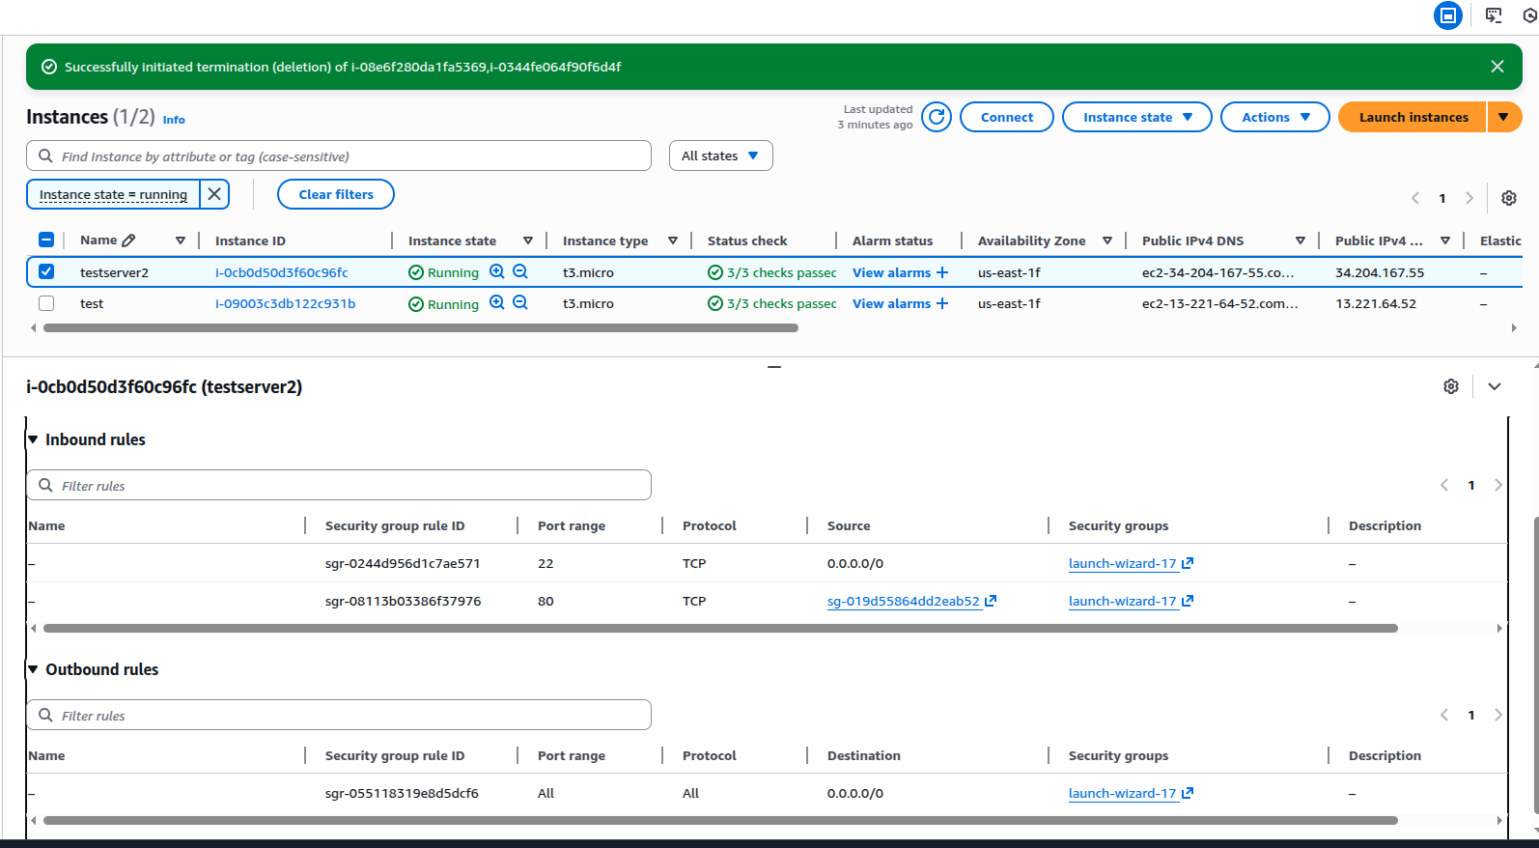

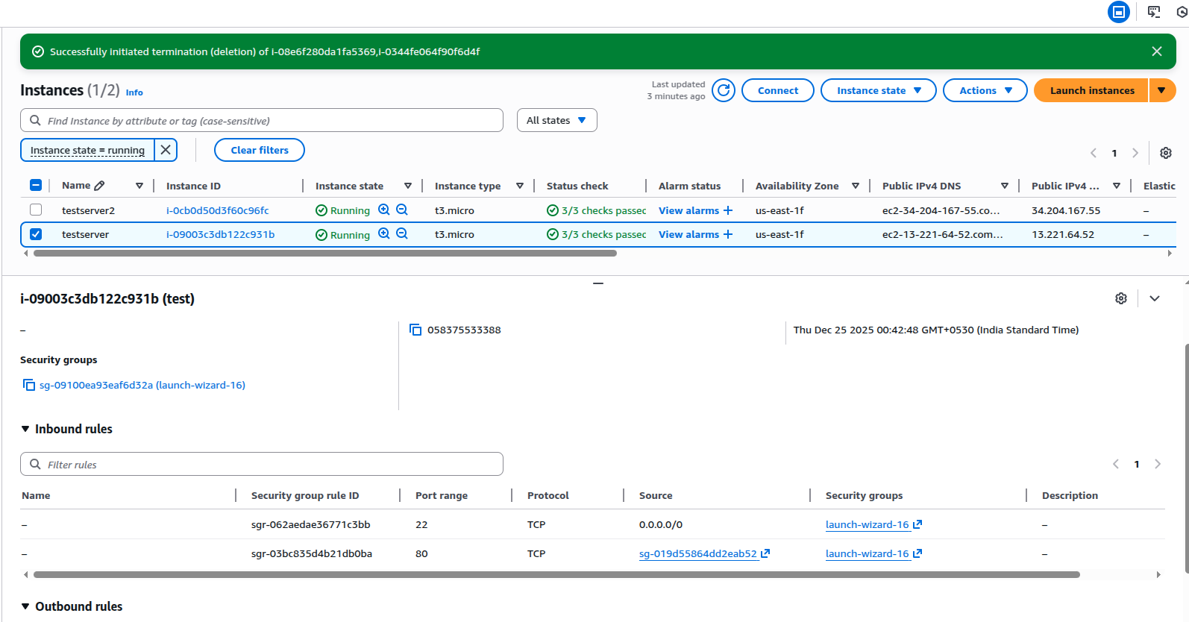
Server with name testserver open with Loadbalancer

Loadbalancer for the two servers
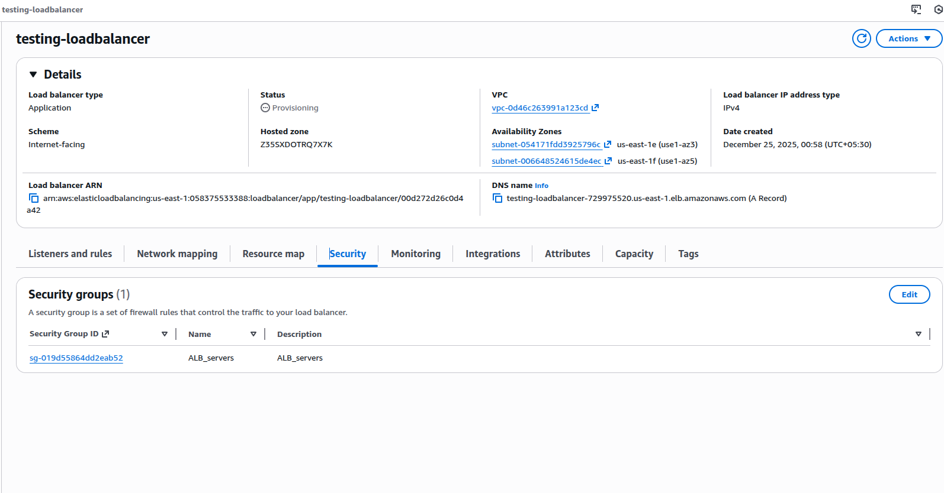

1st instance Loadbalancer output

2nd Instance Loadbalancer output

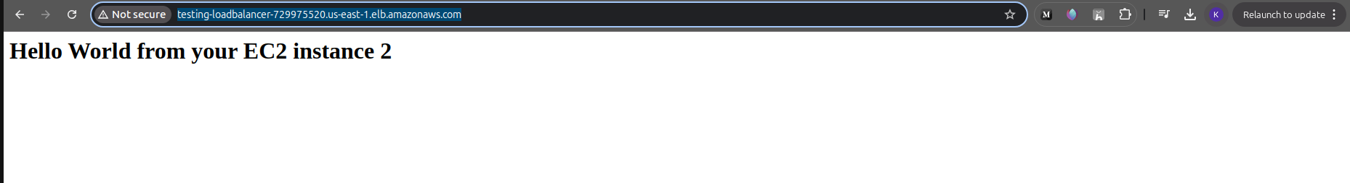

Bucket with no public access

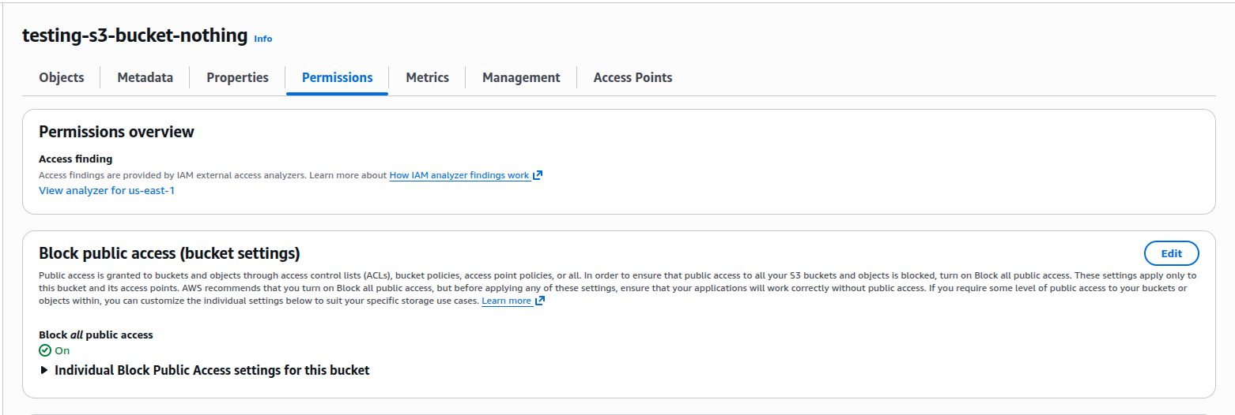
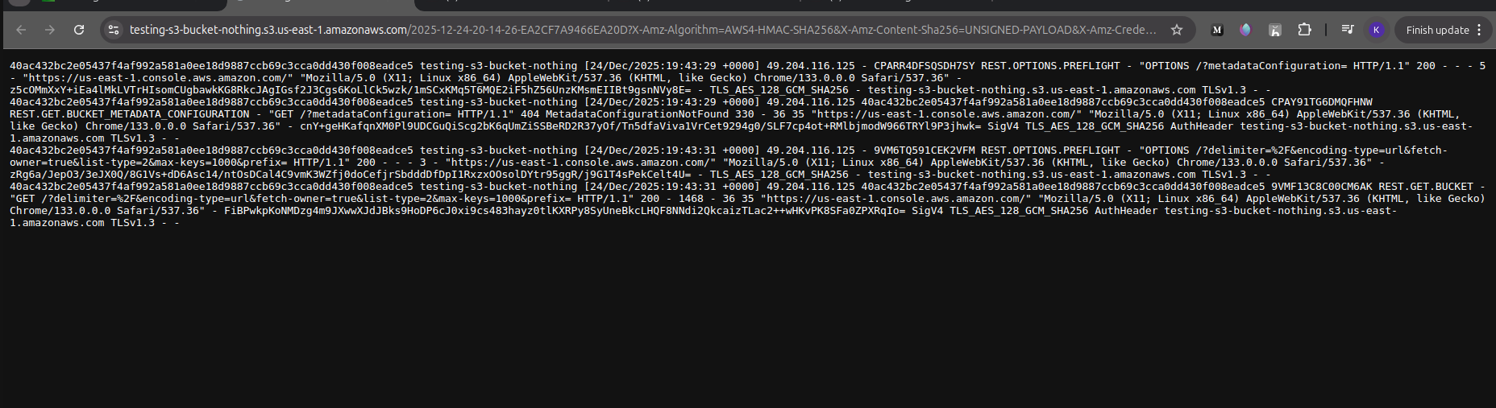
File content from the bucket

