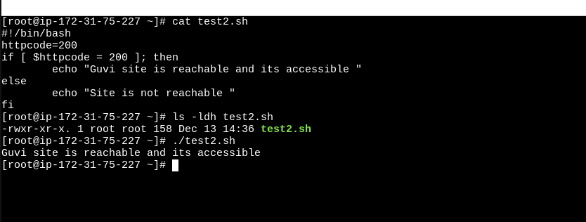
File has been created and permission has been set and script works fine for finding the site reachable

Using sed command to replace the content of line when it meets a given word is present.

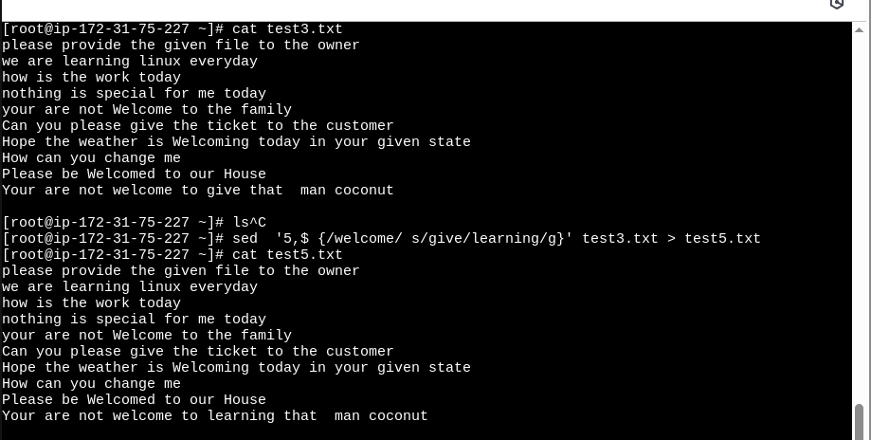
History

