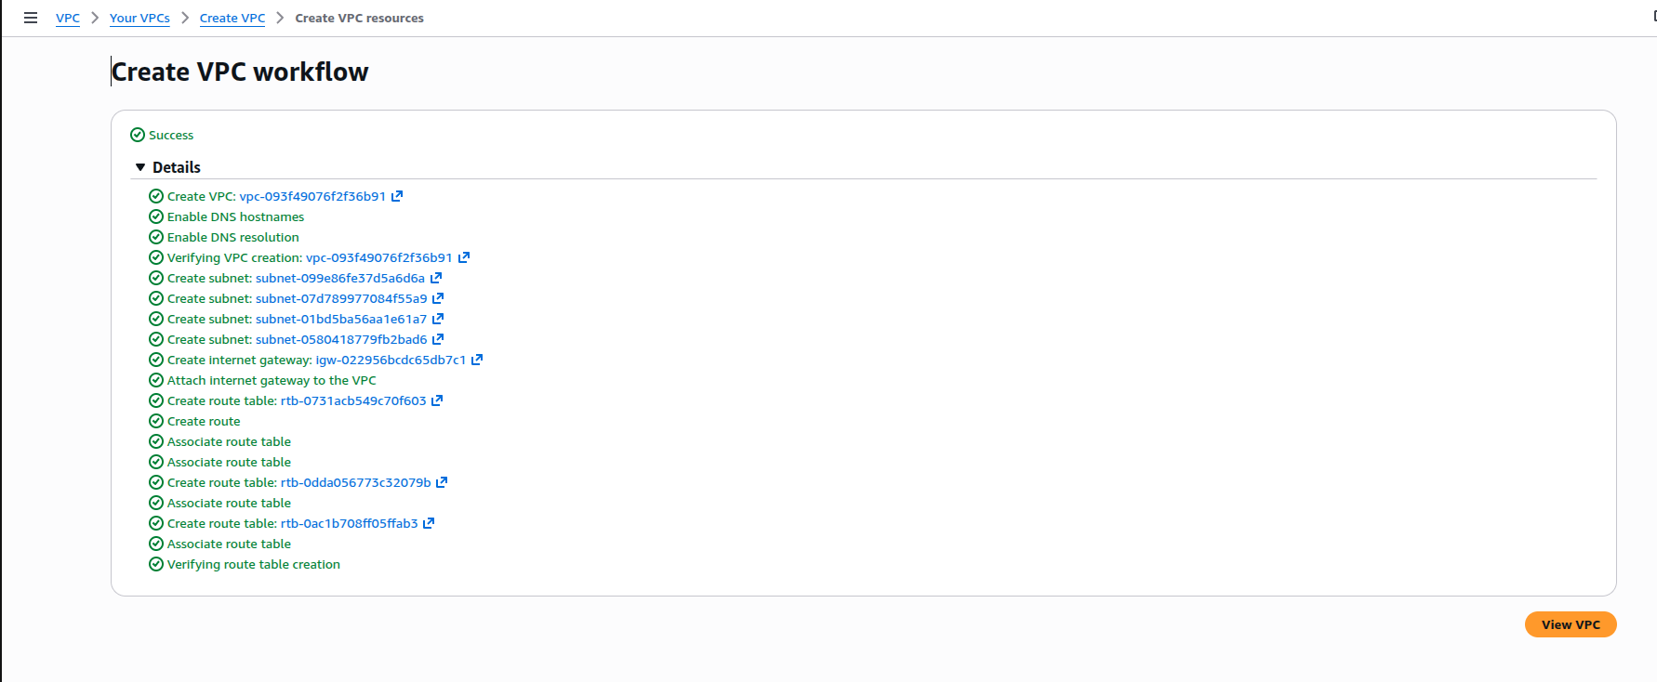
Created VPC with two public subenet and private subnets.

Server is in the public subnet and its in the same new created vpc.

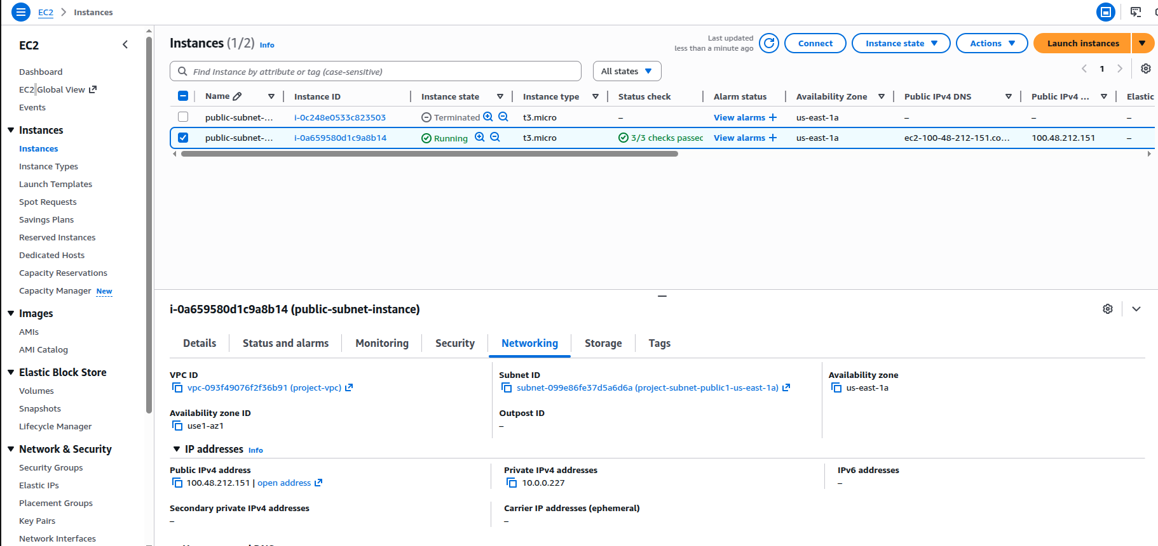
Able to login to the instance

