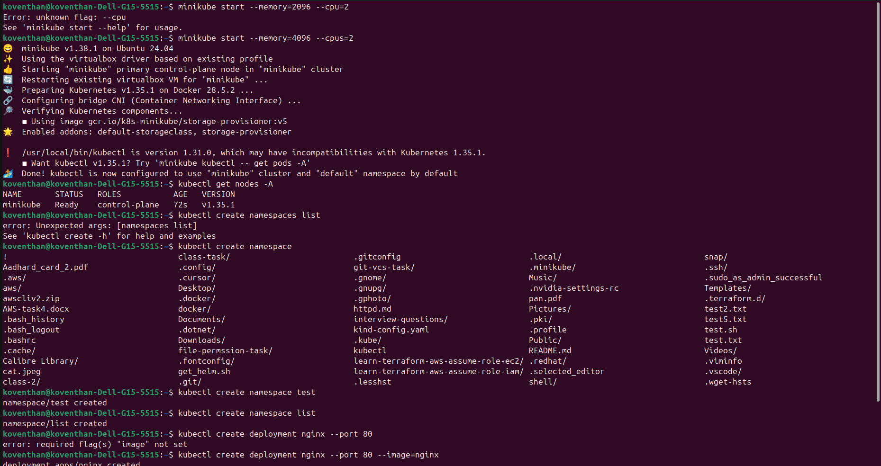
Minikube creation and created a namespace and deployments

Created a nginx deployment and exposed the service and enabled metallb addons

