History of the Command executed for publishing the docker container

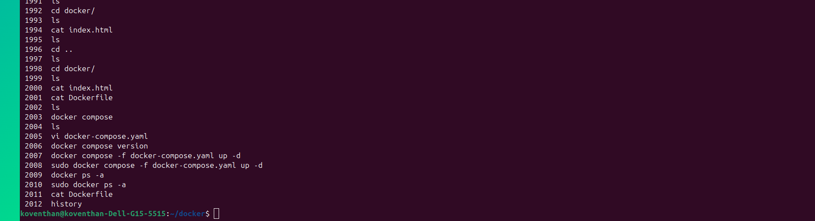

Output of the container from the internet

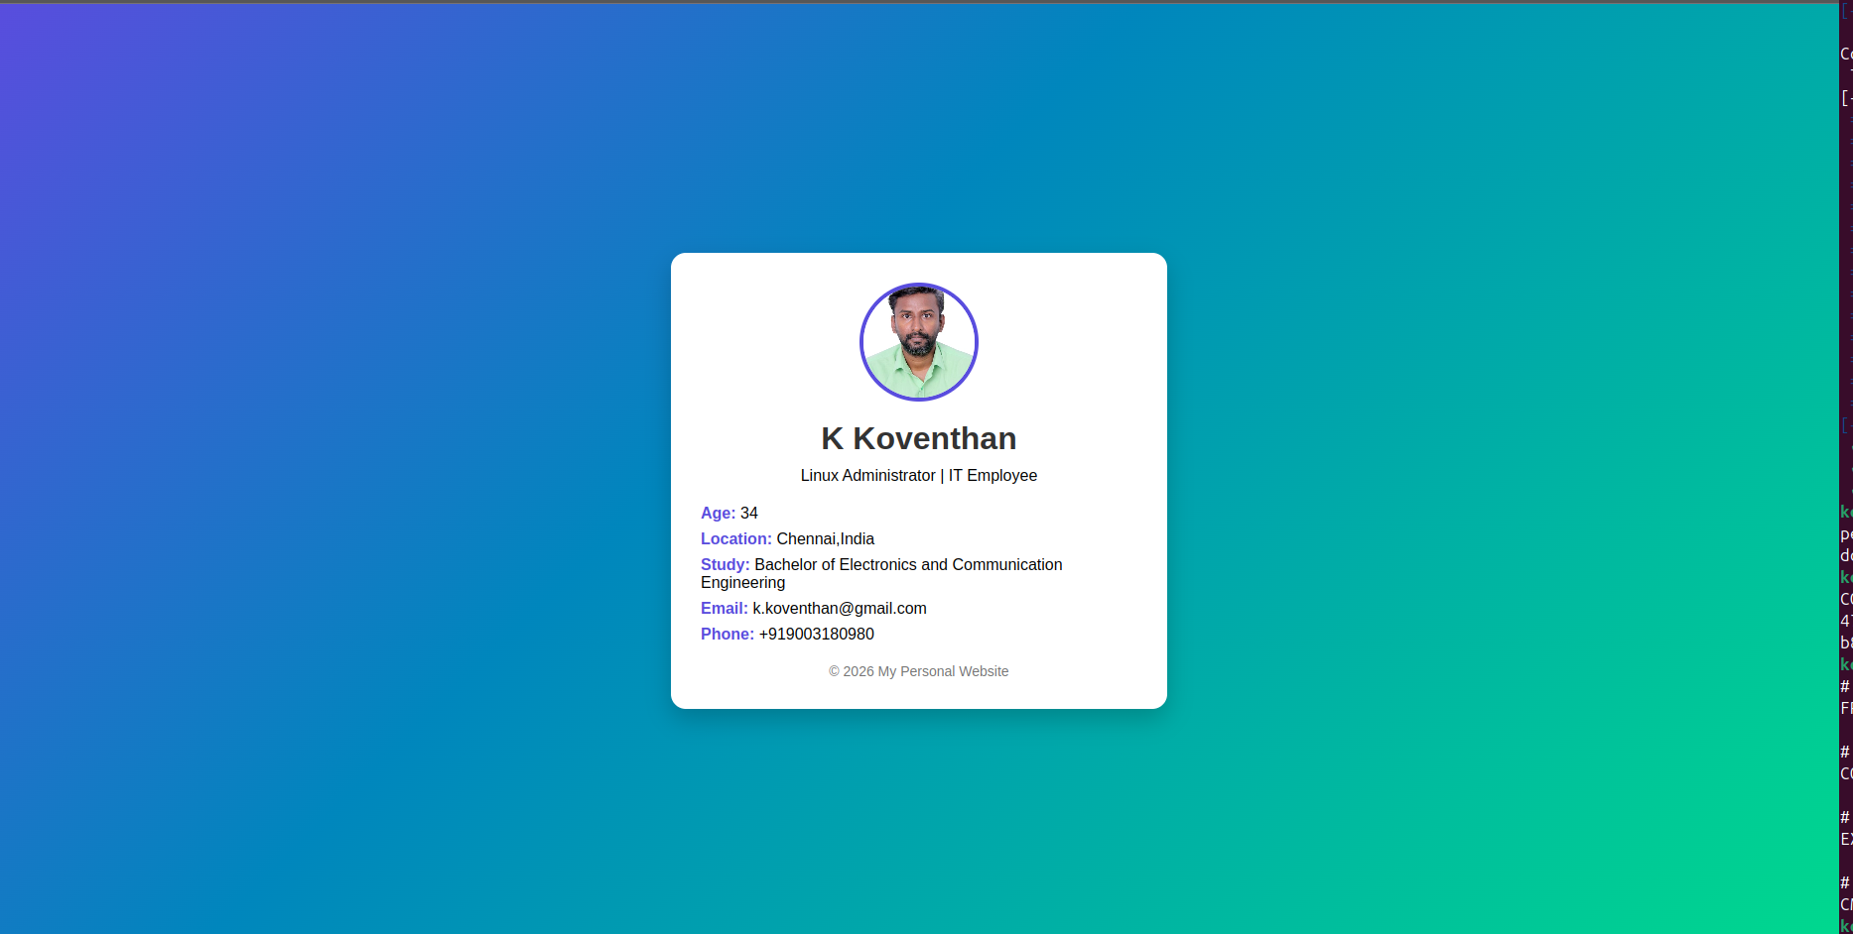

Dockerfile contents

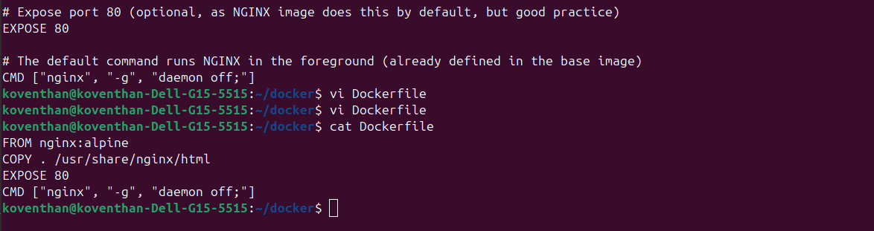
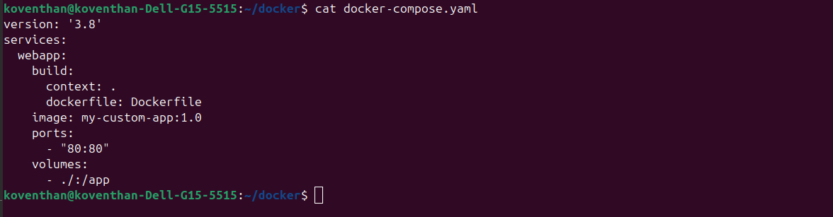
Docker compose contents

