Have installed the Jenkins package and made the ec2 instance up
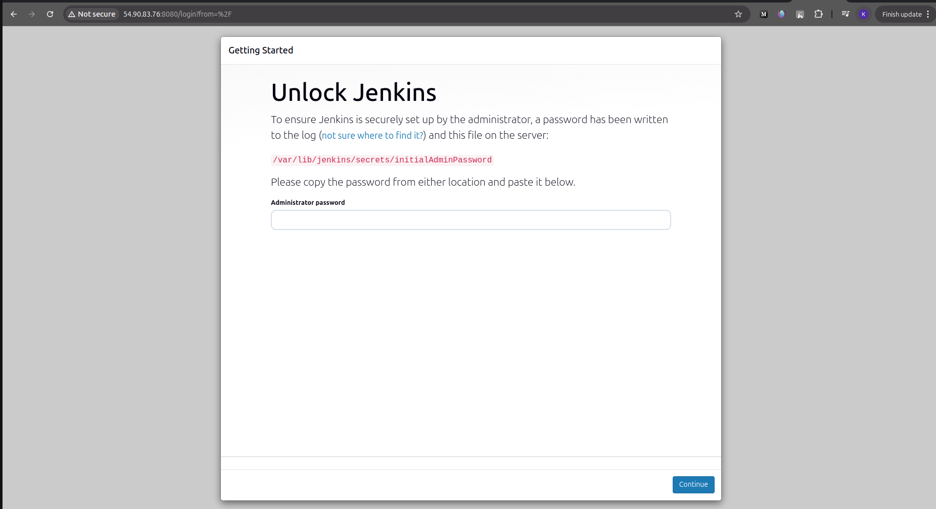

First time Credentials are shared on the server.

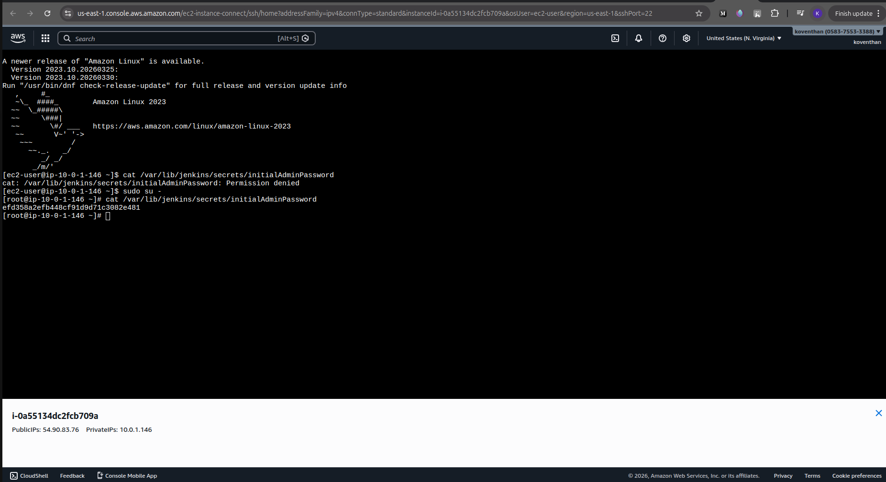

With providing the admin credentials and the password,started and logged into the Jenkins servers

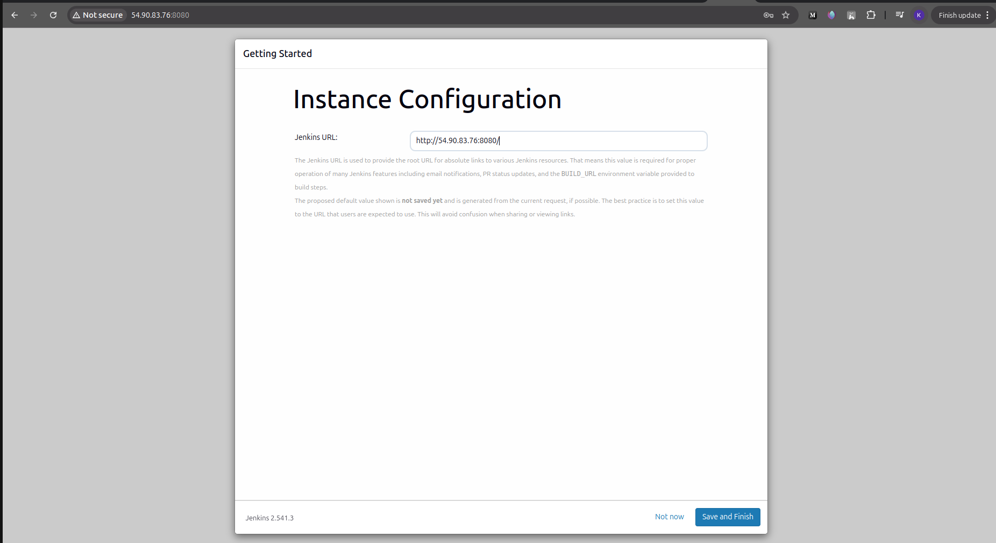

Have created the dockerregistry and AWS Credentials for docker login and EKS login.
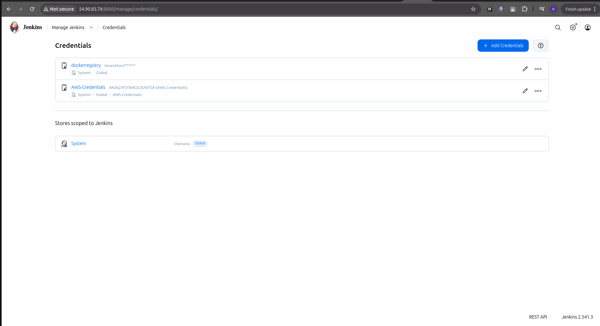

Next two screenshots are for the Github project and the Jenkins Pipeline Details added for the Git

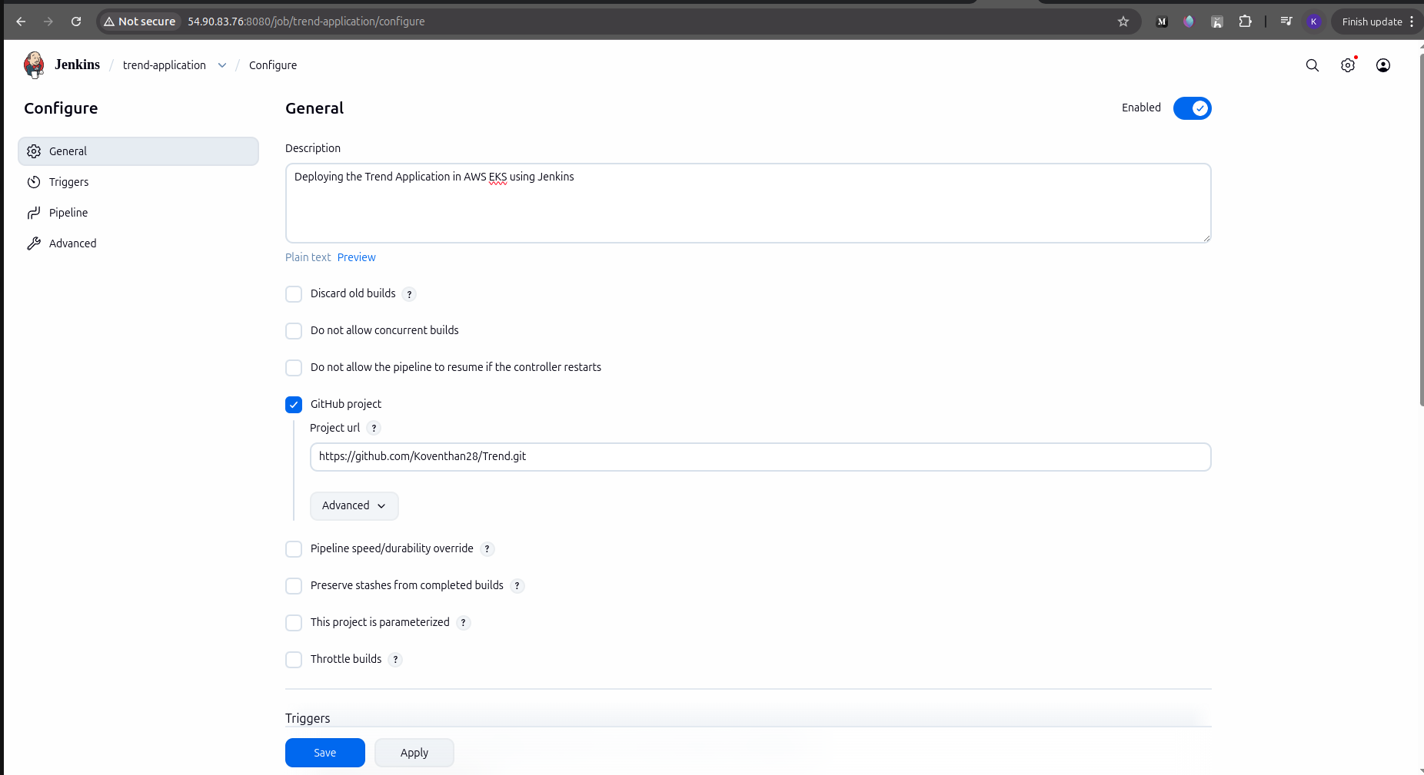

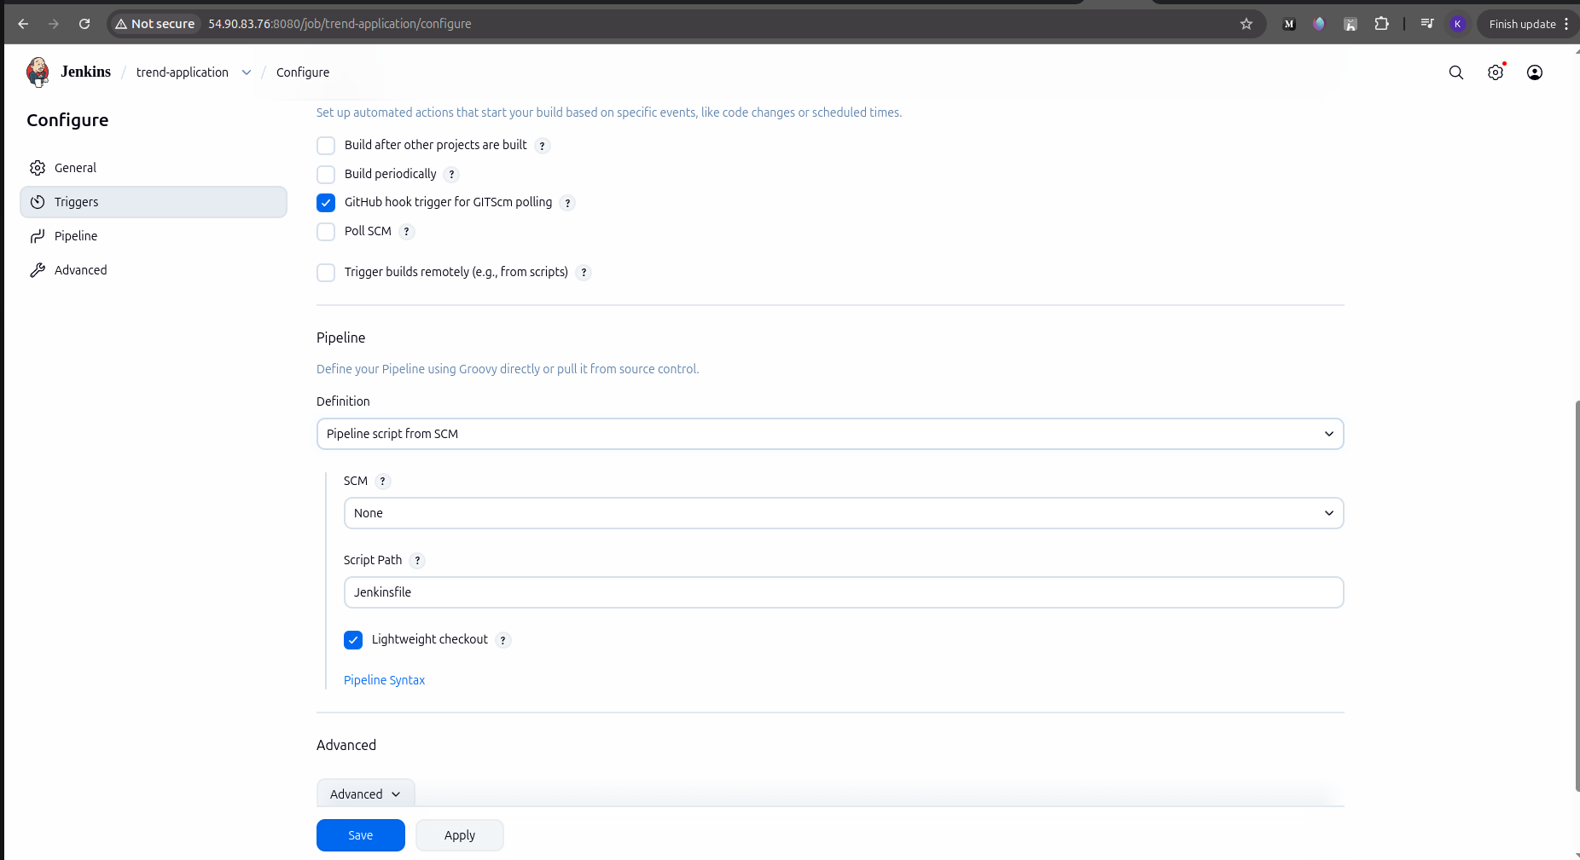

The Next Two screenshots are for github webhook for the Jenkins
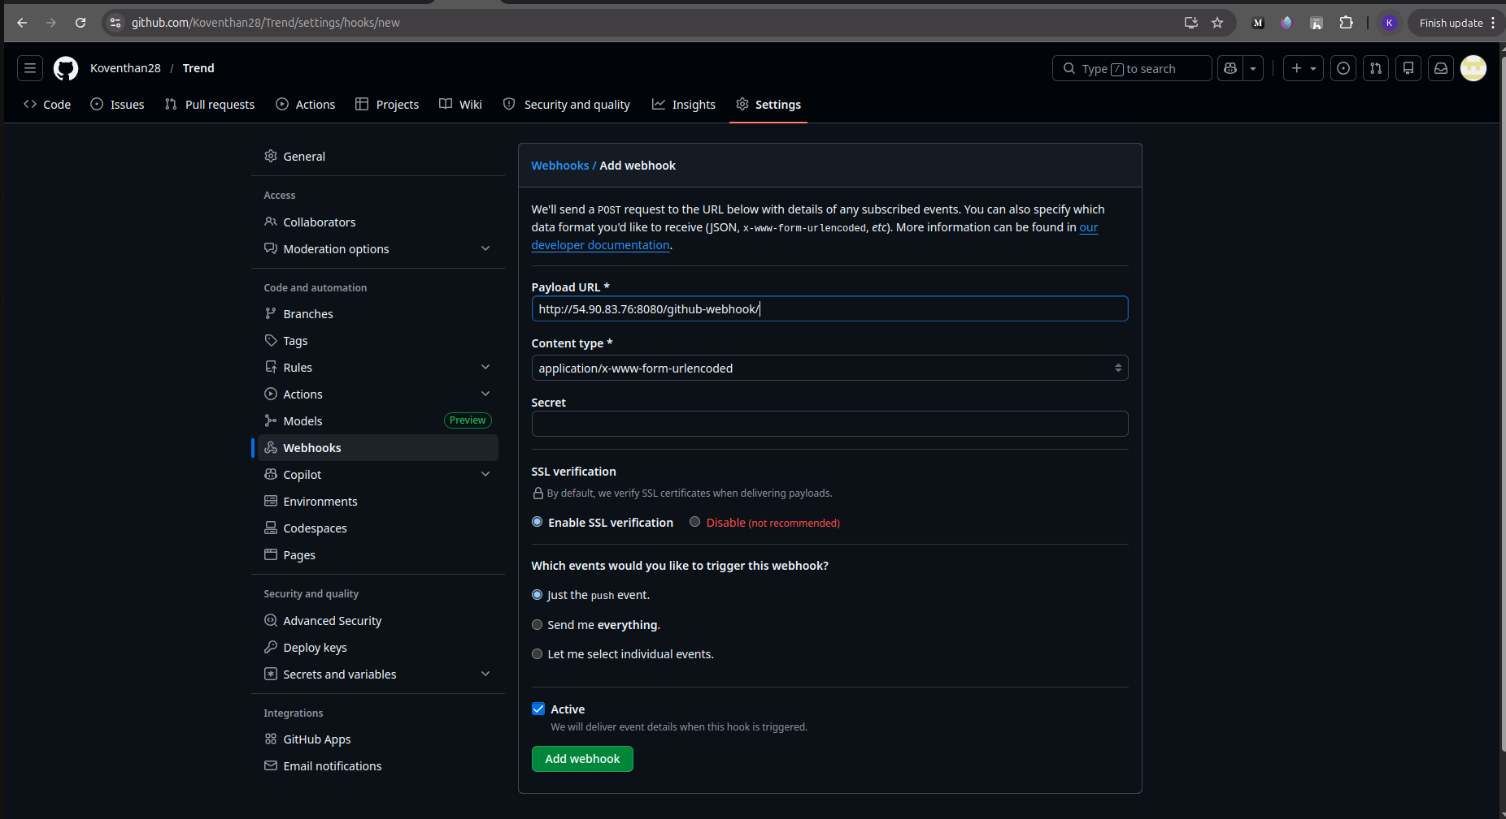

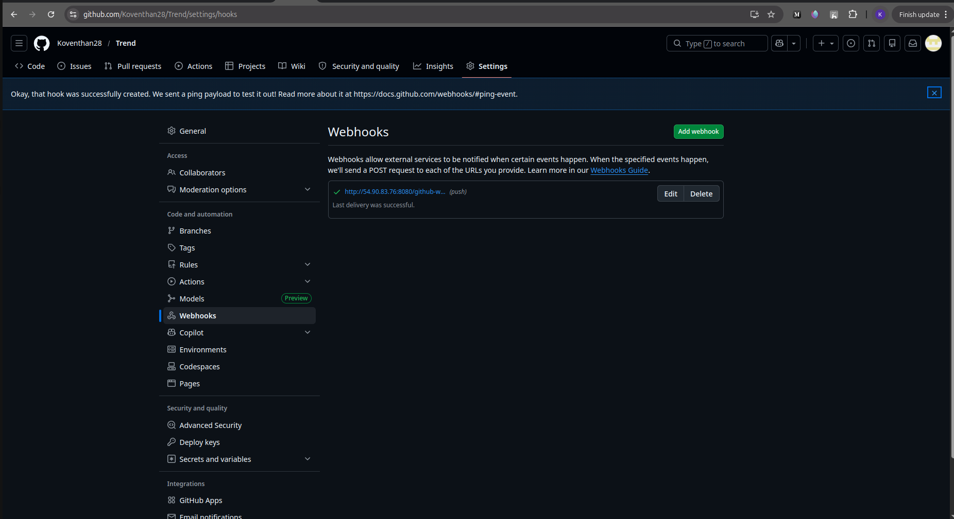

This Screenshot is for showing that EKS cluster is created using the eksctl command

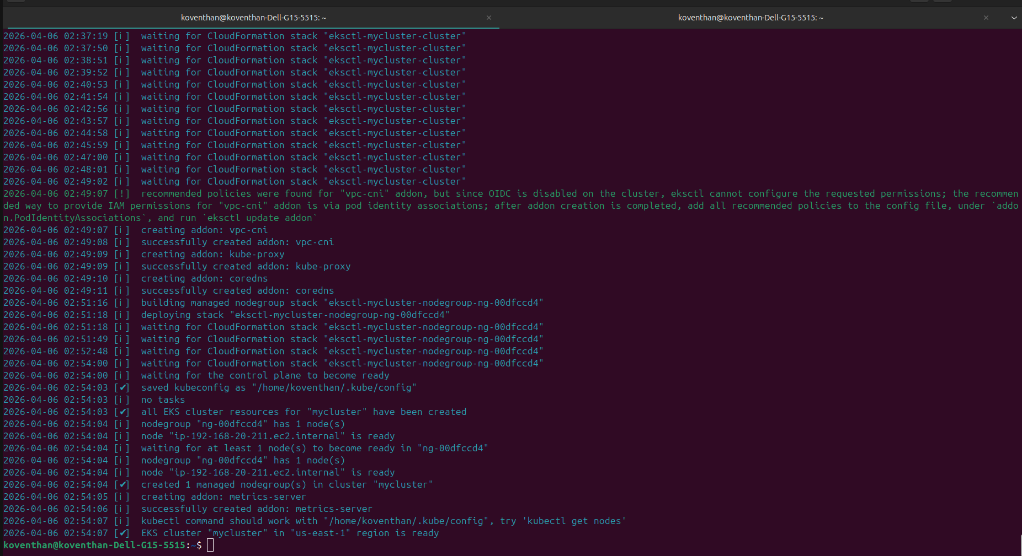

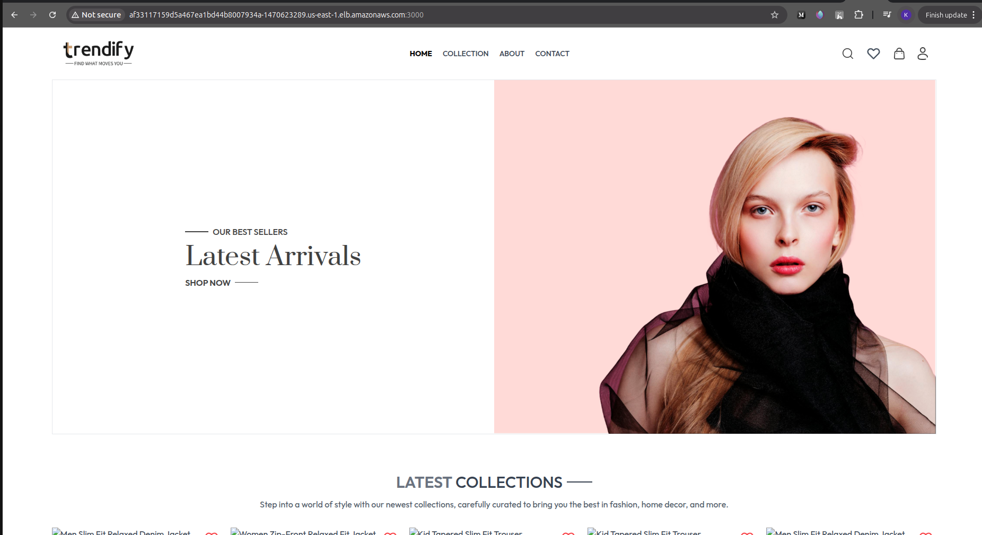
Screenshot of the Application

