6. PARENT AND CHILD
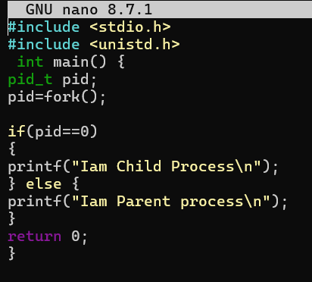
OUTPUT:
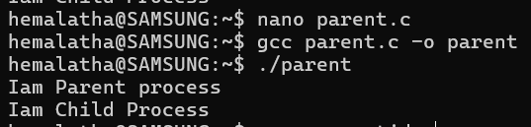
7.PID:
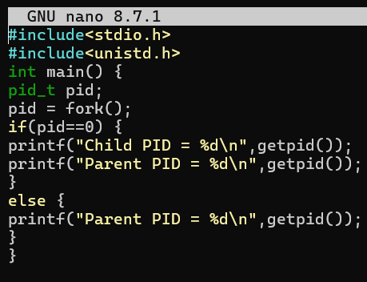

OUTPUT:
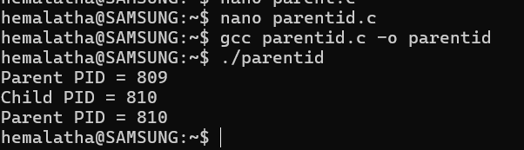
8. RUNNING
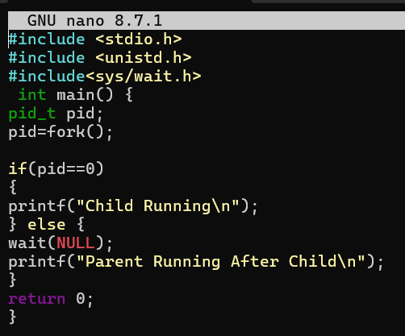
OUTPUT:
