**Historical Climate Data Findings**

In our main tables, “Pest Data” and “Disease Data”, we have a “temperature_range” column, which represents the ideal temperature range for each pest’s or disease’s life cycle progression. This dataset can provide insights into the average temperature in Milan and whether the conditions for certain pests or diseases are favorable or unfavorable.

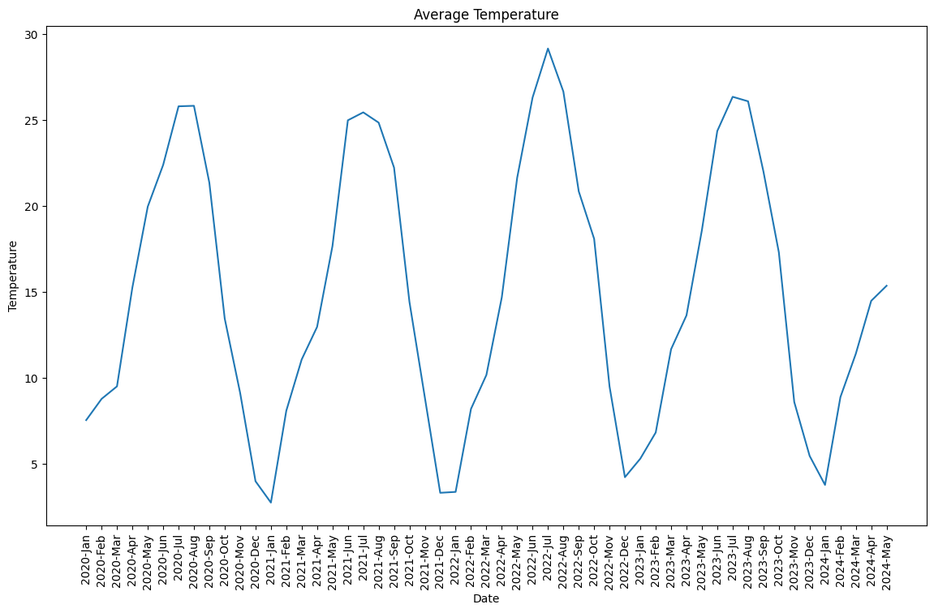

Temperature is very similar for each season each year. It is a good idea to average all the temperatures by month.

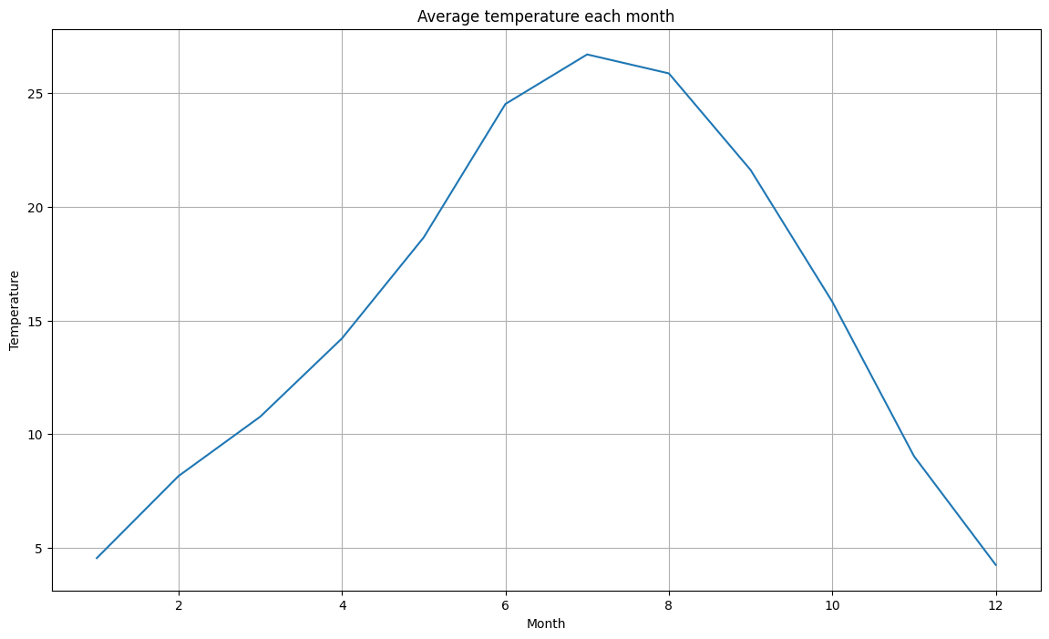

The average temperature for summertime is a little over 25 degrees. Based on the ‘temperature_range’ column from “Pest Data” and “Disease Data”, the ideal temperature ranges from 20 to 30 degrees, which means we may expect to encounter all the diseases and pests in Milan.

**The main insight** from Historical Climate Data is that we can incorporate our “Pest Data” and “Disease Data” tables to give recommendations because the average summer temperatures are within the ideal temperature range for pests and diseases.

To confidently claim that we can utilize the tables for giving recommendations, let us analyze the other dataset.

**History Pest and Disease Data**

In the “Pest Data” and “Disease Data” datasets, there is a column ‘Seasonal_Appearance’ which represents the seasons when each life stage of a pest (or disease) is most active. We can visualize when pests and diseases were identified most often in Milan and then compare the results with the “Seasonal_Appearance” column to determine whether our datasets align, allowing us to confidently work with “Pest Data” and “Disease Data”.

Here is the visualization of when pests and diseases were identified most often:

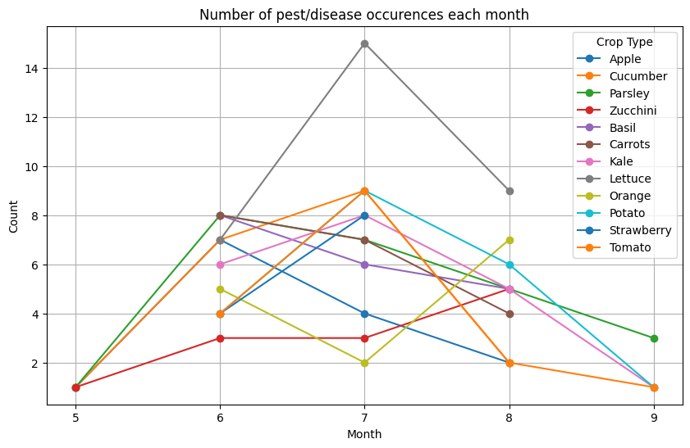

According to the visualization, we can conclude that all the pests and diseases were identified in summer and some in spring and fall. In the “Pest Data” and “Disease Data”, the most frequent seasonal appearance is summer, which aligns with our findings.

Additionally, the visualization of how many crops the ‘History Pest and Disease’ and (‘Pest data’, ‘Disease Data’) have in common shows that these datasets contain mostly the same crops, which strengthens the applicability of our findings.

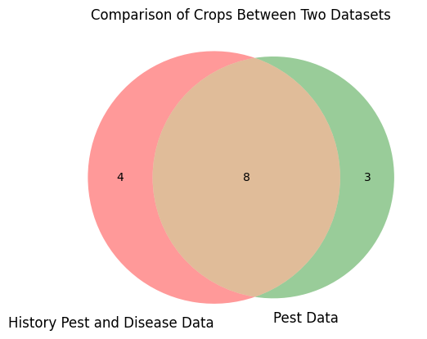

**The main insight** is that we can confidently work with the “Pest Data” and “Disease Data” tables because the data on the seasonal appearance of pests and diseases, as well as crops, align with the data from the two aforementioned tables.

**Pest Data**

Here is one visualization:

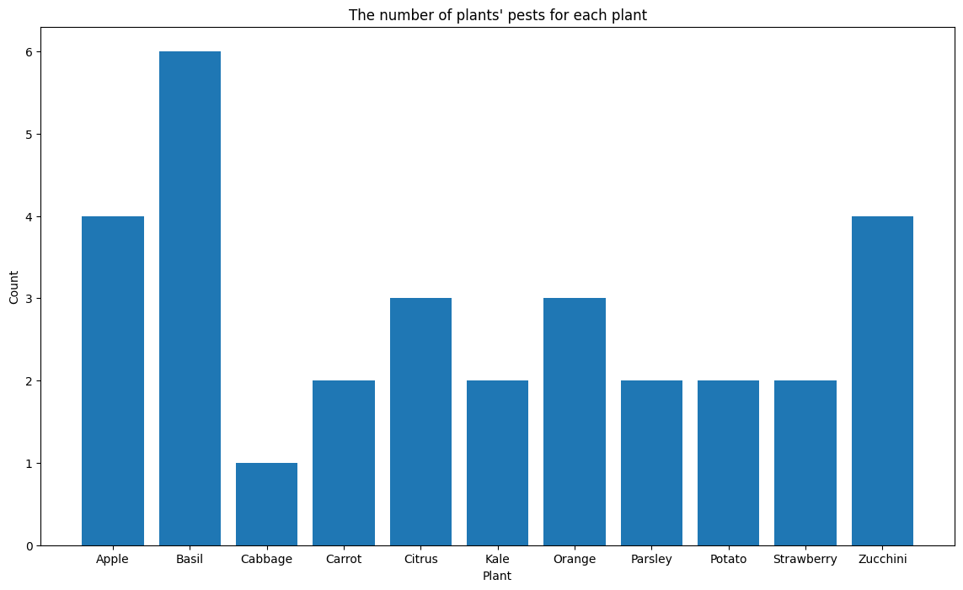

I do not know what to analyze here, but here is an idea on how we could implement our recommendations (it could be a part of the inference code):

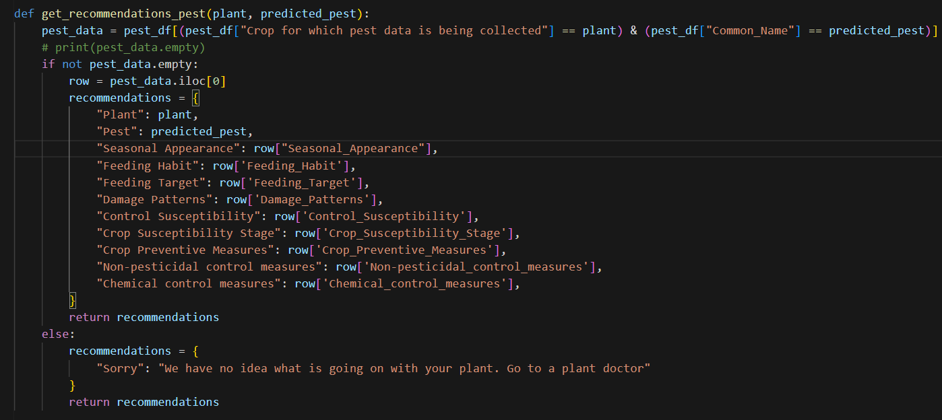

Test:

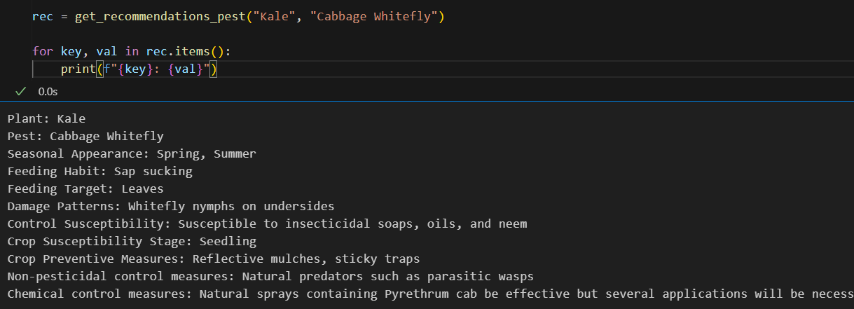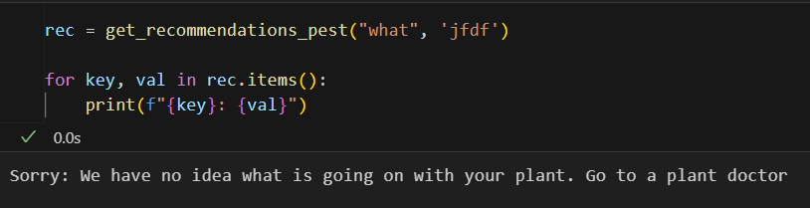

If our recommendations are in a similar format, then we will have to reformulate some of the values in the ‘Pest data’ and ‘Disease Data’ to align with this format.