Лабораторная работа №4

«Синхронные счетчики»

Таблицы истинности:

DV-триггер T-триггер

|  |  |  |
| --- | --- | --- |
| t | | t+1 |
| V | D | Q |
| 0 | 0 | Q(t) |
| 0 | 1 | Q(t) |
| 1 | 0 | 0 |
| 1 | 1 | 1 |

|  |  |
| --- | --- |
| t | t+1 |
| T | Q |
| 0 | Q(t) |
| 1 | nQ(t) |

Матрицы переходов:

DV-триггер T-триггер

|  |  |  |
| --- | --- | --- |
| D | V | Q(t) – Q(t+1) |
| a1 |  | 0 – 0 |
| 1 | 1 | 0 – 1 |
| 0 | 1 | 1 – 0 |
| a2 |  | 1 – 1 |

|  |  |
| --- | --- |
| T | Q(t) – Q(t+1) |
| 0 | 0 – 0 |
| 1 | 0 – 1 |
| 0 | 1 – 1 |
| 1 | 1 – 0 |

1. Проектирование двухразрядного двоично-десятичного счетчика на DV-триггере

|  |  |  |  |  |  |
| --- | --- | --- | --- | --- | --- |
| Десятичные цифры | Двоичный эквивалент в коде 3411 | | | | Номера двоичных наборов |
| 3 | 4 | 1 | 1 |
| 0 | 0 | 0 | 0 | 0 | 0 |
| 1 | 0 | 0 | 0 | 1 | 1 |
| 2 | 0 | 0 | 1 | 1 | 3 |
| 3 | 1 | 0 | 0 | 0 | 8 |
| 4 | 1 | 0 | 0 | 1 | 9 |
| 5 | 1 | 0 | 1 | 1 | 11 |
| 6 | 0 | 1 | 1 | 1 | 7 |
| 7 | 1 | 1 | 0 | 0 | 12 |
| 8 | 1 | 1 | 1 | 0 | 14 |
| 9 | 1 | 1 | 1 | 1 | 15 |

Таблица переходов и функций возбуждения DV-триггеров счетчика

|  |  |  |  |  |  |  |  |  |  |  |  |  |  |  |  |  |  |
| --- | --- | --- | --- | --- | --- | --- | --- | --- | --- | --- | --- | --- | --- | --- | --- | --- | --- |
| Десятичная цифра | Номер набора | Значения выходов триггеров | | | | | | | | Функции возбуждения триггеров | | | | | | | |
| Время, t | | | | Время, t+1 | | | | Время, t | | | | | | | |
| Q3 | Q2 | Q1 | Q0 | Q3 | Q2 | Q1 | Q0 | D3 | V3 | D2 | V2 | D1 | V1 | D0 | V0 |
| 1 | 2 | 3 | 4 | 5 | 6 | 7 | 8 | 9 | 10 | 11 | 12 | 13 | 14 | 15 | 16 |
| 0 | 0 | *0* | *0* | *0* | *0* | *0* | *0* | *0* | *1* |  |  |  |  |  |  | *1* | *1* |
| 1 | 1 | *0* | *0* | *0* | *1* | *0* | *0* | *1* | *1* |  |  |  |  | *1* | *1* |  |  |
| 2 | 3 | *0* | *0* | *1* | *1* | *1* | *0* | *0* | *0* | *1* | *1* |  |  | *0* | *1* | *0* | *1* |
| 3 | 8 | *1* | *0* | *0* | *0* | *1* | *0* | *0* | *1* |  |  |  |  |  |  | *1* | *1* |
| 4 | 9 | *1* | *0* | *0* | *1* | *1* | *0* | *1* | *1* |  |  |  |  | *1* | *1* |  |  |
| 5 | 11 | *1* | *0* | *1* | *1* | *0* | *1* | *1* | *1* | *0* | *1* | *1* | *1* |  |  |  |  |
| 6 | 7 | *0* | *1* | *1* | *1* | *1* | *1* | *0* | *0* | *1* | *1* |  |  | *0* | *1* | *0* | *1* |
| 7 | 12 | *1* | *1* | *0* | *0* | *1* | *1* | *1* | *0* |  |  |  |  | *1* | *1* |  |  |
| 8 | 14 | *1* | *1* | *1* | *0* | *1* | *1* | *1* | *1* |  |  |  |  |  |  | *1* | *1* |
| 9 | 15 | *1* | *1* | *1* | *1* | *0* | *0* | *0* | *0* | *0* | *1* | *0* | *1* | *0* | *1* | *0* | *1* |

Минимизация:

Эталонная диаграмма Вейча:

|  |  |  |  |  |  |
| --- | --- | --- | --- | --- | --- |
|  |  | |  | |  |
|  | 12 | 13 | 9 | 8 |  |
| 14 | 15 | 11 | 10 |  |
|  | 6 | 7 | 3 | 2 |
| 4 | 5 | 1 | 0 |  |
|  |  |  | |  |  |

Триггер Т0:

D0 = nQ2*nQ1 + Q1*nQ0 + nQ2*Q3 V0 = 1

|  |  |  |  |  |  |
| --- | --- | --- | --- | --- | --- |
|  |  | |  | |  |
|  | a7 | X | a4 | 1 |  |
| 1 | 0 | a5 | X |  |
|  | X | 0 | 0 | X |
| X | X | a1 | 1 |  |
|  |  |  | |  |  |

|  |  |  |  |  |  |
| --- | --- | --- | --- | --- | --- |
|  |  | |  | |  |
|  | na7b7 | X | a4b4 | 1 |  |
| 1 | 1 | a5b5 | X |  |
|  | X | 1 | 1 | X |
| X | X | a1b1 | 1 |  |
|  |  |  | |  |  |

Триггер Т1:

D0 = nQ1*nQ2*Q0 + Q3*XOR(Q2*Q0) V0 = 1

|  |  |  |  |  |  |
| --- | --- | --- | --- | --- | --- |
|  |  | |  | |  |
|  | 1 | X | 1 | a3 |  |
| a8 | 0 | a5 | X |  |
|  | X | 0 | 0 | X |
| X | X | 1 | a0 |  |
|  |  |  | |  |  |

|  |  |  |  |  |  |
| --- | --- | --- | --- | --- | --- |
|  |  | |  | |  |
|  | 1 | X | 1 | na3b3 |  |
| a8b8 | 1 | a5b5 | X |  |
|  | X | 1 | 1 | X |
| X | X | 1 | na0b0 |  |
|  |  |  | |  |  |

Триггер Т2:

D0 = nQ0*Q2 + Q1*XOR(Q2, Q3) V0 = 1

|  |  |  |  |  |  |
| --- | --- | --- | --- | --- | --- |
|  |  | |  | |  |
|  | a7 | X | a4 | a3 |  |
| a8 | 0 | 1 | X |  |
|  | X | a6 | a2 | X |
| X | X | a1 | a0 |  |
|  |  |  | |  |  |

|  |  |  |  |  |  |
| --- | --- | --- | --- | --- | --- |
|  |  | |  | |  |
|  | a7b7 | X | na4b4 | na3b3 |  |
| a8b8 | 1 | 1 | X |  |
|  | X | a6b6 | na2b2 | X |
| X | X | na1b1 | na0b0 |  |
|  |  |  | |  |  |

Триггер Т3:

|  |  |  |  |  |  |
| --- | --- | --- | --- | --- | --- |
|  |  | |  | |  |
|  | a7b7 | X | a4b4 | a3b3 |  |
| a8b8 | 1 | 1 | X |  |
|  | X | 1 | 1 | X |
| X | X | na1b1 | na0b0 |  |
|  |  |  | |  |  |

D0 = nQ0*Q2 + XOR(Q1, Q3) V0 = 1

|  |  |  |  |  |  |
| --- | --- | --- | --- | --- | --- |
|  |  | |  | |  |
|  | a7 | X | a4 | a3 |  |
| a8 | 0 | 0 | X |  |
|  | X | 1 | 1 | X |
| X | X | a1 | a0 |  |
|  |  |  | |  |  |

ТС = Q2*Q3*Q0

|  |  |  |  |  |  |
| --- | --- | --- | --- | --- | --- |
|  |  | |  | |  |
|  | 0 | X | 0 | 0 |  |
| 0 | 1 | 0 | X |  |
|  | X | 0 | 0 | X |
| X | X | 0 | 0 |  |
|  |  |  | |  |  |

Схема счетчика на DV-триггерах:

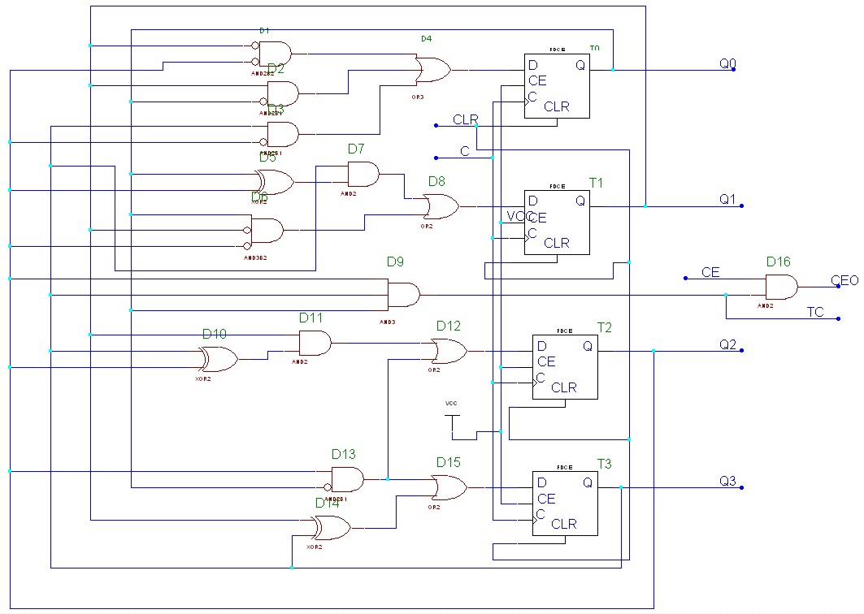Функциональное моделирование: 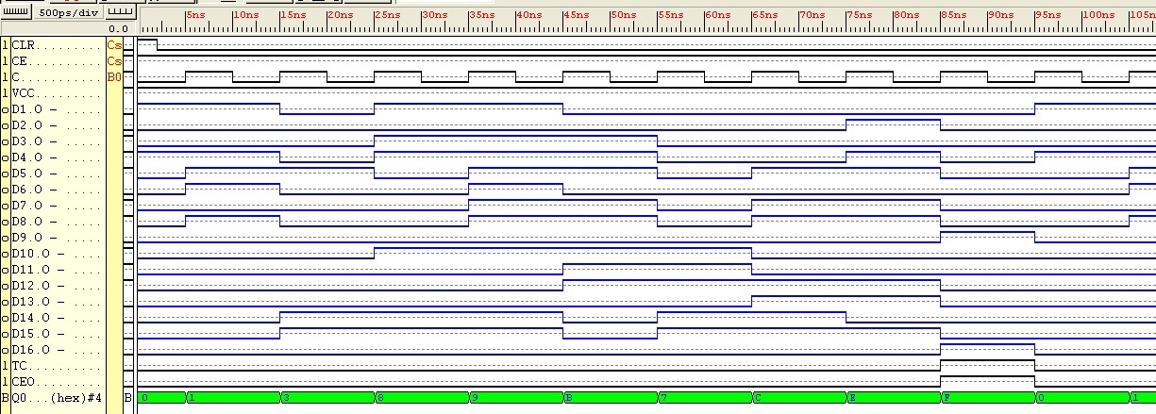

2. Проектирование делителя частоты на N=14 и скважностью S=2 на T-триггерах

|  |  |  |  |  |  |  |  |  |  |  |  |  |  |
| --- | --- | --- | --- | --- | --- | --- | --- | --- | --- | --- | --- | --- | --- |
| Номер набора | Значения выходов триггеров | | | | | | | | Функции возбуждения триггеров | | | | |
| Время, t | | | | Время, t+1 | | | | Время, t | | | | |
| Q3 | Q2 | Q1 | Q0 | Q3 | Q2 | Q1 | Q0 | T3 | T2 | T1 | T0 |
| 1 | 2 | 3 | 4 | 5 | 6 | 7 | 8 | 9 | 10 | 11 | 12 |
| 0 | 0 | 0 | 0 | 0 | 0 | 0 | 0 | 1 | 0 | 0 | 0 | 1 |
| 1 | 0 | 0 | 0 | 1 | 0 | 0 | 1 | 0 | 0 | 0 | 1 | 1 |
| 2 | 0 | 0 | 1 | 0 | 0 | 0 | 1 | 1 | 0 | 0 | 0 | 1 |
| 3 | 0 | 0 | 1 | 1 | 0 | 1 | 0 | 0 | 0 | 1 | 1 | 1 |
| 4 | 0 | 1 | 0 | 0 | 0 | 1 | 0 | 1 | 0 | 0 | 0 | 1 |
| 5 | 0 | 1 | 0 | 1 | 0 | 1 | 1 | 0 | 0 | 0 | 1 | 1 |
| 6 | 0 | 1 | 1 | 0 | 1 | 0 | 0 | 1 | 1 | 1 | 1 | 1 |
| 9 | 1 | 0 | 0 | 1 | 1 | 0 | 1 | 0 | 0 | 0 | 1 | 1 |
| 10 | 1 | 0 | 1 | 0 | 1 | 0 | 1 | 1 | 0 | 0 | 0 | 1 |
| 11 | 1 | 0 | 1 | 1 | 1 | 1 | 0 | 0 | 0 | 1 | 1 | 1 |
| 12 | 1 | 1 | 0 | 0 | 1 | 1 | 0 | 1 | 0 | 0 | 0 | 1 |
| 13 | 1 | 1 | 0 | 1 | 1 | 1 | 1 | 0 | 0 | 0 | 1 | 1 |
| 14 | 1 | 1 | 1 | 0 | 1 | 1 | 1 | 1 | 0 | 0 | 0 | 1 |
| 15 | 1 | 1 | 1 | 1 | 0 | 0 | 0 | 0 | 1 | 1 | 1 | 1 |

Триггер Т0: Триггер Т1:

T0 = 1 Т1 = Q0 + nQ3*Q2*Q1

|  |  |  |  |  |  |
| --- | --- | --- | --- | --- | --- |
|  |  | |  | |  |
|  | 1 | 1 | 1 | X |  |
| 1 | 1 | 1 | 1 |  |
|  | 1 | X | 1 | 1 |
| 1 | 1 | 1 | 1 |  |
|  |  |  | |  |  |

|  |  |  |  |  |  |
| --- | --- | --- | --- | --- | --- |
|  |  | |  | |  |
|  | 0 | 1 | 1 | X |  |
| 0 | 1 | 1 | 0 |  |
|  | 1 | X | 1 | 0 |
| 0 | 1 | 1 | 0 |  |
|  |  |  | |  |  |

Триггер Т2: Триггер Т3:

|  |  |  |  |  |  |
| --- | --- | --- | --- | --- | --- |
|  |  | |  | |  |
|  | 0 | 0 | 0 | X |  |
| 0 | 1 | 0 | 0 |  |
|  | 1 | X | 0 | 0 |
| 0 | 0 | 0 | 0 |  |
|  |  |  | |  |  |

T2 = nQ3*Q2*Q1 + Q0*Q1 Т3 = nQ3*Q2*Q1 + Q0*Q1*Q2

|  |  |  |  |  |  |
| --- | --- | --- | --- | --- | --- |
|  |  | |  | |  |
|  | 0 | 0 | 0 | X |  |
| 0 | 1 | 1 | 0 |  |
|  | 1 | X | 1 | 0 |
| 0 | 0 | 0 | 0 |  |
|  |  |  | |  |  |

ТС = Q0*Q1*Q2

|  |  |  |  |  |  |
| --- | --- | --- | --- | --- | --- |
|  |  | |  | |  |
|  | 0 | 0 | 0 | X |  |
| 0 | 1 | 0 | 0 |  |
|  | 0 | X | 0 | 0 |
| 0 | 0 | 0 | 0 |  |
|  |  |  | |  |  |

Схема делителя частоты на Т-триггерах:

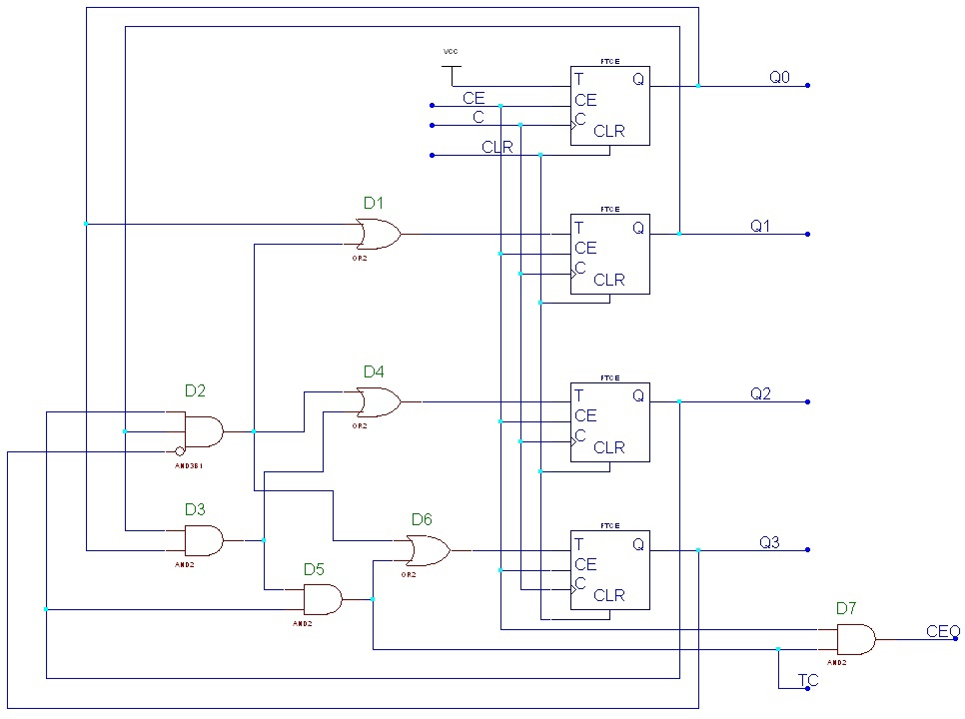

Функциональное моделирование:

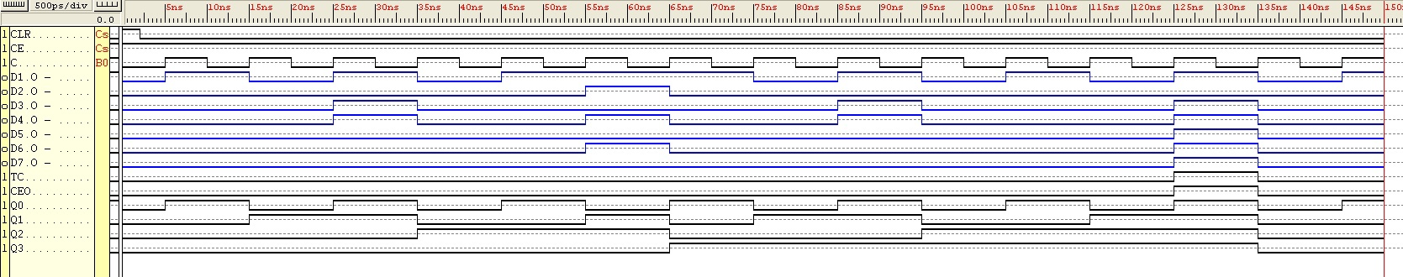

Проектирование делителя частоты на N=14 и скважностью S=2 на счетчике CB4CLE

**Таблица выходов и функций возбуждения счетчика CB4CLE делителя частоты**

|  |  |  |  |  |  |  |  |  |  |
| --- | --- | --- | --- | --- | --- | --- | --- | --- | --- |
| Номер набора | Значения выходов счетчика | | | | Функции возбуждения счетчика | | | | |
| Q3 | Q2 | Q1 | Q0 | D3 | D2 | D1 | D0 | L |
| 0 | 0 | 0 | 0 | 0 | X | X | X | X | 0 |
| 1 | 0 | 0 | 0 | 1 | X | X | X | X | 0 |
| 2 | 0 | 0 | 1 | 0 | X | X | X | X | 0 |
| 3 | 0 | 0 | 1 | 1 | X | X | X | X | 0 |
| 4 | 0 | 1 | 0 | 0 | X | X | X | X | 0 |
| 5 | 0 | 1 | 0 | 1 | X | X | X | X | 0 |
| 6 | 0 | 1 | 1 | 0 | 1 | 0 | 0 | 1 | 1 |
| 9 | 1 | 0 | 0 | 1 | X | X | X | X | 0 |
| 10 | 1 | 0 | 1 | 0 | X | X | X | X | 0 |
| 11 | 1 | 0 | 1 | 1 | X | X | X | X | 0 |
| 12 | 1 | 1 | 0 | 0 | X | X | X | X | 0 |
| 13 | 1 | 1 | 0 | 1 | X | X | X | X | 0 |
| 14 | 1 | 1 | 1 | 0 | X | X | X | X | 0 |
| 15 | 1 | 1 | 1 | 1 | X | X | X | X | 0 |

Минимизация:

|  |  |  |  |  |  |
| --- | --- | --- | --- | --- | --- |
|  |  | |  | |  |
|  | X | X | X | X |  |
| X | X | X | X |  |
|  | 1 | X | X | X |
| X | X | X | X |  |
|  |  |  | |  |  |

|  |  |  |  |  |  |
| --- | --- | --- | --- | --- | --- |
|  |  | |  | |  |
|  | X | X | X | X |  |
| X | X | X | X |  |
|  | 0 | X | X | X |
| X | X | X | X |  |
|  |  |  | |  |  |

D3 = D0 = 1 D2 = D1 = 0

|  |  |  |  |  |  |
| --- | --- | --- | --- | --- | --- |
|  |  | |  | |  |
|  | 0 | 0 | 0 | X |  |
| 0 | 0 | 0 | 0 |  |
|  | 1 | X | 0 | 0 |
| 0 | 0 | 0 | 0 |  |
|  |  |  | |  |  |

L = nQ3*Q2*Q1

Схема делителя частоты на счетчике CB4CLE:

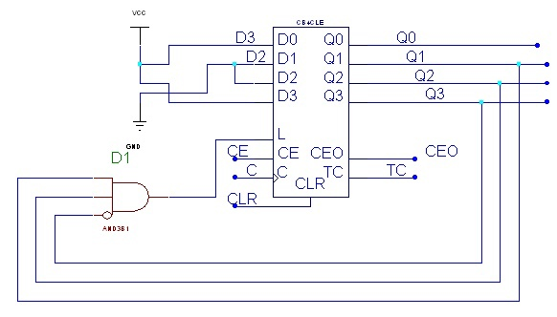

Функциональное моделирование:

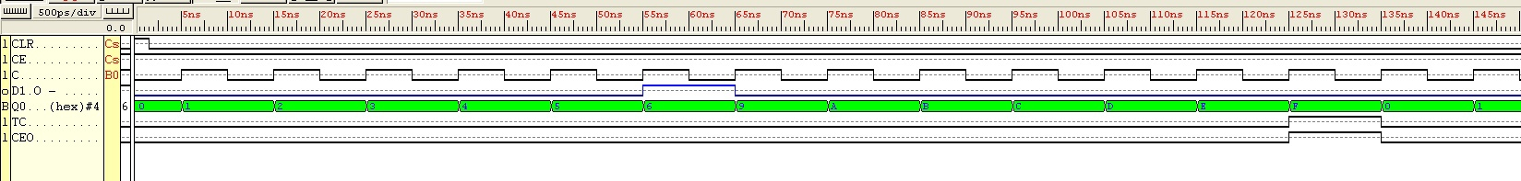

Модель делителя частоты на VHDL:

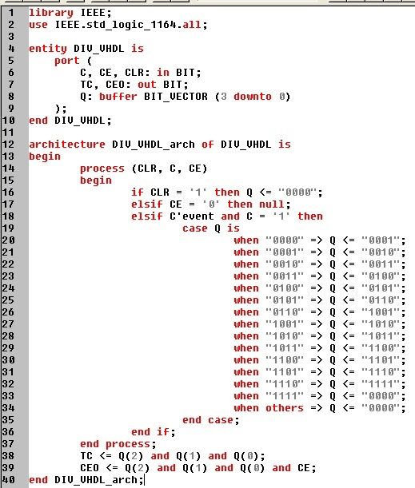

Синтезированный элемент:

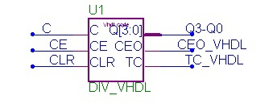

Функциональное моделирование:



Схема управления:

Параллельное – MODE = 1

Последовательное – MODE = 0

