**TRƯỜNG ĐẠI HỌC BÁCH KHOA – ĐHQG-HCM**

**KHOA KHOA HỌC ỨNG DỤNG**

**BỘ MÔN CƠ KỸ THUẬT**

** **

**Báo cáo Tiểu luận cuối kỳ**

**PHƯƠNG PHÁP SỐ NÂNG CAO**

**MSMH:** AS5919

|  |  |  |
| --- | --- | --- |
| **SVTH:** | Nguyễn Minh Khánh |  |
| **MSSV:** | 2470260 |  |
| **Lớp:** | 1 |  |
| **GVHD:** | TS. Nguyễn Thanh Nhã |  |

TP. Hồ Chí Minh, 2025

# MỤC LỤC

MỤC LỤC i

ĐỊNH NGHĨA TỪ VIẾT TẮT ii

KÝ HIỆU iii

DANH MỤC HÌNH iv

1. Câu 1 5

1.1. Giới thiệu chung về Phương pháp Phần tử Hữu hạn (FEM) 5

1.2. Phần tử phẳng Q4 5

1.3. Các bước cơ bản của FEM với phần tử Q4 5

1.4. Ưu điểm và nhược điểm của phần tử Q4 6

1.5. Ứng dụng 6

2. Câu 2 7

3. Câu 3 11

4. Câu 4 15

PHỤ LỤC A. PRG_FEM_Plane.py 26

PHỤ LỤC B. Output – Câu 4 Full integration 58

# ĐỊNH NGHĨA TỪ VIẾT TẮT

|  |  |  |  |
| --- | --- | --- | --- |
| **STT** | **Từ viết tắt** | **Thuật ngữ tiếng Anh** | **Thuật ngữ tiếng Việt** |
| 1 | CFD | Computational Fluid Dynamics | Tính toán Động lực học Lưu chất |
| 2 | FVM | Finite Volume Method | Phương pháp Thể tích hữu hạn |
| 3 | ABS | Acrylonitrile Butadiene Styrene |  |
| 4 | FEM | Finite Element Method | Phương pháp Phần tử hữu hạn |
| 5 | FSI | Fluid Structure Interaction | Tương tác Lưu chất – Kết cấu |

# KÝ HIỆU

|  |  |
| --- | --- |
| Ký hiệu | Mô tả |
|  | Khối lượng riêng |
|  | Vector vận tốc của |
|  | Thể tích mà môi trường chiếm chỗ ở thời điểm |
|  | Thể tích mà môi trường chiếm chỗ ở thời điểm |
|  | Vector định vị điểm ở thời điểm ban đầu trong hệ trực giao |
|  | Vector định vị điểm ở thời điểm sau trong hệ trực giao |
|  | Định thức Jacobian |
|  | Áp suất tĩnh (nhiệt động lực học) |
|  | Tensor ứng suất |
|  | Độ nhớt động học |
|  | Nguồn động lượng |
| **f** | Lực khối như trọng lực hoặc lực quán tính,… |

# DANH MỤC HÌNH

Hình Trang

Hình 4‑1 Lưới chưa biến dạng và điều kiện biên 16

Hình 4‑2 Ứng suất phương XX 23

Hình 4‑3 Ứng suất chương YY 23

Hình 4‑4 Ứng suất phương XY 24

Hình 4‑5 Biến dạng phương XX 24

Hình 4‑6 Biến dạng phương YY 25

Hình 4‑7 Biến dạng phương XY 25

Hình B‑1 (a) - (l). Biểu diễn các kết quả khác của câu 4 66

# Câu 1



## Giới thiệu chung về Phương pháp Phần tử Hữu hạn (FEM)

Phương pháp Phần tử Hữu hạn (FEM) là một kỹ thuật số mạnh mẽ để giải các bài toán vi phân trong kỹ thuật và vật lý, đặc biệt trong các lĩnh vực cơ học. FEM chia miền liên tục thành các phần tử nhỏ (hữu hạn) và xấp xỉ nghiệm bằng các hàm nội suy trên từng phần tử.

## Phần tử phẳng Q4

Phần tử Q4 (Quadrilateral 4-node) là một loại phần tử phẳng phổ biến trong FEM, có các đặc điểm sau:

Hình dạng: Tứ giác với 4 nút (thường là hình chữ nhật hoặc tứ giác bất kỳ).

Bậc tự do: Mỗi nút thường có 2 bậc tự do (chuyển vị theo phương x và y trong bài toán cơ học).

Hàm dạng (Shape functions): Sử dụng hàm nội suy tuyến tính (hoặc bilinear) để biểu diễn trường chuyển vị bên trong phần tử.

## Các bước cơ bản của FEM với phần tử Q4

a. Rời rạc hóa miền

Chia miền bài toán thành các phần tử tứ giác Q4.

Mỗi phần tử có 4 nút, thường được đánh số từ 1 đến 4 theo quy tắc nhất định (ví dụ: ngược chiều kim đồng hồ, nút 1 ở góc bên dưới, bên trái).

b. Xây dựng hàm dạng (Shape Functions)

Hàm dạng của phần tử Q4 trong hệ tọa độ tự nhiên được định nghĩa:

trong đó là tọa độ của nút trong hệ tọa độ tự nhiên.

c. Ma trận độ cứng phần tử

Trong bài toán cơ học, ma trận độ cứng phần tử :

: Ma trận quan hệ biến dạng-chuyển vị.

: Ma trận vật liệu (liên hệ ứng suất-biến dạng).

: Định thức của ma trận Jacobian, chuyển đổi từ tọa độ thực sang tọa độ tự nhiên.

d. Ghép nối và giải hệ phương trình

Ghép các ma trận phần tử thành ma trận tổng thể. Kết hợp với áp đặt điều kiện biên, rút gọn size ma trận và giải hệ phương trình đại số tuyến tính:

với là ma trận độ cứng tổng thể, là vector chuyển vị nút, và là vector lực tại nút.

## Ưu điểm và nhược điểm của phần tử Q4

Ưu điểm:

Đơn giản, dễ lập trình.

Hiệu quả trong các bài toán 2D với hình học đơn giản.

Có thể mô tả biến dạng tuyến tính hoặc bilinear.

Nhược điểm:

Kém chính xác với biến dạng phức tạp hoặc phần tử bị biến dạng nhiều. Cụ thể như các bài toán uốn.

Cần lưới mịn hơn so với phần tử bậc cao (Q8, Q9) để đạt độ chính xác tương đương.

## Ứng dụng

Phần tử Q4 thường được dùng trong:

Phân tích ứng suất-phẳng (plane stress/strain).

Bài toán dẫn nhiệt 2D.

Mô hình hóa tấm, vỏ đơn giản

# Câu 2

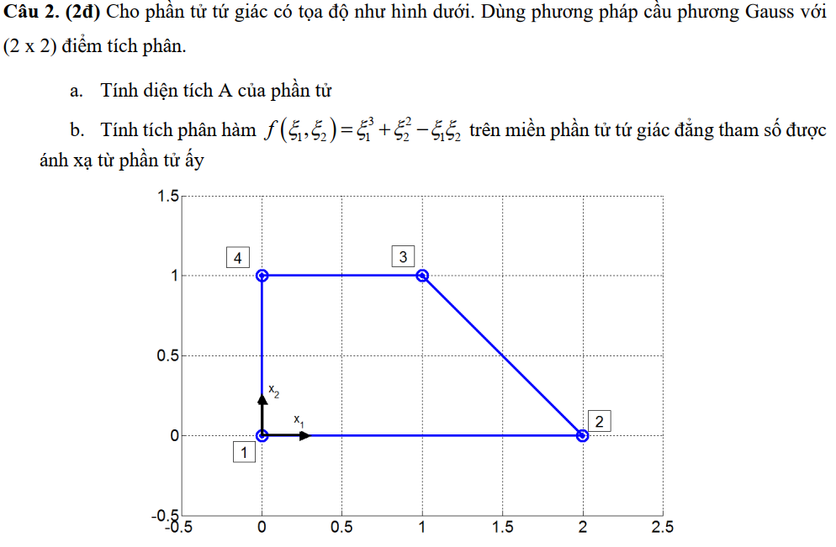

--- Kết quả ---------------------------------------------------------------------------------------------------

--- Lời giải ---------------------------------------------------------------------------------------------------

Phần tử tứ giác Q4 với tích phân Gauss (2x2). Tọa độ các nút trong hệ tọa độ vật lý:

* Nút 1:
* Nút 2:
* Nút 3:
* Nút 4:

a. Tính diện tích A của phần tử

Diện tích được tính bằng tích phân định thức Jacobian trên miền tọa độ tự nhiên :

Phần tử Q4 trong miền tọa độ tự nhiên tương đương với push-forward của phần tử ấy trong miền tọa độ vật lý. Các hàm dạng:

Tọa độ vật lý của điểm bất kỳ:

Jacobian:

Định thức:

Diện tích:

b. Tính tích phân hàm trên miền phần tử

Sử dụng cầu phương Gauss (2×2) với 4 điểm tích phân Gauss:

Trọng số:

Khi đó:

Diện tích của phần tử cũng có thể được tính toán bằng cầu phương Gauss 2x2, với . Chương trình python ***“PRG_gauss.py”*** được tạo ra để kiểm tra cho câu hỏi này:

PS 'C:\Users\KhanhNguyen\OneDrive\Desktop\WorkSpace\Desk\Course\MasterEngMechanics\AdvanceNumericalMethod\FinalReport\_prgWS\PRG_gauss.py'>

Area, A = 1.5000

Integral, I = 0.5000

"""

    By              :   Khanh Nguyen

    Email           :   nmkhanhfem@gmail.com

    Github          :   https://github.com/KowalskiPi

    Date            :   28/04/2025

    Description     :   2D Gause quadrature.

"""

import numpy as np

def shape_functions(xi, eta):

    """

    Compute the bilinear shape functions and their derivatives

    4-------3

    |       |

    |  QX   |

    1-------2

    """

    # Shape functions

    N = np.array([

        0.25 * (1 - xi) * (1 - eta),  # N1: bottom left (xi=-1,eta=-1)

        0.25 * (1 + xi) * (1 - eta),  # N2: bottom right (xi=1,eta=-1)

        0.25 * (1 + xi) * (1 + eta),  # N3: top right (xi=1,eta=1)

        0.25 * (1 - xi) * (1 + eta)   # N4: top left (xi=-1,eta=1)

    ])

    # Derivatives of shape functions w.r.t xi

    dN_dxi = np.array([

        -0.25 * (1 - eta),

         0.25 * (1 - eta),

         0.25 * (1 + eta),

        -0.25 * (1 + eta)

    ])

    # Derivatives of shape functions w.r.t eta

    dN_deta = np.array([

        -0.25 * (1 - xi),

        -0.25 * (1 + xi),

         0.25 * (1 + xi),

         0.25 * (1 - xi)

    ])

    return N, dN_dxi, dN_deta

def mapping(xi, eta, nodes):

    """

    Map from natural coordinates (xi, eta) to physical coordinates (x1, x2)

    """

    N, dN_dxi, dN_deta = shape_functions(xi, eta)

    # Physical coordinates

    x = np.dot(N, nodes)  # x1 and x2 = sum(N_i * (x_i, y_i))

    # Compute the derivatives of physical coordinates with respect to xi and eta:

    dx_dxi  = np.dot(dN_dxi, nodes)

    dx_deta = np.dot(dN_deta, nodes)

    # Jacobian matrix:

    J = np.array([dx_dxi, dx_deta]).T

    # Determinant of the Jacobian matrix

    detJ = np.linalg.det(J)

    return x, J, detJ

def compute_area(nodes):

    """

    Area is calculated as:

      A = int_{-1}^{1}int_{-1}^{1} |detJ(xi, eta)| dxi deta

    """

    # For 2x2 Gauss integration, int. points in the natural coordinate system:

    a = 1 / np.sqrt(3)

    gauss_points = [-a, a]

    area = 0.0

    for xi in gauss_points:

        for eta in gauss_points:

            # Map (xi, eta) to physical

            _, _, detJ = mapping(xi, eta, nodes)

            # Each Gauss weight is 1 for 2-point integration in each direction.

            area += abs(detJ)

    return area

def compute_integral(nodes):

    """

    Compute the integral of f(xi, eta) = ξ^3+η^2-ξη over the quadrilateral element

    using 2x2 Gauss quadrature.

    """

    def f(xi):

        # Integrate: f(xi, eta) = ξ^3 + η^2 - ξη

        return xi[0]**3 + xi[1]**2 - xi[0]*xi[1]

    #2×2 Gauss quadrature (with Gauss points ±1/sqrt(3) and weights 1

    a = 1 / np.sqrt(3)

    gauss_points = [-a, a]

    I = 0.0

    for xi in gauss_points:

        for eta in gauss_points:

            # Get the Jacobian determinant

            _, _, detJ = mapping(xi, eta, nodes)

            I += f([xi, eta]) * abs(detJ)

    return I

if __name__ == '__main__':

    # Define nodal coordinates for the quadrilateral element in counterclockwise order:

    """

       4-------3              4-------3

      /       /               |       |

     /       /     --->       |  QX   |

    1-------2                 1-------2

    """

    nodes_input = np.array([

        [0.0,  0.0],  # Node 1: top right (3 - (xi,eta)=(1,1))

        [2.0, 0.0],  # Node 2: top left (4 - (xi,eta)=(-1,1))

        [1.0, 1.0],  # Node 3: bottom left (1 - (xi,eta)=(-1,-1))

        [0.0, 1.0]   # Node 4: bottom right (2- xi,eta)=(1,-1))

    ])

    nodes = transform_to_natural_coordinates([1, 2, 3, 4], nodes_input)

    # Compute area and the integral I over the element

    area = compute_area(nodes)

    integral_I = compute_integral(nodes)

    print(f"Area, A = {area:.4f}")

    print(f"Integral, I = {integral_I:.4f}")

# Câu 3

--- Kết quả ---------------------------------------------------------------------------------------------------

--- Cau a ---

Natural Frequencies (Hz):

Mode 1: 0.2818 Hz

Mode 2: 0.4352 Hz

Mode 3: 0.5676 Hz

--- Cau b ---

Time History Results:

t = 0.5 s:

u: [-0.06811521 0.00661268 0.00895831]

u_dot: [-0.66307989 0.02772904 0.04577195]

u_ddot: [-6.02560835 -0.17766177 -0.14598285]

--- Code python **“PRG_MotionEquation.py”** ---------------------------------------------------------

import numpy as np

from scipy.linalg import eigh, lu_factor, lu_solve

# a: Calculate natural freq. (no damping)

def cau_a(M, K):

# Solve generalized eigenvalue: K·φ = λ·M·φ = omeaga**2·M·φ

eigenvalues, _ = eigh(K, M)

# Calculate natural freq. (rad/s)

omegaRad = np.sqrt(eigenvalues)

# Convert to Hz

freq_hz = omegaRad / (2 * np.pi)

return freq_hz

# b: Time inte. w/ Newmark-beta method

def cau_b(M, K):

# Damping matrix

C = 0.1 * M + 0.05 * K

# F(t)

def F(t):

return np.array([-5.0, 3.0, 1.0]) * (t**2 + 0.12*t)

# Time parameters

dt = 0.1

t_end = 0.5

t_steps = np.arange(0, t_end + dt, dt)

n_steps = len(t_steps)

# Initialize

u = np.zeros((3, n_steps)) # Displacement

u_dot = np.zeros((3, n_steps)) # Velocity

u_ddot = np.zeros((3, n_steps)) # Acceleration

# Assumed zero initial conditions

u0 = np.array([0.0, 0.0, 0.0])

v0 = np.array([0.0, 0.0, 0.0])

u[:, 0] = u0

u_dot[:, 0] = v0

u_ddot[:, 0] = np.linalg.solve(M, F(0) - C@v0 - K@u0)

# Newmark params (const average u_ddot)

gamma = 0.5

beta = 0.25

# Precompute K_bar and LU factori.

b1 = (1/(beta*dt**2))

b2 = (1/(beta*dt))

K_bar = b1*M + b2*C + K

lu_piv = lu_factor(K_bar)

# Time integration loop

for i in range(n_steps - 1):

t_next = t_steps[i+1]

# Predictor step

u_predictor = u[:, i] + dt*u_dot[:, i] + (0.5 - beta)*dt**2*u_ddot[:, i]

v_predictor = u_dot[:, i] + (1 - gamma)*dt*u_ddot[:, i]

# Effective force vector

F_next = F(t_next)

F_eff = F_next + b1*M@u_predictor + b2*C@v_predictor

# Solve next displacement

u_next = lu_solve(lu_piv, F_eff)

# Update u_ddot and u_dot

u_ddot_next = b1 * (u_next - u_predictor)

u_dot_next = v_predictor + gamma*dt*u_ddot_next

# Store results

u[:, i+1] = u_next

u_dot[:, i+1] = u_dot_next

u_ddot[:, i+1] = u_ddot_next

return u, u_dot, u_ddot, t_steps

Thực thi code và kết quả

# MAIN

if __name__ == "__main__":

M = np.diag([1.5, 3.0, 1.0])

K = np.array([

[12.0, 5.0, 3.0],

[5.0, 13.0, 1.0],

[3.0, 1.0, 11.0]

])

# Cau a: Natural frequencies

frequencies = cau_a(M=M, K=K)

print("Natural Frequencies (Hz):")

for i, f in enumerate(frequencies):

print(f"Mode {i+1}: {f:.4f} Hz")

# Cau b: Time history results

u, u_dot, u_ddot, t_steps = cau_b(M=M, K=K)

print("\nTime History Results:")

for i, t in enumerate(t_steps):

print(f"\nt = {t:.1f} s:")

print(f"u: {u[:, i]}")

print(f"u_dot: {u_dot[:, i]}")

print(f"u_ddot: {u_ddot[:, i]}")

PS

'C:\Users\KhanhNguyen\OneDrive\Desktop\WorkSpace\Desk\Course\MasterEngMechanics\AdvanceNumericalMethod\FinalReport\_prgWS\PRG_MotionEquation.py'>

Natural Frequencies (Hz):

Mode 1: 0.2818 Hz

Mode 2: 0.4352 Hz

Mode 3: 0.5676 Hz

Time History Results:

t = 0.0 s:

u: [0. 0. 0.]

u_dot: [0. 0. 0.]

u_ddot: [-0. 0. 0.]

t = 0.1 s:

u: [-1.73368327e-04 5.47081617e-05 5.35381933e-05]

u_dot: [-0.00346737 0.00109416 0.00107076]

u_ddot: [-0.06934733 0.02188326 0.02141528]

t = 0.2 s:

u: [-0.00143148 0.00039403 0.00041147]

u_dot: [-0.02169477 0.00569223 0.00608778]

u_ddot: [-0.2952008 0.07007815 0.07892496]

t = 0.3 s:

u: [-0.00656066 0.00147284 0.00166636]

u_dot: [-0.08088885 0.01588396 0.01901004]

u_ddot: [-0.8886807 0.13375644 0.17952024]

t = 0.4 s:

u: [-0.02278316 0.00374663 0.00464329]

u_dot: [-0.24356118 0.02959196 0.04052857]

u_ddot: [-2.36476588 0.14040342 0.25085045]

t = 0.5 s:

u: [-0.06811521 0.00661268 0.00895831]

u_dot: [-0.66307989 0.02772904 0.04577195]

u_ddot: [-6.02560835 -0.17766177 -0.14598285]

# Câu 4

--- Kết quả ---------------------------------------------------------------------------------------------------

Processing: ... full integration.......

Nodal Displacements (m):

Node 1: u_x = 0.000000e+00, u_y = 0.000000e+00

Node 2: u_x = -7.674101e-03, u_y = -1.763349e-02

Node 3: u_x = -3.264614e-03, u_y = -1.833043e-02

Node 4: u_x = 0.000000e+00, u_y = 0.000000e+00

Node 5: u_x = 0.000000e+00, u_y = 0.000000e+00

Node 6: u_x = 1.403728e-03, u_y = -2.136536e-02

Node 7: u_x = -6.964278e-03, u_y = -2.301712e-02

Node 8: u_x = -8.275887e-03, u_y = -1.222135e-02

Node 9: u_x = -1.084112e-03, u_y = -2.204550e-02

Node 10: u_x = 0.000000e+00, u_y = 0.000000e+00

Maximum y-displacement: u_y = 0.000000e+00 m at Node 1

Minimum y-displacement: u_y = -2.301712e-02 m at Node 7

Extrapolated data:

Node Element Stress XX Stress YY Stress XY Strain XX Strain YY Strain XY

-------------------------------------------------------------------------------------------------

2 1 -6.421e+09 -4.529e+09 -2.053e+09 -2.558e-02 -1.244e-02 -2.852e-02

6 1 1.150e+08 -2.350e+09 -2.949e+09 4.679e-03 -1.243e-02 -4.096e-02

2 2 2.279e+09 -1.629e+09 2.011e+09 1.470e-02 -1.244e-02 2.794e-02

6 2 -6.921e+09 -4.695e+09 1.782e+09 -2.789e-02 -1.244e-02 2.475e-02

2 4 4.234e+09 4.235e+09 -1.749e+09 1.470e-02 1.471e-02 -2.429e-02

Extrapolated data - Nodal average:

Node Element Stress XX Stress YY Stress XY Strain XX Strain YY Strain XY

-------------------------------------------------------------------------------------------------

2 1 3.063e+07 -6.408e+08 -5.969e+08 1.272e-03 -3.391e-03 -8.291e-03

6 1 -3.403e+09 -3.523e+09 -5.834e+08 -1.161e-02 -1.244e-02 -8.102e-03

--- Code python **“PRG_MotionEquation.py”** ---------------------------------------------------------

Hình 4‑1 Lưới chưa biến dạng và điều kiện biên

Bên dưới là chương trình chính và pseudo-code của một số hàm chủ đạo. Chương trình đầy đủ trình bày tại phụ lục <PRG_FEM_Plane.py>

# -----------------------------------------------------------------------------------------------

# 7. MAIN PROGRAM

# -----------------------------------------------------------------------------------------------

if __name__ == "__main__":

# --------------------------------------------------------------

# --- Set numpy print options ----------------------------------

np.set_printoptions(

linewidth=np.inf, # type: ignore # Disable line wrapping

precision=4, # Show 4 decimal places

suppress=False, # Suppress scientific notation

threshold=np.inf # type: ignore # Show all elements

)

# -------------------------------------------------------------------------------------------

# === Preparation ===========================================================================

# -------------------------------------------------------------------------------------------

E = 1.8e11 # Young's modulus (Pa)

nu = 0.25 # Poisson's ratio

a = 0.3 # m

p = 5000e6 # N/m

F = 200000e3 # N

alpha = 60 # Degrees

t = 1 # 1m, unit length, keep 1 for plane strain

GVL_mode = "PLANE_STRAIN" # "PLANE_STRAIN" / "PLANE_STRESS"

GVL_integrationMode = "Full" # "SelReduced" / "BBar" / "Full" / "IncompatibleStrain"

# Global nodes

nodes_global = np.array([

[0 , a], # Node 1

[a , a], # Node 2

[2 * a , a], # Node 3

[3 * a , a], # Node 4

[0 , 2 * a], # Node 5

[a , 2 * a], # Node 6

[2 * a , 2 * a], # Node 7

[3 * a , 2 * a], # Node 8

[a , 0 ], # Node 9

[2 * a , 0 ], # Node 10

])

# Define elements

elements = np.array([

[1, 2, 6, 5],

[2, 3, 7, 6],

[3, 4, 8, 7],

[9, 10, 3, 2]

])

elements = elements - 1 # Convert to 0-based

num_nodes = nodes_global.shape[0]

total_dof = num_nodes * 2 # 2 DOF per node

# --- Force Vector Assembly --------------------------------------

# Point loads:

point_loads = []

F1 = F

alpha1 = alpha # Degrees

alpha1 = 2 * np.pi - np.deg2rad(90 + alpha1) # radians

point_loads += pointLoadToXY(node=8, FF=F1, alphaF=alpha1)

# Distributed loads:

distributed_loads = []

distributed_loads = [

{'edge': (4, 5), 'direction': 1, 'value': (-1) * p}, # Load value (N/m) for nodes 5 and 6

{'edge': (5, 6), 'direction': 1, 'value': (-1) * p}, # Load value (N/m) for nodes 6 and 7

{'edge': (6, 7), 'direction': 1, 'value': (-1) * p} # Load value (N/m) for nodes 7 and 8

]

# --- Apply Boundary Conditions ----------------------------------

fixed_dofs = []

# Fix nodes 1, 5, 4, 10

for fixed_node in [0, 4, 3, 9]:

fixed_dofs.extend([2 * fixed_node, 2 * fixed_node + 1])

fixed_dofs = np.array(fixed_dofs)

# -------------------------------------------------------------------------------------------

# === Solve =================================================================================

# -------------------------------------------------------------------------------------------

# --- Solve solid mechanic prob. ------------------------------------------------------------

results, K_reduced, free_dofs = fem_solver(E, nu, elements, nodes_global, t, point_loads,

distributed_loads,

fixed_dofs, mode=GVL_mode,

integrationMode=GVL_integrationMode)

# --- Extract Results ---

# Nodal displacement print

U = results["nodal_displacements"]

ux = U[0::2]

uy = U[1::2]

print("\nNodal Displacements (m):")

for i in range(num_nodes):

print(f"Node {i + 1}: u_x = {ux[i]:.6e}, u_y = {uy[i]:.6e}")

# Max. nodal displacement in y-direction

max_uy = np.max(uy)

max_uy_node = np.argmax(uy) + 1 # 1-based node index

print(f"\nMaximum y-displacement: u_y = {max_uy:.6e} m at Node {max_uy_node}")

# Min. nodal displacement in y-direction

min_uy = np.min(uy)

min_uy_node = np.argmin(uy) + 1 # 1-based node index

print(f"\nMinimum y-displacement: u_y = {min_uy:.6e} m at Node {min_uy_node}")

# -------------------------------------------------------------------------------------------

# === Post-Processing & Plotting ============================================================

# -------------------------------------------------------------------------------------------

  #

# ...Plot...

#

nodal_data, _ = extrapolate_gauss_to_nodes(elements, nodes_global, isAverageNodalValue=False)

# Get extrapolated nodal values

for indxElemResult in element_extrapolate_results:

# . . . .

nodal_data, _ = extrapolate_gauss_to_nodes(elements, nodes_global, isAverageNodalValue=True)

# Get extrapolated nodal values

for indxElemResult in element_extrapolate_results:

# . . . .

# ElementDataStorage

class ElementData(TypedDict):

element: int

nodes: NDArray[np.int_]

displacements: np.ndarray

intPts: int

intePtsStresses: Dict[str, np.ndarray] # {'xx': [], 'yy': [], 'xy': []}

intePtsStrains: Dict[str, np.ndarray] # {'xx': [], 'yy': [], 'xy': []}

class ElementNodalData(TypedDict):

element: int

nodes: NDArray[np.int_]

displacements: np.ndarray

nodalStresses: Dict[str, np.ndarray] # {'xx': [], 'yy': [], 'xy': []}

nodalStrains: Dict[str, np.ndarray] # {'xx': [], 'yy': [], 'xy': []}

# Global storage

element_results: Dict[int, ElementData] = {}

element_extrapolate_results: Dict[int, ElementNodalData] = {}

# -----------------------------------------------------------------------------------------------

# 1. HELPER FUNCTIONS

# -----------------------------------------------------------------------------------------------

def C_matrix(E, nu, mode="PLANE_STRESS"):

"""

Constitutive matrix

Parameters:

E : Young's modulus

nu : Poisson's ratio

mode : "PLANE_STRESS" or "PLANE_STRAIN"

Returns:

C : Full constitutive matrix

C_vol : Volumetric part of the constitutive matrix

"""

  #

return C, C_vol

def integrationPoints(elementType = 'Q4', type = 'FULL'):

"""

Parameters:

elementType : Type of element (e.g., 'Q4' for quadrilateral)

type : Integration type ('FULL' or 'REDUCED')

Returns:

nIntegrationPoints : Number of int points

gauss_points : Integration points

gauss_weights: Weights for the integration points

"""

#

return nIntegrationPoints, gaussPoints, gaussWeights

def shape_functions_Q4(xi, eta):

"""

Bilinear shape functions and derivatives in (xi, eta)

@ 4-node quadrilateral element.

4-------3

| |

| QX |

1-------2

Parameters:

xi, eta : natural coordinates (each in [-1, 1])

Returns:

N : Array of shape functions [N1, N2, N3, N4]

dN_dxi : Array of derivatives with respect to xi

dN_deta : Array of derivatives with respect to eta

"""

N = np.array([

0.25 * (1 - xi) * (1 - eta), # N1 (bottom left)

0.25 * (1 + xi) * (1 - eta), # N2 (bottom right)

0.25 * (1 + xi) * (1 + eta), # N3 (top right)

0.25 * (1 - xi) * (1 + eta) # N4 (top left)

])

dN_dxi = np.array([

-0.25 * (1 - eta),

0.25 * (1 - eta),

0.25 * (1 + eta),

-0.25 * (1 + eta)

])

dN_deta = np.array([

-0.25 * (1 - xi),

-0.25 * (1 + xi),

0.25 * (1 + xi),

0.25 * (1 - xi)

])

return N, dN_dxi, dN_deta

def mapping(xi, eta, nodes):

"""

Map from (xi, eta) to physical coord. (x, y).

Parameters:

xi, eta : Natural coordinates.

nodes : (4 x 2) array of nodal (x,y) coordinates for the element.

Returns:

x : Physical coordinates (x, y) corresponding to (xi, eta)

J : 2x2 Jacobian matrix d(x,y)/d(xi,eta)

detJ : Determinant of the Jacobian matrix.

"""

#

return x, J, detJ

# -----------------------------------------------------------------------------------------------

# 1.1 Element Stiffness Matrix Computation

# -----------------------------------------------------------------------------------------------

# Compute stiffness matrix using full integration -----------------------------------------------

def compute_quad_element_stiffness(E, nu, nodes, t=1, mode="PLANE_STRESS"):

"""

Compute Q4 stiffness matrix (8 x 8) using 2x2 Gauss integration.

Returns:

Ke : Element stiffness matrix (8 x 8)

B_matrices : List of strain-displacement matrices (B) for each Gauss point

"""

# Store B matrices for each Gauss point

# --- Full Integration ---

for i, gp in enumerate(gauss_points_full):

# Compute global derivatives

# Assemble strain-displacement matrix B (3 x 8)

# Add contribution to the element stiffness matrix

Ke += gp_weights_xi * gp_weights_eta * (B.T @ C @ B) * detJ * t

# Store the B matrix for this Gauss point

return Ke, B_matrices, C

# -----------------------------------------------------------------------------------------------

# 2. FORCE ASSEMBLY & B.C. APPLY

# -----------------------------------------------------------------------------------------------

def assemble_force_vector(total_dof, point_loads=None, distributed_loads=None, nodes_global=None):

"""

Assemble the global force vector.

Parameters:

total_dof : Total degrees of freedom.

point_loads : List of tuples (node_index, dof, value)

dof = 0 (x-direction) or 1 (y-direction).

distributed_loads : {'edge': (n1, n2), 'direction': 'y', 'value': load_value}

nodes_global : Global nodal coordinates.

Returns:

f : Global force vector.

"""

# Apply point loads

# Apply distributed loads (1D line loads on edges)

# For each distributed load over an edge:

# Compute length of edge

# Use 2-point Gauss quadrature in 1D for line integration:

# Linear shape functions along the edge:

# Distribute load to the relevant DOFs (assume vertical load if direction=='y')

return f

def apply_boundary_conditions(K, f, fixed_dofs):

"""

Apply boundary conditions -> reduce global K and f.

Parameters:

K : Global stiffness matrix.

f : Global force vector.

fixed_dofs: Array or list of fixed degree-of-freedom.

Returns:

K_reduced, f_reduced, free_dofs : Reduced K, f, and free DOFs.

"""

K_reduced = K[np.ix_(free_dofs, free_dofs)]

f_reduced = f[free_dofs]

return K_reduced, f_reduced, free_dofs

# -----------------------------------------------------------------------------------------------

# 3. ASSEMBLY

# -----------------------------------------------------------------------------------------------

def assemble_global_stiffness_matrix(E, nu, elements, nodes_global, t=1, mode="PLANE_STRESS", integrationMode='Full'):

"""

Assemble global stiffness matrix.

Parameters:

E : Young's modulus (Pa)

nu : Poisson's ratio

elements : List of elements with node indices

nodes_global: Global nodal coordinates

t : Thickness of the element (default=1 for unit thickness)

mode : default('PLANE_STRESS') / 'PLANE_STRAIN'

integrationMode : Mode of integration ('Full' / 'BBar' / 'SelReduced' / 'IncompatibleStrain')

Returns:

global_K : Global stiffness matrix

"""

# 2 DOF per node

elif integrationMode == 'Full':

Ke_local, _, _ = compute_quad_element_stiffness(E, nu, elem_nodes, t, mode)

###

dof_indices = []

for node in elem:

dof_indices.extend([2 * node, 2 * node + 1])

dof_indices = np.array(dof_indices)

for i in range(len(dof_indices)):

for j in range(len(dof_indices)):

global_K[dof_indices[i], dof_indices[j]] += Ke_local[i, j]

return global_K

# -----------------------------------------------------------------------------------------------

# 4. FEM SOLID MECHANIC SOLVER

# -----------------------------------------------------------------------------------------------

def fem_solver(E, nu, elements, nodes_global, t, point_loads, distributed_loads, fixed_dofs, mode="PLANE_STRESS",

integrationMode='Full'):

"""

Finite Element Method Solver for 2D Plane Stress/Strain.

Returns:

results : Dictionary of nodal displacements, element stresses, etc.

K_reduced : Reduced stiffness matrix (export for eigen.)

free_dofs : Free degrees of freedom (export for eigen.)

"""

# --- Global Stiffness Matrix Assembly ---

# --- Force Vector Assembly ---

# --- Apply Boundary Conditions ---

# --- Solve the System KU = f ---

# --- Compute Stresses for Each Element ---

# Elements displacements

u_element = np.zeros(8) # 4 nodes * 2 DOF per node

for i, node in enumerate(element_nodes):

# x-displacement

# y-displacement

# Get B and C

# Stress at Gauss points

# Store 1 element result

# Store all elements results

results = {

"nodal_displacements": U,

"element_results": element_results

}

return results, K_reduced, free_dofs

# -----------------------------------------------------------------------------------------------

# 6. POST-PROCESSING FUNCTIONS

# -----------------------------------------------------------------------------------------------

def extrapolate_gauss_to_nodes(elements: np.ndarray,

nodes_global: np.ndarray,

isAverageNodalValue: bool = True,

element_results: Dict = element_results) -> Tuple[Dict, Dict]:

# Get shape functions and inverse matrix

# Initialize data structures

# Process each element

for elem_idx, elem_data in element_results.items():

# Extrapolate stresses and strains

# Store extrapolated results

element_extrapolate_results[elem_idx] = ElementNodalData(

element=elem_idx + 1,

nodes=elem_nodes,

displacements=elem_data['displacements'],

nodalStresses={

'xx': nodal_stresses[:, 0],

'yy': nodal_stresses[:, 1],

'xy': nodal_stresses[:, 2]

},

nodalStrains={

'xx': nodal_strains[:, 0],

'yy': nodal_strains[:, 1],

'xy': nodal_strains[:, 2]

}

)

# Accumulate for averaging

# Average nodal

for node in range(num_global_nodes):

for comp in ['xx', 'yy', 'xy']:

# Average stresses

# Average strains

  for comp in ['xx', 'yy', 'xy']:

nodal_average_data['stresses'][comp] = np.array(nodal_average_data['stresses'][comp])

nodal_average_data['strains'][comp] = np.array(nodal_average_data['strains'][comp])

# --- Assign averaged nodal values back to each element ---

for elem_idx, elem_data in element_results.items():

# For each node in the element, get the averaged value from nodal_data

element_extrapolate_results[elem_idx] = ElementNodalData(

element=elem_idx + 1,

nodes=elem_nodes,

displacements=elem_data['displacements'],

nodalStresses=nodalStresses,

nodalStrains=nodalStrains

)

return nodal_average_data, element_extrapolate

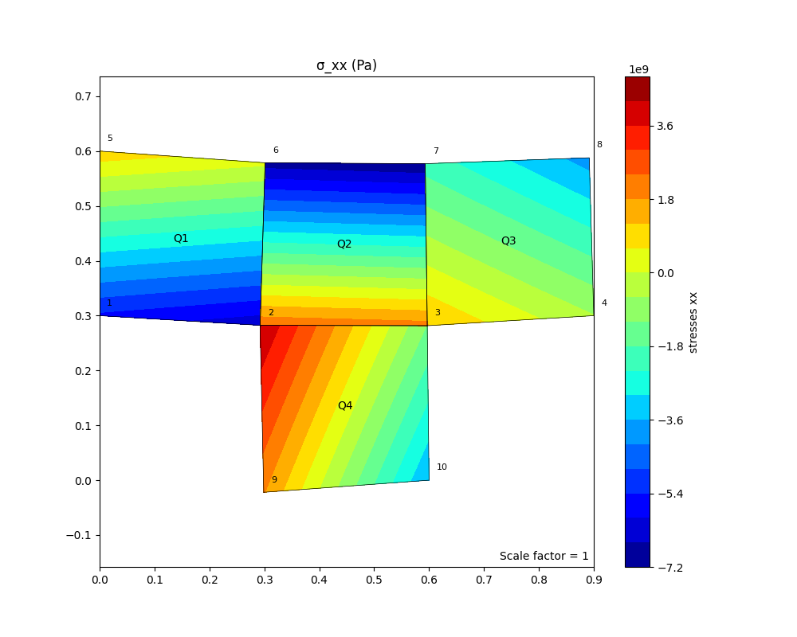

Hình 4‑2 Ứng suất phương XX

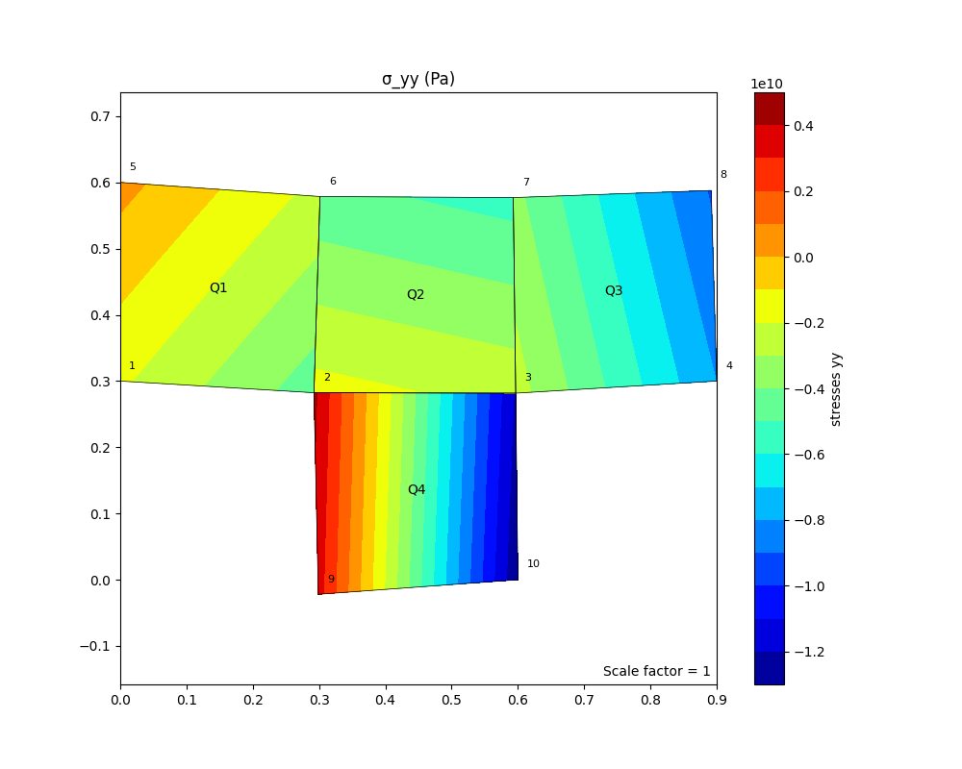

Hình 4‑3 Ứng suất chương YY

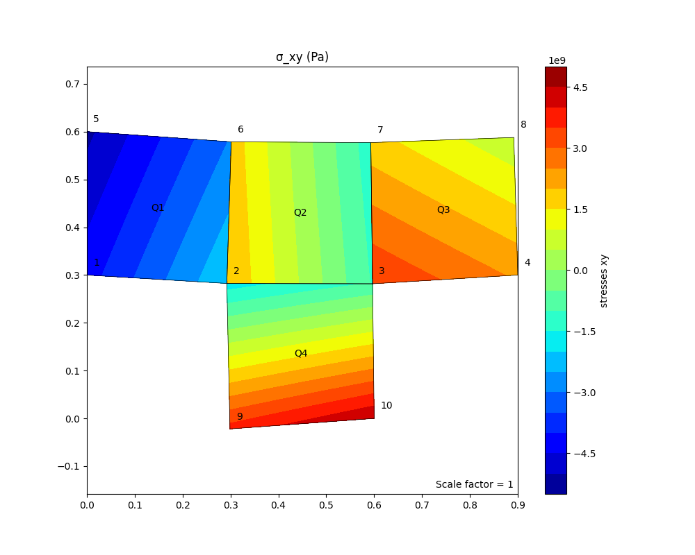

Hình 4‑4 Ứng suất phương XY

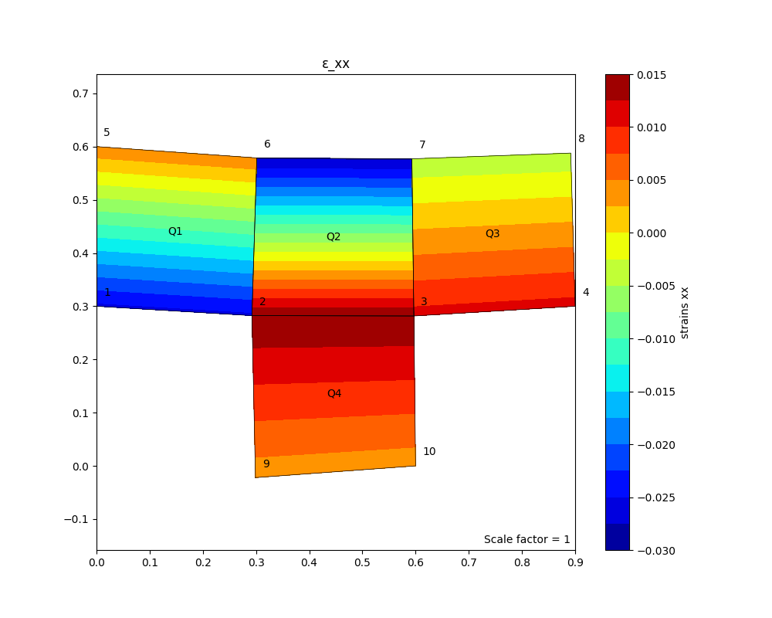

Hình 4‑5 Biến dạng phương XX

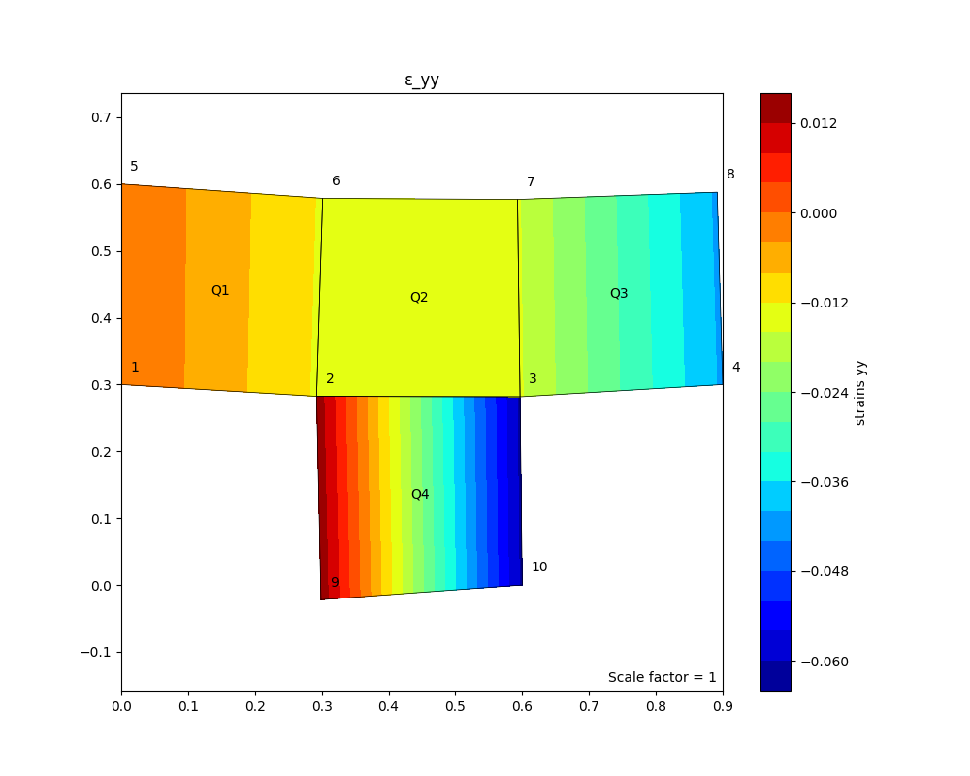

Hình 4‑6 Biến dạng phương YY

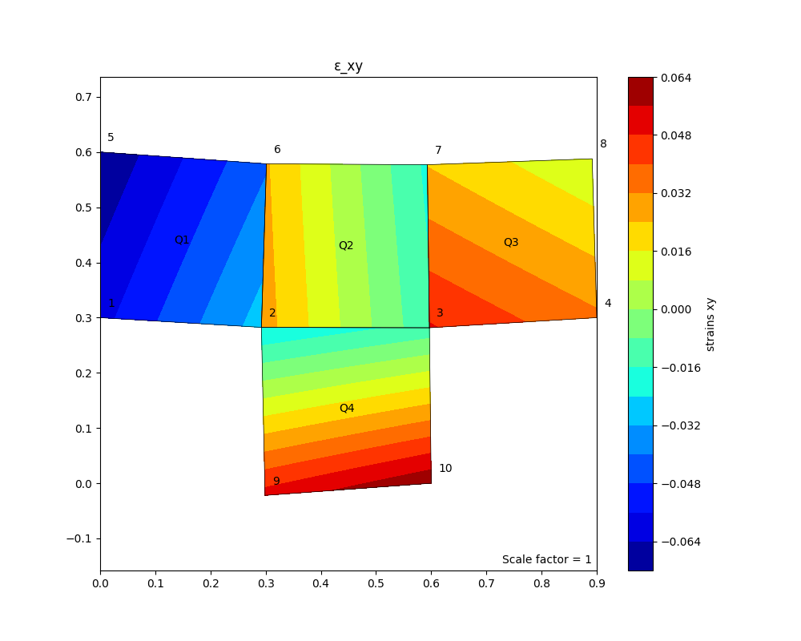

Hình 4‑7 Biến dạng phương XY

PRG_FEM_Plane.py

"""

By : Khanh Nguyen

Email : nmkhanhfem@gmail.com

Github : https://github.com/KowalskiPi

Date : 28/04/2025

Description : 2D Finite Element Method (FEM) Solver for Plane Stress/Strain Problems.

Modify for HCMUT Master's Course. + Eigenvalue Analysis.

"""

# -----------------------------------------------------------

# 0. LIBRARIES

# -----------------------------------------------------------

import numpy as np

import matplotlib.pyplot as plt

import matplotlib.cm as cm

import matplotlib.tri as tri

from matplotlib import patheffects as pe

from matplotlib.collections import PolyCollection

from scipy.linalg import eigh

from typing import Dict, List, Any

from typing import TypedDict, Tuple

from numpy.typing import NDArray

# ElementDataStorage

class ElementData(TypedDict):

element: int

nodes: NDArray[np.int_]

displacements: np.ndarray

intPts: int

intePtsStresses: Dict[str, np.ndarray] # {'xx': [], 'yy': [], 'xy': []}

intePtsStrains: Dict[str, np.ndarray] # {'xx': [], 'yy': [], 'xy': []}

class ElementNodalData(TypedDict):

element: int

nodes: NDArray[np.int_]

displacements: np.ndarray

nodalStresses: Dict[str, np.ndarray] # {'xx': [], 'yy': [], 'xy': []}

nodalStrains: Dict[str, np.ndarray] # {'xx': [], 'yy': [], 'xy': []}

# Global storage

element_results: Dict[int, ElementData] = {}

element_extrapolate_results: Dict[int, ElementNodalData] = {}

# ------------------------------------------------------------------------------------------------------------------------

# 1. HELPER FUNCTIONS

# ------------------------------------------------------------------------------------------------------------------------

def C_matrix(E, nu, mode="PLANE_STRESS"):

"""

Constitutive matrix

Parameters:

E : Young's modulus

nu : Poisson's ratio

mode : "PLANE_STRESS" or "PLANE_STRAIN"

Returns:

C : Full constitutive matrix

C_vol : Volumetric part of the constitutive matrix

"""

# Bulk modulus

# K = E / (3 * (1 - 2 * nu))

# Shear modulus

# G = E / (2 * (1 + nu))

if mode == "PLANE_STRESS":

# Full constitutive matrix

C = (E / (1 - nu**2)) * np.array([

[1, nu, 0],

[nu, 1, 0],

[0, 0, (1 - nu) / 2]

])

# Volumetric part

C_vol = (E / (1 - nu**2)) * np.array([

[1 + nu, 0, 0],

[0, 1 + nu, 0],

[0, 0, 0]

])

elif mode == "PLANE_STRAIN":

# Full constitutive matrix

C = E / ((1 + nu) * (1 - 2 * nu)) * np.array([

[1 - nu, nu, 0],

[nu, 1 - nu, 0],

[0, 0, (1 - 2 * nu) / 2]

])

# Volumetric part

C_vol = E / ((1 + nu) * (1 - 2 * nu)) * np.array([

[1, 0, 0],

[0, 1, 0],

[0, 0, 0]

])

else:

print("Unsupported mode. Use 'PLANE_STRESS' or 'PLANE_STRAIN'.")

return None, None

return C, C_vol

def integrationPoints(elementType = 'Q4', type = 'FULL'):

"""

Parameters:

elementType : Type of element (e.g., 'Q4' for quadrilateral)

type : Integration type ('FULL' or 'REDUCED')

Returns:

gauss_points : Integration points

gauss_weights: Weights for the integration points

"""

nIntegrationPoints, gaussPoints, gaussWeights = 0, None, None

if type == 'FULL':

if elementType == 'Q4':

nIntegrationPoints = 4

gaussPoints = np.array([

[-1/np.sqrt(3), -1/np.sqrt(3)],

[ 1/np.sqrt(3), -1/np.sqrt(3)],

[ 1/np.sqrt(3), 1/np.sqrt(3)],

[-1/np.sqrt(3), 1/np.sqrt(3)]

])

gaussWeights = np.array([1.0, 1.0])

elif type == 'REDUCED':

if elementType == 'Q4':

nIntegrationPoints = 1

gaussPoints = np.array([[0, 0]])

gaussWeights = np.array([4.0])

return nIntegrationPoints, gaussPoints, gaussWeights

def shape_functions_Q4(xi, eta):

"""

Bilinear shape functions and derivatives in (xi, eta)

@ 4-node quadrilateral element.

4-------3

| |

| QX |

1-------2

Parameters:

xi, eta : natural coordinates (each in [-1, 1])

Returns:

N : Array of shape functions [N1, N2, N3, N4]

dN_dxi : Array of derivatives with respect to xi

dN_deta : Array of derivatives with respect to eta

"""

N = np.array([

0.25 * (1 - xi) * (1 - eta), # N1 (bottom left)

0.25 * (1 + xi) * (1 - eta), # N2 (bottom right)

0.25 * (1 + xi) * (1 + eta), # N3 (top right)

0.25 * (1 - xi) * (1 + eta) # N4 (top left)

])

dN_dxi = np.array([

-0.25 * (1 - eta),

0.25 * (1 - eta),

0.25 * (1 + eta),

-0.25 * (1 + eta)

])

dN_deta = np.array([

-0.25 * (1 - xi),

-0.25 * (1 + xi),

0.25 * (1 + xi),

0.25 * (1 - xi)

])

return N, dN_dxi, dN_deta

def mapping(xi, eta, nodes):

"""

Map from (xi, eta) to physical coord. (x, y).

Parameters:

xi, eta : Natural coordinates.

nodes : (4 x 2) array of nodal (x,y) coordinates for the element.

Returns:

x : Physical coordinates (x, y) corresponding to (xi, eta)

J : 2x2 Jacobian matrix d(x,y)/d(xi,eta)

detJ : Determinant of the Jacobian matrix.

"""

N, dN_dxi, dN_deta = shape_functions_Q4(xi, eta)

x = np.dot(N, nodes)

dx_dxi = np.dot(dN_dxi, nodes)

dx_deta = np.dot(dN_deta, nodes)

J = np.array([dx_dxi, dx_deta]).T

detJ = np.linalg.det(J)

return x, J, detJ

def compute_area_Q4(nodes, gauss_points=[-1/np.sqrt(3), 1/np.sqrt(3)]):

"""

Compute the area of Q4 using 2x2 Gauss integration.

Parameters:

nodes : (4 x 2) (physical space)

gauss_points : Gauss points (default: [-1/sqrt(3), 1/sqrt(3)])

Returns:

area : Element area.

"""

area = 0.0

for xi in gauss_points:

for eta in gauss_points:

_, _, detJ = mapping(xi, eta, nodes)

area += abs(detJ)

return area

# ------------------------------------------------------------------------------------------------------------------------

# 1.1 Element Stiffness Matrix Computation

# ------------------------------------------------------------------------------------------------------------------------

# Compute stiffness matrix using full integration -------------------------------------------------------------

def compute_quad_element_stiffness(E, nu, nodes, t=1, mode="PLANE_STRESS"):

"""

Compute Q4 stiffness matrix (8 x 8) using 2x2 Gauss integration.

Returns:

Ke : Element stiffness matrix (8 x 8)

B_matrices : List of strain-displacement matrices (B) for each Gauss point

"""

print("\nProcessing: Element stiffness matrix, full integration.......")

nFullIntegrationPoints, gauss_points_full, gauss_weights_full = integrationPoints('Q4', 'FULL')

if gauss_points_full is None or gauss_weights_full is None:

print("Gauss points = None")

return None, None, None

if mode == "PLANE_STRAIN":

t = 1 # Force thickness to 1 for plane strain

C, _ = C_matrix(E, nu, mode)

if C is None:

print("C matrix = None")

return None, None, None

Ke = np.zeros((8, 8))

B_matrices = [] # Store B matrices for each Gauss point

# --- Full Integration ---

print("\nFull Integration Points (2x2 Quadrature):")

gp_weights_xi = gauss_weights_full[0]

gp_weights_eta = gauss_weights_full[1]

for i, gp in enumerate(gauss_points_full):

xi, eta = gp

print(f"GP{i}: (ξ={xi:.4f}, η={eta:.4f}), weight=({gp_weights_xi:.4f}, {gp_weights_eta:.4f})")

N, dN_dxi, dN_deta = shape_functions_Q4(xi, eta)

_, J, detJ = mapping(xi, eta, nodes)

if detJ <= 0:

print("Jacobian determinant is non-positive. Check node ordering!")

invJ = np.linalg.inv(J)

# Compute global derivatives

dN_dx = invJ[0, 0] * dN_dxi + invJ[0, 1] * dN_deta

dN_dy = invJ[1, 0] * dN_dxi + invJ[1, 1] * dN_deta

# Assemble strain-displacement matrix B (3 x 8)

B = np.zeros((3, 8))

for k in range(4):

B[0, 2 * k] = dN_dx[k]

B[1, 2 * k + 1] = dN_dy[k]

B[2, 2 * k] = dN_dy[k]

B[2, 2 * k + 1] = dN_dx[k]

# Add contribution to the element stiffness matrix

Ke += gp_weights_xi * gp_weights_eta * (B.T @ C @ B) * detJ * t

# Store the B matrix for this Gauss point

B_matrices.append(B)

return Ke, B_matrices, C

# Compute stiffness matrix using B-Bar method -----------------------------------------------------------------

def compute_quad_element_stiffness_bbar(E, nu, nodes, t=1, mode="PLANE_STRESS"):

"""

Compute Q4 stiffness matrix (8 x 8) using 2x2 Gauss integration with B-Bar method.

Parameters:

E : Young's modulus

nu : Poisson's ratio

nodes: (4 x 2) array of nodal coordinates

t : Thickness of the element

mode : "PLANE_STRESS" or "PLANE_STRAIN"

Returns:

Ke : Element stiffness matrix (8 x 8)

B_matrices : List of strain-displacement matrices (B) for each Gauss point

"""

print("\nProcessing: Element stiffness matrix, BBar.......")

# Full integration points (2x2 Gauss quadrature)

nFullIntegrationPoints, gauss_points_full, gauss_weights_full = integrationPoints('Q4', 'FULL')

if gauss_points_full is None or gauss_weights_full is None:

print("Gauss points = None")

return None, None, None

if mode == "PLANE_STRAIN":

t = 1 # Force thickness to 1 for plane strain

C, _ = C_matrix(E, nu, mode)

if C is None:

print("C matrix = None")

return None, None, None

Ke = np.zeros((8, 8))

B_matrices = [] # Store B matrices for each Gauss point

# Volumetric strain-displacement matrix normalization

BvolNorm = np.zeros((4, 2)) # 4 nodes, 2 coord (x, y)

element_volume = 0.0

# --- First loop: Bvol and Ve ---

print("\nNormalizing volumetric B_vol matrix......")

gp_weights_xi = gauss_weights_full[0]

gp_weights_eta = gauss_weights_full[1]

for i, gp in enumerate(gauss_points_full):

xi, eta = gp

print(f"GP{i}: (ξ={xi:.4f}, η={eta:.4f}), weight=({gp_weights_xi:.4f}, {gp_weights_eta:.4f})")

N, dN_dxi, dN_deta = shape_functions_Q4(xi, eta)

_, J, detJ = mapping(xi, eta, nodes)

if detJ <= 0:

print("Jacobian determinant is non-positive. Check node ordering!")

invJ = np.linalg.inv(J)

# Compute global derivatives

dN_dx = invJ[0, 0] * dN_dxi + invJ[0, 1] * dN_deta

dN_dy = invJ[1, 0] * dN_dxi + invJ[1, 1] * dN_deta

# Accumulate volumetric strain-displacement matrix

for k in range(4): # Loop over nodes

BvolNorm[k, 0] += dN_dx[k] * gp_weights_xi * gp_weights_eta * detJ

BvolNorm[k, 1] += dN_dy[k] * gp_weights_xi * gp_weights_eta * detJ

# Accumulate element volume

element_volume += gp_weights_xi * gp_weights_eta * detJ

# Normalize Bvol by Ve

BvolNorm = (1 / 2) * BvolNorm / element_volume

# Second loop: Compute stiffness matrix with B-Bar correction

print("\nCorrection of B matrix......")

gp_weights_xi = gauss_weights_full[0]

gp_weights_eta = gauss_weights_full[1]

for i, gp in enumerate(gauss_points_full):

xi, eta = gp

print(f"GP{i}: (ξ={xi:.4f}, η={eta:.4f}), weight=({gp_weights_xi:.4f}, {gp_weights_eta:.4f})")

N, dN_dxi, dN_deta = shape_functions_Q4(xi, eta)

_, J, detJ = mapping(xi, eta, nodes)

if detJ <= 0:

print("Jacobian determinant is non-positive. Check node ordering!")

invJ = np.linalg.inv(J)

# Compute global derivatives

dN_dx = invJ[0, 0] * dN_dxi + invJ[0, 1] * dN_deta

dN_dy = invJ[1, 0] * dN_dxi + invJ[1, 1] * dN_deta

# Assemble eps-displacement matrix B (3 x 8)

B = np.zeros((3, 8))

for k in range(4):

B[0, 2 * k] = dN_dx[k]

B[1, 2 * k + 1] = dN_dy[k]

B[2, 2 * k] = dN_dy[k]

B[2, 2 * k + 1] = dN_dx[k]

# Correct B using B-Bar method

for k in range(4):

B[0, 2 * k] += (- dN_dx[k]/2 + BvolNorm[k, 0])

B[1, 2 * k] += (- dN_dx[k]/2 + BvolNorm[k, 0])

B[0, 2 * k + 1] += (- dN_dy[k]/2 + BvolNorm[k, 1])

B[1, 2 * k + 1] += (- dN_dy[k]/2 + BvolNorm[k, 1])

# Add contribution to the element stiffness matrix

Ke += gp_weights_xi * gp_weights_eta * (B.T @ C @ B) * detJ * t

# Store the B matrix for this Gauss point

B_matrices.append(B)

return Ke, B_matrices, C

# Compute stiffness matrix using selective reduced integration method -----------------------------------------

def compute_quad_element_stiffness_selective_reduced(E, nu, nodes, t=1, mode="PLANE_STRESS"):

"""

Compute Q4 stiffness matrix (8 x 8) using selective reduced integration.

Parameters:

E : Young's modulus

nu : Poisson's ratio

nodes: (4 x 2) array of nodal coordinates

t : Thickness of the element

mode : "PLANE_STRESS" or "PLANE_STRAIN"

Returns:

Ke : Element stiffness matrix (8 x 8)

B_matrices : List of strain-displacement matrices (B) for each Gauss point

"""

print("\nProcessing: Element stiffness matrix, selective reduced integration......")

# Full integration points (2x2 Gauss quadrature)

nFullIntegrationPoints, gauss_points_full, gauss_weights_full = integrationPoints('Q4', 'FULL')

# Reduced integration points (1x1 Gauss quadrature)

nReducedIntegrationPoints, gauss_points_reduced, gauss_weights_reduced = integrationPoints('Q4', 'REDUCED')

if gauss_points_full is None or gauss_weights_full is None \

or gauss_points_reduced is None or gauss_weights_reduced is None:

print("Gauss points = None")

return None, None, None

if mode == "PLANE_STRAIN":

t = 1 # Force thickness to 1 for plane strain

C, C_vol = C_matrix(E, nu, mode)

if C is None or C_vol is None:

print("C matrices = None")

return None, None, None

Ke = np.zeros((8, 8))

B_matrices = []

# --- Full Integration: Deviatoric Part ---

print("\nDeviatoric: Full Integration Points (2x2 Quadrature):")

gp_weights_xi = gauss_weights_full[0]

gp_weights_eta = gauss_weights_full[1]

for i, gp in enumerate(gauss_points_full):

xi, eta = gp

print(f"GP{i}: (ξ={xi:.4f}, η={eta:.4f}), weight=({gp_weights_xi:.4f}, {gp_weights_eta:.4f})")

N, dN_dxi, dN_deta = shape_functions_Q4(xi, eta)

_, J, detJ = mapping(xi, eta, nodes)

if detJ <= 0:

print("Jacobian determinant is non-positive. Check node ordering!")

invJ = np.linalg.inv(J)

# Compute global derivatives

dN_dx = invJ[0, 0] * dN_dxi + invJ[0, 1] * dN_deta

dN_dy = invJ[1, 0] * dN_dxi + invJ[1, 1] * dN_deta

# Assemble strain-displacement matrix B (3 x 8)

B = np.zeros((3, 8))

for k in range(4):

B[0, 2 * k] = dN_dx[k]

B[1, 2 * k + 1] = dN_dy[k]

B[2, 2 * k] = dN_dy[k]

B[2, 2 * k + 1] = dN_dx[k]

# Remove volumetric part from stiffness matrix

Ke += gp_weights_xi * gp_weights_eta * (B.T @ C @ B) * detJ * t

Ke -= (1/2) * gp_weights_xi * gp_weights_eta * (B.T @ C_vol @ B) * detJ * t

# Store the B matrix for this Gauss point

B_matrices.append(B)

# --- Reduced Integration: Recover volumetric ---

print("\nRecover volumetric: Reduced Integration Points (1x1 Quadrature):")

for i, gp in enumerate(gauss_points_reduced):

xi, eta = gp

print(f"GP{i}: (ξ={xi:.4f}, η={eta:.4f}), weight={gauss_weights_reduced[0]:.4f}")

N, dN_dxi, dN_deta = shape_functions_Q4(xi, eta)

_, J, detJ = mapping(xi, eta, nodes)

if detJ <= 0:

print("Jacobian determinant is non-positive. Check node ordering!")

invJ = np.linalg.inv(J)

# Global derivatives

dN_dx = invJ[0, 0] * dN_dxi + invJ[0, 1] * dN_deta

dN_dy = invJ[1, 0] * dN_dxi + invJ[1, 1] * dN_deta

# Assemble strain-displacement matrix B (3 x 8)

B = np.zeros((3, 8))

for k in range(4):

B[0, 2 * k] = dN_dx[k]

B[1, 2 * k + 1] = dN_dy[k]

B[2, 2 * k] = dN_dy[k]

B[2, 2 * k + 1] = dN_dx[k]

# Add back the volumetric part via reduced inter.

Ke += (1/2) * gauss_weights_reduced[0] * (B.T @ C_vol @ B) * detJ * t

# print("Type of Ke:", type(Ke))

return Ke, B_matrices, C

# Compute stiffness matrix using incompatible simplified strain -----------------------------------------------

def compute_quad_element_stiffness_incompatible(E, nu, nodes, t=1, mode="PLANE_STRESS"):

"""

Compute Q4 stiffness matrix (8 x 8) using incompatible modes and static condensation.

Parameters:

E : Young's modulus

nu : Poisson's ratio

nodes : (4 x 2) array of nodal coordinates

t : Thickness of the element

mode : "PLANE_STRESS" or "PLANE_STRAIN"

Returns:

Ke_condensed : Condensed element K (8 x 8)

B_matrices : List of standard B matrices

"""

print("\nProcessing: Element stiffness matrix, incompatible mode.......")

# Full integration points (2x2 Gauss quadrature)

nFullIntegrationPoints, gauss_points_full, gauss_weights_full = integrationPoints('Q4', 'FULL')

if gauss_points_full is None or gauss_weights_full is None:

print("Gauss points = None")

return None, None, None

if mode == "PLANE_STRAIN":

t = 1 # Force thickness to 1 for plane strain

C, C_vol = C_matrix(E, nu, mode)

if C is None or C_vol is None:

print("C matrices = None")

return None, None, None

B_matrices = []

B_std_list = []

B_inc_list = []

# Compute Jacobian at centroid (xi=0, eta=0)

xi_center, eta_center = 0.0, 0.0

_, J0, detJ0 = mapping(xi_center, eta_center, nodes)

invJ0 = np.linalg.inv(J0)

# Initialize

Kuu = np.zeros((8, 8))

Kua = np.zeros((8, 4))

Kau = np.zeros((4, 8))

Kaa = np.zeros((4, 4))

# Integration loop

gp_weights_xi = gauss_weights_full[0]

gp_weights_eta = gauss_weights_full[1]

for i, gp in enumerate(gauss_points_full):

xi, eta = gp

print(f"GP{i}: (ξ={xi:.4f}, η={eta:.4f}), weight=({gp_weights_xi:.4f}, {gp_weights_eta:.4f})")

N, dN_dxi, dN_deta = shape_functions_Q4(xi, eta)

_, J, detJ = mapping(xi, eta, nodes)

if detJ <= 0:

print("Jacobian determinant is non-positive. Check node ordering!")

invJ = np.linalg.inv(J)

weight = gp_weights_xi * gp_weights_eta

# Standard B matrix (Voigt)

N, dN_dxi, dN_deta = shape_functions_Q4(xi, eta)

dN_dx = invJ[0, 0] * dN_dxi + invJ[0, 1] * dN_deta

dN_dy = invJ[1, 0] * dN_dxi + invJ[1, 1] * dN_deta

B_std = np.zeros((3, 8))

for a in range(4):

B_std[0, 2*a] = dN_dx[a] # ε_xx

B_std[1, 2*a + 1] = dN_dy[a] # ε_yy

B_std[2, 2*a] = dN_dy[a] # ε_xy

B_std[2, 2*a + 1] = dN_dx[a]

# --- Incompatible Modes --------------

scaling = (detJ0 / detJ)

xi_scaled = xi * scaling

eta_scaled = eta * scaling

# Derivatives of incompatible modes (alpha1: xi-term, alpha2: eta-term)

dalpha1_dx = invJ0[0, 0] * xi_scaled

dalpha1_dy = invJ0[1, 0] * xi_scaled

dalpha2_dx = invJ0[0, 1] * eta_scaled

dalpha2_dy = invJ0[1, 1] * eta_scaled

# B_alpha matrix (3x4)

B_alpha = np.zeros((3, 4))

# Mode 1 (xi-term)

B_alpha[0, 0] = dalpha1_dx # ε_xx

B_alpha[1, 0] = 0.0

B_alpha[2, 0] = dalpha1_dy # ε_xy

# Mode 2 (eta-term)

B_alpha[0, 1] = dalpha2_dx

B_alpha[1, 1] = 0.0

B_alpha[2, 1] = dalpha2_dy

# Modes 3 & 4

B_alpha[0, 2] = 0.0

B_alpha[1, 2] = dalpha1_dy # ε_yy

B_alpha[2, 2] = dalpha1_dx

B_alpha[0, 3] = 0.0

B_alpha[1, 3] = dalpha2_dy

B_alpha[2, 3] = dalpha2_dx

# --- Assemble Sub-Matrices ---

Kuu += (B_std.T @ C @ B_std) * detJ * t * weight

Kua += (B_std.T @ C @ B_alpha) * detJ * t * weight

Kau += (B_alpha.T @ C @ B_std) * detJ * t * weight

Kaa += (B_alpha.T @ C @ B_alpha) * detJ * t * weight

# B_matrices.append(B_std)

B_std_list.append(B_std)

B_inc_list.append(B_alpha)

# Static condensation

Kaa += 1e-10 * np.eye(4) # Stabilize

Kaa_inv = np.linalg.inv(Kaa)

Ke_condensed = Kuu - Kua @ Kaa_inv @ Kau

B_eff_list = []

for B_std, B_alpha in zip(B_std_list, B_inc_list):

B_eff = B_std - B_alpha @ Kaa_inv @ Kau

B_eff_list.append(B_eff)

B_matrices = B_eff_list

return Ke_condensed, B_matrices, C

# ------------------------------------------------------------------------------------------------------------------------

# 2. FORCE ASSEMBLY & B.C. APPLY

# ------------------------------------------------------------------------------------------------------------------------

def assemble_force_vector(total_dof, point_loads=None, distributed_loads=None, nodes_global=None):

"""

Assemble the global force vector.

Parameters:

total_dof : Total degrees of freedom.

point_loads : List of tuples (node_index, dof, value)

dof = 0 (x-direction) or 1 (y-direction).

distributed_loads : {'edge': (n1, n2), 'direction': 'y', 'value': load_value}

nodes_global : Global nodal coordinates.

Returns:

f : Global force vector.

"""

f = np.zeros(total_dof)

# Apply point loads

if point_loads is not None:

for load in point_loads:

node, dof, value = load # node index (0-indexed), dof: 0 => x, 1 => y.

f[2*node + dof] += value

# Apply distributed loads (1D line loads on edges)

if distributed_loads is not None:

if nodes_global is None:

print("Global nodal coordinates must be provided for distributed loads.")

return

# For each distributed load over an edge:

for dload in distributed_loads:

n1, n2 = dload['edge']

direction = dload['direction']

load_value = dload['value']

# Compute length of edge

x1, y1 = nodes_global[n1]

x2, y2 = nodes_global[n2]

edge_length = np.sqrt((x2-x1)**2 + (y2-y1)**2)

# Use 2-point Gauss quadrature in 1D for line integration:

gp_1D = np.array([-1/np.sqrt(3), 1/np.sqrt(3)])

gp_weights = np.array([1.0, 1.0])

for gp, w in zip(gp_1D, gp_weights):

# Linear shape functions along the edge:

N_edge = np.array([0.5*(1-gp), 0.5*(1+gp)])

f_edge = N_edge * load_value * (edge_length / 2) * w

# Distribute load to the relevant DOFs (assume vertical load if direction=='y')

if direction == 1:

f[2*n1+1] += f_edge[0]

f[2*n2+1] += f_edge[1]

else:

f[2*n1] += f_edge[0]

f[2*n2] += f_edge[1]

return f

def apply_boundary_conditions(K, f, fixed_dofs):

"""

Apply boundary conditions -> reduce global K and f.

Parameters:

K : Global stiffness matrix.

f : Global force vector.

fixed_dofs: Array or list of fixed degree-of-freedom.

Returns:

K_reduced, f_reduced, free_dofs : Reduced K, f, and free DOFs.

"""

total_dof = K.shape[0]

all_dofs = np.arange(total_dof)

free_dofs = np.setdiff1d(all_dofs, fixed_dofs)

# print("Type of free_dofs:", type(free_dofs))

# print("free_dofs dtype:", free_dofs.dtype)

if f is None:

f = np.zeros(total_dof)

# Ensure no overlap

assert len(np.intersect1d(fixed_dofs, free_dofs)) == 0, "Fixed DOFs overlap with Free DOFs!"

assert np.max(free_dofs) < total_dof, "Free DOFs contain out-of-bounds indices!"

# print("Type of K:", type(K))

# print("Shape of K:", K.shape)

K_reduced = K[np.ix_(free_dofs, free_dofs)]

f_reduced = f[free_dofs]

# print("Type of K_reduced:", type(K_reduced))

# print("Shape of K_reduced:", K_reduced.shape)

return K_reduced, f_reduced, free_dofs

# ------------------------------------------------------------------------------------------------------------------------

# 3. ASSEMBLY

# ------------------------------------------------------------------------------------------------------------------------

def assemble_global_stiffness_matrix(E, nu, elements, nodes_global, t=1, mode="PLANE_STRESS", integrationMode='Full'):

"""

Assemble global stiffness matrix.

Parameters:

E : Young's modulus (Pa)

nu : Poisson's ratio

elements : List of elements with node indices

nodes_global: Global nodal coordinates

t : Thickness of the element (default=1 for unit thickness)

mode : default('PLANE_STRESS') / 'PLANE_STRAIN'

integrationMode : Mode of integration ('Full' / 'BBar' / 'SelReduced' / 'IncompatibleStrain')

Returns:

global_K : Global stiffness matrix

"""

total_dof = nodes_global.shape[0] * 2 # 2 DOF per node

global_K = np.zeros((total_dof, total_dof))

Ke_local = None

for e_idx, elem in enumerate(elements):

elem_nodes = nodes_global[elem, :]

# Use B-Bar

if integrationMode == 'BBar':

Ke_local, _, _ = compute_quad_element_stiffness_bbar(E, nu, elem_nodes, t, mode)

elif integrationMode == 'Full':

Ke_local, _, _ = compute_quad_element_stiffness(E, nu, elem_nodes, t, mode)

elif integrationMode == 'SelReduced':

Ke_local, _, _ = compute_quad_element_stiffness_selective_reduced(E, nu, elem_nodes, t, mode)

elif integrationMode == 'IncompatibleStrain':

Ke_local, _, _ = compute_quad_element_stiffness_incompatible(E, nu, elem_nodes, t, mode)

else:

print("Unsupported integration mode %s" % integrationMode)

if Ke_local is None:

print("Element stiffness matrix = None. Check element %d." % (e_idx + 1))

return None

print(f"\nElement {e_idx + 1}:\n", Ke_local)

###

dof_indices = []

for node in elem:

dof_indices.extend([2 * node, 2 * node + 1])

dof_indices = np.array(dof_indices)

for i in range(len(dof_indices)):

for j in range(len(dof_indices)):

global_K[dof_indices[i], dof_indices[j]] += Ke_local[i, j]

# print("Type of global_K:", type(global_K))

# print("Shape of global_K:", global_K.shape)

return global_K

# ------------------------------------------------------------------------------------------------------------------------

# 4. FEM SOLID MECHANIC SOLVER

# ------------------------------------------------------------------------------------------------------------------------

def fem_solver(E, nu, elements, nodes_global, t, point_loads, distributed_loads, fixed_dofs, mode="PLANE_STRESS",

integrationMode='Full'):

"""

Finite Element Method Solver for 2D Plane Stress/Strain.

Returns:

results : Dictionary of nodal displacements, element stresses, etc.

K_reduced : Reduced stiffness matrix (export for eigen.)

free_dofs : Free degrees of freedom (export for eigen.)

"""

# --- Global Stiffness Matrix Assembly ---

global_K = assemble_global_stiffness_matrix(E, nu, elements, nodes_global, t, mode, integrationMode)

print("\nGlobal Stiffness Matrix (K):\n", global_K)

# --- Force Vector Assembly ---

total_dof = nodes_global.shape[0] * 2

f = assemble_force_vector(total_dof, point_loads=point_loads, distributed_loads=distributed_loads,

nodes_global=nodes_global)

# --- Apply Boundary Conditions ---

K_reduced, f_reduced, free_dofs = apply_boundary_conditions(global_K, f, fixed_dofs)

print("\nReduced Global Stiffness Matrix (K):\n", K_reduced)

print("\nReduced Force Vector (f):\n", f_reduced)

# --- Solve the System KU = f ---

U_reduced = np.linalg.solve(K_reduced, f_reduced)

U = np.zeros(total_dof)

U[free_dofs] = U_reduced

# --- Compute Stresses for Each Element ---

for elem_idx, element_nodes in enumerate(elements):

element_coords = nodes_global[element_nodes] # Coordinates of element nodes

# Elements displacements

u_element = np.zeros(8) # 4 nodes * 2 DOF per node

for i, node in enumerate(element_nodes):

u_element[2 * i] = U[2 * node] # x-displacement

u_element[2 * i + 1] = U[2 * node + 1] # y-displacement

# Get B and C

B_matrices = None

C = None

if integrationMode == 'BBar':

_, B_matrices, C = compute_quad_element_stiffness_bbar(E, nu, element_coords, t, mode)

elif integrationMode == 'Full':

_, B_matrices, C = compute_quad_element_stiffness(E, nu, element_coords, t, mode)

elif integrationMode == 'SelReduced':

_, B_matrices, C = compute_quad_element_stiffness_selective_reduced(E, nu, element_coords, t, mode)

elif integrationMode == 'IncompatibleStrain':

_, B_matrices, C = compute_quad_element_stiffness_incompatible(E, nu, element_coords, t, mode)

else:

print("Unsupported integration mode %s" % integrationMode)

# Stress at Gauss points

stresses = []

strains = []

if B_matrices is not None and C is not None:

for B in B_matrices:

strain = B @ u_element

stress = C @ strain

stresses.append(stress)

strains.append(strain)

else:

print(f"\nElement {elem_idx+1}: B_matrices or C = None, stress/strain computation error.")

stresses = np.zeros((4, 3))

strains = np.zeros((4, 3))

stresses = np.array(stresses)

strains = np.array(strains)

# Store 1 element result

element_results[elem_idx] = {

'element': elem_idx + 1,

'intPts': 4,

'nodes': element_nodes,

'displacements': u_element,

# 'intePtsStresses': stresses,

# 'intePtsStrains': strains

'intePtsStresses': {'xx':stresses[:, 0], 'yy':stresses[:, 1], 'xy':stresses[:, 2]},

'intePtsStrains': {'xx':strains[:, 0], 'yy':strains[:, 1], 'xy':strains[:, 2]}

}

# Store all elements results

results = {

"nodal_displacements": U,

"element_results": element_results

}

return results, K_reduced, free_dofs

# ------------------------------------------------------------------------------------------------------------------------

# 5. FEM EIGEN VALUE SOLVER

# ------------------------------------------------------------------------------------------------------------------------

def compute_Q4_element_mass(density, t, nodes):

"""

Compute the consistent mass matrix Q4.

Parameters:

density : Material density (kg/m^3)

t : Thickness of the element (m)

nodes : (4 x 2) node coord.

Returns:

M_local : Element mass matrix (8 x 8)

"""

# Compute the area of the element

area = compute_area_Q4(nodes)

# Total mass of the element

mass = density * t * area

# Consistent mass matrix for a 4-node quadrilateral element

M_local = (mass / 36) * np.array([

[4, 0, 2, 0, 1, 0, 2, 0],

[0, 4, 0, 2, 0, 1, 0, 2],

[2, 0, 4, 0, 2, 0, 1, 0],

[0, 2, 0, 4, 0, 2, 0, 1],

[1, 0, 2, 0, 4, 0, 2, 0],

[0, 1, 0, 2, 0, 4, 0, 2],

[2, 0, 1, 0, 2, 0, 4, 0],

[0, 2, 0, 1, 0, 2, 0, 4]

])

return M_local

def assemble_global_mass_matrix(density, t, elements, nodes_global):

"""

Assemble the global mass matrix for the entire structure.

Parameters:

density : Material density (kg/m^3)

t : Thickness of the element (m)

elements : Connectivity array (list of elements with node indices)

nodes_global : Global nodal coordinates

Returns:

global_M : Global mass matrix

"""

total_dof = nodes_global.shape[0] * 2 # 2 DOF per node

global_M = np.zeros((total_dof, total_dof))

for e_idx, elem in enumerate(elements):

elem_nodes = nodes_global[elem, :] # Get nodal coordinates for the element

M_local = compute_Q4_element_mass(density, t, elem_nodes) # Local mass matrix

# Map local mass matrix to global mass matrix

dof_indices = []

for node in elem:

dof_indices.extend([2 * node, 2 * node + 1])

dof_indices = np.array(dof_indices)

for i in range(len(dof_indices)):

for j in range(len(dof_indices)):

global_M[dof_indices[i], dof_indices[j]] += M_local[i, j]

return global_M

def fem_eigen_solver(K_reduced, density, t, elements, nodes_global, free_dofs, num_modes=4, modeShapeScale=[1]):

"""

Compute the first few eigenfrequencies and mode shapes of the structure.

Parameters:

K_reduced : Reduced stiffness matrix

density : Material density (kg/m^3)

t : Thickness of the element (m)

elements : Connectivity array (list of elements with node indices)

nodes_global: Global nodal coordinates

free_dofs : List of free degrees of freedom

num_modes : Number of eigenfrequencies and mode shapes to compute

Returns:

eigenfrequencies : Array of eigenfrequencies (Hz)

mode_shapes : Array of mode shapes (eigenvectors)

"""

# Assemble global mass matrix

global_M = assemble_global_mass_matrix(density, t, elements, nodes_global)

print("\nGlobal mass matrix:\n", global_M)

# Apply boundary conditions

M_reduced = global_M[np.ix_(free_dofs, free_dofs)]

print("\nReduced mass matrix:\n", M_reduced)

# Solve the generalized eigenvalue problem

eigenvalues, eigenvectors = eigh(K_reduced, M_reduced, subset_by_index=[0, num_modes - 1])

numModeScale = np.size(modeShapeScale)

for i in range(numModeScale):

eigenvectors[:, i] = modeShapeScale[i]*eigenvectors[:, i]

# Compute eigenfrequencies (Hz)

eigenfrequencies = np.sqrt(eigenvalues) / (2 * np.pi)

# Normalize mode shapes

mode_shapes = np.zeros((global_M.shape[0], num_modes))

mode_shapes[free_dofs, :] = eigenvectors

return eigenfrequencies, mode_shapes

# ------------------------------------------------------------------------------------------------------------------------

# 6. POST-PROCESSING FUNCTIONS

# ------------------------------------------------------------------------------------------------------------------------

def element_average(elemIdx: int) -> Dict[str, Dict[str, float]]:

# Initialize averages

averageValues = {

'stresses': {'xx': 0.0, 'yy': 0.0, 'xy': 0.0},

'strains': {'xx': 0.0, 'yy': 0.0, 'xy': 0.0}

}

# Get all (0-based)

element_data = element_results.get(elemIdx)

if not element_data:

print(f"Element {elemIdx} not found in results")

return averageValues

# Calculate averages across all nodes

num_nodes = len(element_data['nodes'])

num_intPts = element_data['intPts']

for i, comp in enumerate(['xx', 'yy', 'xy']):

if len(element_data['intePtsStresses'][comp]) != num_intPts:

print(f"σ_{comp} != no. of integration points")

break

averageValues['stresses'][comp] = float(np.mean(element_data['intePtsStresses'][comp]))

for i, comp in enumerate(['xx', 'yy', 'xy']):

if len(element_data['intePtsStrains'][comp]) != num_nodes:

print(f"ε_{comp} != no. of integration points")

break

averageValues['strains'][comp] = float(np.mean(element_data['intePtsStrains'][comp]))

return averageValues

def extrapolate_gauss_to_nodes(elements: np.ndarray,

nodes_global: np.ndarray,

isAverageNodalValue: bool = True,

element_results: Dict = element_results) -> Tuple[Dict, Dict]:

# Get shape functions and inverse matrix

n_gp, gp_points, gp_weights = integrationPoints('Q4', 'FULL')

if gp_points is None or gp_weights is None:

print("Gauss points = None")

return {}, {}

elemN = [shape_functions_Q4(xi, eta)[0] for xi, eta in gp_points]

inv_N = np.linalg.inv(np.array(elemN))

# Initialize data structures

num_global_nodes = nodes_global.shape[0]

element_extrapolate = {}

nodal_accumulator = {

'stresses': {comp: np.zeros(num_global_nodes) for comp in ['xx', 'yy', 'xy']},

'strains': {comp: np.zeros(num_global_nodes) for comp in ['xx', 'yy', 'xy']},

'count': np.zeros(num_global_nodes, dtype=int)

} if isAverageNodalValue else None

# Process each element

for elem_idx, elem_data in element_results.items():

elem_nodes = elements[elem_idx]

num_elem_nodes = len(elem_nodes)

# Extrapolate stresses and strains

stresses_gp = np.column_stack([elem_data['intePtsStresses'][comp]

for comp in ['xx', 'yy', 'xy']])

strains_gp = np.column_stack([elem_data['intePtsStrains'][comp]

for comp in ['xx', 'yy', 'xy']])

nodal_stresses = inv_N @ stresses_gp # Shape: (4 nodes, 3 components)

nodal_strains = inv_N @ strains_gp

# Store extrapolated results

element_extrapolate_results[elem_idx] = ElementNodalData(

element=elem_idx + 1,

nodes=elem_nodes,

displacements=elem_data['displacements'],

nodalStresses={

'xx': nodal_stresses[:, 0],

'yy': nodal_stresses[:, 1],

'xy': nodal_stresses[:, 2]

},

nodalStrains={

'xx': nodal_strains[:, 0],

'yy': nodal_strains[:, 1],

'xy': nodal_strains[:, 2]

}

)

# Accumulate for averaging

if isAverageNodalValue and nodal_accumulator is not None:

for i, node in enumerate(elem_nodes):

nodal_accumulator['count'][node] += 1

for comp in ['xx', 'yy', 'xy']:

nodal_accumulator['stresses'][comp][node] += element_extrapolate_results[elem_idx]['nodalStresses'][comp][i]

nodal_accumulator['strains'][comp][node] += element_extrapolate_results[elem_idx]['nodalStrains'][comp][i]

# Average nodal

nodal_average_data = None

if isAverageNodalValue and nodal_accumulator is not None:

nodal_average_data = {

'node': np.arange(num_global_nodes),

'stresses': {comp: [] for comp in ['xx', 'yy', 'xy']},

'strains': {comp: [] for comp in ['xx', 'yy', 'xy']}

}

for node in range(num_global_nodes):

count = nodal_accumulator['count'][node]

if count == 0:

print(f"Node {node+1} not connected to any elements")

for comp in ['xx', 'yy', 'xy']:

# Average stresses

val = nodal_accumulator['stresses'][comp][node] / count if count > 0 else 0.0

nodal_average_data['stresses'][comp].append(val)

# Average strains

val = nodal_accumulator['strains'][comp][node] / count if count > 0 else 0.0

nodal_average_data['strains'][comp].append(val)

# To numpy arrays

for comp in ['xx', 'yy', 'xy']:

nodal_average_data['stresses'][comp] = np.array(nodal_average_data['stresses'][comp])

nodal_average_data['strains'][comp] = np.array(nodal_average_data['strains'][comp])

# --- Assign averaged nodal values back to each element ---

for elem_idx, elem_data in element_results.items():

elem_nodes = elements[elem_idx]

# For each node in the element, get the averaged value from nodal_data

nodalStresses = {comp: nodal_average_data['stresses'][comp][elem_nodes] for comp in ['xx', 'yy', 'xy']}

nodalStrains = {comp: nodal_average_data['strains'][comp][elem_nodes] for comp in ['xx', 'yy', 'xy']}

element_extrapolate_results[elem_idx] = ElementNodalData(

element=elem_idx + 1,

nodes=elem_nodes,

displacements=elem_data['displacements'],

nodalStresses=nodalStresses,

nodalStrains=nodalStrains

)

element_extrapolate = element_extrapolate_results

else:

element_extrapolate = element_extrapolate_results

if nodal_average_data is None:

nodal_average_data = {}

return nodal_average_data, element_extrapolate

def plotUndeformedMesh(nodes_global, elements, point_loads, distributed_loads, figsize = (10, 8)):

"""Plot original problem with undeformed mesh"""

fig, ax = plt.subplots(figsize=figsize)

for i, elem in enumerate(elements):

x_orig = nodes_global[elem, 0]

y_orig = nodes_global[elem, 1]

x_orig = np.append(x_orig, x_orig[0])

y_orig = np.append(y_orig, y_orig[0])

ax.plot(x_orig, y_orig, 'k-', linewidth=1)

# Annotate element numbers (center of the element)

elem_center_x = np.mean(nodes_global[elem, 0])

elem_center_y = np.mean(nodes_global[elem, 1])

ax.text(elem_center_x, elem_center_y, f"Q{i + 1}", color="blue", fontsize=10, ha="center")

# Annotate node numbers

for i, (x, y) in enumerate(nodes_global):

ax.text(x, y, f"{i + 1}", color="red", fontsize=10, ha="right", va="bottom")

# Plot point loads as arrows

for i in range(0, len(point_loads), 2): # Iterate over load pairs (fx, fy)

node = point_loads[i][0] # Node index is the same for both fx and fy

x, y = nodes_global[node]

Fx = point_loads[i][2] # x-direction force

Fy = point_loads[i + 1][2] # y-direction force

magnitude = np.sqrt(Fx**2 + Fy**2)

if magnitude > 0:

ax.arrow(x, y, Fx / magnitude * 0.05, Fy / magnitude * 0.05, head_width=0.01, head_length=0.02,

fc='red', ec='red')

if distributed_loads is not None:

# Plot distributed loads as arrows

for dload in distributed_loads:

n1, n2 = dload['edge']

direction = dload['direction']

load_value = dload['value']

x1, y1 = nodes_global[n1]

x2, y2 = nodes_global[n2]

edge_length = np.sqrt((x2 - x1)**2 + (y2 - y1)**2)

num_arrows = 5

for i in range(num_arrows):

x_arrow = x1 + (x2 - x1) * (i + 0.5) / num_arrows

y_arrow = y1 + (y2 - y1) * (i + 0.5) / num_arrows

if direction == 0: # x-direction

ax.arrow(x_arrow, y_arrow, load_value / abs(load_value) * 0.05, 0, head_width=0.01, head_length=0.02,

fc='red', ec='red')

elif direction == 1: # y-direction

ax.arrow(x_arrow, y_arrow, 0, load_value / abs(load_value) * 0.05, head_width=0.01, head_length=0.02,

fc='red', ec='red')

# Set plot properties

ax.scatter(nodes_global[:, 0], nodes_global[:, 1], c='blue', marker='o', label="Nodes")

ax.set_title("Original Mesh with Node and Element Labels")

ax.set_xlabel("x (m)")

ax.set_ylabel("y (m)")

ax.axis("equal")

ax.legend()

return fig

def plotDeformedMesh(nodes_global, elements, ux, uy, scaleFactor, figsize = (10, 8),

isShowUndeformedShap = True):

# Deformed nodes

original_nodes = nodes_global.copy()

deformed_nodes = original_nodes.copy()

if ux is not None and uy is not None:

deformed_nodes += scaleFactor * np.column_stack((ux.ravel(), uy.ravel()))

fig, ax = plt.subplots(figsize=figsize)

if isShowUndeformedShap:

for i, elem in enumerate(elements):

x_orig = nodes_global[elem, 0]

y_orig = nodes_global[elem, 1]

x_orig = np.append(x_orig, x_orig[0])

y_orig = np.append(y_orig, y_orig[0])

ax.plot(x_orig, y_orig, 'k--', linewidth=1, label="Original Mesh" if i == 0 else "")

for i, elem in enumerate(elements):

x_def = deformed_nodes[elem, 0]

y_def = deformed_nodes[elem, 1]

x_def = np.append(x_def, x_def[0])

y_def = np.append(y_def, y_def[0])

ax.plot(x_def, y_def, 'r-', linewidth=2, label="Deformed Mesh" if i == 0 else "")

ax.scatter(nodes_global[:, 0], nodes_global[:, 1], c='blue', marker='o', label="Original Nodes")

ax.scatter(deformed_nodes[:, 0], deformed_nodes[:, 1], c='red', marker='x', label="Deformed Nodes")

ax.set_title(f"Deformed Configuration (Scale factor = {scaleFactor})")

ax.legend()

return fig

def plotModeShape(nodes_global, elements, eigenfrequencies, mode_shapes, figsize=(10, 8), isShowUndeformedShap=True):

numMode = len(eigenfrequencies)

fig, axes = plt.subplots(nrows=(numMode + 1) // 2, ncols=2, figsize=figsize)

axes = axes.flatten()

scale_mode = 1

for mode in range(numMode):

mode_shape = mode_shapes[:, mode]

mode_displacements = np.column_stack((mode_shape[0::2], mode_shape[1::2]))

deformed_mode_nodes = nodes_global + scale_mode * mode_displacements

if isShowUndeformedShap:

for i, elem in enumerate(elements):

x_orig = nodes_global[elem, 0]

y_orig = nodes_global[elem, 1]

x_orig = np.append(x_orig, x_orig[0])

y_orig = np.append(y_orig, y_orig[0])

axes[mode].plot(x_orig, y_orig, 'k--', linewidth=1, label="Original Mesh" if i == 0 else "")

for i, elem in enumerate(elements):

x_def = deformed_mode_nodes[elem, 0]

y_def = deformed_mode_nodes[elem, 1]

x_def = np.append(x_def, x_def[0])

y_def = np.append(y_def, y_def[0])

axes[mode].plot(x_def, y_def, 'b-', linewidth=2, label="Mode Shape" if i == 0 else "")

axes[mode].scatter(nodes_global[:, 0], nodes_global[:, 1], c='blue', marker='o', label="Original Nodes")

axes[mode].scatter(deformed_mode_nodes[:, 0], deformed_mode_nodes[:, 1], c='red', marker='x', label="Deformed Nodes")

axes[mode].set_title(f"Mode {mode + 1} (f = {eigenfrequencies[mode]:.2f} Hz)")

axes[mode].set_xlabel("x (m)")

axes[mode].set_ylabel("y (m)")

axes[mode].axis("equal")

axes[mode].legend()

fig.tight_layout()

return fig

def generate_triangulation(elements, nodes_global):

"""Convert quadrilateral mesh to triangular mesh for plotting"""

triangles = []

for elem in elements:

n1, n2, n3, n4 = elem # Q4

triangles.append([n1, n2, n3])

triangles.append([n1, n3, n4])

return tri.Triangulation(nodes_global[:, 0], nodes_global[:, 1], triangles)

def plotSmoothQuadContours(element_extrapolate, nodes_global, elements,

component='stresses', field='xx',

ux=None, uy=None,

resolution=20, isShowNodes=True, isShowElements=True,

plotTitle="", scaleFactor=1,

isShowUndeformedShape=True, # Controls undeformed mesh visibility

isShowScaleFactor=True,

node_fontsize=8, element_fontsize=10,

figsize=(10, 8)):

fig, ax = plt.subplots(figsize=figsize)

# Deformed nodes

original_nodes = nodes_global.copy()

deformed_nodes = original_nodes.copy()

if ux is not None and uy is not None:

deformed_nodes += scaleFactor * np.column_stack((ux.ravel(), uy.ravel()))

# Generate Contour Data

all_x = []

all_y = []

all_data = []

all_triangles = []

point_index = 0 # current index for triangle

for elem_idx in element_extrapolate:

elem_data = element_extrapolate[elem_idx]

nodes = elem_data['nodes']

elem_coords = deformed_nodes[nodes] # Use deformed coordinates

# Get extrapolated values for this component/field

nodal_values = elem_data['nodalStresses' if component == 'stresses' else 'nodalStrains'][field]

# Parametric grid

xi = np.linspace(-1, 1, resolution)

eta = np.linspace(-1, 1, resolution)

xi_grid, eta_grid = np.meshgrid(xi, eta, indexing='ij')

# Interpolate to grid

x_phys = []

y_phys = []

data = []

for xi_val, eta_val in zip(xi_grid.ravel(), eta_grid.ravel()):

N, _, _ = shape_functions_Q4(xi_val, eta_val)

x = N @ elem_coords[:, 0]

y = N @ elem_coords[:, 1]

val = N @ nodal_values

x_phys.append(x)

y_phys.append(y)

data.append(val)

# Store points

current_indices = np.arange(point_index, point_index + len(x_phys))

all_x.extend(x_phys)

all_y.extend(y_phys)

all_data.extend(data)

# Create triangles for this element's grid

indices = current_indices.reshape(resolution, resolution)

for i in range(resolution-1):

for j in range(resolution-1):

all_triangles.append([indices[i, j], indices[i+1, j], indices[i, j+1]])

all_triangles.append([indices[i+1, j], indices[i+1, j+1], indices[i, j+1]])

point_index += len(x_phys)

# --------------------------

# Plotting

# --------------------------

triang = tri.Triangulation(all_x, all_y, triangles=all_triangles)

tcf = ax.tricontourf(triang, all_data, levels=20, cmap='jet')

fig.colorbar(tcf, ax=ax, label=f'{component} {field}')

# Plot deformed mesh edges

for elem in elements:

elem_nodes = deformed_nodes[elem]

elem_nodes_closed = np.vstack([elem_nodes, elem_nodes[0]]) # Close

ax.plot(elem_nodes_closed[:, 0], elem_nodes_closed[:, 1], 'k-', linewidth=0.5)

# Plot undeformed mesh

if isShowUndeformedShape:

for i, elem in enumerate(elements):

x_orig = nodes_global[elem, 0]

y_orig = nodes_global[elem, 1]

x_orig = np.append(x_orig, x_orig[0])

y_orig = np.append(y_orig, y_orig[0])

ax.plot(x_orig, y_orig, 'k--', linewidth=1, label="Original Mesh" if i == 0 else "")

# Annotations

if isShowNodes:

# Offset for node numbers (as a fraction of the mesh size)

x_span = np.max(deformed_nodes[:, 0]) - np.min(deformed_nodes[:, 0])

y_span = np.max(deformed_nodes[:, 1]) - np.min(deformed_nodes[:, 1])

x_offset = 0.015 * x_span

y_offset = 0.025 * y_span

for node_idx, (x, y) in enumerate(deformed_nodes):

ax.text(x + x_offset, y + y_offset, str(node_idx+1), color='black', fontsize=node_fontsize,

ha='left', va='bottom')

if isShowUndeformedShape and isShowNodes:

ax.scatter(nodes_global[:, 0], nodes_global[:, 1], c='blue', marker='o', label="Original Nodes")

# ax.scatter(deformed_nodes[:, 0], deformed_nodes[:, 1], c='red', marker='x', label="Deformed Nodes")

if isShowElements:

for elem_idx, elem in enumerate(elements):

center = np.mean(deformed_nodes[elem], axis=0)

ax.text(center[0], center[1], f"Q{elem_idx+1}", color='black',

fontsize=element_fontsize, ha='center', va='center')

# Show scale factor on plot

if isShowScaleFactor:

ax.text(0.99, 0.01, f"Scale factor = {scaleFactor}", color='black',

fontsize=10, ha='right', va='bottom', transform=ax.transAxes)

ax.set_title(plotTitle or f"Deformed Mesh with {component} {field}")

ax.axis('equal')

return fig

def plotElementAverage(element_result, nodes_global,

elements,

component='stresses', field='xx',

ux=None, uy=None,

scaleFactor=1,

isShowNodes=True, isShowElements=True,

isShowUndeformedShape=True,

isShowScaleFactor=True,

node_fontsize=8, element_fontsize=10,

plotTitle="",

figsize=(10, 8)):

"""

Plot element-based contours using average of all integration points in each element,

and overlay both deformed and undeformed mesh.

"""

fig, ax = plt.subplots(figsize=figsize)

# Compute deformed node coordinates

original_nodes = nodes_global.copy()

deformed_nodes = original_nodes.copy()

if ux is not None and uy is not None:

deformed_nodes += scaleFactor * np.column_stack((ux.ravel(), uy.ravel()))

quads = []

values = []

for elem_idx in element_result:

elem_data = element_result[elem_idx]

nodes = elem_data['nodes']

coords = deformed_nodes[nodes] # Use deformed coordinates for filled polygons

# Compute average value for this element (over all integration points)

if component == 'stresses':

data_array = elem_data.get('intePtsStresses', {}).get(field, None)

else:

data_array = elem_data.get('intePtsStrains', {}).get(field, None)

if data_array is not None:

avg_val = np.mean(data_array)

else:

avg_val = 0.0

quads.append(coords)

values.append(avg_val)

# Create PolyCollection for all elements (deformed mesh)

pc = PolyCollection(quads, array=np.array(values), cmap='jet', edgecolors='k', linewidths=0.5)

ax.add_collection(pc)

fig.colorbar(pc, ax=ax, label=f'{field} ({component})')

# Overlay deformed mesh edges

for elem in elements:

elem_nodes = deformed_nodes[elem]

elem_nodes_closed = np.vstack([elem_nodes, elem_nodes[0]])

ax.plot(elem_nodes_closed[:, 0], elem_nodes_closed[:, 1], 'k-', linewidth=0.5)

# Overlay undeformed mesh edges

if isShowUndeformedShape:

for i, elem in enumerate(elements):

x_orig = nodes_global[elem, 0]

y_orig = nodes_global[elem, 1]

x_orig = np.append(x_orig, x_orig[0])

y_orig = np.append(y_orig, y_orig[0])

ax.plot(x_orig, y_orig, 'k--', linewidth=1, label="Original Mesh" if i == 0 else "")

# Annotate node numbers (optional, offset from deformed node)

if isShowNodes:

x_span = np.max(deformed_nodes[:, 0]) - np.min(deformed_nodes[:, 0])

y_span = np.max(deformed_nodes[:, 1]) - np.min(deformed_nodes[:, 1])

x_offset = 0.015 * x_span

y_offset = 0.025 * y_span

for node_idx, (x, y) in enumerate(deformed_nodes):

ax.text(x + x_offset, y + y_offset, str(node_idx+1), color='black', fontsize=node_fontsize,

ha='left', va='bottom')

if isShowUndeformedShape and isShowNodes:

ax.scatter(nodes_global[:, 0], nodes_global[:, 1], c='blue', marker='o', label="Original Nodes")

# ax.scatter(deformed_nodes[:, 0], deformed_nodes[:, 1], c='red', marker='x', label="Deformed Nodes")

# Annotate element numbers (optional, at center of deformed element)

if isShowElements:

for elem_idx, elem in enumerate(elements):

center = np.mean(deformed_nodes[elem], axis=0)

ax.text(center[0], center[1], f"Q{elem_idx+1}", color='black',

fontsize=element_fontsize, ha='center', va='center')

# Show scale factor on plot

if isShowScaleFactor:

ax.text(0.99, 0.01, f"Scale factor = {scaleFactor}", color='black',

fontsize=10, ha='right', va='bottom', transform=ax.transAxes)

ax.set_title(plotTitle or f"Element-Based {component} - {field}")

ax.set_xlabel("X")

ax.set_ylabel("Y")

ax.axis('equal')

return fig

# ------------------------------------------------------------------------------------------------------------------------

# A. UTILITY FUNCTIONS

# ------------------------------------------------------------------------------------------------------------------------

def pointLoadToXY(node, FF, alphaF):

Fx = FF * np.cos(alphaF)

Fy = FF * np.sin(alphaF)

point_loads = [

(node, 0, Fx), # Node _, x-direction

(node, 1, Fy) # Node _, y-direction

]

return point_loads

def transform_to_natural_coordinates(sequence, nodes_input):

"""

Reorder nodal coordinates (by user) to Q4 natural ordering.

Natural order: [bottom left, bottom right, top right, top left].

Parameters:

sequence : List of order (e.g. [1,4,2,3]).

nodes_input : (4 x 2) array of original nodal coordinates.

Returns:

nodes : Reordered nodal coordinates in the natural order.

"""

if sorted(sequence) != [1, 2, 3, 4]:

print("Sequence must contain 1 & 2 & 3 & 4.")

nodes = np.array([

nodes_input[sequence[0]-1], # Node 1: bottom left

nodes_input[sequence[1]-1], # Node 2: bottom right

nodes_input[sequence[2]-1], # Node 3: top right

nodes_input[sequence[3]-1] # Node 4: top left

])

return nodes

# ------------------------------------------------------------------------------------------------------------------------

# 7. MAIN PROGRAM

# ------------------------------------------------------------------------------------------------------------------------

if __name__ == "__main__":

# --------------------------------------------------------------

# --- Set numpy print options ----------------------------------

np.set_printoptions(

linewidth=np.inf, # type: ignore # Disable line wrapping

precision=4, # Show 4 decimal places

suppress=False, # Suppress scientific notation

threshold=np.inf # type: ignore # Show all elements

)

# ---------------------------------------------------------------------------------------------------------------

# === Preparation ===============================================================================================

# ---------------------------------------------------------------------------------------------------------------

E = 1.8e11 # Young's modulus (Pa)

nu = 0.25 # Poisson's ratio

# density = 7830 # kg/m^3

a = 0.3 # m

p = 5000e6 # N/m

F = 200000e3 # N

alpha = 60 # Degrees

t = 1 # 1m, unit length, keep 1 for plane strain

GVL_mode = "PLANE_STRAIN" # "PLANE_STRAIN" / "PLANE_STRESS"

GVL_integrationMode = "Full" # "SelReduced" / "BBar" / "Full" / "IncompatibleStrain"

# Global nodes

nodes_global = np.array([

[0 , a], # Node 1

[a , a], # Node 2

[2 * a , a], # Node 3

[3 * a , a], # Node 4

[0 , 2 * a], # Node 5

[a , 2 * a], # Node 6

[2 * a , 2 * a], # Node 7

[3 * a , 2 * a], # Node 8

[a , 0 ], # Node 9

[2 * a , 0 ], # Node 10

])

# Define elements

elements = np.array([

[1, 2, 6, 5],

[2, 3, 7, 6],

[3, 4, 8, 7],

[9, 10, 3, 2]

])

elements = elements - 1 # Convert to 0-based

num_nodes = nodes_global.shape[0]

total_dof = num_nodes * 2 # 2 DOF per node

# --- Force Vector Assembly --------------------------------------

# Point loads:

point_loads = []

F1 = F

alpha1 = alpha # Degrees

alpha1 = 2 * np.pi - np.deg2rad(90 + alpha1) # radians

point_loads += pointLoadToXY(node=8, FF=F1, alphaF=alpha1)

# Distributed loads:

distributed_loads = []

distributed_loads = [

{'edge': (4, 5), 'direction': 1, 'value': (-1) * p}, # Load value (N/m) for nodes 5 and 6

{'edge': (5, 6), 'direction': 1, 'value': (-1) * p}, # Load value (N/m) for nodes 6 and 7

{'edge': (6, 7), 'direction': 1, 'value': (-1) * p} # Load value (N/m) for nodes 7 and 8

]

# --- Apply Boundary Conditions ----------------------------------

fixed_dofs = []

# Fix nodes 1, 5, 4, 10

for fixed_node in [0, 4, 3, 9]:

fixed_dofs.extend([2 * fixed_node, 2 * fixed_node + 1])

fixed_dofs = np.array(fixed_dofs)

# ---------------------------------------------------------------------------------------------------------------

# === Solve =====================================================================================================

# ---------------------------------------------------------------------------------------------------------------

# --- Solve solid mechanic prob. --------------------------------------------------------------------------------

results, K_reduced, free_dofs = fem_solver(E, nu, elements, nodes_global, t, point_loads, distributed_loads,

fixed_dofs, mode=GVL_mode, integrationMode=GVL_integrationMode)

# --- Extract Results ---

# Nodal displacement print

U = results["nodal_displacements"]

ux = U[0::2]

uy = U[1::2]

print("\nNodal Displacements (m):")

for i in range(num_nodes):

print(f"Node {i + 1}: u_x = {ux[i]:.6e}, u_y = {uy[i]:.6e}")

# Max. nodal displacement in y-direction

max_uy = np.max(uy)

max_uy_node = np.argmax(uy) + 1 # 1-based node index

print(f"\nMaximum y-displacement: u_y = {max_uy:.6e} m at Node {max_uy_node}")

# Min. nodal displacement in y-direction

min_uy = np.min(uy)

min_uy_node = np.argmin(uy) + 1 # 1-based node index

print(f"\nMinimum y-displacement: u_y = {min_uy:.6e} m at Node {min_uy_node}")

# Element stress prints

print("\nElement Stresses (Pa):")

for indxElemResult in element_results:

element_result = element_results.get(indxElemResult)

if element_result is None:

print(f"Element {indxElemResult} not found in results")

continue

print(f"Element {element_result['element']}:")

intPtsStress = element_result['intePtsStresses']

for intePt in range(element_result['intPts']):

print(f" GP {intePt + 1}: σ_xx = {intPtsStress['xx'][intePt]:.6e}, \

σ_yy = {intPtsStress['yy'][intePt]:.6e}, σ_xy = {intPtsStress['xy'][intePt]:.6e}")

# Element strain prints

print("\nElement Strain:")

for indxElemResult in element_results:

element_result = element_results.get(indxElemResult)

if element_result is None:

print(f"Element {indxElemResult} not found in results")

continue

print(f"Element {element_result['element']}:")

intPtsStrain = element_result['intePtsStrains']

for intePt in range(element_result['intPts']):

print(f" GP {intePt + 1}: ε_xx = {intPtsStrain['xx'][intePt]:.6e}, \

ε_yy = {intPtsStrain['yy'][intePt]:.6e}, ε_xy = {intPtsStrain['xy'][intePt]:.6e}")

# Element average

for indxElemResult in element_results:

element_result = element_results.get(indxElemResult)

averageValues = element_average(indxElemResult)

if element_result is None:

print(f"Element {indxElemResult} not found in results")

continue

print(f"\nElement {element_result['element']} mean stress: σ_xx = {averageValues['stresses']['xx']:.6e}, \

σ_yy = {averageValues['stresses']['yy']:.6e}, σ_xy = {averageValues['stresses']['xy']:.6e}")

for indxElemResult in element_results:

element_result = element_results.get(indxElemResult)

averageValues = element_average(indxElemResult)

if element_result is None:

print(f"Element {indxElemResult} not found in results")

continue

print(f"\nElement {element_result['element']} mean strain: ε_xx = {averageValues['strains']['xx']:.6e}, \

ε_yy = {averageValues['strains']['yy']:.6e}, ε_xy = {averageValues['strains']['xy']:.6e}")

# ---------------------------------------------------------------------------------------------------------------

# === Post-Processing & Plotting ================================================================================

# ---------------------------------------------------------------------------------------------------------------

# --- Plot Original Mesh with Node and Element Labels ------------------------------------

fig1 = plotUndeformedMesh(nodes_global, elements, point_loads, distributed_loads, figsize = (10,8))

# --- Plot Deformed mesh -----------------------------------------------------------------

fig2 = plotDeformedMesh(nodes_global, elements, ux, uy, scaleFactor=1,

figsize = (10,8), isShowUndeformedShap=True)

# --- Plot Stress and Strain--------------------------------------------------------------

nodal_data, _ = extrapolate_gauss_to_nodes(elements, nodes_global, isAverageNodalValue=False)

# Get extrapolated nodal values

print("\nExtrapolated data:")

header = "{:<10} {:<10} {:<15} {:<15} {:<15} {:<15} {:<15} {:<15}".format("Node", "Element", "Stress XX", "Stress YY", "Stress XY",

"Strain XX", "Strain YY", "Strain XY"

)

format_str = (

"{:<10} {:<10} "

"{:<15.6e} {:<15.6e} {:<15.6e} "

"{:<15.6e} {:<15.6e} {:<15.6e}"

)

print("\n" + header)

print("-" * 116)

for indxElemResult in element_extrapolate_results:

element_ext_result = element_extrapolate_results[indxElemResult]

for i, node in enumerate(element_ext_result['nodes']):

print(format_str.format(

int(node + 1),

int(element_ext_result['element']),

element_ext_result['nodalStresses']['xx'][i],

element_ext_result['nodalStresses']['yy'][i],

element_ext_result['nodalStresses']['xy'][i],

element_ext_result['nodalStrains']['xx'][i],

element_ext_result['nodalStrains']['yy'][i],

element_ext_result['nodalStrains']['xy'][i]

))

fig3a = plotSmoothQuadContours(

element_extrapolate_results,

nodes_global,

elements,

component='stresses',

field='xx',

ux=ux,

uy=uy,

resolution=20,

isShowNodes=True,

isShowElements=True,

plotTitle= "σ_xx (Pa)",

scaleFactor=1,

isShowUndeformedShape=False,

isShowScaleFactor=True,

node_fontsize=8,

element_fontsize=10,

figsize=(10, 8)

)

fig3b = plotSmoothQuadContours(

element_extrapolate_results,

nodes_global,

elements,

component='stresses',

field='yy',

ux=ux,

uy=uy,

resolution=20,

isShowNodes=True,

isShowElements=True,

plotTitle= "σ_yy (Pa)",

scaleFactor=1,

isShowUndeformedShape=False,

isShowScaleFactor=True,

node_fontsize=8,

element_fontsize=10,

figsize=(10, 8)

)

fig3c = plotSmoothQuadContours(

element_extrapolate_results,

nodes_global,

elements,

component='stresses',

field='xy',

ux=ux,

uy=uy,

resolution=20,

isShowNodes=True,

isShowElements=True,

plotTitle= "σ_xy (Pa)",

scaleFactor=1,

isShowUndeformedShape=False,

isShowScaleFactor=True,

node_fontsize=10,

element_fontsize=10,

figsize=(10, 8)

)

fig4a = plotSmoothQuadContours(

element_extrapolate_results,

nodes_global,

elements,

component='strains',

field='xx',

ux=ux,

uy=uy,

resolution=20,

isShowNodes=True,

isShowElements=True,

plotTitle= "ε_xx",

scaleFactor=1,

isShowUndeformedShape=False,

isShowScaleFactor=True,

node_fontsize=10,

element_fontsize=10,

figsize=(10, 8)

)

fig4b = plotSmoothQuadContours(

element_extrapolate_results,

nodes_global,

elements,

component='strains',

field='yy',

ux=ux,

uy=uy,

resolution=20,

isShowNodes=True,

isShowElements=True,

plotTitle= "ε_yy",

scaleFactor=1,

isShowUndeformedShape=False,

isShowScaleFactor=True,

node_fontsize=10,

element_fontsize=10,

figsize=(10, 8)

)

fig4c = plotSmoothQuadContours(

element_extrapolate_results,

nodes_global,

elements,

component='strains',

field='xy',

ux=ux,

uy=uy,

resolution=20,

isShowNodes=True,

isShowElements=True,

plotTitle= "ε_xy",

scaleFactor=1,

isShowUndeformedShape=False,

isShowScaleFactor=True,

node_fontsize=10,

element_fontsize=10,

figsize=(10, 8)

)

fig5a = plotElementAverage(

element_results,

nodes_global,

elements,

component='stresses',

field='xx',

ux=ux,

uy=uy,

isShowNodes=True,

isShowElements=True,

plotTitle= "σ_xx (Pa)",

scaleFactor=1,

isShowUndeformedShape=False,

isShowScaleFactor=True,

node_fontsize=8,

element_fontsize=10,

figsize=(10, 8)

)

fig5b = plotElementAverage(

element_results,

nodes_global,

elements,

component='stresses',

field='yy',

ux=ux,

uy=uy,

isShowNodes=True,

isShowElements=True,

plotTitle= "σ_yy (Pa)",

scaleFactor=1,

isShowUndeformedShape=False,

isShowScaleFactor=True,

node_fontsize=8,

element_fontsize=10,

figsize=(10, 8)

)

fig5c = plotElementAverage(

element_results,

nodes_global,

elements,

component='stresses',

field='xy',

ux=ux,

uy=uy,

isShowNodes=True,

isShowElements=True,

plotTitle= "σ_xy (Pa)",

scaleFactor=1,

isShowUndeformedShape=False,

isShowScaleFactor=True,

node_fontsize=8,

element_fontsize=10,

figsize=(10, 8)

)

fig6a = plotElementAverage(

element_results,

nodes_global,

elements,

component='strains',

field='xx',

ux=ux,

uy=uy,

isShowNodes=True,

isShowElements=True,

plotTitle= "ε_xx",

scaleFactor=1,

isShowUndeformedShape=False,

isShowScaleFactor=True,

node_fontsize=8,

element_fontsize=10,

figsize=(10, 8)

)

fig6b = plotElementAverage(

element_results,

nodes_global,

elements,

component='stresses',

field='yy',

ux=ux,

uy=uy,

isShowNodes=True,

isShowElements=True,

plotTitle= "ε_yy",

scaleFactor=1,

isShowUndeformedShape=False,

isShowScaleFactor=True,

node_fontsize=8,

element_fontsize=10,

figsize=(10, 8)

)

fig6c = plotElementAverage(

element_results,

nodes_global,

elements,

component='stresses',

field='xy',

ux=ux,

uy=uy,

isShowNodes=True,

isShowElements=True,

plotTitle= "ε_xy",

scaleFactor=1,

isShowUndeformedShape=False,

isShowScaleFactor=True,

node_fontsize=8,

element_fontsize=10,

figsize=(10, 8)

)

# --- Plot Stress and strains with nodal average values------------------------------------

nodal_data, _ = extrapolate_gauss_to_nodes(elements, nodes_global, isAverageNodalValue=True)

# Get extrapolated nodal values

print("\nExtrapolated data - Nodal average:")

header = "{:<10} {:<10} {:<15} {:<15} {:<15} {:<15} {:<15} {:<15}".format("Node", "Element", "Stress XX", "Stress YY", "Stress XY",

"Strain XX", "Strain YY", "Strain XY"

)

format_str = (

"{:<10} {:<10} "

"{:<15.6e} {:<15.6e} {:<15.6e} "

"{:<15.6e} {:<15.6e} {:<15.6e}"

)

print("\n" + header)

print("-" * 116)

for indxElemResult in element_extrapolate_results:

element_ext_result = element_extrapolate_results[indxElemResult]

for i, node in enumerate(element_ext_result['nodes']):

print(format_str.format(

int(node + 1),

int(element_ext_result['element']),

element_ext_result['nodalStresses']['xx'][i],

element_ext_result['nodalStresses']['yy'][i],

element_ext_result['nodalStresses']['xy'][i],

element_ext_result['nodalStrains']['xx'][i],

element_ext_result['nodalStrains']['yy'][i],

element_ext_result['nodalStrains']['xy'][i]

))

fig8a = plotSmoothQuadContours(

element_extrapolate_results,

nodes_global,

elements,

component='stresses',

field='xx',

ux=ux,

uy=uy,

resolution=20,

isShowNodes=True,

isShowElements=True,

plotTitle= "σ_xx (Pa) - Nodal average",

scaleFactor=1,

isShowUndeformedShape=False,

isShowScaleFactor=True,

node_fontsize=8,

element_fontsize=10,

figsize=(10, 8)

)

fig8b = plotSmoothQuadContours(

element_extrapolate_results,

nodes_global,

elements,

component='stresses',

field='yy',

ux=ux,

uy=uy,

resolution=20,

isShowNodes=True,

isShowElements=True,

plotTitle= "σ_yy (Pa) - Nodal average",

scaleFactor=1,

isShowUndeformedShape=False,

isShowScaleFactor=True,

node_fontsize=8,

element_fontsize=10,

figsize=(10, 8)

)

fig8c = plotSmoothQuadContours(

element_extrapolate_results,

nodes_global,

elements,

component='stresses',

field='xy',

ux=ux,

uy=uy,

resolution=20,

isShowNodes=True,

isShowElements=True,

plotTitle= "σ_xy (Pa) - Nodal average",

scaleFactor=1,

isShowUndeformedShape=False,

isShowScaleFactor=True,

node_fontsize=10,

element_fontsize=10,

figsize=(10, 8)

)

fig9a = plotSmoothQuadContours(

element_extrapolate_results,

nodes_global,

elements,

component='strains',

field='xx',

ux=ux,

uy=uy,

resolution=20,

isShowNodes=True,

isShowElements=True,

plotTitle= "ε_xx - Nodal average",

scaleFactor=1,

isShowUndeformedShape=False,

isShowScaleFactor=True,

node_fontsize=10,

element_fontsize=10,

figsize=(10, 8)

)

fig9b = plotSmoothQuadContours(

element_extrapolate_results,

nodes_global,

elements,

component='strains',

field='yy',

ux=ux,

uy=uy,

resolution=20,

isShowNodes=True,

isShowElements=True,

plotTitle= "ε_yy - Nodal average",

scaleFactor=1,

isShowUndeformedShape=False,

isShowScaleFactor=True,

node_fontsize=10,

element_fontsize=10,

figsize=(10, 8)

)

fig9c = plotSmoothQuadContours(

element_extrapolate_results,

nodes_global,

elements,

component='strains',

field='xy',

ux=ux,

uy=uy,

resolution=20,

isShowNodes=True,

isShowElements=True,

plotTitle= "ε_xy - Nodal average",

scaleFactor=1,

isShowUndeformedShape=False,

isShowScaleFactor=True,

node_fontsize=10,

element_fontsize=10,

figsize=(10, 8)

)

plt.show()

Output – Câu 4 Full integration

Processing: Element stiffness matrix, full integration.......

Full Integration Points (2x2 Quadrature):

GP0: (ξ=-0.5774, η=-0.5774), weight=(1.0000, 1.0000)

GP1: (ξ=0.5774, η=-0.5774), weight=(1.0000, 1.0000)

GP2: (ξ=0.5774, η=0.5774), weight=(1.0000, 1.0000)

GP3: (ξ=-0.5774, η=0.5774), weight=(1.0000, 1.0000)

Element 1:

[[ 9.6000e+10 3.6000e+10 -6.0000e+10 -4.7684e-07 -4.8000e+10 -3.6000e+10 1.2000e+10 -9.5367e-07]

[ 3.6000e+10 9.6000e+10 -4.7684e-07 1.2000e+10 -3.6000e+10 -4.8000e+10 -9.5367e-07 -6.0000e+10]

[-6.0000e+10 4.7684e-07 9.6000e+10 -3.6000e+10 1.2000e+10 4.7684e-07 -4.8000e+10 3.6000e+10]

[ 4.7684e-07 1.2000e+10 -3.6000e+10 9.6000e+10 4.7684e-07 -6.0000e+10 3.6000e+10 -4.8000e+10]

[-4.8000e+10 -3.6000e+10 1.2000e+10 0.0000e+00 9.6000e+10 3.6000e+10 -6.0000e+10 -9.5367e-07]

[-3.6000e+10 -4.8000e+10 0.0000e+00 -6.0000e+10 3.6000e+10 9.6000e+10 -9.5367e-07 1.2000e+10]

[ 1.2000e+10 0.0000e+00 -4.8000e+10 3.6000e+10 -6.0000e+10 9.5367e-07 9.6000e+10 -3.6000e+10]

[ 0.0000e+00 -6.0000e+10 3.6000e+10 -4.8000e+10 9.5367e-07 1.2000e+10 -3.6000e+10 9.6000e+10]]

.

.

.

Reduced Global Stiffness Matrix (K):

[[ 2.8800e+11 -3.6000e+10 -1.2000e+11 4.7684e-07 2.4000e+10 -4.7684e-07 -4.8000e+10 -3.6000e+10 0.0000e+00 0.0000e+00 1.2000e+10 0.0000e+00]

[-3.6000e+10 2.8800e+11 4.7684e-07 2.4000e+10 -4.7684e-07 -1.2000e+11 -3.6000e+10 -4.8000e+10 0.0000e+00 0.0000e+00 0.0000e+00 -6.0000e+10]

[-1.2000e+11 -4.7684e-07 2.8800e+11 3.6000e+10 -4.8000e+10 3.6000e+10 2.4000e+10 -1.4305e-06 -4.8000e+10 -3.6000e+10 -4.8000e+10 -3.6000e+10]

[-4.7684e-07 2.4000e+10 3.6000e+10 2.8800e+11 3.6000e+10 -4.8000e+10 -1.4305e-06 -1.2000e+11 -3.6000e+10 -4.8000e+10 -3.6000e+10 -4.8000e+10]

[ 2.4000e+10 0.0000e+00 -4.8000e+10 3.6000e+10 1.9200e+11 0.0000e+00 -6.0000e+10 9.5367e-07 0.0000e+00 0.0000e+00 0.0000e+00 0.0000e+00]

[ 0.0000e+00 -1.2000e+11 3.6000e+10 -4.8000e+10 0.0000e+00 1.9200e+11 9.5367e-07 1.2000e+10 0.0000e+00 0.0000e+00 0.0000e+00 0.0000e+00]

[-4.8000e+10 -3.6000e+10 2.4000e+10 9.5367e-07 -6.0000e+10 -9.5367e-07 1.9200e+11 -7.6294e-06 -6.0000e+10 0.0000e+00 0.0000e+00 0.0000e+00]

[-3.6000e+10 -4.8000e+10 9.5367e-07 -1.2000e+11 -9.5367e-07 1.2000e+10 -7.6294e-06 1.9200e+11 0.0000e+00 1.2000e+10 0.0000e+00 0.0000e+00]

[ 0.0000e+00 0.0000e+00 -4.8000e+10 -3.6000e+10 0.0000e+00 0.0000e+00 -6.0000e+10 0.0000e+00 9.6000e+10 3.6000e+10 0.0000e+00 0.0000e+00]

[ 0.0000e+00 0.0000e+00 -3.6000e+10 -4.8000e+10 0.0000e+00 0.0000e+00 0.0000e+00 1.2000e+10 3.6000e+10 9.6000e+10 0.0000e+00 0.0000e+00]

[ 1.2000e+10 -9.5367e-07 -4.8000e+10 -3.6000e+10 0.0000e+00 0.0000e+00 0.0000e+00 0.0000e+00 0.0000e+00 0.0000e+00 9.6000e+10 3.6000e+10]

[-9.5367e-07 -6.0000e+10 -3.6000e+10 -4.8000e+10 0.0000e+00 0.0000e+00 0.0000e+00 0.0000e+00 0.0000e+00 0.0000e+00 3.6000e+10 9.6000e+10]]

Reduced Force Vector (f):

[ 0.0000e+00 0.0000e+00 0.0000e+00 0.0000e+00 0.0000e+00 -1.5000e+09 0.0000e+00 -1.5000e+09 0.0000e+00 -7.5000e+08 -1.7321e+08 -1.0000e+08]

Nodal Displacements (m):

Node 1: u_x = 0.000000e+00, u_y = 0.000000e+00

Node 2: u_x = -7.674101e-03, u_y = -1.763349e-02

Node 3: u_x = -3.264614e-03, u_y = -1.833043e-02

Node 4: u_x = 0.000000e+00, u_y = 0.000000e+00

Node 5: u_x = 0.000000e+00, u_y = 0.000000e+00

Node 6: u_x = 1.403728e-03, u_y = -2.136536e-02

Node 7: u_x = -6.964278e-03, u_y = -2.301712e-02

Node 8: u_x = -8.275887e-03, u_y = -1.222135e-02

Node 9: u_x = -1.084112e-03, u_y = -2.204550e-02

Node 10: u_x = 0.000000e+00, u_y = 0.000000e+00

Maximum y-displacement: u_y = 0.000000e+00 m at Node 1

Minimum y-displacement: u_y = -2.301712e-02 m at Node 7

Element Stresses (Pa):

Element 1:

GP 1: σ_xx = -4.333398e+09, σ_yy = -1.949193e+09, σ_xy = -3.960902e+09

GP 2: σ_xx = -4.850500e+09, σ_yy = -3.500499e+09, σ_xy = -2.703041e+09

GP 3: σ_xx = -1.076917e+09, σ_yy = -2.242638e+09, σ_xy = -3.220143e+09

GP 4: σ_xx = -5.598153e+08, σ_yy = -6.913318e+08, σ_xy = -4.478004e+09

Element 2:

GP 1: σ_xx = 2.866115e+08, σ_yy = -2.421993e+09, σ_xy = 1.314938e+09

GP 2: σ_xx = 1.543074e+08, σ_yy = -2.818905e+09, σ_xy = -4.555630e+08

GP 3: σ_xx = -5.157197e+09, σ_yy = -4.589407e+09, σ_xy = -5.878671e+08

GP 4: σ_xx = -5.024893e+09, σ_yy = -4.192495e+09, σ_xy = 1.182634e+09

Element 3:

GP 1: σ_xx = 1.472844e+08, σ_yy = -3.969432e+09, σ_xy = 2.897145e+09

GP 2: σ_xx = -8.967492e+08, σ_yy = -7.101532e+09, σ_xy = 2.263045e+09

GP 3: σ_xx = -2.799049e+09, σ_yy = -7.735632e+09, σ_xy = 1.219011e+09

GP 4: σ_xx = -1.755016e+09, σ_yy = -4.603532e+09, σ_xy = 1.853111e+09

Element 4:

GP 1: σ_xx = 1.191962e+09, σ_yy = 1.451397e+08, σ_xy = 2.724529e+09

GP 2: σ_xx = -1.959324e+09, σ_yy = -9.308716e+09, σ_xy = 3.185307e+09

GP 3: σ_xx = -5.769912e+08, σ_yy = -8.847939e+09, σ_xy = 3.402145e+07

GP 4: σ_xx = 2.574294e+09, σ_yy = 6.059172e+08, σ_xy = -4.267561e+08

Element Strain:

Element 1:

GP 1: ε_xx = -1.918577e-02, ε_yy = -2.628785e-03, ε_xy = -5.501252e-02

GP 2: ε_xx = -1.918577e-02, ε_yy = -9.810759e-03, ε_xy = -3.754223e-02

GP 3: ε_xx = -1.715476e-03, ε_yy = -9.810759e-03, ε_xy = -4.472421e-02

GP 4: ε_xx = -1.715476e-03, ε_yy = -2.628785e-03, ε_xy = -6.219450e-02

Element 2:

GP 1: ε_xx = 5.697617e-03, ε_yy = -1.311214e-02, ε_xy = 1.826303e-02

GP 2: ε_xx = 5.697617e-03, ε_yy = -1.494969e-02, ε_xy = -6.327264e-03

GP 3: ε_xx = -1.889268e-02, ε_yy = -1.494969e-02, ε_xy = -8.164821e-03

GP 4: ε_xx = -1.889268e-02, ε_yy = -1.311214e-02, ε_xy = 1.642548e-02

Element 3:

GP 1: ε_xx = 7.658481e-03, ε_yy = -2.092983e-02, ε_xy = 4.023812e-02

GP 2: ε_xx = 7.658481e-03, ε_yy = -3.543029e-02, ε_xy = 3.143118e-02

GP 3: ε_xx = -1.148464e-03, ε_yy = -3.543029e-02, ε_xy = 1.693071e-02

GP 4: ε_xx = -1.148464e-03, ε_yy = -2.092983e-02, ε_xy = 2.573766e-02

Element 4:

GP 1: ε_xx = 5.956155e-03, ε_yy = -1.313442e-03, ε_xy = 3.784068e-02

GP 2: ε_xx = 5.956155e-03, ε_yy = -4.508129e-02, ε_xy = 4.424037e-02

GP 3: ε_xx = 1.235584e-02, ε_yy = -4.508129e-02, ε_xy = 4.725201e-04

GP 4: ε_xx = 1.235584e-02, ε_yy = -1.313442e-03, ε_xy = -5.927168e-03

Element 1 mean stress: σ_xx = -2.705158e+09, σ_yy = -2.095916e+09, σ_xy = -3.590522e+09

Element 2 mean stress: σ_xx = -2.435293e+09, σ_yy = -3.505700e+09, σ_xy = 3.635356e+08

Element 3 mean stress: σ_xx = -1.325882e+09, σ_yy = -5.852532e+09, σ_xy = 2.058078e+09

Element 4 mean stress: σ_xx = 3.074852e+08, σ_yy = -4.351400e+09, σ_xy = 1.379275e+09

Element 1 mean strain: ε_xx = -1.045062e-02, ε_yy = -6.219772e-03, ε_xy = -4.986837e-02

Element 2 mean strain: ε_xx = -6.597532e-03, ε_yy = -1.403092e-02, ε_xy = 5.049106e-03

Element 3 mean strain: ε_xx = 3.255008e-03, ε_yy = -2.818006e-02, ε_xy = 2.858442e-02

Element 4 mean strain: ε_xx = 9.155999e-03, ε_yy = -2.319737e-02, ε_xy = 1.915660e-02

Extrapolated data:

Node Element Stress XX Stress YY Stress XY Strain XX Strain YY Strain XY

--------------------------------------------------------------------------------------------------------------------

1 1 -5.525353e+09 -1.841784e+09 -4.232038e+09 -2.558034e-02 -8.714615e-19 -5.877831e-02

2 1 -6.421000e+09 -4.528726e+09 -2.053359e+09 -2.558034e-02 -1.243954e-02 -2.851888e-02

6 1 1.150372e+08 -2.350047e+09 -2.949006e+09 4.679095e-03 -1.243954e-02 -4.095842e-02

5 1 1.010684e+09 3.368948e+08 -5.127685e+09 4.679095e-03 -1.182414e-18 -7.121785e-02

2 2 2.279184e+09 -1.628665e+09 2.011414e+09 1.469829e-02 -1.243954e-02 2.793630e-02

3 2 2.050026e+09 -2.316137e+09 -1.055185e+09 1.469829e-02 -1.562229e-02 -1.465535e-02

7 2 -7.149769e+09 -5.382735e+09 -1.284342e+09 -2.789335e-02 -1.562229e-02 -1.783809e-02

6 2 -6.920612e+09 -4.695263e+09 1.782256e+09 -2.789335e-02 -1.243954e-02 2.475356e-02

3 3 1.225717e+09 -2.590907e+09 3.511384e+09 1.088205e-02 -1.562229e-02 4.876923e-02

4 3 -5.826018e+08 -8.015864e+09 2.413091e+09 1.088205e-02 -4.073783e-02 3.351515e-02

8 3 -3.877482e+09 -9.114157e+09 6.047718e+08 -4.372030e-03 -4.073783e-02 8.399608e-03

7 3 -2.069163e+09 -3.689200e+09 1.703065e+09 -4.372030e-03 -1.562229e-02 2.365368e-02

9 4 1.839443e+09 3.436835e+09 3.709324e+09 3.613706e-03 1.470670e-02 5.151838e-02

10 4 -3.618743e+09 -1.293772e+10 4.507414e+09 3.613706e-03 -6.110144e-02 6.260297e-02

3 4 -1.224473e+09 -1.213963e+10 -9.507728e+08 1.469829e-02 -6.110144e-02 -1.320518e-02

2 4 4.233714e+09 4.234925e+09 -1.748863e+09 1.469829e-02 1.470670e-02 -2.428976e-02

Extrapolated data - Nodal average:

Node Element Stress XX Stress YY Stress XY Strain XX Strain YY Strain XY

--------------------------------------------------------------------------------------------------------------------

1 1 -5.525353e+09 -1.841784e+09 -4.232038e+09 -2.558034e-02 -8.714615e-19 -5.877831e-02

2 1 3.063242e+07 -6.408218e+08 -5.969361e+08 1.272082e-03 -3.390795e-03 -8.290780e-03

6 1 -3.402787e+09 -3.522655e+09 -5.833751e+08 -1.160713e-02 -1.243954e-02 -8.102432e-03

5 1 1.010684e+09 3.368948e+08 -5.127685e+09 4.679095e-03 -1.182414e-18 -7.121785e-02

2 2 3.063242e+07 -6.408218e+08 -5.969361e+08 1.272082e-03 -3.390795e-03 -8.290780e-03

3 2 6.837569e+08 -5.682226e+09 5.018089e+08 1.342621e-02 -3.078200e-02 6.969568e-03

7 2 -4.609466e+09 -4.535968e+09 2.093614e+08 -1.613269e-02 -1.562229e-02 2.907798e-03

6 2 -3.402787e+09 -3.522655e+09 -5.833751e+08 -1.160713e-02 -1.243954e-02 -8.102432e-03

3 3 6.837569e+08 -5.682226e+09 5.018089e+08 1.342621e-02 -3.078200e-02 6.969568e-03

4 3 -5.826018e+08 -8.015864e+09 2.413091e+09 1.088205e-02 -4.073783e-02 3.351515e-02

8 3 -3.877482e+09 -9.114157e+09 6.047718e+08 -4.372030e-03 -4.073783e-02 8.399608e-03

7 3 -4.609466e+09 -4.535968e+09 2.093614e+08 -1.613269e-02 -1.562229e-02 2.907798e-03

9 4 1.839443e+09 3.436835e+09 3.709324e+09 3.613706e-03 1.470670e-02 5.151838e-02

10 4 -3.618743e+09 -1.293772e+10 4.507414e+09 3.613706e-03 -6.110144e-02 6.260297e-02

3 4 6.837569e+08 -5.682226e+09 5.018089e+08 1.342621e-02 -3.078200e-02 6.969568e-03

2 4 3.063242e+07 -6.408218e+08 -5.969361e+08 1.272082e-03 -3.390795e-03 -8.290780e-03

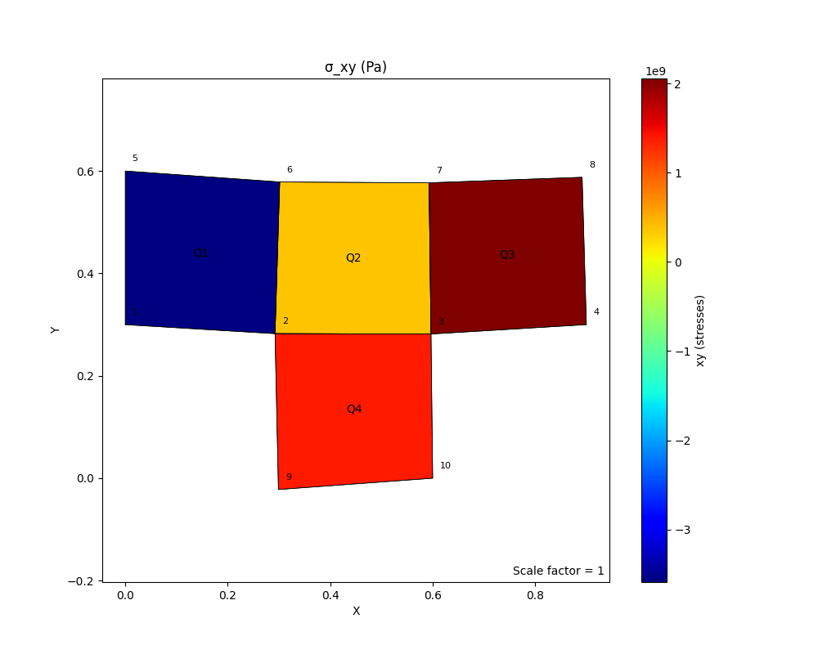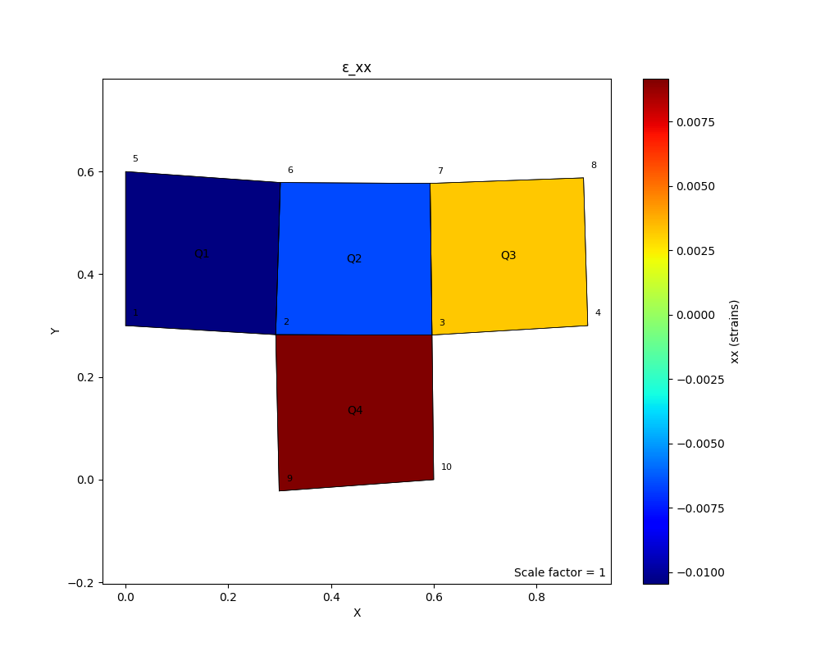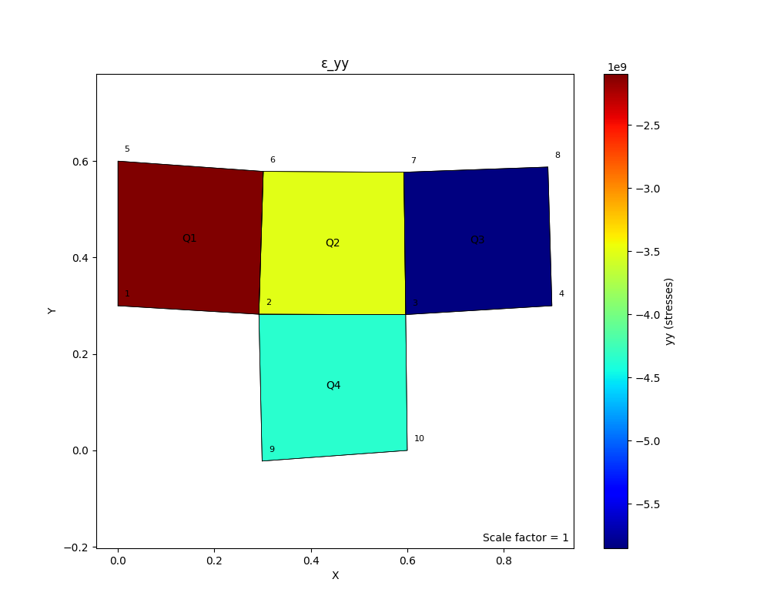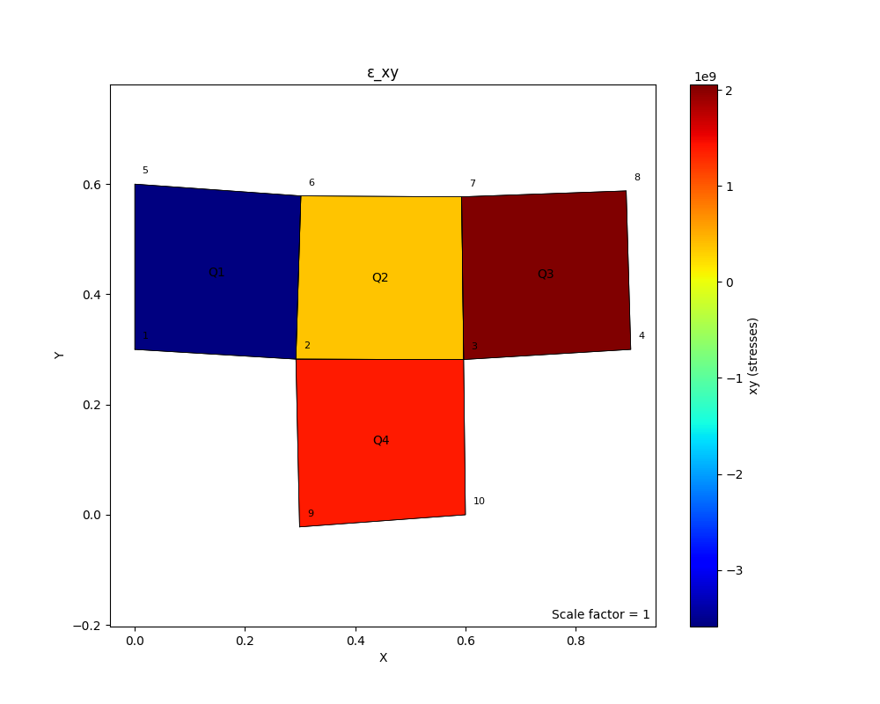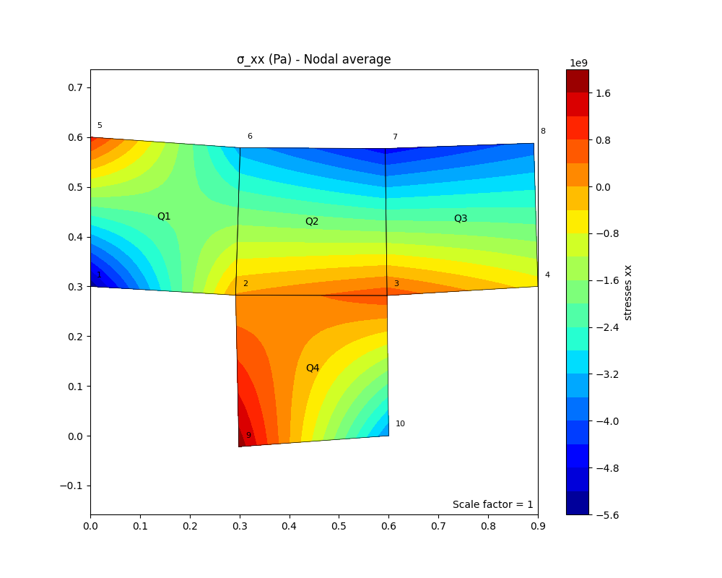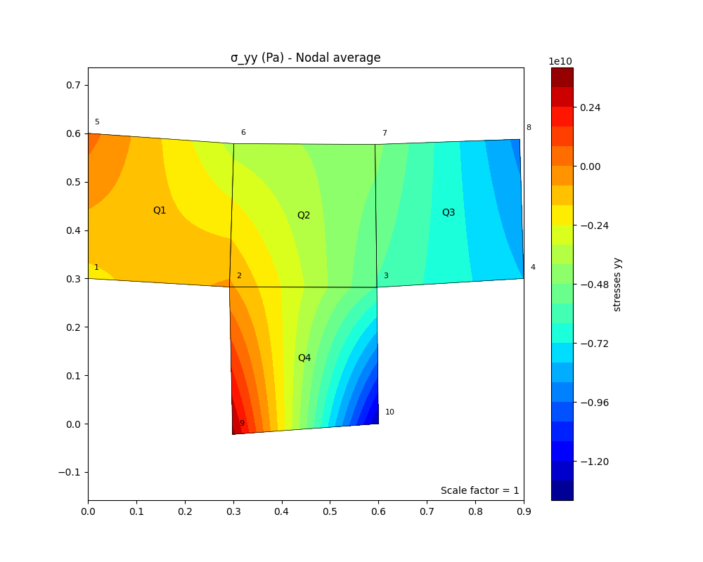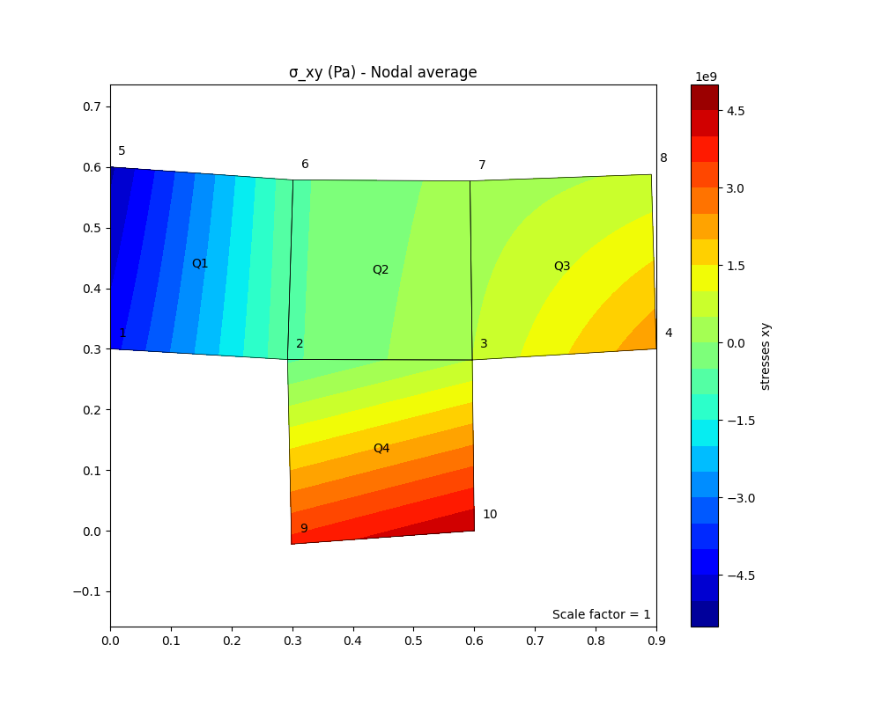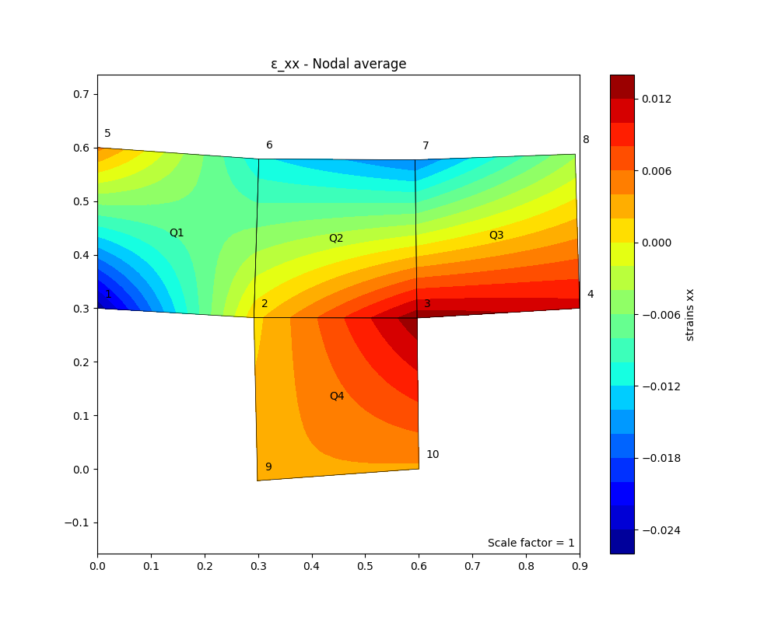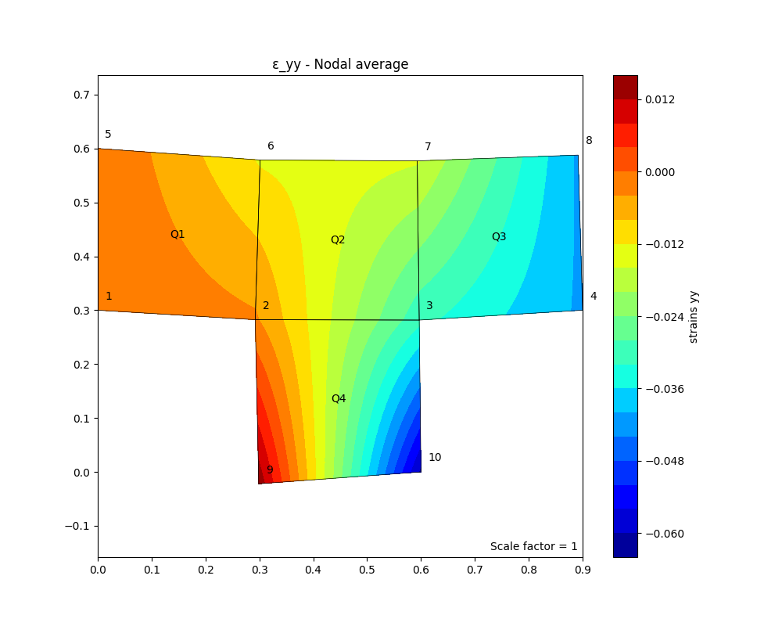

Hình B‑1 (a) - (l). Biểu diễn các kết quả khác của câu 4

**TÀI LIỆU THAM KHẢO**

|  |  |
| --- | --- |
| [1] | ANSYS, Inc., ANSYS CFX-Solver Theory Guide, ANSYS, Inc., 2017. |
| [2] | ANSYS, Inc., ANSYS CFX Introduction, ANSYS, Inc., 2017. |
| [3] | ANSYS, Inc., "ANSYS Mechanical APDL Element Reference," ANSYS, Inc., 2011. |
| [4] | ANSYS, Inc., "ANSYS Mechanical APDL Command Reference," ANSYS, Inc., 2010. |
| [5] | A. F. Bower, Applied Mechanics of Solids, ISBN 978-1439802472: CRC Press, 2009. |
| [6] | K.-J. Bathe, Finite Element Procedures, ISBN 0-13-301458-4: Prentice Hall, 1996. |