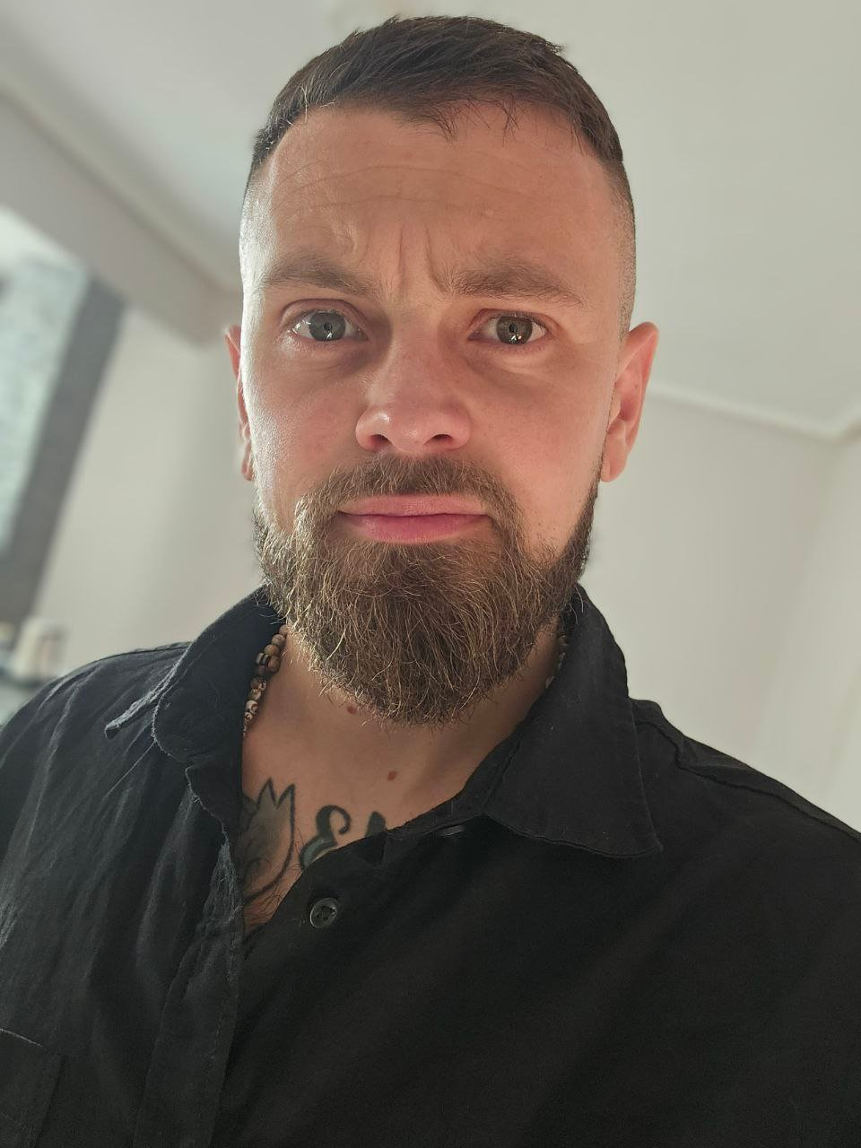 | SAULO TORRADO  Web3 Builder | DeFi Strategist | Business Operator  Dubai, UAE • +971 58 570 5313 • saulotorrado@gmail.com  X: @K0walskixd • TG: @kowalski659 • github.com/Kowalskk

WHO I AM
I spent 13 years building a glass manufacturing business from internship to co-ownership, scaling it to €1M revenue with clients like Inditex, Mercadona, and Ikea. I know how businesses actually work: P&L, supply chains, B2B sales, hiring, operations. In 2023 I left it all to go full-time crypto. Nine years in the space, two of them dedicated.
I am not a developer. I am a power user who builds. When I see a gap in the tools I use every day, I build the solution myself using AI-assisted development (Claude, Cursor, Antigravity). No coding background. No CS degree. I prototype functional systems, connect APIs, deploy bots, and validate ideas at startup speed. I don't wait for engineering resources because I don't need to.
My edge is the combination: real business experience, deep crypto-native knowledge (on-chain analysis, DeFi protocol mechanics, community dynamics), and the ability to go from idea to working prototype in days. I understand what users need because I am the user.
WHAT I'VE BUILT

ProphetLabs Prediction Market Arbitrage Engine [Deployed]
- Cross-platform arbitrage detection between Polymarket and Opinion Labs with real-time WebSocket price streaming
- FastAPI backend, React dashboard (built with partner), Telegram control interface
- Multi-strategy framework: mathematical arbitrage (YES+NO spread capture), three-pass matching engine with LLM validation

Funding Radar DEX Funding Rate Aggregator [Deployed]
- FastAPI + PostgreSQL backend aggregating perpetual futures funding rates across Hyperliquid and Aster
- Dockerized deployment with automated data pipeline, Redis caching, and Telegram alert system

Meteora LP Agent Autonomous Liquidity Agent (Solana) [Architecture + Prototype]
- Designed autonomous agent for Meteora DLMM pool management with contextual bandit (LinUCB) learning system
- Architecture integrates Helius RPC, Jito bundles, and social intelligence from Discord and Twitter

On-Chain Intelligence Suite Smart Money Detection and Analytics
- Dune Analytics SQL queries optimized from 30-min execution to seconds via indexed table strategies [Deployed]
- Custom wallet tracking bot (Node.js) across Jupiter, Orca, Raydium, and Pump.fun [Deployed]
- Token holder analysis via Birdeye + Helius APIs with Google Apps Script automation [Deployed]
- EVM bundle detection bot and dormant pool search via Telegram [Prototype]

Trading Bots Multi-Chain Execution Tools
- BSC copytrading bot with HFT-grade optimizations: nonce management, approve-sniffing, gas optimization [Deployed]
- Polymarket multi-strategy bots: stink-bid detector, early-bird trader, spread capture [Prototype]
- All systems with Telegram-first remote monitoring and control
TOOLS AND WORKFLOW

On-Chain Analysis | Arkham, Cielo, Dune Analytics (advanced SQL), Etherscan, Solscan, Helius, Birdeye. Smart money tracking, flow analysis, wallet clustering.
DeFi Protocols I Use | Hyperliquid, Polymarket, Jupiter, Orca, Raydium, Meteora, Kamino, MarginFi. LP management, perpetual futures, prediction markets.
How I Build | Claude (API + Desktop + MCP), Cursor, Antigravity. I use AI-assisted development to go from idea to working prototype fast. No traditional dev background.
What I Build With | Python (FastAPI), Node.js, PostgreSQL, Docker, WebSockets, Telegram Bots. Whatever gets the job done.
Chains I Work On | Solana (Helius RPC, Jito Bundles, Meteora SDK), Ethereum, BSC, Base.
Product Delivery | Telegram Bot interfaces, React dashboards (with partners), real-time alerts, user flow design.
WHAT I BRING TO A TEAM

Product Thinking  ■ I see product gaps as a user  ■ Rapid MVP prototyping with AI  ■ Market gap identification  ■ Roadmap prioritization  ■ User research from the inside | Business Operations  ■ P&L management (13 years)  ■ B2B sales and negotiation  ■ Supply chain optimization  ■ Process automation  ■ Stakeholder management | Crypto-Native Knowledge  ■ On-chain data analysis  ■ DeFi protocol mechanics  ■ Trading systems design  ■ Tokenomics evaluation  ■ Community and cabal dynamics
PROFESSIONAL EXPERIENCE

Independent Web3 Builder and DeFi Strategist
Dubai, UAE (Remote) 2024 – Present (Full-time) | 2017 – 2024 (Active participant)
- Went full-time crypto in 2024 after 7 years of active participation, starting from buying Bitcoin in 2017
- Built 10+ tools and systems for personal use: arbitrage engines, wallet trackers, funding rate aggregators, and trading bots
- Developed deep on-chain expertise: Dune SQL optimization, cross-chain wallet tracking, smart money identification, cabal detection
- Validated investment theses with custom-built analytical tools across Solana, Polymarket, and Hyperliquid
- All tools built using AI-assisted development (Claude, Cursor, Antigravity). Concept to working prototype in days.
- Participated in and profited from major airdrops (Hyperliquid, zkSync, StarkNet, LayerZero, Wormhole), gaining deep protocol-level understanding

Co-Owner and Business Development Director
Grupo Vevey Vidrio Glass Manufacturing
Galicia, Spain 2010 – 2023 (13 years)
- Started as an intern, grew into co-owner. Scaled the company alongside my father through strategic investment in machinery and market expansion.
- Grew to €1M annual revenue and 8 employees. Specialized in retail furniture and fixtures for Inditex (Zara), Adolfo Domínguez, Mercadona, and Ikea.
- Owned the full business development cycle: finding clients, negotiating contracts, planning production, managing delivery logistics.
- Ran day-to-day operations: manufacturing, quality control, inventory, distribution. I know what it takes to keep a business running.
- Maintained long-term B2B relationships with Spain's largest retail and construction companies.
- Survived economic downturns and supply chain crises. The adaptability I built there is the same adaptability I bring to startups.
EDUCATION

Bachiller Colegio Peleteiro, Santiago de Compostela
Everything else I know, I learned by doing:
- On-chain analysis and DeFi (2017 to present). Learned by using protocols, losing money, building tools, and doing it again.
- AI-assisted development (2024 to present). Learned by building real products with Claude, Cursor, and Antigravity.
- Trading and market microstructure (2023 to present). Learned by building arbitrage systems and execution tools.
- Product thinking. Learned by identifying what I needed as a user, building it, and iterating based on what worked.
LANGUAGES AND AVAILABILITY

Spanish (Native) • English (Professional Working Proficiency)
Based in Dubai, UAE • Open to remote or hybrid roles • UAE timezone (GMT+4)

