**Precision ohmmeter**

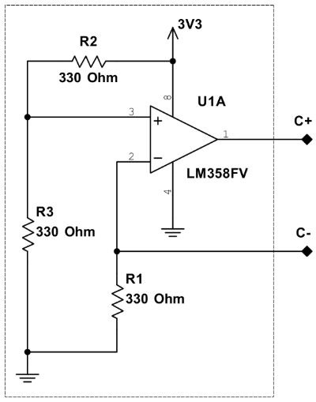**Current source**

**Differential amplifier**

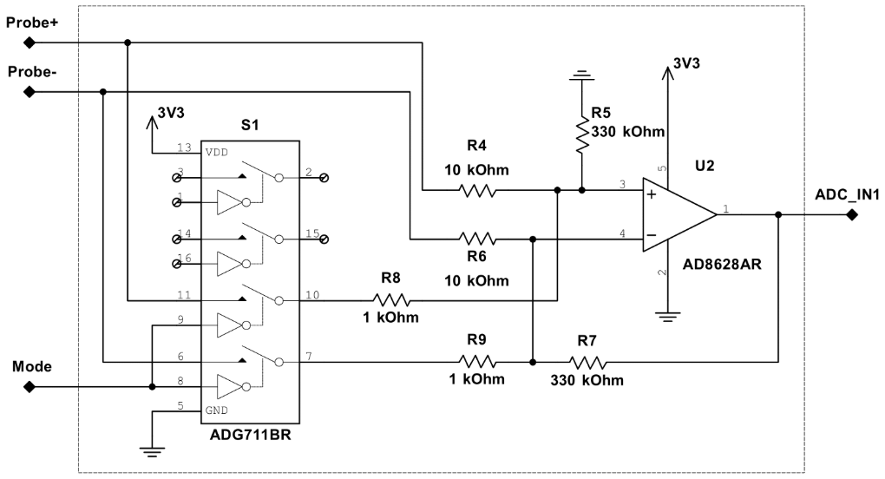

**Mode 1**

**Mode 2**