Lab Report
Use this template to document your work as you complete your assignment.

Your Information
Your Name: Kendall Owens
Assignment Title: 24 Performance Assessment Kowens94/SDC380_project1

Screenshots
As you complete the procedure, add the screenshots for the required step(s) below.

- Open a JupyterLab Python notebook and create a Markdown cell with the following information: Python Data Cleaning and Visualization - <The Date> - <Your StudentID>.
- Remove any duplicate entries. 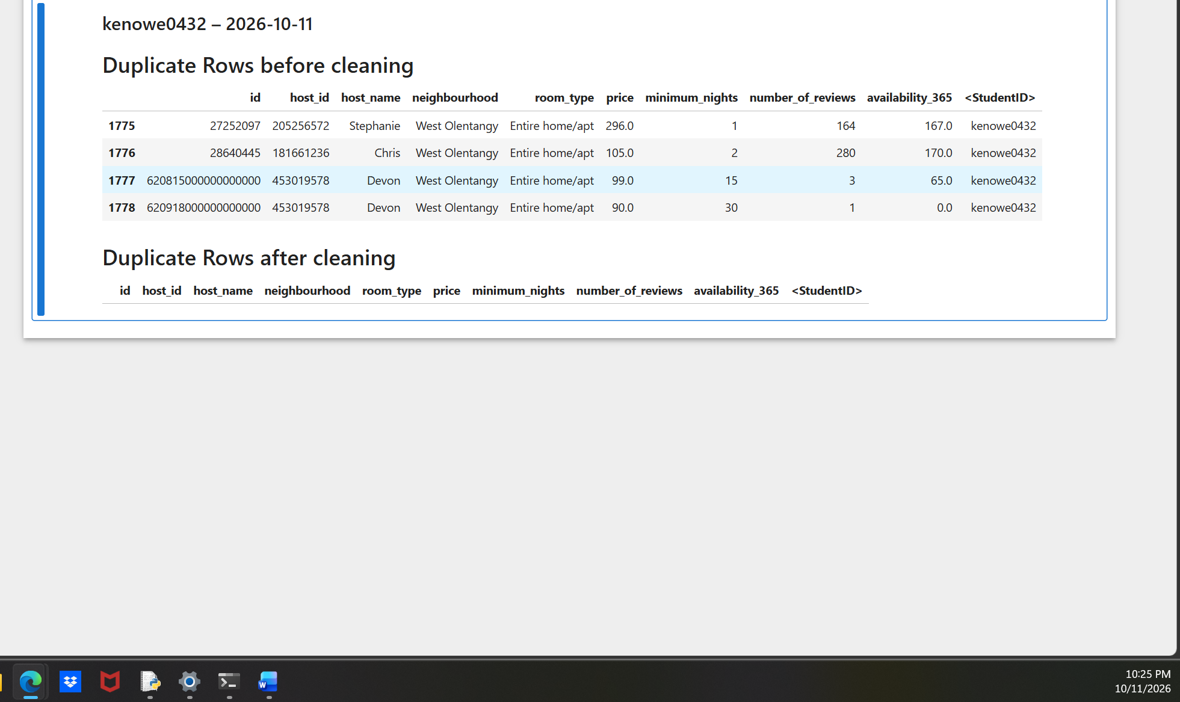
- Find all instances of "Private room" and correct them to "Private Room". 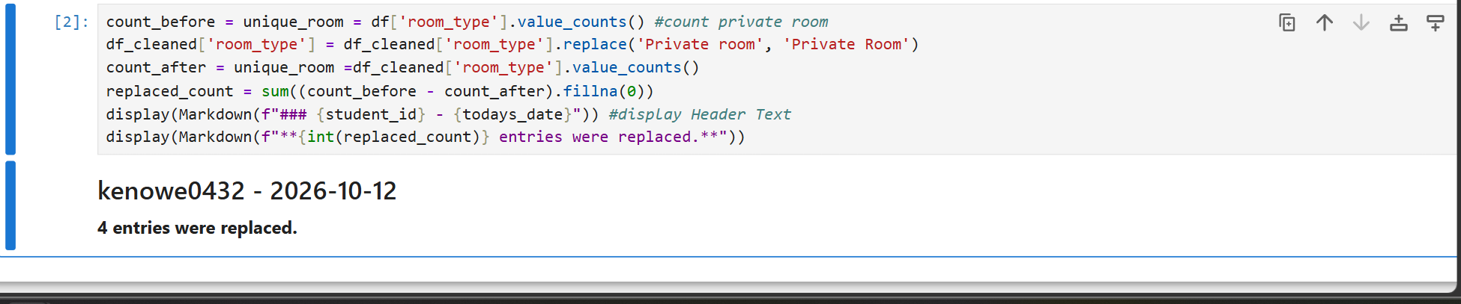
- Fill in any missing values using the MEDIAN function. 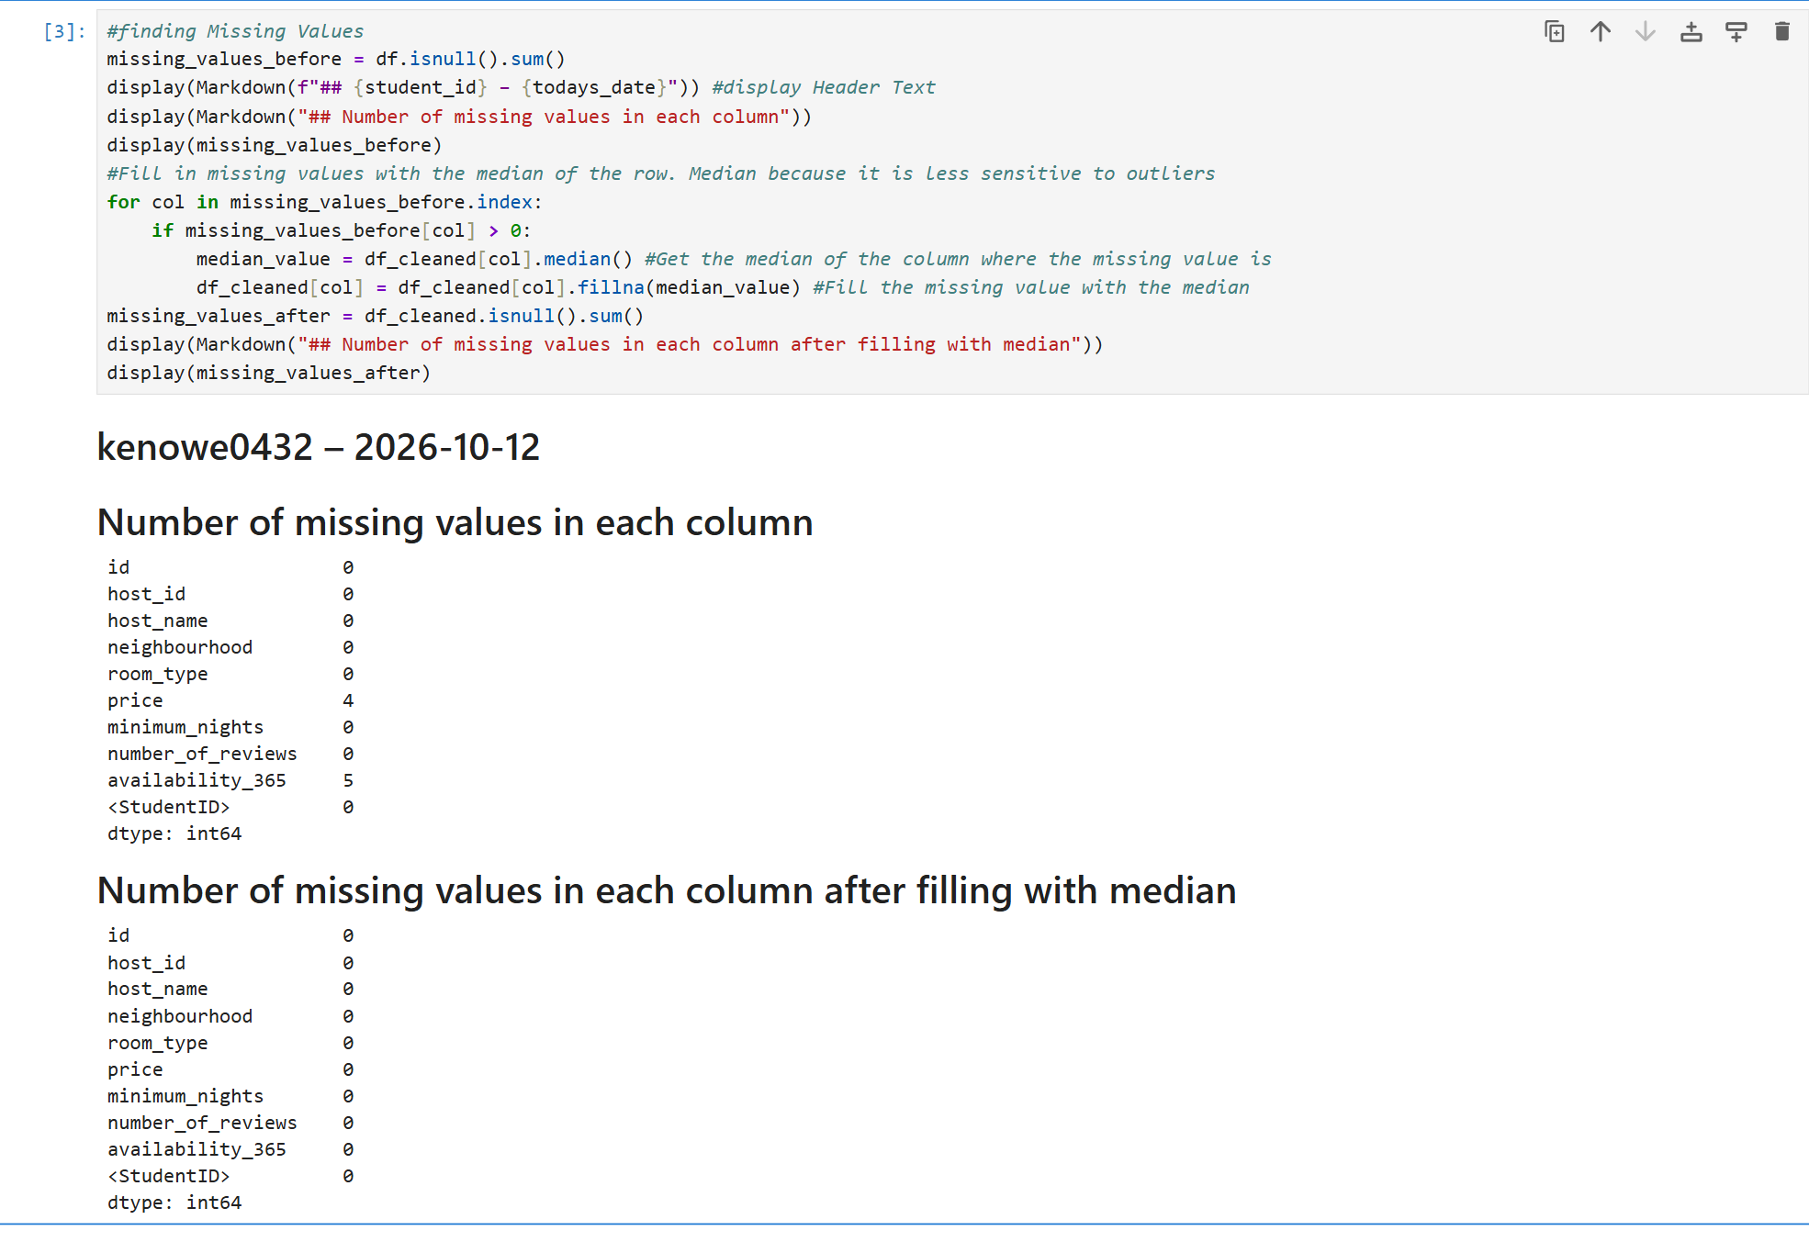
- Use the Interquartile Range (IQR) method to remove any outliers in the dataset. 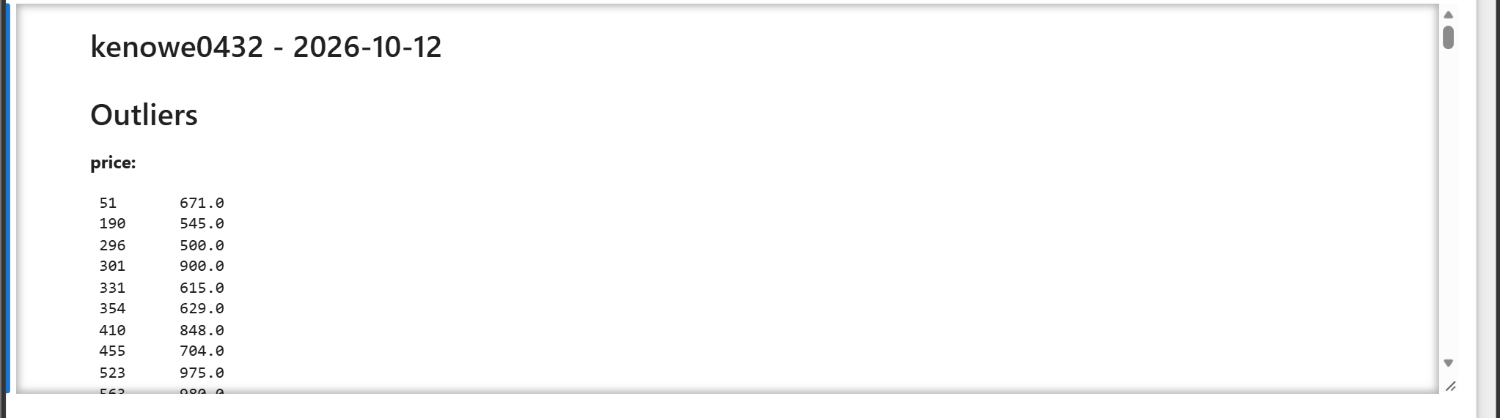 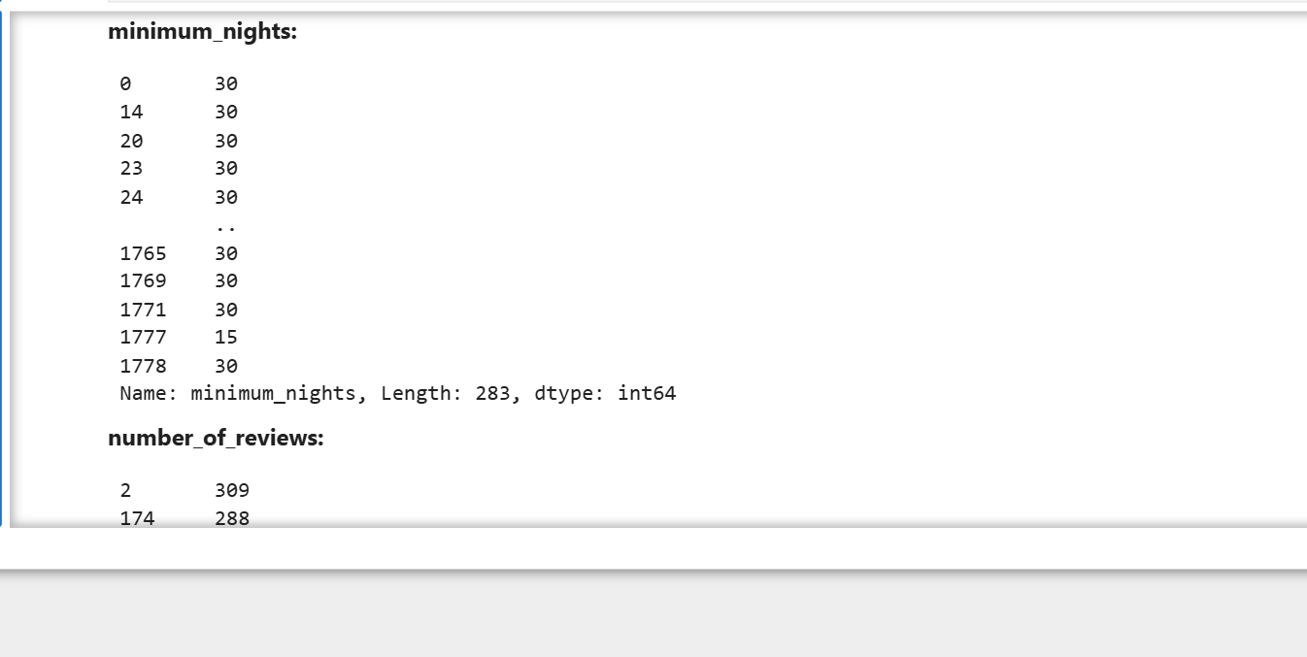 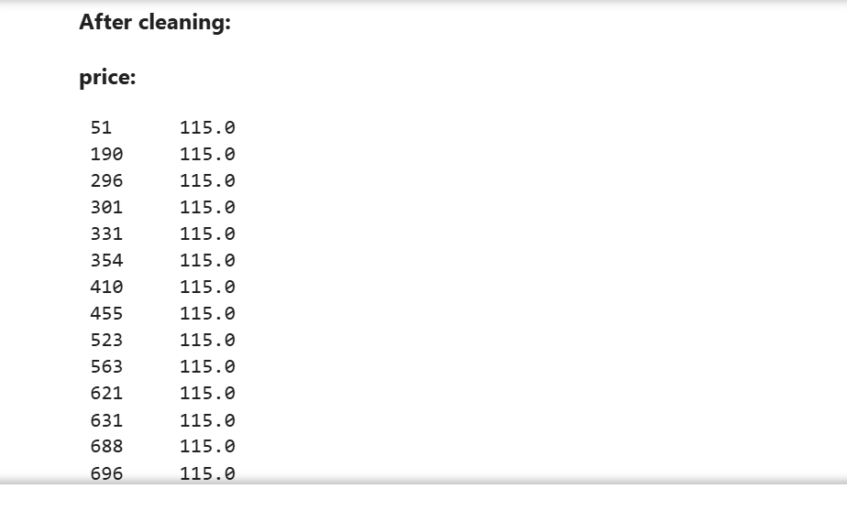 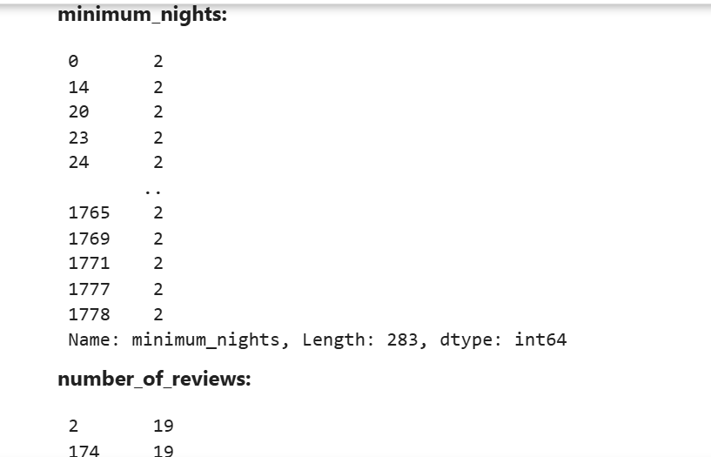
- Save the cleaned data frame to a new Excel spreadsheet named AirBnBSummary_v2_Python_Cleaned. 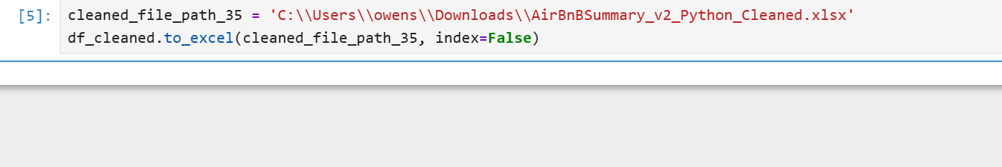 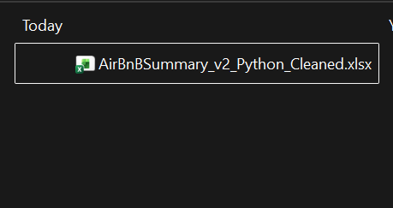
- Display the following statistics:
  - Total count of listings
  - Minimum price
  - Maximum price
  - Mean price of listings
  - Median of number_of_reviews
  - Mode of minimum_nights
  - Standard Deviation of price
  - Correlation between price and availability_365 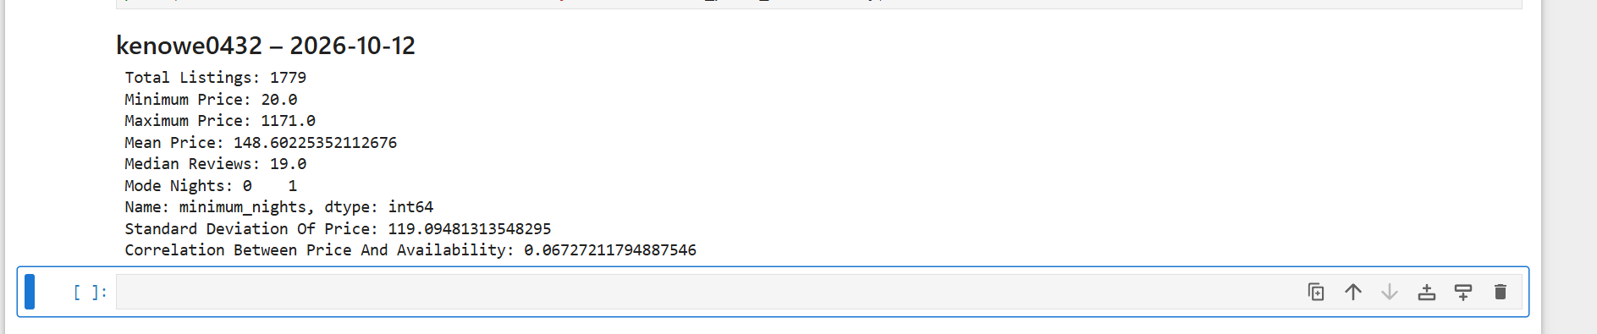
- Create a Histogram of number_of_reviews. 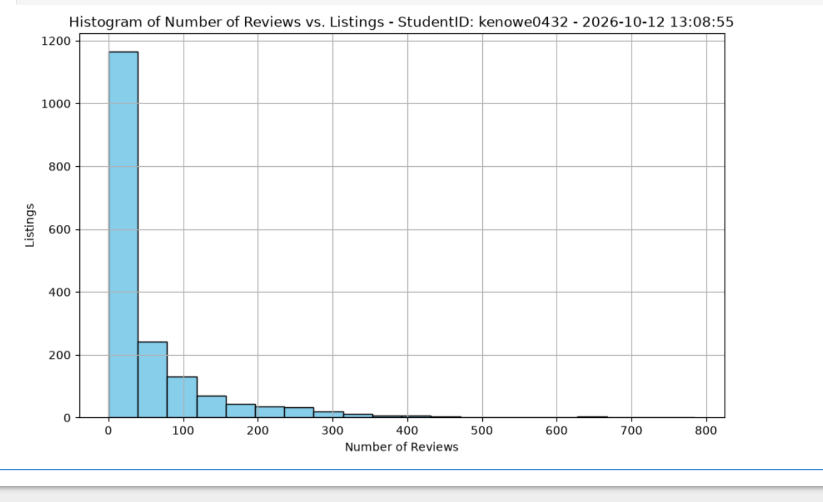
- Create a Bar Chart of minimum_nights. 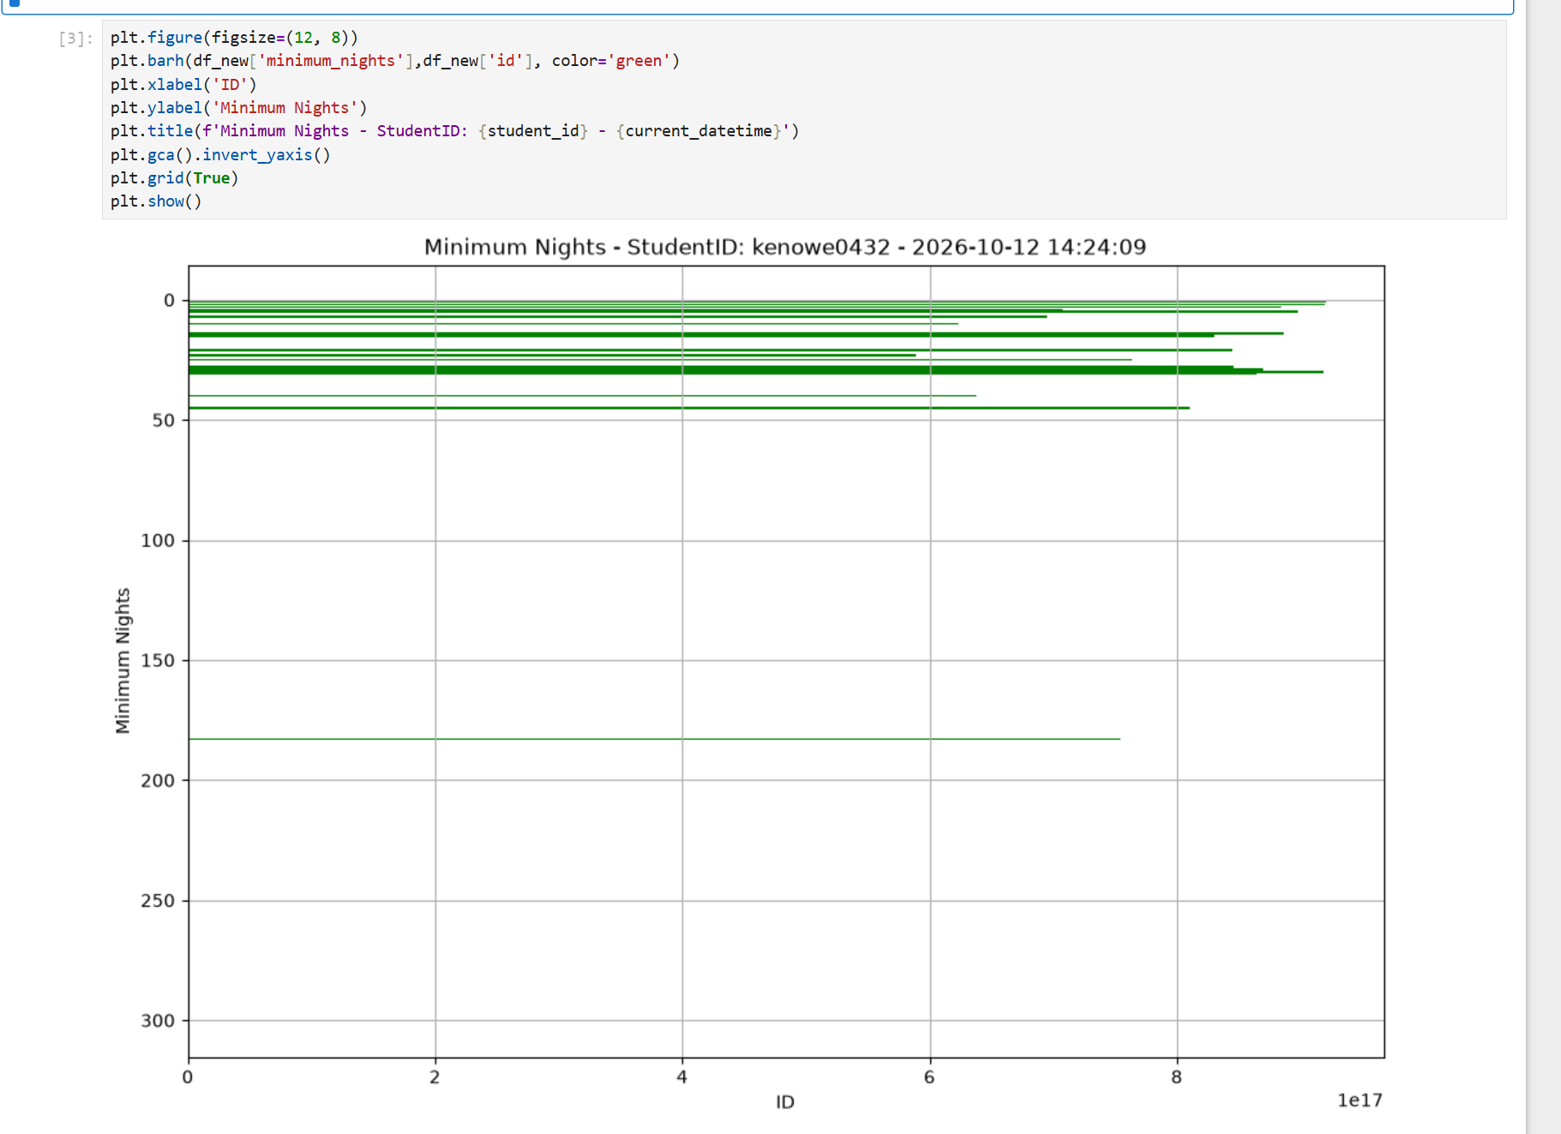
- Create a Scatter Plot of availability_365. 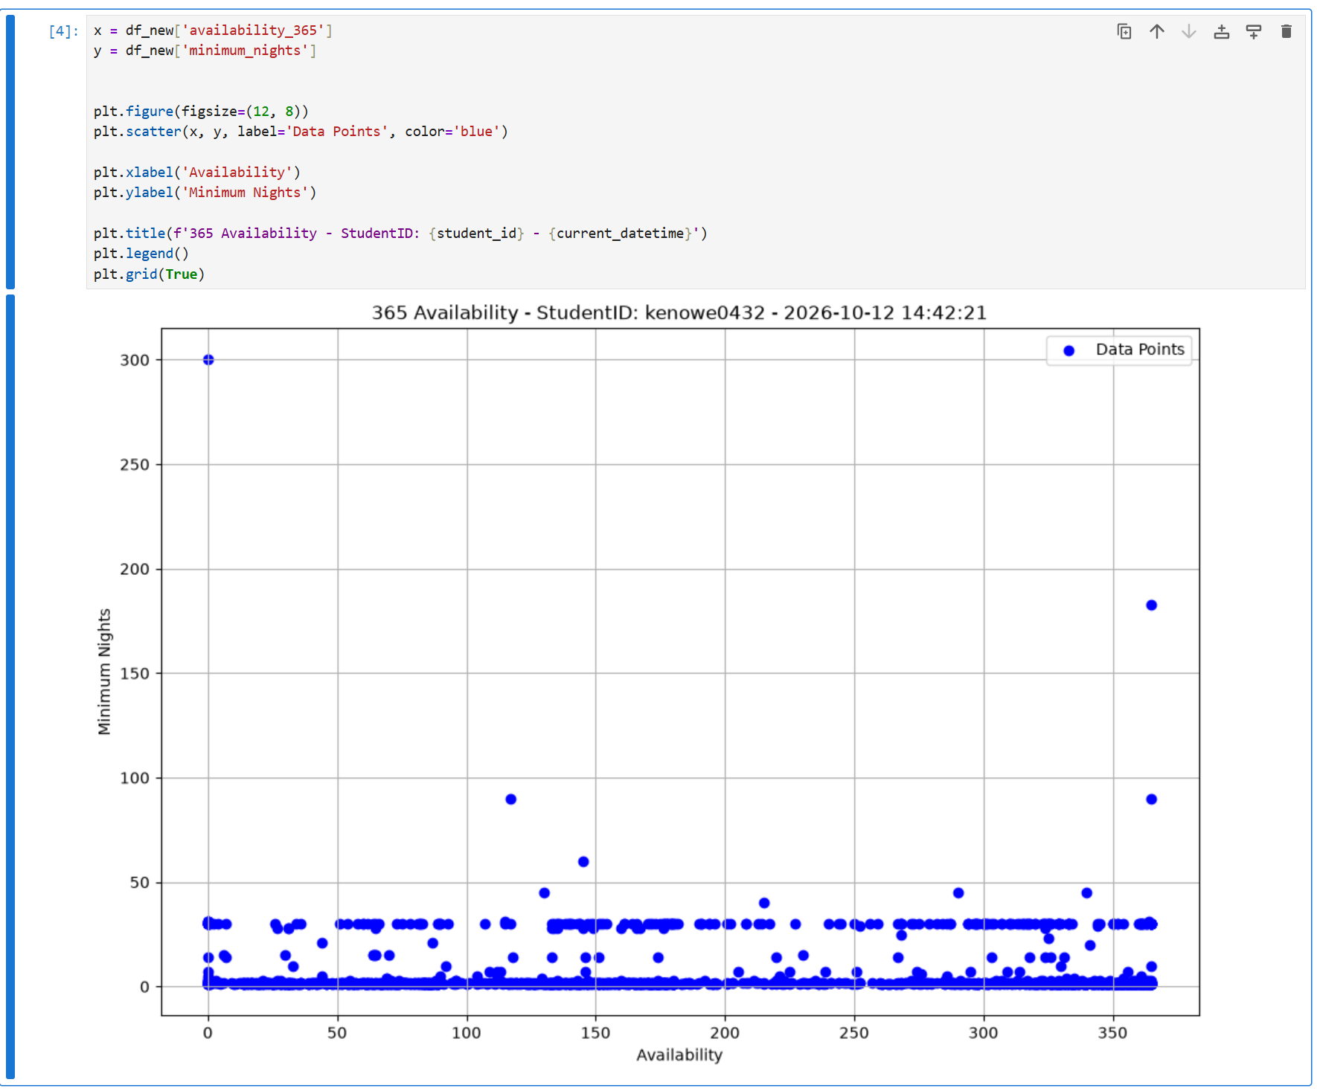
- Create a Heat map of correlations using columns: price, minimum_nights, number_of_reviews, and availability_365 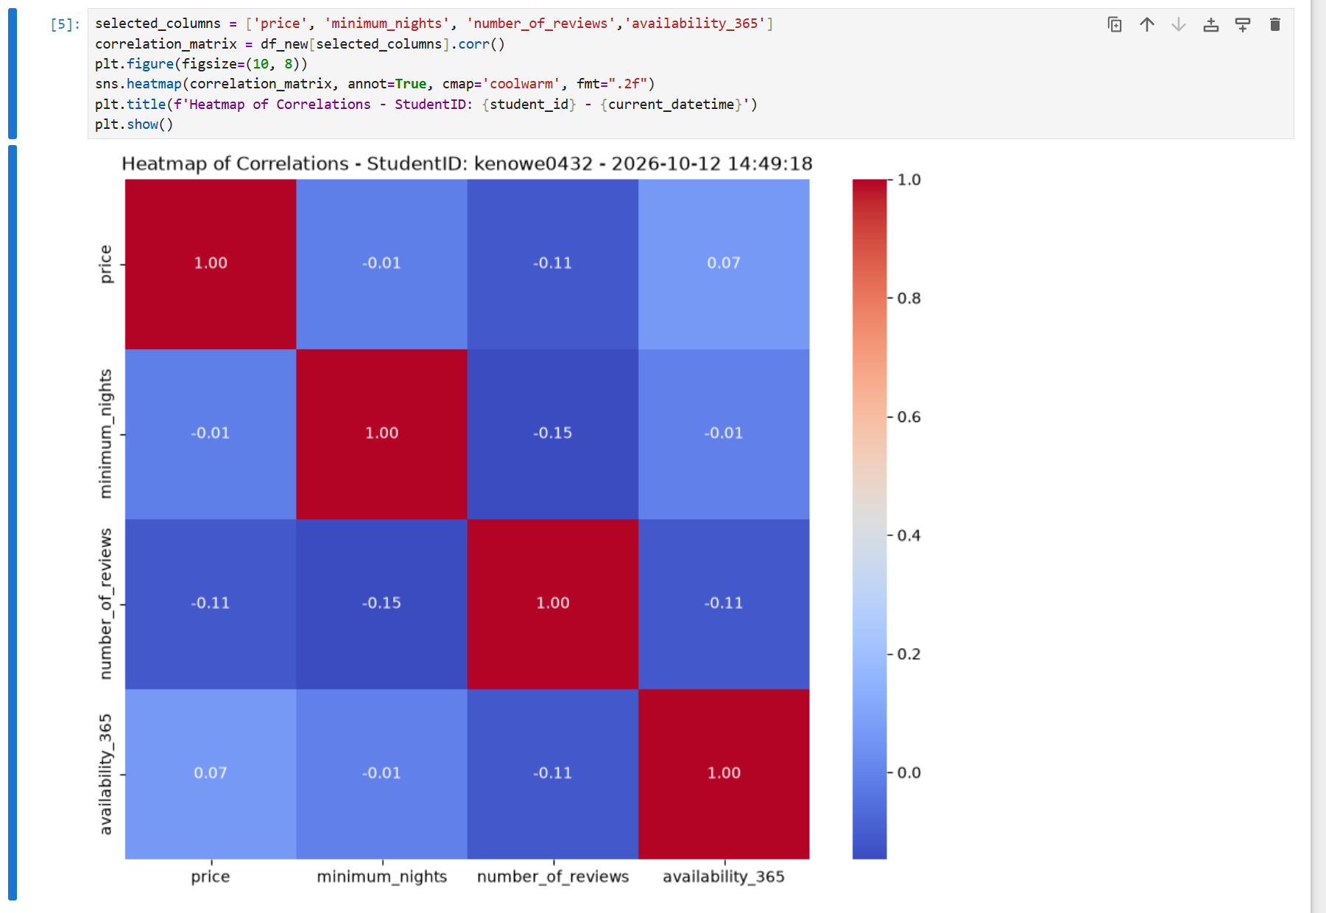

Questions
Answer the required questions in the space below.
What does the trend line for the Scatter Plot created in Step 10 suggest about the data?
The majority of minimum nights stays are 1 and 30 days.
What are the strong correlation combinations from the color-coded heat map?
Price – price, minimum_nights – minimum_nights, number of reviews to number of reviews, availability to availability.

