HANGMAN GAME :

Hangman without pic:

import random

with open("demo.txt",'r') as a:

result = []

for line in a.readlines():

result.append(line.strip())

words=random.choice(result)

word=words.upper()

dash=['-']\*len(word)

def game():

cnt=6

while cnt!=0:

user=input("enter letter").upper()

print("\n"+user)

if len(user)==1:

if user in word:

for i in range(len(word)):

if word[i]==user:

dash[i]=user

print(dash)

if "".join(dash)==word:

print("won the game")

cnt=0

else:

print("letter not in word")

cnt-=1

print("you have chances",cnt)

if cnt==0:

print("sorry ,your chance left")

if len(user)>1:

print("enter one character")

game()

OUTPUT:

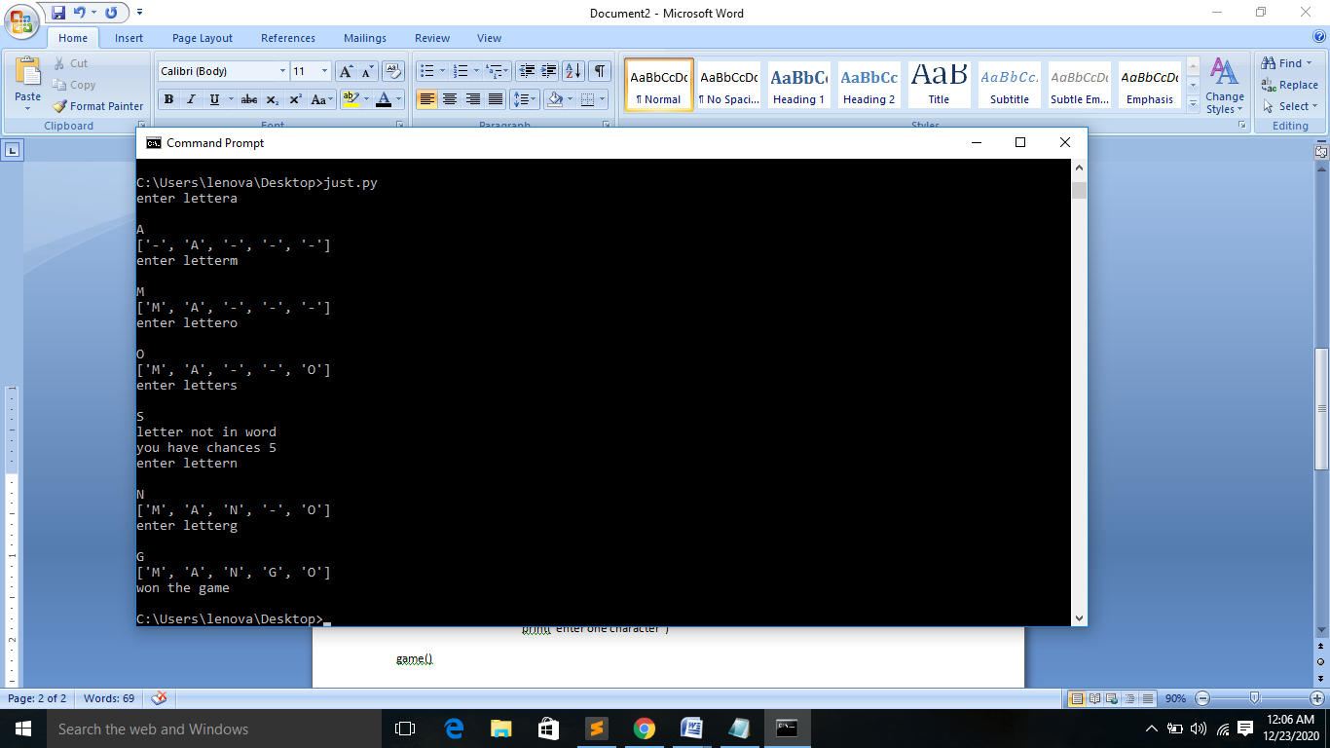

Hangmangame with pic:

import random

from hangmanpic import hangman

with open("demo.txt",'r') as a:

result = []

for line in a.readlines():

result.append(line.strip())

words=random.choice(result)

word=words.upper()

dash=['-']\*len(word)

def game():

cnt=7

while cnt!=0:

user=input("enter letter").upper()

print("\n"+user)

if len(user)==1:

if user in word:

for i in range(len(word)):

if word[i]==user:

dash[i]=user

print(dash)

if "".join(dash)==word:

print("won the game")

cnt=0

else:

print("letter not in word")

cnt-=1

print(hangman[cnt])

print("you have chances",cnt)

if len(user)>1:

print("enter one character")

game()

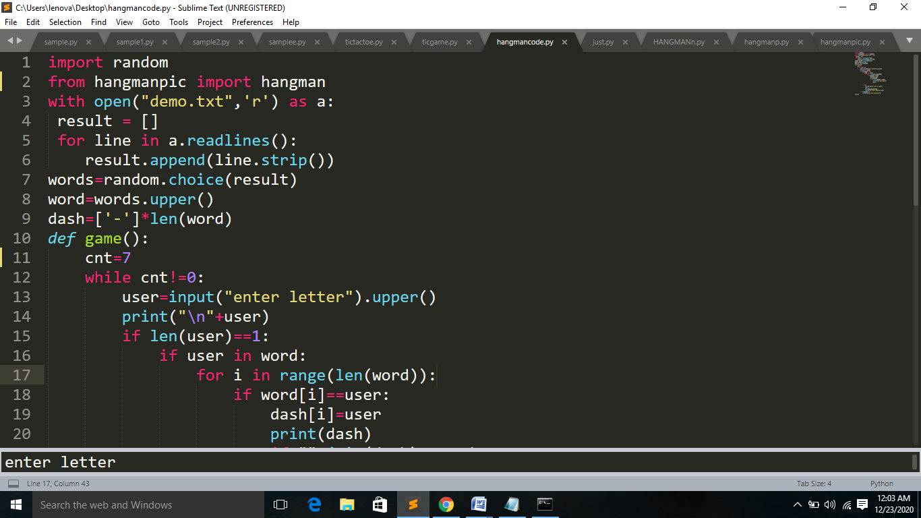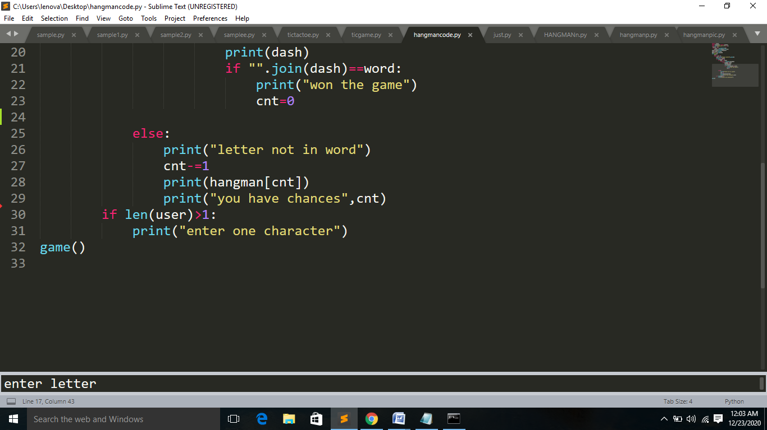

OUTPUT:

