**IBM HR Analytics Employee Attrition & Performance**

Contents

Abstract 2

Introduction 2

Objectives 2

Dataset Overview 2

Preprocessing 2

Exploratory Data Analysis 2

Attrition Rate Analysis 2

Average Tenure 3

Demographic Breakdown 3

Key Factors Influencing Attrition 3

Conclusion 4

**Abstract:**

This project analyzes employee attrition using IBM's HR dataset. It explores key factors influencing turnover, demographics, tenure, and satisfaction metrics to help HR departments make data-driven decisions.

**Introduction:**

Employee attrition is a critical issue for organizations. High turnover impacts productivity and increases costs. This analysis aims to uncover patterns and correlations that contribute to attrition using IBM's fictional HR dataset.

**Objectives:**

1. Understand Current Turnover Rates: Analyze the employee attrition rate and demographic distribution.  
2. Identify Key Factors Influencing Turnover: Examine job satisfaction, salary, and work-life balance.  
3. Support HR decision-making with data-driven insights.

**Dataset Overview:**

The dataset contains 1470 records and 35 features including age, gender, department, job role, income, satisfaction scores, and attrition status. It is clean with no missing values or duplicates.

**Preprocessing:**

Initial steps included checking for missing values, duplicates, and verifying data types. All columns were appropriately formatted. Summary statistics confirmed the data was within expected ranges.

**Exploratory Data Analysis:**

EDA revealed that most employees are aged 30–35, predominantly male, and concentrated in the Research & Development department. The attrition rate was calculated to be 16.12%.

**Attrition Rate Analysis**

The attrition rate was computed as the proportion of employees who left the company. Approximately 16.12% of employees decided to leave during the analyzed period.

**Average Tenure**

The average tenure of employees before leaving the company was found to be approximately 7.01 years, indicating a relatively stable workforce.

**Demographic Breakdown**

Age distribution showed a concentration in the 30–35 range. Gender distribution was skewed towards male employees. Most employees worked in the Research & Development department.

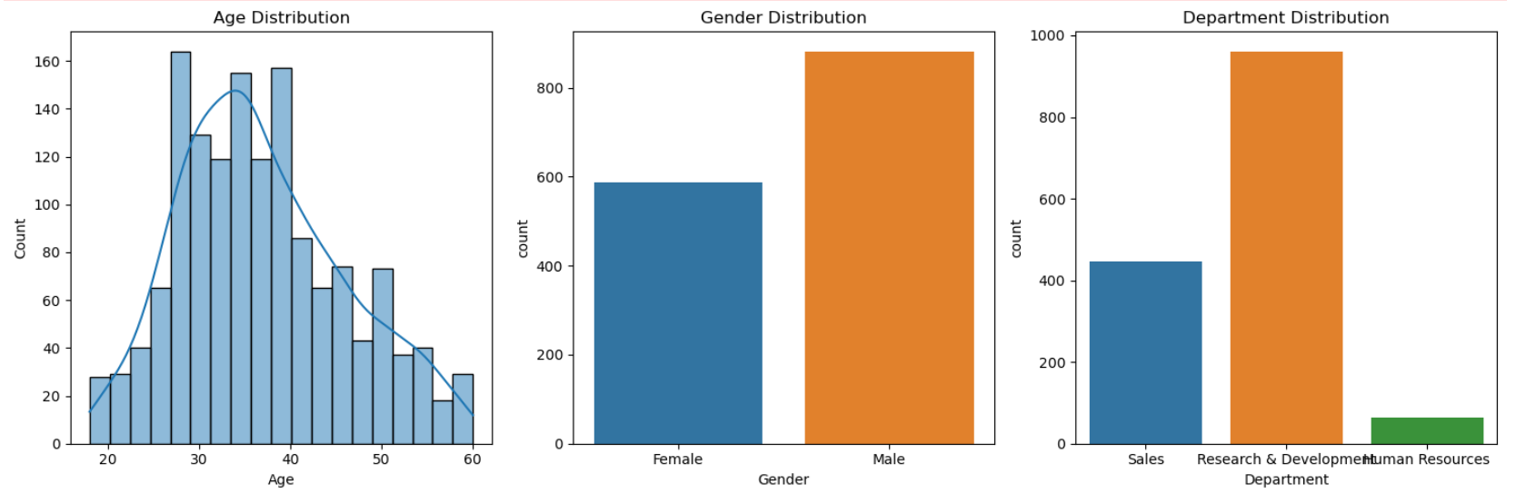

**Key Factors Influencing Attrition**

Analysis of job satisfaction, monthly income, distance from home, work-life balance, and environmental satisfaction revealed that lower scores in these areas correlated with higher attrition rates.

**Average values of key features by attrition status:**

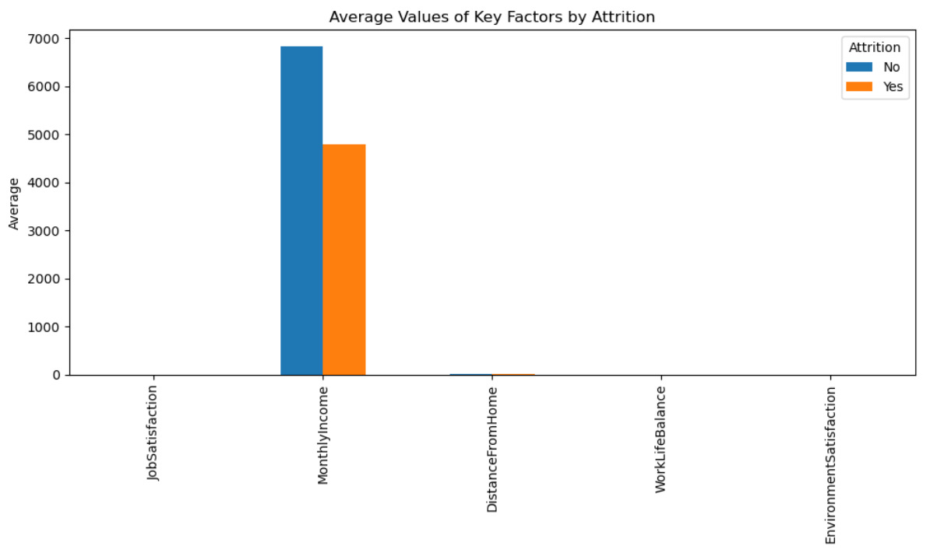

**Conclusion:**

Employees with lower job satisfaction and work-life balance are more likely to leave. Higher income and satisfaction correlate with retention. R&D department has the highest employee count and attrition risk.