USER MANUAL

STEP 1:

Install the drawing app in your mobile phone.

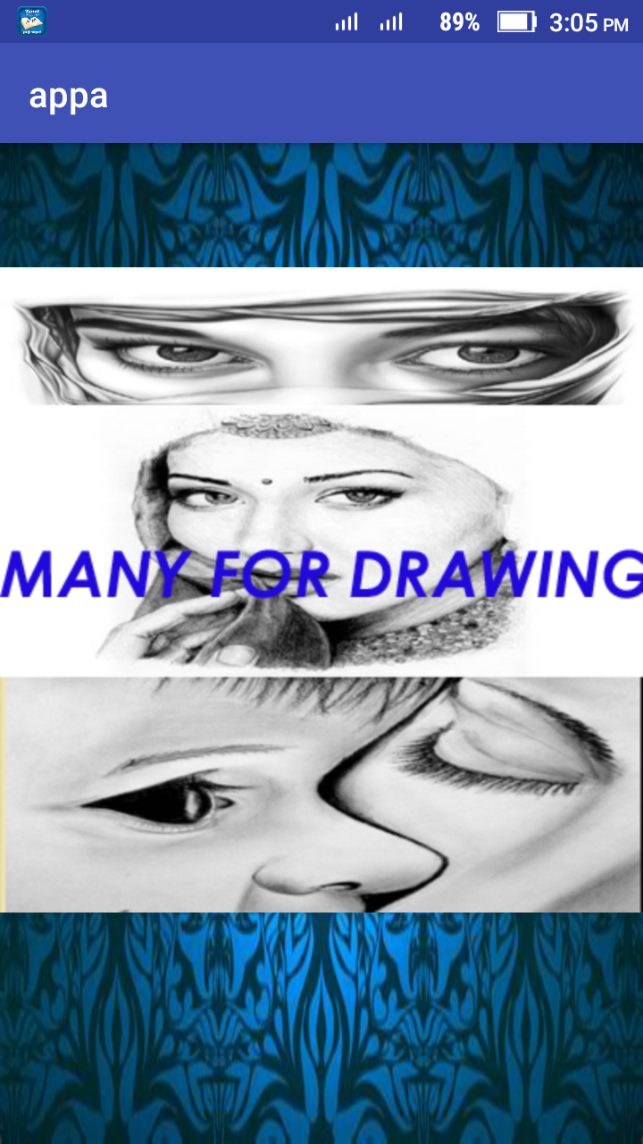

STEP 2:
This application contains the option database image delete draw with tools.We can communicate this application with the help of share option.

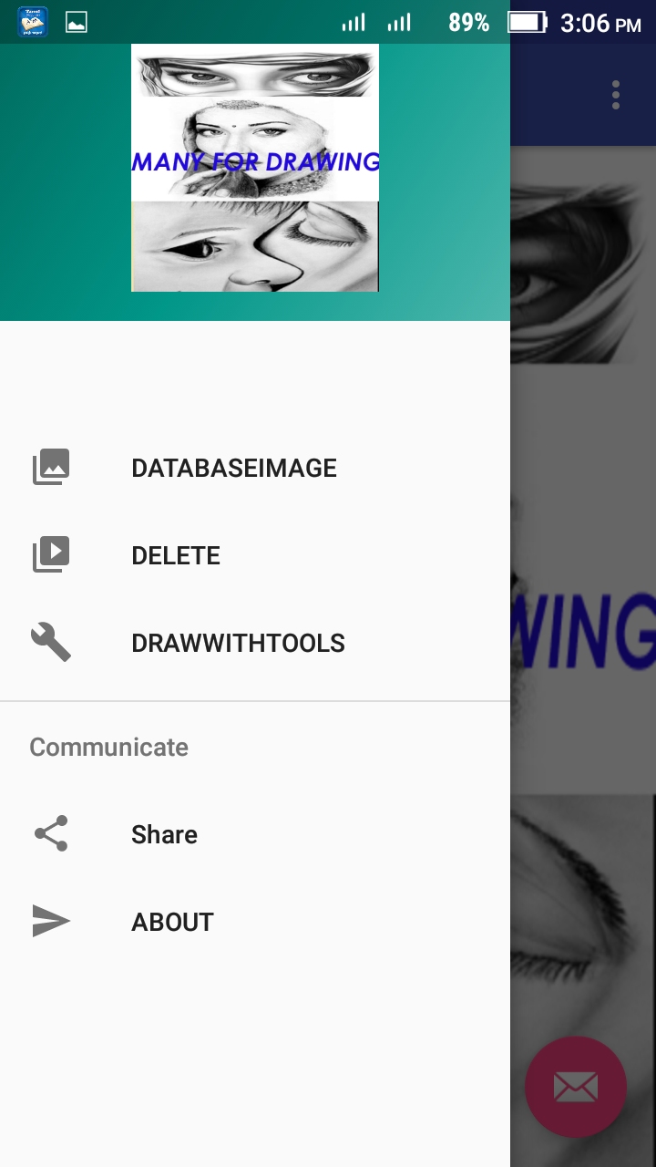

STEP:3
Go to the database image you can add or delete the image.

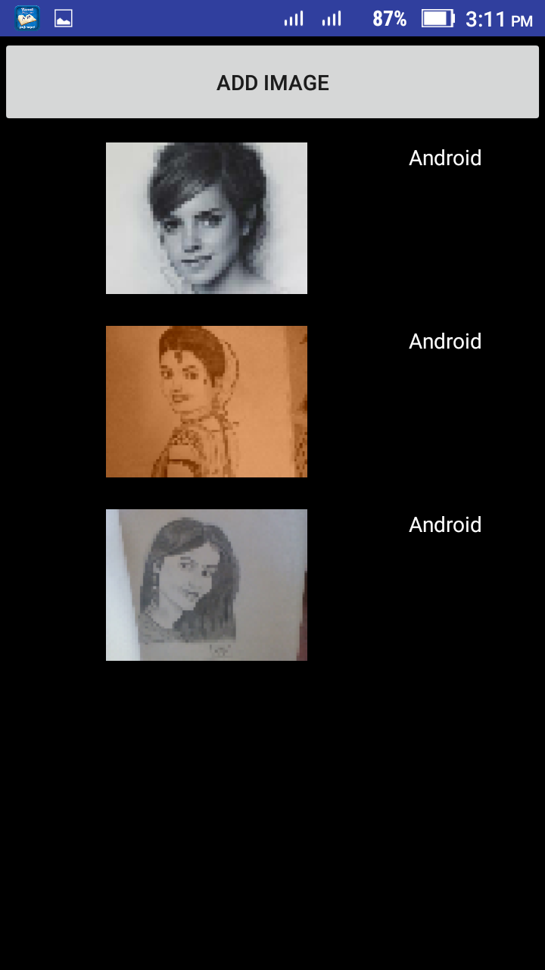

STEP:4
Draw with tools provide the environment for drawing.

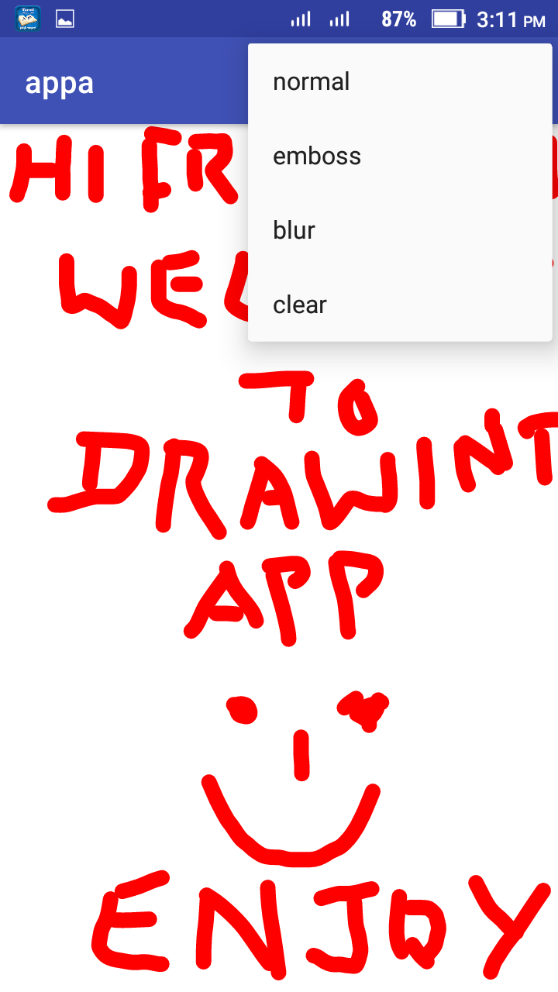

STEP:5
Share option provides the facility to share our option via whatsapp,shareit,blutettoth etc.
