Introduction
This project focuses on designing and implementing a centralized file-sharing and backup system within AWS using a custom Virtual Private Cloud (VPC). The goal is to ensure that files shared between two EC2 instances using Amazon Elastic File System (EFS) are automatically synchronized with an Amazon S3 bucket in near real-time.
This implementation demonstrates how core AWS services such as EC2, EFS, S3, VPC and IAM can be combined to provide a scalable, cost-effective, and automated cloud storage solution without using any advanced automation services like Lambda or DataSync.

Objectives
- To design a custom AWS VPC for secure networking and internet connectivity.
- To launch two EC2 instances in different subnets and mount a common EFS file system.
- To create an Amazon S3 bucket to store and back up all project files from EFS.
- To implement a near real-time sync mechanism between EFS and S3 using inotify and AWS CLI.
- To enforce least-privilege IAM permissions for secure and controlled access.
- To enable bi-directional sync, ensuring that changes from either EC2 instance are reflected in S3.

AWS Services Used
Service | Purpose / Functionality
Amazon VPC | Provides an isolated virtual network environment for EC2, EFS, and S3 communication.
Amazon EC2 | Compute instances where the EFS is mounted and file sync operations are performed.
Amazon EFS | A shared file system accessible by multiple EC2 instances, used for centralized file sharing.
Amazon S3 | Object storage used to mirror and back up files from EFS in near real-time.
AWS IAM | Used to create roles and policies following least-privilege principles, allowing EC2 to interact securely with S3.

Project Implementation Details
Step 1: VPC Setup
- Created a custom VPC (10.0.0.0/16) with two public subnets in different Availability Zones.
- Attached an Internet Gateway (IGW) for internet connectivity.
- Configured route tables with 0.0.0.0/0 → IGW.
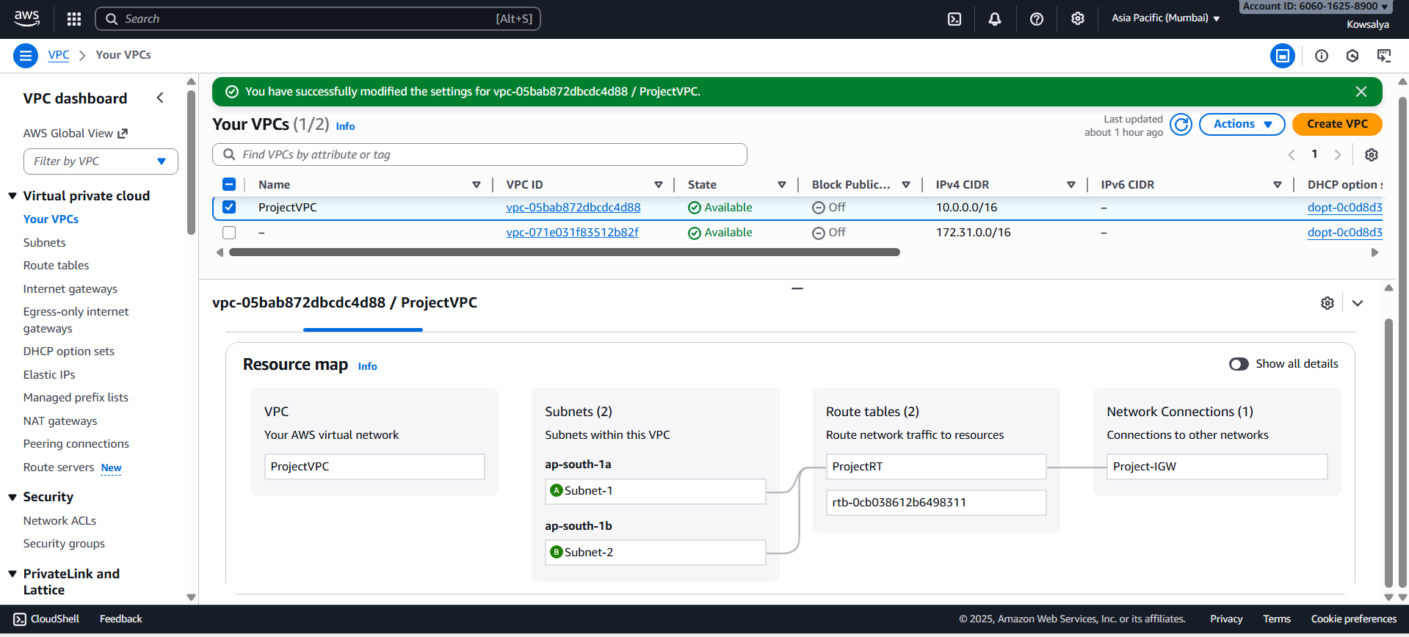
- Created security groups:
          - EC2 SG: Allowed SSH (port 22)
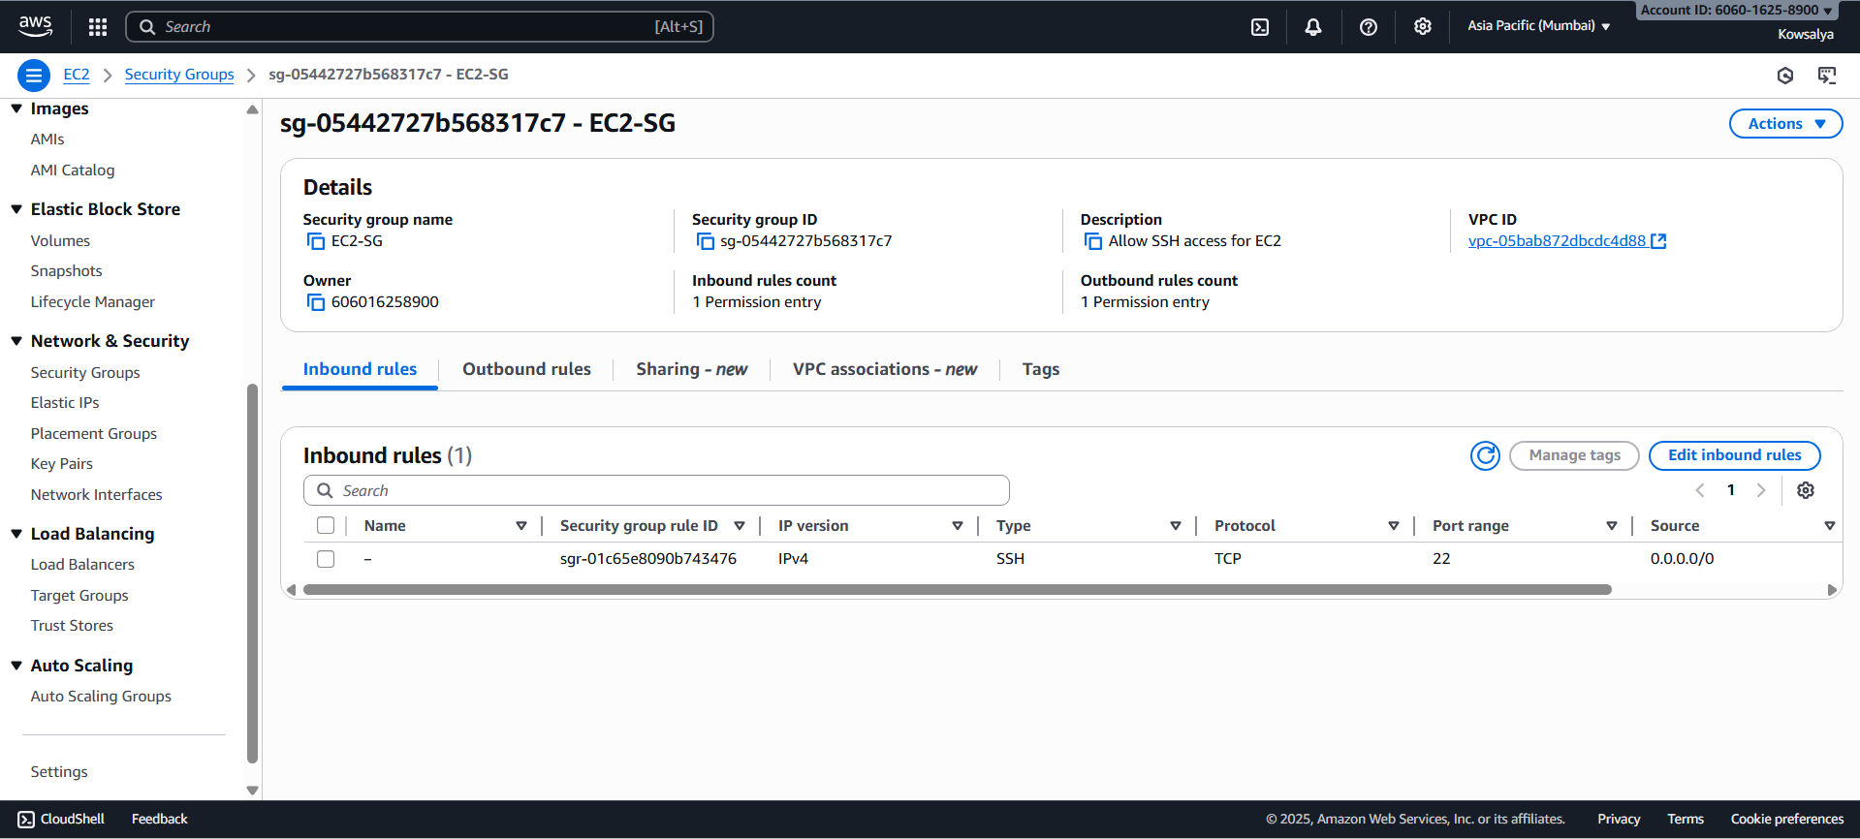

          - EFS SG: Allowed inbound NFS (2049)
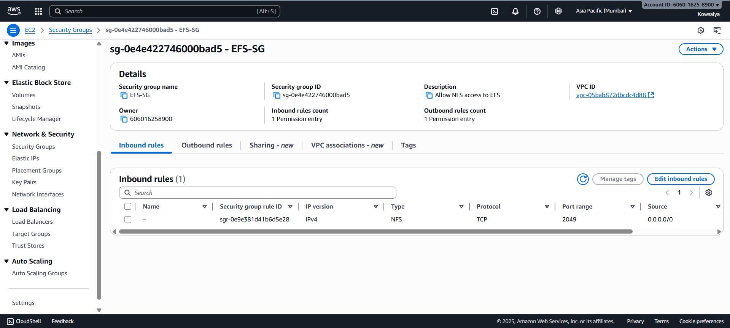

Step 2: EC2 Instances
- Launched two Amazon Linux 2023 EC2 instances in separate subnets (AZ-A and AZ-B).
- Verified internet access and installed necessary packages:
sudo yum install -y amazon-efs-utils awscli inotify-tools
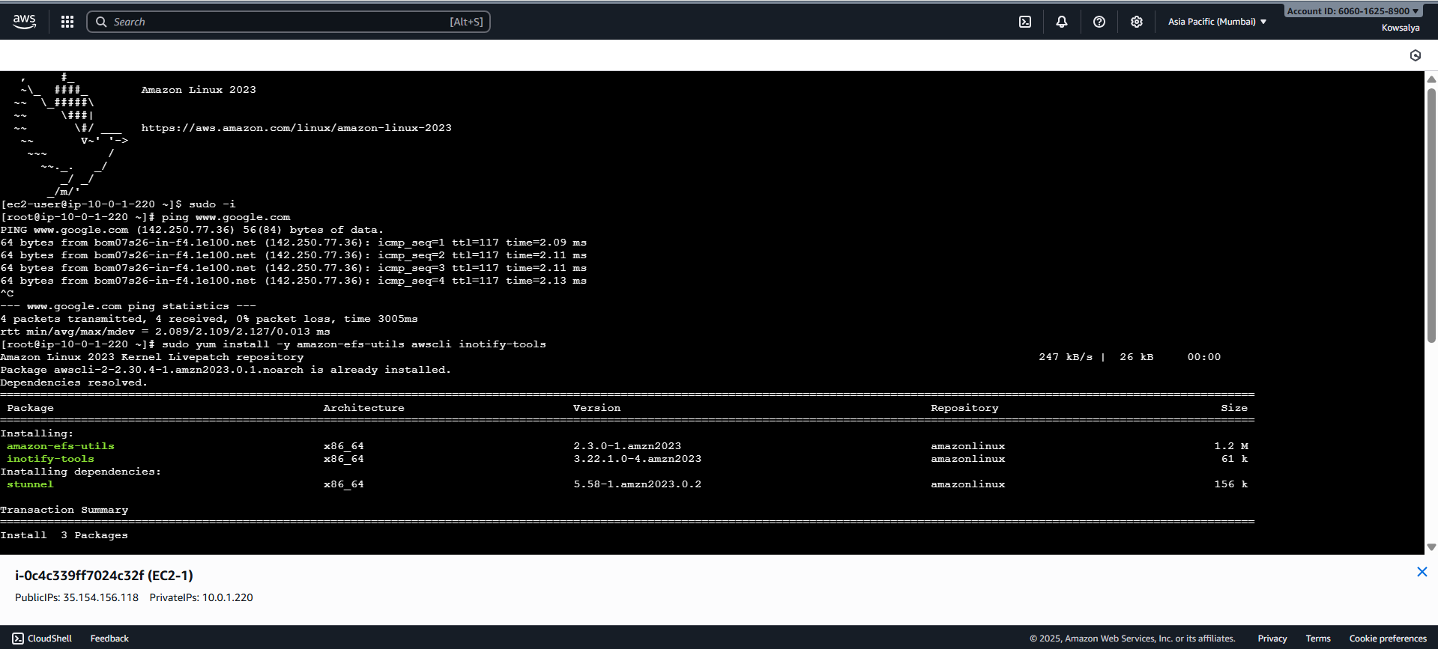
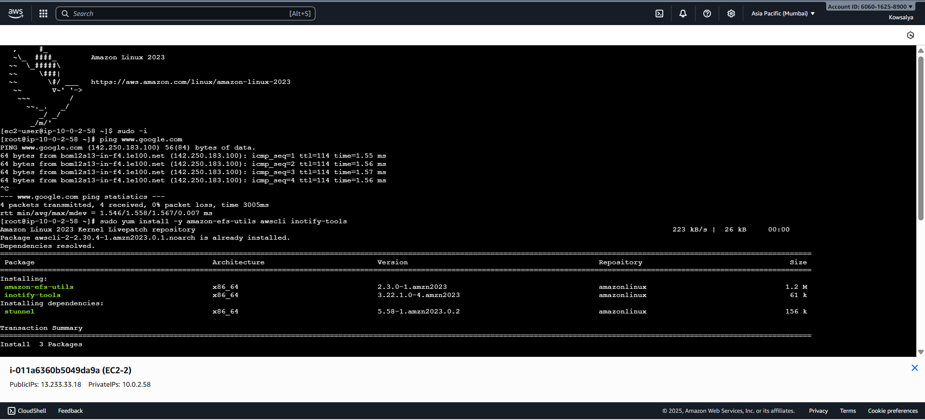

Step 3: Amazon EFS Configuration
- Created a new EFS file system within the same VPC.
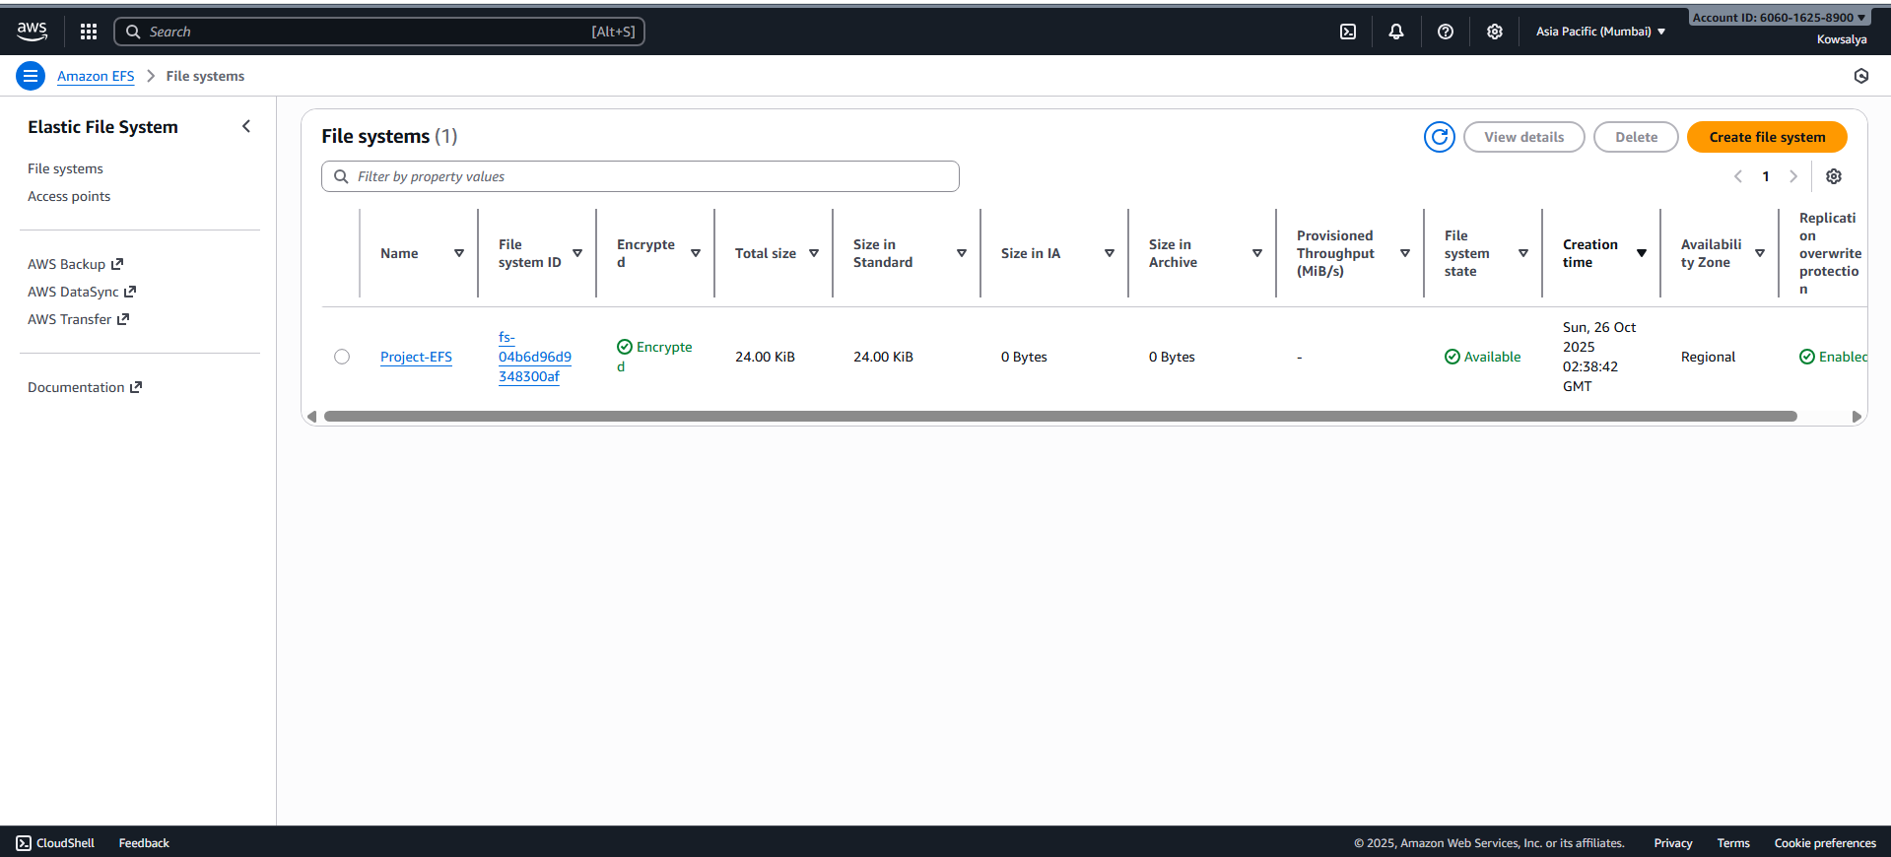
- Created mount targets in both subnets.
- On both EC2s:
  - sudo mkdir -p /share/projects
  - sudo mount -t efs fs-04b6d96d9348300af:/ /share/projects
  - Verified mount: df -h | grep share
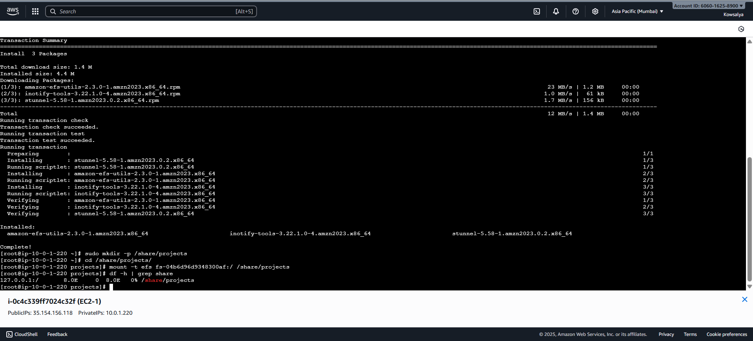
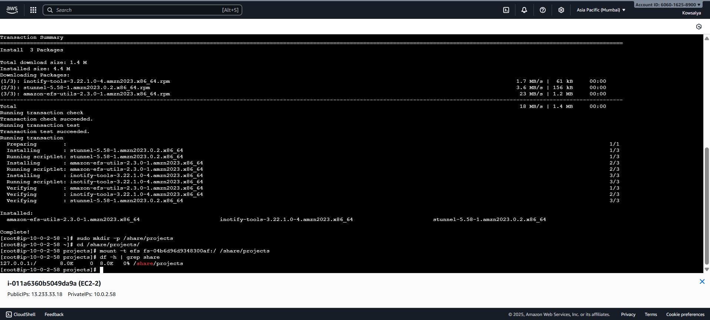

Step 4: Amazon S3 Bucket
- Created a dedicated S3 bucket named project-s3-bucket-realtimesync
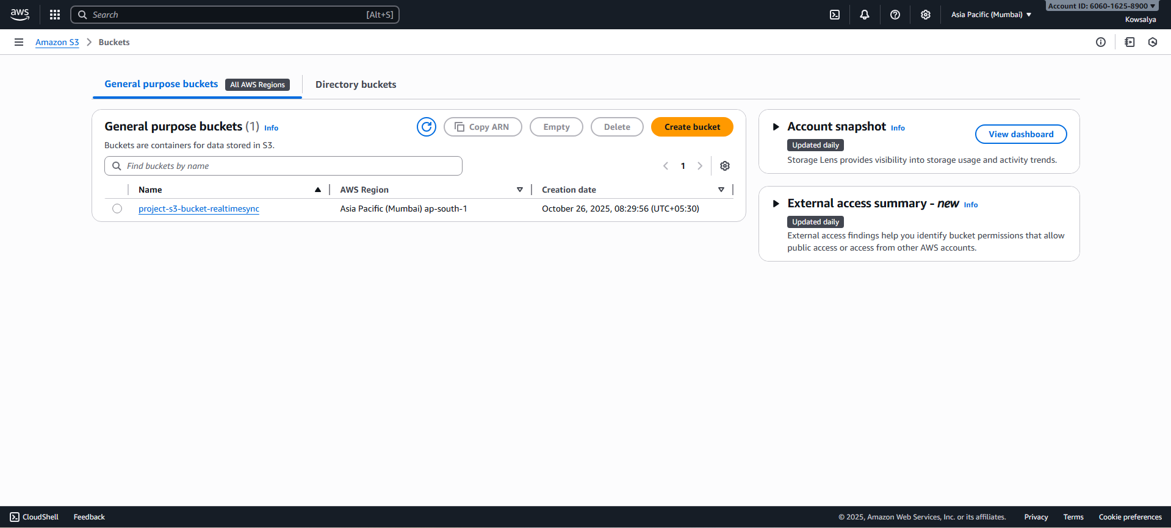

Step 5: IAM Role and Policy
- Created an IAM role EC2Realtimesync and attached the following inline policy
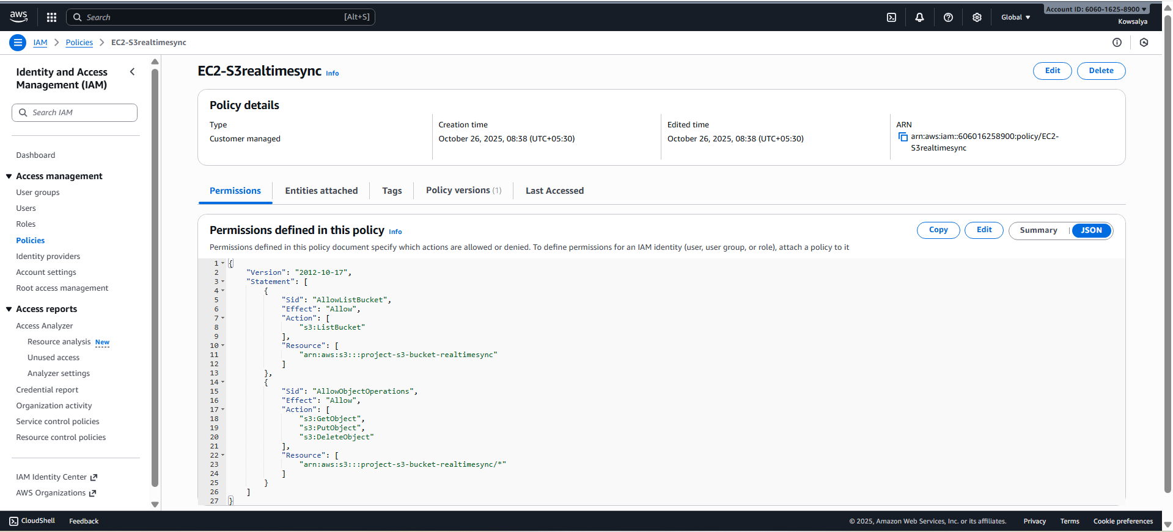
- Attached this role to both EC2 instances.

Step 6: Near Real-Time Sync Using inotify + AWS CLI
nohup inotifywait -m -r -e create -e modify -e moved_to -e moved_from -e delete -e delete_self /share/projects --format '%e %w%f' | while read EVENT FILE; do
if [[ "$EVENT" =~ CREATE|MODIFY|MOVED_TO ]]; then
aws s3 cp "$FILE" s3://project-s3-bucket-realtimesync/"${FILE#/share/projects/}" 2>/dev/null
elif [[ "$EVENT" =~ DELETE|MOVED_FROM|DELETE_SELF ]]; then
aws s3 rm s3://project-s3-bucket-realtimesync/"${FILE#/share/projects/}" 2>/dev/null
fi
done &

Explanation:
- inotifywait monitors /share/projects for any file changes.
- Whenever a change occurs, it automatically triggers aws s3 sync to update S3.
- This ensures files are mirrored to S3 within seconds of modification.

Step 7: Testing and Validation
Action | Expected Result
Created file on EC2-1 | File appeared in S3 within seconds
Modified file on EC2-2 | Updated version synced to S3
Deleted file on EC2-1 | File removed from S3
Both EC2 instances monitored | Changes reflected on both due to shared EFS mount
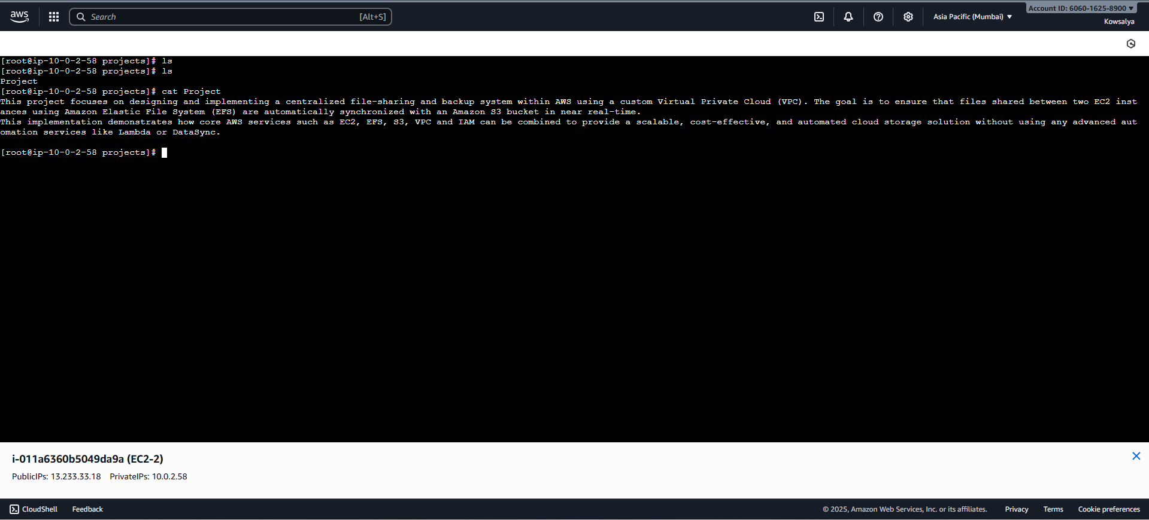
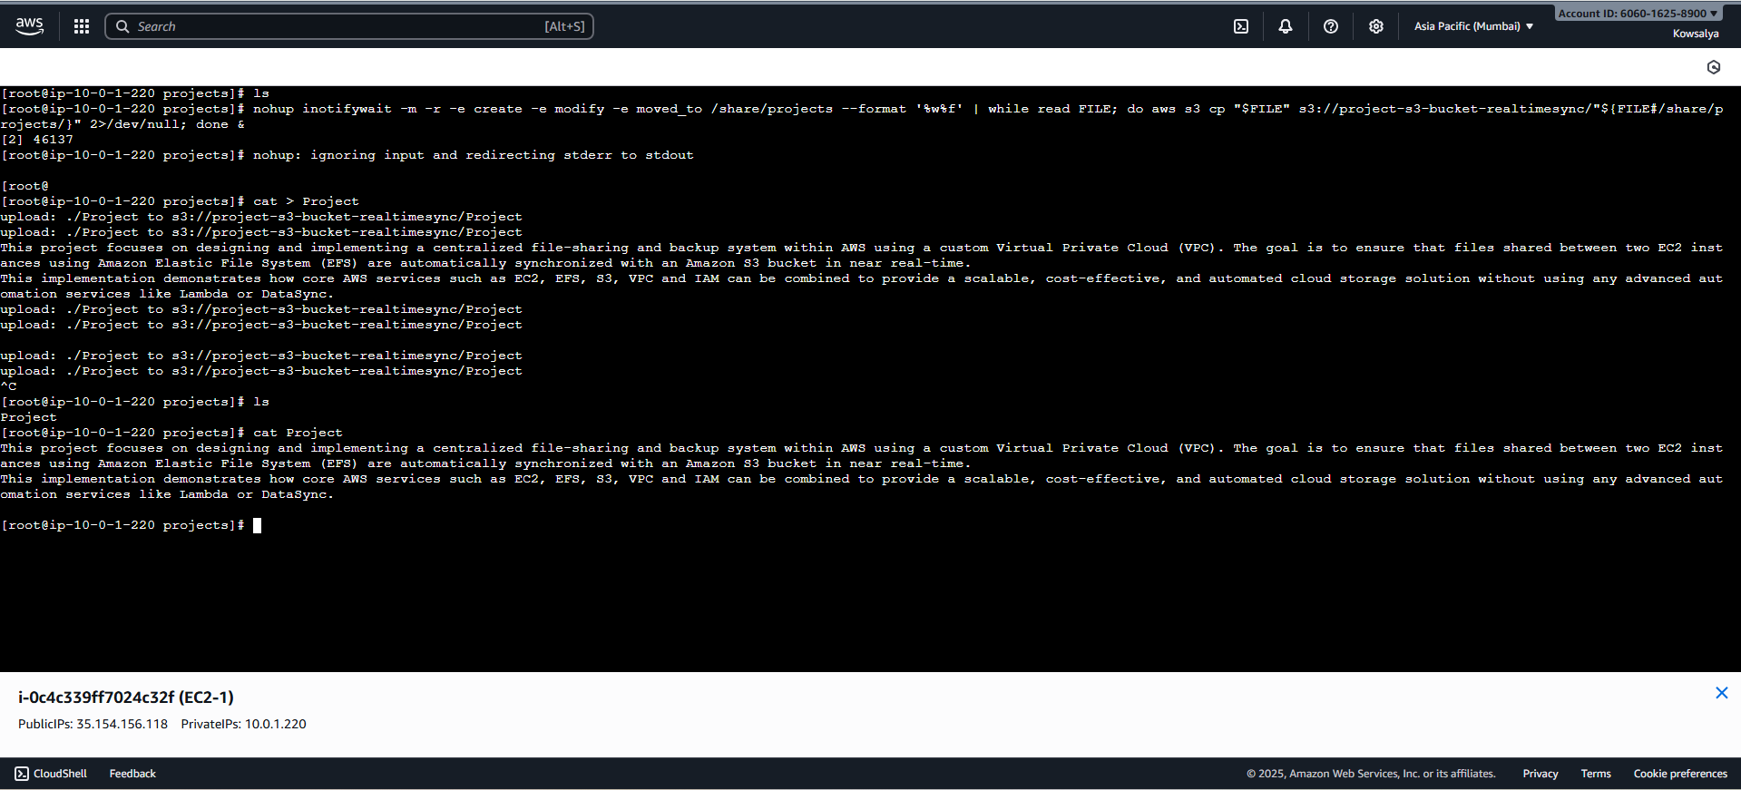
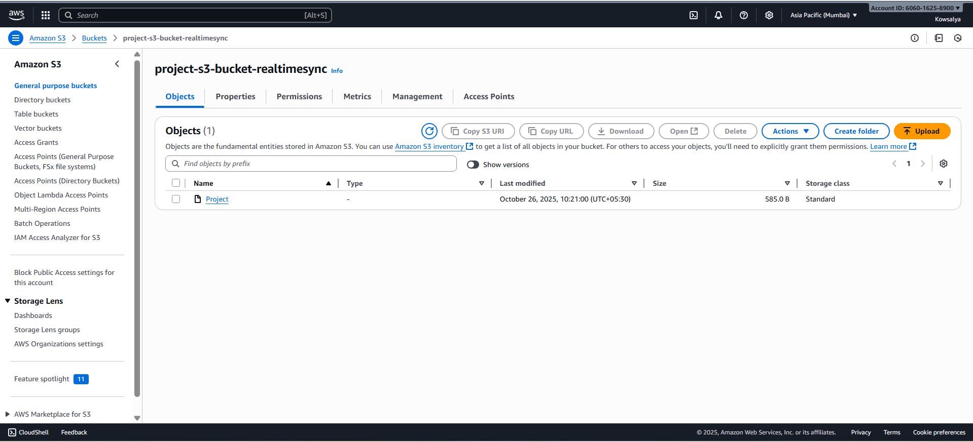

Challenges Faced
- IAM permission errors when syncing to S3 due to initially missing ListBucket access.
→ Solved by updating IAM policy to include necessary S3 actions.
- Testing file event detection required tuning inotify parameters for recursive monitoring.

Lessons Learned
- Learned how to integrate core AWS services manually without managed automation tools.
- Understood the importance of least-privilege IAM policies for security.
- Discovered that inotifywait combined with aws s3 sync is a simple yet powerful solution for near real-time replication.
- Gained hands-on experience with VPC networking, EFS mounts, and CLI-based automation.

Conclusion
This project successfully implemented a centralized file-sharing and synchronization system using only EC2, EFS, S3, VPC, and IAM.
Files modified in EFS were automatically uploaded to S3 in near real-time using an event-driven approach (inotify + AWS CLI).
The solution achieved all objectives — secure architecture, minimal service usage, and bi-directional synchronization — without using any additional AWS automation services.
Future improvements: Integrating event logging with CloudTrail or implementing version control for backup recovery.

Output Screenshots
VPC topology diagram

Security Group configuration

EC2 instances - Necessary Package Installation

EC2 instances with EFS mount (df -h)

IAM policy JSON

Results

