**Day 10 – Create an asp.net page which displays number of active users.**

**Task Summary**

1. Create a new ASP.Net Web page with following controls:
   1. Button: Text of the button should be “Fetch Active Users”. The button should hold the functionality to fetch the number of active users.
   2. Label1: id = lbl_display. Text should be number of active users.
   3. Label2: id = lbl_display. Text should be assigned when users click “Fetch Active Users”
2. A function “fetch_active_user_count” Should be developed in business logic class:
   1. Formulate the query like we did for fetching user details.
   2. Use getdataset() function to fetch results from DB and return the result (Dataset.tables[0].rows.count)

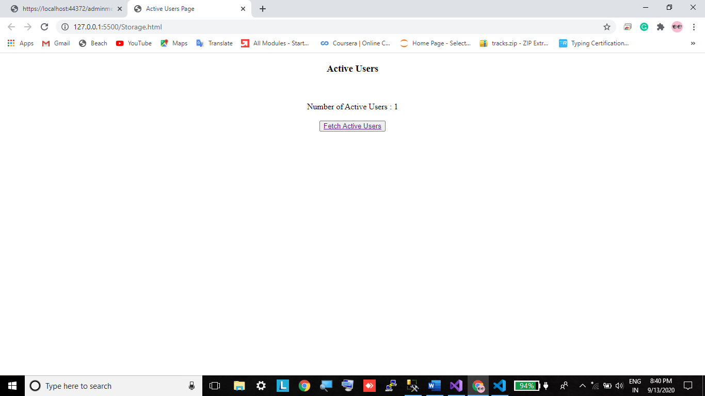

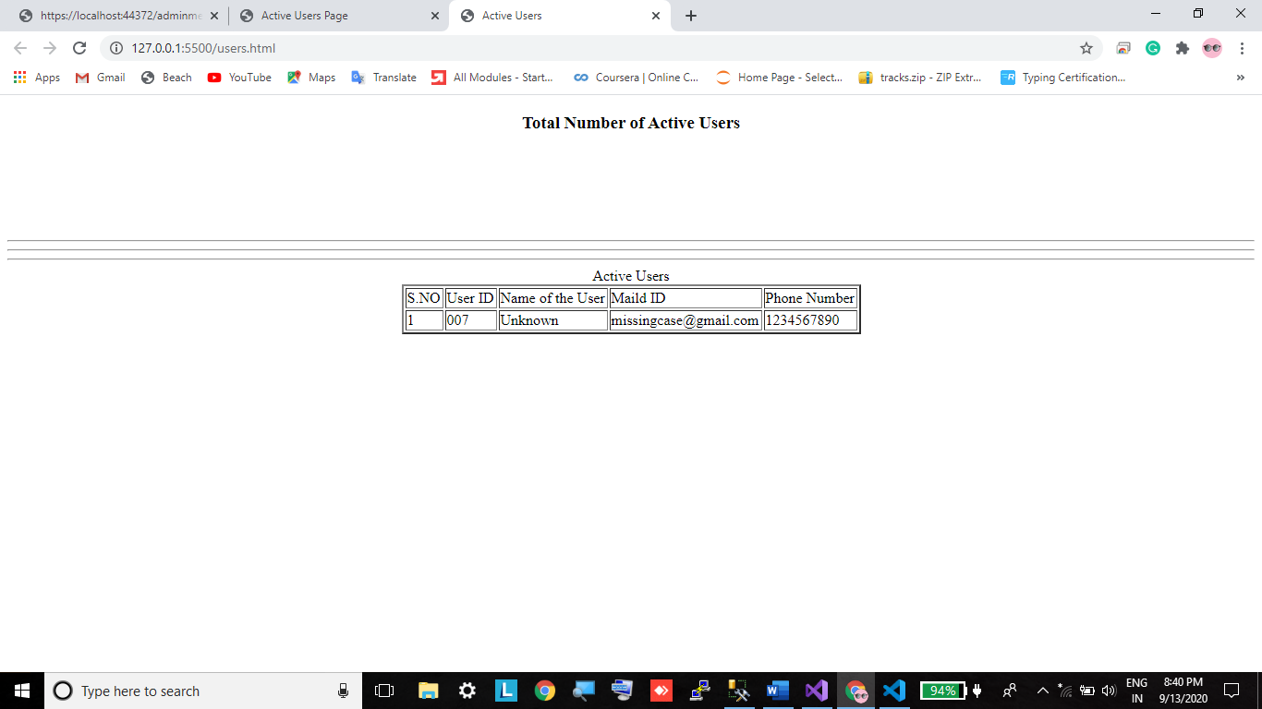

<!DOCTYPE html>

<html lang="en">

<head>

<meta charset="UTF-8">

<meta name="viewport" content="width=device-width, initial-scale=1.0">

<title>Active Users Page</title>

</head>

<body>

<center>

<h3>Active Users</h3> <br><br>

<label>Number of Active Users : 1 </label><br><br>

<button><a href="users.html">Fetch Active Users</a></button><br><br>

</center>

</body>

</html>

<!DOCTYPE html>

<html lang="en">

<head>

<meta charset="UTF-8">

<meta name="viewport" content="width=device-width, initial-scale=1.0">

<title>Active Users</title>

</head>

<body>

<center>

<form>

<h3>Total Number of Active Users </h3>

<br><br><br><br><br>

<hr><hr><hr>

<label> Active Users </label>

</form>

<table border="2px solid">

<tr>

<td>S.NO</td>

<td>User ID</td>

<td>Name of the User</td>

<td>Maild ID</td>

<td>Phone Number</td>

</tr>

<tr>

<td>1</td>

<td>007</td>

<td>Unknown</td>

<td>missingcase@gmail.com</td>

<td>1234567890</td>

</tr>

</table>

</center>

</body>

</html>